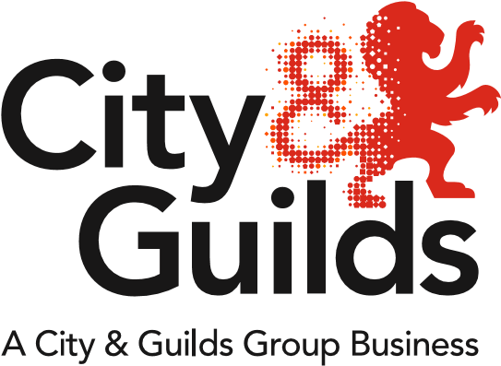

All ABOUT CHILDCARE

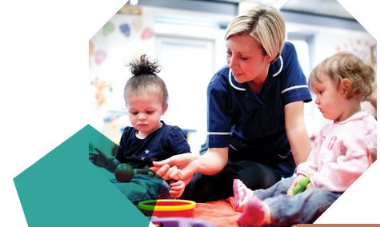

All about Childcare
Welcome to the first Centre Newsletter for Childcare. We will be aiming to provide additional newsletters in Autumn, Spring and next Summer.

Meet the team
Geraldine Donworth  Industry Manager | Suzi Gray  Technical Advisor  N. Ireland, Wales and England | Paul Robottom  Technical Advisor  England

Hot off the Press!
NEW 4228-02 Level 2 Diploma for the Early Years Practitioner (England) qualification
Our new Level 2 Diploma for the Early Years Practitioner (England) will be available for first teaching from 01 September 2019. This qualification has been developed in partnership with sector experts and has been confirmed by the Department for Education, as being a full and relevant level 2 qualification in early years for starts at level 2 from 01 September 2019. It has been based on and meets the DfE Early Years Practitioner qualification criteria. The new qualification will be included in the Department for Education list of approved qualifications shortly. The qualification has been accredited with Ofqual with QAN 603/4935/9. The qualification web page should be available shortly.

The new qualification is suitable for those individuals working with 0-5 year olds in a range of early years settings. The current 4227-01 Level 2 Certificate for the Children and Young People’s Workforce will be extended BUT is only suitable from 01 September 2019 for new starts working with Children and Young People from 6-19 years old. Existing learners can complete their qualification without having to register on the new qualification.
We were delighted to speak to some centres about this new qualification during our network events that happened in early July. Don’t worry if you weren’t able to attend these events as we will be hosting some online events soon.
In summary, the new qualification comprises of 9 mandatory units (see below) and is assessed by a portfolio of evidence. The qualification does not include any optional units. Centres who are currently approved to offer the 4227-01 and/or 3605-03 will benefit from Automatic Approval. The new qualification will be supported by new Smartscreen resources and Learning Assistant.
Level 2 Diploma for the Early Years Practitioner (England)
City & Guilds unit number
Mandatory
201 | Exploring roles and development opportunities in early years settings
202 | Child development from birth to 7 years
203 | Safeguarding babies and young children in early years settings
204 | Supporting health and safety in early years settings
205 | Promoting wellbeing in early years settings
206 | Supporting effective communication in early years settings
207 | Supporting activities, purposeful play and educational programmes
208 | Understand how to support children with special educational needs and/or disabilities
209 | Working with parents, colleagues and other professionals in early years settings

Level 3 Early Years Educator
Our 3605-03 Level 3 Diploma for the Early Years Practitioner (Early Years Educator) will be extended and following feedback from our centres we will be refreshing aspects of content so that the qualification remains current.
We will also be thinking about the role of the current assignments and so please do let us know if you have any thoughts on this aspect.
PACEY - Bringing Childminding into the 21st Century - Survey Open
A message from PACEY
With the ongoing decline in the numbers of registered childminders in England and Wales, we are all aware that childminding is in danger. We know how much childminding is valued by the families who use it and we want to ensure that future generations can choose home-based care.
So, PACEY is launching its 'Inquiry into Childminding in the 21st century' . We are looking to get firstly, up to date evidence on why people are leaving the sector and secondly, insight into a better understanding about why even fewer people are choosing to register as a childminder.
Over the summer PACEY will be working with researchers at the University of Plymouth to run a national survey. Alongside this PACEY will be holding online discussions via social media as well as focus groups with a wide range of different people.
We would be grateful if you could share the news story and survey to all your contacts and links to early years. We want childminders past, present and future to fill this in.
The survey is now launched and you can read the press release here. Please do share the survey and support our post on Facebook as well

Apprenticeships - England
Childcare
The Early Years Educator level 3 standard
This has been published on the Institute for Apprenticeships website and can be found here
We are currently seeking expressions of interests and indications of demand for the Level 3 Early Years Educator End Point Assessment, as we are intending to offer this service. Our current Level 3 Diploma for the Early Years Practitioner (Early Years Educator) (Work-based) (3605-03), which is being extended, can be used to meet part of the mandatory on-programme requirements.

Other standards in development
We are aware of the development of two additional Childcare related standards.
A group of employers is working on a standard for the Early Years Practitioner at level 2. The intention of the group is to submit a standard and assessment plan very soon. It is hoped that our new Level 2 Diploma for the Early Years Practitioner will be included as a mandatory qualification , as it meets the DfE criteria, however until we see the standard published we are not able to confirm that.
A separate group of employers is working on a Level 5 Early Years Senior Practitioner standard and exploring an Early Years Lead Practitioner (degree) standard at Level 6.
Look out for any IfA consultations associated with either of these developments.

Children’s Residential Care
There are two published standards on the IfA website here
We have qualifications available, which meet the mandatory requirements for 3 of the 4 options
Children Young People & Families Practitioner level 4
Children’s Residential Care Option - 4340-31 Level 3 Diploma for Residential Childcare (England)
Community - This option requires a Higher Education Certificate at Level 4, which you would need to source from a Higher Education Institution
Children Young People & Families Practitioner Level 5
Children’s Residential Care Option – 4340-51 Level 5 Diploma in Leadership and Management for Residential Childcare (England)
Community – 4978-52 Level 5 Diploma in Leadership for Health and Social Care and Children and Young People's Services - Children and Young People's Management (England)

We are not planning to offer end point Assessment for these standards over the next year but would like to be able to gauge interest from centres, so please do get in touch about this.

SASE Framework for Children and Young People’s Workforce
Skills for Care, as the issuing authority for the Children and Young People’s Workforce SASE framework has confirmed that they have been asked by DfE to do two things:
- To create a new early years pathway in the level 2 intermediate apprenticeship for those apprentices who work with children between 0-5 years. This pathway will include the new Early Years Practitioner qualifications, which have been approved by DfE.
- To retain the current Children and Young People’s Workforce pathway with the current 4227-01 qualification, the Level 2 Certificate for the Children and Young People’s Workforce BUT to restrict this to apprentices working with children and young people aged 6-19

The Advanced Apprenticeship pathways in the CYPW SASE framework will remain the same. There has not been a request to remove the Early Years Educator pathway even though there is now an Early Years Educator apprenticeship standard. It is expected that there will be an overlap of SASE and standard provision for the time being. Notice will be given prior to the removal of closure of the SASE pathway for Early Years Educator.
The Children’s Social Care pathway in SASE continues to be available for those apprentices NOT working in Residential Childcare. The 4227-04 Level 3 Diploma for the Children and Young People's Workforce (Social Care pathway) has been extended to 31 December 2020.
The whole SASE Framework is expected to close on 31 July 2020.

Teaching and Learning

City & Guilds is planning to develop an EPA service for the Level 3 Teaching Assistant apprenticeship standard during 2019/20. The On-Programme offer will include an Apprenticeship Training Manual, and possibly an optional qualification (no mandatory qualification in the standard). This is all subject to a successful business case submission this Spring/Summer. If this is something you are interested in David Wackett is the Industry Manager for Teaching and Learning.

In the meantime, there is a mapping matrix available on the 5329 webpage (Documents tab, under Additional documents here: https://www.cityandguilds.com/qualifications-and-apprenticeships/learning/learning-support/5329-supporting-teaching-and-learning-in-schools#tab=documents

This maps our current 5329-33 Level 3 Diploma in Specialist Support for Teaching and Learning in Schools to the Teaching Assistant apprenticeship standards, so that 5329-33 can be used to support the delivery of the KSBs in the latter.

For other standards in Teaching and Learning/Education, specifically the Level 3 Learning Mentor, Level 4 Assessor-Coach and Level 5 Learning and Skills Teacher, we will not be developing our EPA services during FY20, but I will be hoping to get something on the pipeline for the following year. In the meantime, the 6502-51/52 Level 5 Diploma in education and Training is available and is a mandatory On-Programme component of the Level 5 Learning and Skills Teacher standard.

We are delighted to confirm that the following Supporting Teaching and Learning in Schools qualifications will be extended end Aug 2022:
Our website and the Walled Garden will be updated shortly
Qualifications extended until end August 2022
5329-20 | Level 2 Award in Support Work in Schools
5329-21 | Level 2 Certificate in Supporting Teaching and Learning in Schools
5329-31 | Level 3 Certificate in Supporting Teaching and Learning in Schools
5329-33 | Level 3 Diploma in Specialist Support for Teaching and Learning in Schools

Technicals – England only
The following qualifications will be closed from 1 September 2019:
•3605-32 Level 3 Advanced Technical Extended Diploma for the Early Years Practitioner (Early Years Educator) (1080)
•3605-31 Level 3 Advanced Technical Diploma in Early Years and Childcare
We would like to extend our thanks to all of our centres who have been on this journey with us and we wish you and your learners every success in the years to come.

Playwork
We are delighted to confirm that the following Playwork qualifications will be extended until 2024: Our website and the Walled Garden will be updated shortly
Qualifications extended until 2024
4964-02 | Level 2 in Playwork
4964-03 | Level 3 Diploma in Playwork (NVQ)
4964-30 | Level 3 Award in Transition to Playwork (from Early Years)
4964-05 | Level 5 Diploma in Playwork

Apprenticeship in England – Helpful Information for any standard
Apprenticeship website
https://www.cityandguilds.com/apprenticeships
New Ten Steps Guide to the City & Guilds EPA process
https://www.cityandguilds.com/~/media/cityandguilds-site/documents/apprenticeships/epa-10-step-guide%20pdf.ashx
Manual for End Point Assessment Service
https://www.cityandguilds.com/~/media/cityandguilds-site/documents/apprenticeships/manual-for-the-end-point-assessment-service%20pdf.ashx

Being and End Point Assessor
We invite applications from individuals who are interested in becoming Independent End Point Assessors with City & Guilds and will include details of the standards we are recruiting for at the link below.
Become an independent assessor - find out more here

Functional Skills Reform
Please visit our website to learn about how we can support delivery of maths and English
Functional Skills Updates

Qualifications being extended
The following childcare qualifications are in the process of being extended. Some of these extension requests are still in process so please check the Walled Garden.
3599-02 | Level 3 Award in Work with Parents
3599-03 | Level 3 Certificate in Work with Parents
3599-04 | Level 4 Award in Work with Parents
3599-05 | Level 3 Certificate in Work with Parents - Parent Support Adviser Pathway
3599-92 | Level 3 Certificate in Work with Parents
4227-04 | Level 3 Diploma for the Children and Young People's Workforce: Social Care Pathway
4227-06 | Level 3 Diploma for Children's Care, Learning and Development (Wales & Northern Ireland)
4227-07 | City & Guilds Level 5 Diploma in Leadership for Children's Care, Learning and Development (Advanced Practice) (Wales and Northern Ireland)
4227-08 | City & Guilds Level 5 Diploma in Leadership for Children's Care, Learning and Development (Management) (Wales and Northern Ireland)
4227-11 | Level 5 Diploma in Leadership for the Children and Young People's Workforce - Early Years (Management)
4227-12 | Level 5 Diploma in Leadership for the Children and Young People's Workforce - Early Years (Advanced Practice)
4230-01 | Level 1 Award in Introduction to Health and Social Care (Adults and Children and Young People), Early Years and Childcare (Wales and Northern Ireland)
4230-02 | Level 1 Certificate in Introduction to Health and Social Care (Adults and Children and Young People), Early Years and Childcare (Wales and Northern Ireland)
4230-03 | Level 1 Diploma in Introduction to Health and Social Care (Adults and Children and Young People), Early Years and Childcare (Wales and Northern Ireland)
4237-01 | Level 1 Award in Caring for Children
4237-02 | Level 1 Certificate in Caring for Children
4237-03 | Level 1 Diploma in Caring for Children
4237-90 | Level 1 Award in Caring for Children
4237-90 | Level 1 Certificate in Caring for Children
4237-90 | Level 1 Diploma in Caring for Children
4338-04 | Level 4 Award in Working with Parents (Intense support for families with multiple and complex needs)
4340-31 | Level 3 Diploma for Residential Childcare (England)
4340-51 | Level 5 Diploma in Leadership and Management for Residential Childcare (England)
4340-81 | Level 3 Diploma for Residential Childcare (England)
4340-91 | Level 5 Diploma in Leadership and Management for Residential Childcare (England)
4964-03 | Level 3 Diploma in Playwork (NVQ)
4964-05 | Level 5 Diploma in Playwork
4964-30 | Level 3 Transition award in Playwork (from Early Years)
4964-92 | Level 2 Diploma in Playwork
4964-93 | Level 3 Diploma in Playwork (NVQ)

The following unit routes will close as per the current registration end date on Walled Garden due to very low take up
4227-91 | Level 2 Certificate for the Children and Young People's Workforce
4227-92 | Level 2 Diploma for Children's Care, Learning and Development (Wales & Northern Ireland)
4227-96 | Level 3 Diploma for Children's Care, Learning and Development (Wales & Northern Ireland)
4227-97 | Level 5 Diploma in Leadership for Children's Care, Learning and Development: Advanced practice pathway (Wales & Northern Ireland)
4227-98 | Level 5 Diploma in Leadership for Children's Care, Learning and Development (Management) (Wales and Northern Ireland)
4230-90 | Level 1 Award In Introduction to Health and Social Care (Adults and Children and Young People), Early Years and Childcare (Wales and Northern Ireland)
4230-90 | Level 1 Certificate in Introduction to Health and Social Care (Adults and Children and Young People), Early Years and Childcare (Wales and Northern Ireland)
4230-90 | Level 1 Diploma In Introduction to Health and Social Care (Adults and Children and Young People), Early Years and Childcare (Wales and Northern Ireland)
4964-92 | Level 2 Award in Playwork
4964-92 | Level 2 Certificate in Playwork
4964-93 | Level 3 Award in Induction to Playwork
4964-93 | Level 3 Certificate in Playwork
4978-52 | Level 5 Diploma in Leadership for Health and Social Care and Children and Young People's Services - Children and Young People's Management (England)

Focus on Northern Ireland
Children’s Care, Learning and Development
We are pleased to confirm that the 4227-02 will be replaced by the Level 2 Diploma in Children’s Care, Learning and Development (Northern Ireland) (3087-02) that will be available for first teaching from 01 September 2019.
In light of the above, the Level 2 Diploma in Children’s Care, Learning and Development (4227-02) will close for registrations on 31 August 2019.
The new qualification has been developed collaboratively with the Social Care Council and other key stakeholders including Early Years, Playboard NI, the Northern Ireland Childminding Association and representatives from the Childcare Partnerships and Further Education Colleges.
The new qualification includes mandatory content only that is presented in eight Core Themes as listed below:
Structure – L2 Diploma in Children's Care Learning and Development (Northern Ireland)
City & Guilds unit number | Unit title | GLH
201 | Context, principles and values that underpin practice | 50
202 | Communication and partnership working | 30
203 | Safeguarding children | 30
204 | Keeping children safe, healthy and well | 60
205 | Support children’s personal care and nutrition | 40
206 | Supporting children’s development | 60
207 | Support children’s play, learning and development | 60
208 | Contribute to the support of children with disabilities and/or special needs | 40

The revised and updated content reflects the breadth and depth of knowledge and skills needed to practice at Level 2 in registered settings in Northern Ireland and is appropriate for practitioners working with children from 0-7yrs 11mths.

Total Qualification Time

Total Qualification Time (TQT) is the total amount of time, in hours, expected to be spent by a learner to achieve a qualification. It includes both guided learning hours (which are listed separately) and hours spent in preparation, study and assessment.
Title and level | GLH | TQT
L2 Diploma in Children's Care Learning and Development (Northern Ireland) | 370 | 480

We have delivered a series of launch events during June 2019 hosted by Suzi Gray, our Technical Adviser.

Qualifications extended until 31 August 2020
4227-06 | Level 3 Children’s Care, Learning and Development
4227-07 | Level 5 Diploma in Leadership for Children's Care, Learning and Development: Advanced Practice (Wales & Northern Ireland)
4227-08 | Level 5 Diploma in Leadership for Children's Care, Learning and Development (Wales & Northern Ireland)

Focus on Wales
As a result of Qualifications Wales Qualification review during 2016 a suite of new qualifications for Children’ Care, Play, Learning and Development will be available for first teaching from 01 September 2019. The new qualifications will form part of the new Apprenticeship Framework in Wales.
Centres can apply to become approved centres using a specific approval form that is ONLY available here
The following table details the current City & Guilds qualifications that are impacted by the Qualifications Wales review and so will close for registration on 31 August 2019.
Current Qualification – closing 31 August 2019 | New Qualification – available from 01 September 2019
No existing qualification | WJEC Level 2 Children’s Care, Play, Learning and Development: Core
Level 2 Diploma in Children’s Care, Learning and Development (4227-02) | City & Guilds Level 2 Children’s Care, Play, Learning and Development: Practice
Level 3 Diploma in Children’s Care, Learning and Development (4227-06) (Closing in Wales only) | City & Guilds Level 3 Children’s Care, Play, Learning and Development: Practice

We have been working with colleagues at WJEC Awarding Body to deliver a whole suite of qualifications which is outlined below and on our HCLW Website

The whole suite of qualifications currently looks like this:
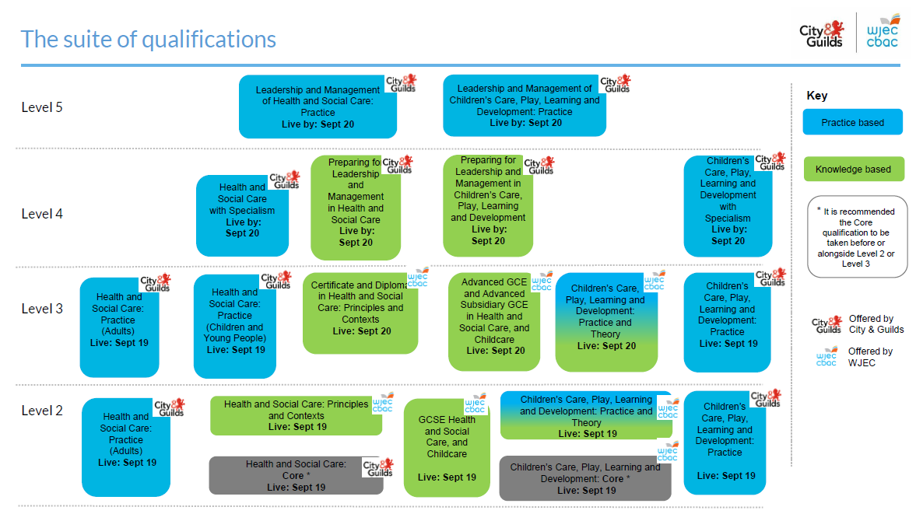
All of the centre documents needed to support the delivery of the new qualifications can be accessed here. We are also developing bespoke digital learning resources that can support centres and learners and we are in the process of adding these resources here
Supporting centres to prepare for delivery
We have just completed a series of events that were designed to support centres to prepare for the new qualifications and these have received some really positive feedback.

Here’s Suzi in action, presenting at one of the Events
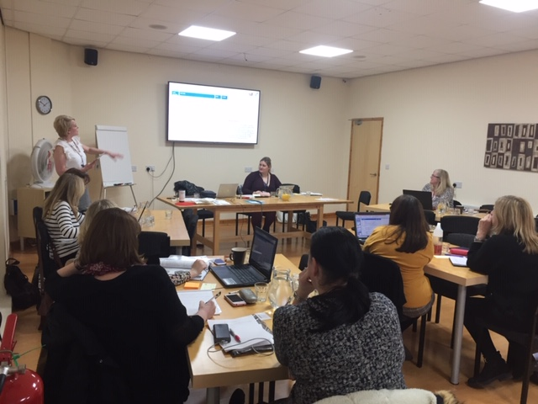
It was all excellent. The resources being prepared are superb.” Attendee at event

“Excellent presentations and in depth of knowledge of trainer” Attendee at event

These events have been followed up with a number of recorded webinars that can be accessed here under ‘Past training and events’
Employer engagement in Wales
We recently joined colleagues from Social Care Wales as they facilitated a number of information events aimed at early years and childcare employers across Wales. The events, held during late June, early July across Wales provided employers with the opportunity to hear about the new qualifications, their content and new assessment approach, and also to share their views about what should be included in the new Early Years and Childcare Apprenticeship in Wales. We were delighted to see how please employers were with the new qualifications and to have the opportunity to respond to their queries and concerns.

Please note that the following qualifications have been extended until 31 August 2020:

- Level 5 Diploma in Leadership for Children's Care, Learning and Development: Advanced Practice (Wales & Northern Ireland) (4227-07)
- Level 5 Diploma in Leadership for Children's Care, Learning and Development (Wales & Northern Ireland) (4227-08)

Funding Updates
We have a very comprehensive web page on Funding for Qualifications, which can be found
Here
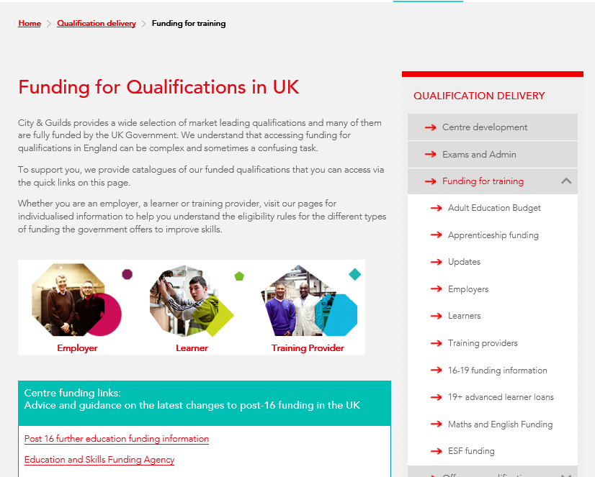

Events
Dates for our free centre networks for early years and childcare will be communicated via the City & Guilds Email Updates system and via email for events in Wales and you will be able to book places for these by following the links provided. Please make sure you are registered to receive the updates, on the City & Guilds Updates and/or the Health and Care Learning Wales Updates webpages.
New CPD Events
'Best practice in the quality assurance of the new Apprenticeship Standards (England)'
This one day event (10-4pm) is being delivered nationally at the following venues/dates. The cost will be £150 per delegate.
- 29 October– City & Guilds London

''Best practice in preparing apprentices for their EPA Professional Discussion or Interview'
As part of our continued support, we are running a series of national quality improvement events aimed at all vocational sectors delivering new apprenticeship standards and EPA with City & Guilds. A workshop filled with engaging practical and other activities, aims to provide ideas for further developing your individual and centre practice when working with new apprentices in preparing them for their EPA professional discussion or interview. The workshop is aimed at Assessors/Trainers, Curriculum Managers, IQAs, Apprenticeship/WBL Managers, Quality Managers and others who may have a teaching, learning and/or assessment role within the delivery of the new apprenticeship standards. Employers are also welcome to attend.
Dates/venues as follows:
- 08 October City & Guilds Warrington
- 26 November City & Guilds London

The CPD events are being delivered by Paul Robottom Technical Advisor at City & Guilds. The delegate cost for the above is £150 per person. For further event information please see https://www.cityandguilds.com/cpd
Available in-house for up to 25 delegates £2000
We also offer this as an in-house event. This means you can have this delivered on your own premises, on your chosen date for up to 25 delegates. Our expert facilitators can also customise your session to the specific needs of your staff, offering a uniquely tailored CPD experience.
For further details and registration;
https://www.cityandguilds.com/what-we-offer/centres/cpd-training

Contact details
Geraldine geraldine.donworth@cityandguilds.com
Follow me on Twitter @g_donworth
Connect on LinkedIn: https://www.linkedin.com/in/geraldine-donworth-bsc-hons-rgn-afcgi-48160352/
Suzi suzi.gray@cityandguilds.com
Paul paul.robottom@cityandguilds.com
David Wackett Industry Manager for Teaching and Learning david.wackett@cityandguilds.com

We have a specific Twitter account, which you can follow if you are interested in the qualifications we are designing specifically for Wales
@HCL_Wales

Which team should I contact? | Speak to this team about… | Contact details
Sales team | Information about our EPA service | E: directsales@cityandguilds.com.com  T: 01924 206 709
EPA application team | Getting set up as an EPA customer | E: epaapplications@cityandguilds.com  T: 01924 206 719.
EPA customer success team | Support throughout your EPA journey with us once you’ve completed the application process .  The EPA customer success team will be in touch with you ensure you have everything in place for a smooth booking process. | E: epasupport@cityandguilds.com  T: (0)20 7294 3201
Technical Advisors | Sector specific technical guidance. | Contact details for all advisors: https://www.cityandguilds.com/what-we-offer/centres/technical-advisors
EPA bookings team | Specific enquiries about your EPA booking once you have started your EPA booking request (stage 5). | E: epa@cityandguilds.com
Customer services | Support with our platforms including Walled Garden, SmartScreen and  e-volve. | E: centresupport@cityandguilds.com  T: 0844 543 000*  *calls to 0844 numbers cost 7p per minute plus your phone company’s access charge.
Customer Support | For any of the suite of qualifications being developed for Wales in Children’s Care Play Learning & Development or Health & Social Care | E: hclw.customer@cityandguilds.com  T: 0844 543 0033 (option 3)

