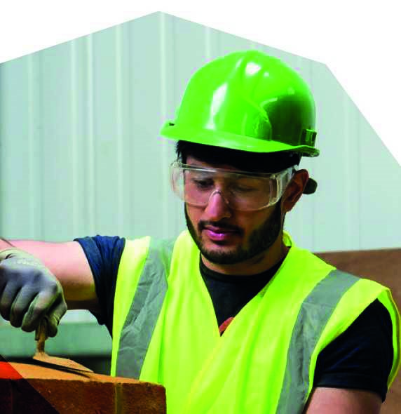
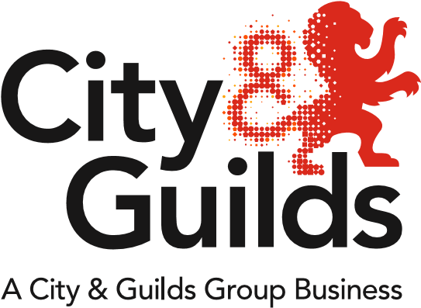
All About Construction
Issue 05
May 2018

A newsletter from City & Guilds on professional and technical education updates in construction for all nations.

In this issue:

- NVQ Incremental changes
- The return of 6144 and 6146 short-courses
- Update on City & Guilds apprenticeship standards:
- Carpentry & Joinery
- Update on City & Guilds support materials
- Update on Scotland
- Network and support events
- Update on government reforms
  - Trailblazer Apprenticeship standards – England
  - T-Levels - England
  - Qualifications Wales Sector Review – Wales

If you are interested in supporting City & Guilds either as a writer, marker, assessor, or as an EQA please do get in touch with us at construction@cityandguilds.com

For more information regarding the City & Guilds Construction offer, please refer to the Construction – a Summary document on our website:
https://www.cityandguilds.com/qualifications-and-apprenticeships/construction/latest-news-in-construction
Extensions and Withdrawals
Qualification extensions and withdrawals

NVQ incremental changes
As part of the “incremental changes” being made to the NVQs this year, several suites will be given new qualification numbers. For a summary of the changes being made to the NVQs, including new qualification numbers, please refer to our “Summary of NVQ incremental changes” document on the website:
https://www.cityandguilds.com/qualifications-and-apprenticeships/construction/latest-news-in-construction

For the NVQs listed below there will be a period of time where centres will be unable to register candidates. We are working to resolve this issue for as soon as possible.
- 6569-01 to -07 in Roofing Operations expired in April 2018. The replacement offer will be available from June 2018.
- 6577-01 to -06 in Construction Site Supervision expired in April 2018. The replacement offer will be available from July 2018.
- 6574-11 to -18 in Construction Operations and Civil Engineering Services is set to expire on 30.06.2018. The replacement offer will be available from July 2018.

Further detail of the changes can be found in the updated Qualification Handbooks on the individual product pages. Centres approved on existing NVQs will be given automatic approval to the replacement.

Once completed all City & Guilds NVQs will reflect the latest version of the National Occupational Standards as developed and maintained by CITB through employer-led meetings. The NVQs are recognised by CSCS for granting learner’s with access to work on construction sites.

New qualifications

The return of 6144 and 6146 short-courses
The following short-courses have been reinstated:

6147-21 Level 2 in Excavation Support Systems
And
6144-31 Level 3 Award in Understanding Planning, Supervising and Managing Working at Height

Both qualifications had originally ended for registration on 31.12.2017. However, as a result of unanticipated popular demand City & Guilds has agreed to extend the programmes for a further two years.
Update on City & Guilds apprenticeship standards
With SASE funding set to continue in several trade areas until at least 2020, City & Guilds have similarly extended their construction VRQs and NVQs to 2020, to assist centres with the transition over to the new standards.

Summary of Carpentry & Joinery standards
Approved for delivery by the Institute for Apprenticeships (IFA) on 27th February 2018

 |  | Carpentry & Joinery | Advanced Carpentry & Joinery
 | Level | 2 | 3
 | Number of pathways | 2 | 2
 | Duration | 18 months | 12 months
 | Funding Band | £12K | £9K
On-programme (mandatory) | NVQ | Mandatory:  6571-21 Level 2 NVQ Diploma in Wood Occupations (construction) - Site Carpentry  Or  6571-22 Level 2 NVQ Diploma in Wood Occupations (Construction) - Architectural Joinery | Mandatory:  6571-27 Level 3 NVQ Diploma in Wood Occupations (Construction) - Site Carpentry  Or  6571-28 Level 3 NVQ Diploma in Wood Occupations (Construction) - Architectural Joinery
 | Technical training | Training Specification available.  City & Guilds are currently developing a Learner Training Manual and Extended SmartScreen resources to cover this requirement. Available from November 2018. | Training Specification available.  City & Guilds are currently developing a Learner Training Manual and Extended SmartScreen resources to cover this requirement. Available from November 2018.
 | Maths & English | Level 1 (achieved)  Level 2 (to have taken) | Level 2 (achieved)
On-programme (optional) | City & Guilds support materials | - Learning Assistant (e-portfolio)  - End-point assessment Preparation Tool (covering behaviours and soft skills)  - End-point assessment Exemplar materials (demonstrating good practice for the EPA)  - Carpentry & Joinery Textbook | - Learning Assistant (e-portfolio)  - End-point assessment Preparation Tool (covering behaviours and soft skills)  - End-point assessment Exemplar materials (demonstrating good practice for the EPA)  - Carpentry & Joinery Textbook
 | Technical qualifications* | 6706-23 Level 2 Diploma in Site Carpentry  6706-26 Level 2 Diploma in Bench Joinery  7906-20 Level 2 Technical Certificate in Site Carpentry  7906-21 Level 2 Technical Certificate in Architectural Joinery | 6706-33 Level 3 Diploma in Site Carpentry  6706-36 Level 3 Diploma in Bench Joinery  7906-30 Level 3 Advanced Technical Diploma in Site Carpentry  7906-31 Level 3 Advanced Technical Diploma in Architectural Joinery
End-point assessment | Practical Test | 6 hours | 6 hours
 | Short-answer test | 45 minutes | 45 minutes

*Centres should be aware that technical qualifications cannot be claimed against the apprenticeship levy.

Update on City & Guilds support materials
Training Manuals
Available for Level 2 Bricklaying, Architectural Joinery, and Site Carpentry. Suitable for use on either the Diploma qualifications (6705 and 6706) or the new City & Guilds technical qualification specifications (7905 and 7906).

Available to purchase on Walled Garden or online bookshops.

The following screenshot has been taken from Walled Garden, showing how to find the new Training Manuals:
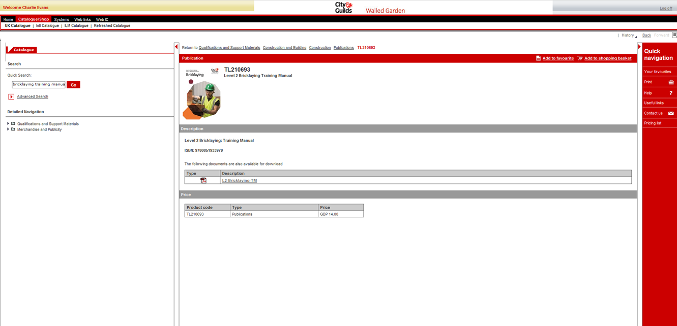

Enhanced SmartScreen
New e-learning packages are available for Bricklaying and Carpentry & Joinery via our SmartScreen platform.

An example module can be found by clicking on the links below:

Bricklaying Bricks, Blocks and Bonding
Carpentry Roof Types and their Components

Update on Scotland
City & Guilds now offer the following Modern Apprenticeships in Construction Building at SCQF Level 6:
- Bricklaying
- Carpentry and Joinery
- Painting and Decorating
- Plastering
Click here for our one-page summary of the Modern Apprenticeships.

For more information please visit our new dedicated webpage for Scotland:
https://www.cityandguilds.com/about-us/uk-local-teams/scotland

Network and support events
Please find below further details and joining instructions for our Construction Network Events:

Network events
Norwich, 15th June 2018
https://www.eventbrite.co.uk/e/norwich-construction-regional-network-tickets-46102866916

Cancelled: Manchester, 5th June 2018
Unfortunately, due to a conflict of dates we have had to cancel the event at Hopwood Hall, Manchester. We apologise for any inconvenience caused.

Support events
Webinar, 31st May 2018 - The end-point assessment journey and what to expect:
https://register.gotowebinar.com/register/6072097335523063298?source=IMs

CPD events
Please take a look at our full list of CPD events below:
https://www.eventbrite.co.uk/o/city-amp-guilds-10977079418

Construction Apprenticeship workshops
To be confirmed.
Update on government reforms

No further updates. The following has been taken from Newsletter 04; April 2018:

Trailblazer Apprenticeship standards – England
To check the status of standards currently in development, please visit the government website:
https://www.instituteforapprenticeships.org/apprenticeship-standards/

Several standards have had recent IfA approvals, including:
- Carpentry & Joinery: approved for delivery
- Advanced Carpentry & Joinery: approved for delivery
- Bricklayer: Assessment Plan approved, but not yet ready for delivery
- Plasterer: Assessment Plan approved, but not yet ready for delivery
- Lifting Technician: approved for delivery

T-Levels - England
The Department for Education are currently reviewing the outputs of the public consultation, which ended on 8th February 2018. For more information regarding T-Levels please visit the City & Guilds webpage:
https://www.cityandguilds.com/tlevels

Qualifications Wales Sector Review - Wales
Qualifications Wales has published its sector review of qualifications and the qualification system in Construction and the Built Environment. For the full Building Futures report please visit the Qualifications Wales website:
http://qualificationswales.org/english/qualifications/vocational-qualifications/sector-reviews/construction-and-the-built-environment/

Public consultation on the sector review closed on 13th April 2018.

Tell us what you think
All About Construction is a newsletter that brings together all of the key developments from City & Guilds relevant to Construction skills learning across England, Scotland, Northern Ireland and Wales. It contains updates on the range of teaching and learning resources we offer, plus relevant public policy or other information we think you might be interested in.

Each edition is numbered, so we can refer back to previous issues or tell you when information has been superseded.

For specific queries and enquiries please contact our dedicated customer support team: CentreSupport@cityandguilds.com

Meet the team:

Ed Shaw
Industry Manager
edward.shaw@cityandguilds.com
02072943314

Ian Roberts
Technical Advisor
Ianm.Roberts@cityandguilds.com
07826903967

Paul Brown
Technical Advisor
Paul.brown@cityandguilds.com
07872463185

Please follow us on twitter @ConstructionCG

Thank you for your continued support.

Every effort has been made to ensure that the information contained in this publication is true and correct at time of going to press. However, City & Guilds’ products and services are subject to continuous development and improvement and the right is reserved to change products and services from time to time. City & Guilds cannot accept responsibility for any loss or damage arising from the use of information in this publication.© 2018. The City and Guilds of London Institute. All rights reserved. City & Guilds is a trademark of The City and Guilds of London Institute, a charity established to promote education and training registered in England & Wales (312832) and Scotland (SC039576).

