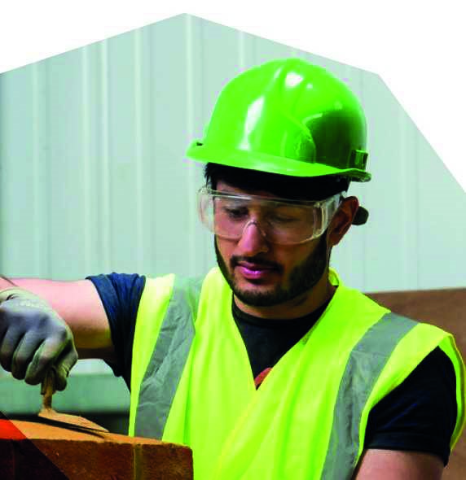
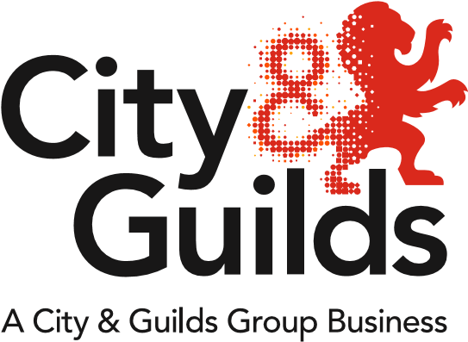
All About Construction
Issue 01
January 2018

A newsletter from City & Guilds on professional and technical education updates in construction for all nations.

In this issue:

- Qualification extensions and withdrawals
- New qualifications
  - Technical Qualifications approved for delivery
  - Updated Health & Safety in a Construction Environment
  - New Level 2 NVQ Diploma in Steelfixing Occupations
  - New Modern Apprenticeships for Scotland
- New enhanced SmartScreen package available
- Network events
- Update on government reforms

Extensions and Withdrawals
Qualification extensions and withdrawals
The following qualifications have now been extended to 31/12/2019:
6573-05 (601/1173/2) Level 3 NVQ Diploma in Plastering (Construction) solid
6573-06 (601/1173/2) Level 3 NVQ Diploma in Plastering (Construction) fibrous
6715-01 (601/3613/3) Level 1 Diploma in Stonemasonry
6715-02 (601/3612/1) Level 2 Diploma in Stonemasonry
6715-03 (601/3598/0) Level 3 Diploma in Stonemasonry
6718-02 (601/3615/7) Level 2 Diploma in Roof Slating and Tiling

There are several City & Guilds qualifications currently set to expire in 2018. Please note that these WILL be extended where appropriate, including:
- The NVQs in Construction, which are to be extended beyond April 2018.
- The Diplomas in Construction, which are to be extended beyond July 2018.

A detailed list of the qualifications above and their new registration dates will be available to centres from February.

New qualifications
Technical Qualifications approved for delivery
City & Guilds now have 16 qualifications available for delivery across Key Stage 4 and 5:
Key Stage 4 (KS4) - Level 2
6720-21 (601/7245/9) Level 2 Technical Award in Constructing and Maintaining the Built Environment
6720-22 (601/7246/0) Level 2 Technical Award in Designing and Planning the Built Environment
Key Stage 5 (KS5) - Level 2
7905-20 (603/0313/X) Level 2 Technical Certificate in Bricklaying
7906-20 (603/0352/9) Level 2 Technical Certificate in Site Carpentry
7906-21 (603/0354/2) Level 2 Technical Certificate in Architectural Joinery
7907-20 (603/0364/5) Level 2 Technical Certificate in Painting and Decorating
7908-20 (603/0319/0) Level 2 Technical Certificate in Plastering
Key Stage 5 - Level 3
6720-34 (601/4510/9) Level 3 Advanced Technical Certificate in Constructing the Built Environment (360 GLH)
6720-35 (601/4509/2) Level 3 Advanced Technical Diploma in Constructing the Built Environment (540 GLH)
6720-36 (601/4508/0) Level 3 Advanced Technical Extended Diploma in Constructing the Built Environment (720 GLH)
6720-37 (601/5640/5) Level 3 Advanced Technical Extended Diploma in Constructing the Built Environment (1080 GLH)
7905-30 (601/7236/8) Level 3 Advanced Technical Diploma in Bricklaying(450GLH)
7906-30 (601/7418/3) Level 3 Advanced Technical Diploma in Site Carpentry (450GLH)
7906-31 (601/7419/5) Level 3 Advanced Technical Diploma in Architectural Joinery (450GLH)
7907-30 (601/7420/1) Level 3 Advanced Technical Diploma in Painting and Decorating(450GLH)
7908-30 (601/7417/1) Level 3 Advanced Technical Diploma in Plastering(450GLH)

UCAS Points
City & Guilds Technical Qualifications
Grade | Level 3 Advanced  Technical Certificate  (360) | Level 3 Advanced Technical Diploma  (450) | Level 3 Advanced Technical Diploma  (540) | Level 3 Advanced Extended Technical Diploma  (720) | Level 3 Advanced Technical Extended Diploma (1080)
Distinction* | 56 | 56 | 84 | 112 | 168
Distinction | 48 | 48 | 72 | 96 | 144
Merit | 32 | 32 | 48 | 64 | 96
Pass | 16 | 16 | 24 | 32 | 48
For further information visit:
https://www.cityandguilds.com/techbac/technical-qualifications#quals

Updated: 6072-51 (603/1347/X) Health & Safety in a Construction Environment
After CITB and industry consultation, the Guided Learning Hours (GLH) and Total Quality Time (TQT) for the Level 1 Award in Health and Safety in a Construction Environment has been reduced.

6072-51 has therefore now replaced 6072-01 as the CSCS approved Health & Safety qualification.

New: 2455-02 (603/1168/X) Level 2 NVQ Diploma in Steelfixing Occupations
The Level 2 NVQ is now available through City & Guilds for learners working towards becoming a steelfixer in the construction sector.

New: Modern Apprenticeships in Scotland
From January 2018, City & Guilds will be offering the following Modern Apprenticeships in Construction Building at SCQF Level 6:
- Bricklaying
- Carpentry and Joinery
- Painting and Decorating
- Plastering
http://www.skillsdevelopmentscotland.co.uk/media/43980/modern-apprenticeship-framework-contruction-building-at-scqf-6.pdf

New Learning Support Materials
New enhanced SmartScreen package available
City & Guilds are delighted to announce that we are working with MidKent College to offer e-learning packages for Bricklaying and Carpentry & Joinery via our SmartScreen platform.

Each module features graphics, animation and videos to help bring the knowledge elements of the qualifications to life. The modules support blended learning and can be used as a directed study activity, as the basis for group work, as a teaching aid, or for revision and catch-up exercises.

An example module can be found by clicking on the links below:

Bricklaying Bricks, Blocks and Bonding
Carpentry Roof Types and their Components

Network events
Please find below further details and joining instructions for our Construction Network Events:

Cardiff: 11th January 2018

https://www.eventbrite.co.uk/e/construction-regional-network-cardiff-tickets-41307962227

Coleg Llandrillo: 12th January 2018

https://www.eventbrite.co.uk/e/construction-regional-network-coleg-llandrillo-wales-tickets-41307569051

Update on government reforms
Trailblazer Apprenticeship standards – England
It is anticipated that several trailblazer standards for core construction trades in England will be approved by the Institute for Apprenticeships (IfA) over the next couple of months. Once approved IfA will confirm the end dates for the SASE frameworks, but with a period of time where they will be running in parallel with the new Apprenticeship standards.

To check the status of standards currently in development, please visit the government website:
https://www.instituteforapprenticeships.org/apprenticeship-standards/

Post-16 Skills Plan consultation - England
Public consultation on the new “T-level” reforms opened on 30th November 2017 and closes on 8th February 2018. After this point we should start to see some further defined design principals of T-levels starting to emerge.

You can take part in the consultation here: https://www.gov.uk/government/consultations/implementation-of-t-level-programmes
Tell us what you think
All About Construction is a newsletter that brings together all of the key developments from City & Guilds relevant to Construction skills learning across England, Northern Ireland and Wales. It contains updates on the range of teaching and learning resources we offer, plus relevant public policy or other information we think you might be interested in.

Each edition is numbered, so we can refer back to previous issues or tell you when information has been superseded.

If there’s anything else you’d particularly like us to cover or explain more fully in future issues of All About, please feel free to drop us a line to construction@cityandguilds.com

For specific queries and enquiries please contact our dedicated customer support team: PDCustomerSupport@cityandguilds.com

Thank you for your continued support.

Every effort has been made to ensure that the information contained in this publication is true and correct at time of going to press. However, City & Guilds’ products and services are subject to continuous development and improvement and the right is reserved to change products and services from time to time. City & Guilds cannot accept responsibility for any loss or damage arising from the use of information in this publication.© 2018. The City and Guilds of London Institute. All rights reserved. City & Guilds is a trademark of The City and Guilds of London Institute, a charity established to promote education and training registered in England & Wales (312832) and Scotland (SC039576).

