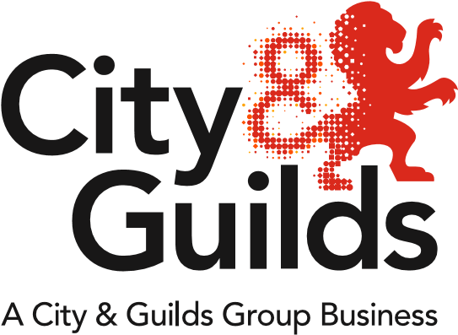
All About Construction
Issue 02
February 2018

A newsletter from City & Guilds on professional and technical education updates in construction for all nations.

In this issue:
  - Extensions and Withdrawals
- New: 6038-01 (603/2768/6): Level 2 Award in Safe Location and Avoidance of Underground Services
  - New website for Modern Apprenticeships in Scotland
  - New Training Manuals available
  - Network events
  - Update on government reforms
- City & Guilds win MoJ contract for Construction & Building Services
- Trailblazer Apprenticeship standards – England
- Post-16 Skills Plan consultation - England
- Qualifications Wales Sector Review - Wales

Extensions and Withdrawals
Qualification extensions and withdrawals

NVQs
City & Guilds are making several “incremental changes” to the NVQs this year, in accordance to CITB’s reviews of the standards. This will require minor updates to the units, but may include some structural amendments (for example, the addition of new units). All changes will be clearly communicated to centres throughout 2018. For an update on future registration end dates, please refer to the following spreadsheet:

Awards and Diploma qualifications
The above attachment also provides an update to the Awards and Diploma qualifications which will be extended beyond 31.07.2018 to 31.07.2020.

Qualification closure
The third tab on the spreadsheet above shows the pathways that are closing for registration between January and July 2018. The majority of NVQ pathways listed as closing are now out of date and have been replaced with new pathways.

New qualifications
New: 6038-01 (603/2768/6): Level 2 Award in Safe Location and Avoidance of Underground Services
This qualification will provide learners with an understanding of how to avoid danger from underground services, and the importance of clearing an area prior to and during an excavation.

New website for Modern Apprenticeships in Scotland
City & Guilds now offer the following Modern Apprenticeships in Construction Building at SCQF Level 6:
- Bricklaying
- Carpentry and Joinery
- Painting and Decorating
- Plastering
Click here for our one-page summary of the Modern Apprenticeships.

For more information please visit our new dedicated webpage for Scotland:
https://www.cityandguilds.com/about-us/uk-local-teams/scotland

New Learning Support Materials
New Training Manuals available for Level 2 Bricklaying, Architectural Joinery, and Site Carpentry
These new training manuals are an essential practice resource for any learner starting out on the industry. Suitable for use on either the Diploma qualifications (6705 and 6706) or the new City & Guilds technical qualification specifications (7905 and 7906), these resources provide the learner with a series of practical tasks to support their learning experience.

Each task includes:
- theory questions to get the learner to think about the task before starting
- planning sections for learners to consider what tools, equipment (including PPE) and resources they’ll need to complete the task successfully
- a risk-assessment for learners to fill out to ensure safe completion of the work
- a step-by-step guide with detailed working drawings so learners know how to complete the task to the required specifications
- a set of self-assessment criteria for learners and tutors to assess competency level at each skillset
- space for learners to reflect on how the task went and what they need to work on in the future.

Available to purchase on Walled Garden or online bookshops.

Network events
Please find below further details and joining instructions for our Construction Network Events:

Chichester: 28th March 2018
https://www.eventbrite.co.uk/e/construction-regional-network-chichester-tickets-42899542687

Newcastle: 20th April 2018
https://www.eventbrite.co.uk/e/construction-regional-network-newcastle-tickets-42899127445

Wakefield: 25th April 2018
https://www.eventbrite.co.uk/e/city-guilds-construction-network-wakefield-tickets-41705288641

Oxford: 2nd May 2018
https://www.eventbrite.co.uk/e/construction-regional-network-oxford-tickets-42899508585

Update on government reforms

City & Guilds win MoJ contract for Construction & Building Services
The Ministry of Justice has awarded City & Guilds the contract to be the exclusive provider of qualifications in English, Maths, Hospitality & Catering and Construction & Building Services in prisons across England, becoming the only awarding organisation to win across multiple bid areas. https://www.cityandguilds.com/news/January-2018/A-big-break-into-prisons-education

Trailblazer Apprenticeship standards – England
To check the status of standards currently in development, please visit the government website:
https://www.instituteforapprenticeships.org/apprenticeship-standards/

As of January 2018, no further apprenticeship frameworks will be withdrawn until 2020.
https://www.gov.uk/government/publications/removal-of-apprenticeship-frameworks/information-about-the-withdrawal-of-apprenticeship-frameworks

Off-the-job qualifications can be included in apprenticeships, IfA confirms.
https://feweek.co.uk/2018/02/06/off-the-job-qualifications-can-be-included-in-apprenticeships-ifa-confirms/

Post-16 Skills Plan consultation - England
Public consultation on the new “T-level” reforms closed on 8th February 2018. For more information regarding T-Levels please visit the City & Guilds webpage:
https://www.cityandguilds.com/tlevels

Qualifications Wales Sector Review - Wales
Qualifications Wales has now published its sector review of qualifications and the qualification system in Construction and the Built Environment. For the full Building Futures report and information on how to respond to the consultation please visit the Qualifications Wales website:
http://qualificationswales.org/english/qualifications/vocational-qualifications/sector-reviews/construction-and-the-built-environment/

Tell us what you think
All About Construction is a newsletter that brings together all of the key developments from City & Guilds relevant to Construction skills learning across England, Scotland, Northern Ireland and Wales. It contains updates on the range of teaching and learning resources we offer, plus relevant public policy or other information we think you might be interested in.

Each edition is numbered, so we can refer back to previous issues or tell you when information has been superseded.

If there’s anything else you’d particularly like us to cover or explain more fully in future issues of All About, please feel free to drop us a line to construction@cityandguilds.com

For specific queries and enquiries please contact our dedicated customer support team: PDCustomerSupport@cityandguilds.com

Thank you for your continued support.

Every effort has been made to ensure that the information contained in this publication is true and correct at time of going to press. However, City & Guilds’ products and services are subject to continuous development and improvement and the right is reserved to change products and services from time to time. City & Guilds cannot accept responsibility for any loss or damage arising from the use of information in this publication.© 2018. The City and Guilds of London Institute. All rights reserved. City & Guilds is a trademark of The City and Guilds of London Institute, a charity established to promote education and training registered in England & Wales (312832) and Scotland (SC039576).

