**5528-22/23**

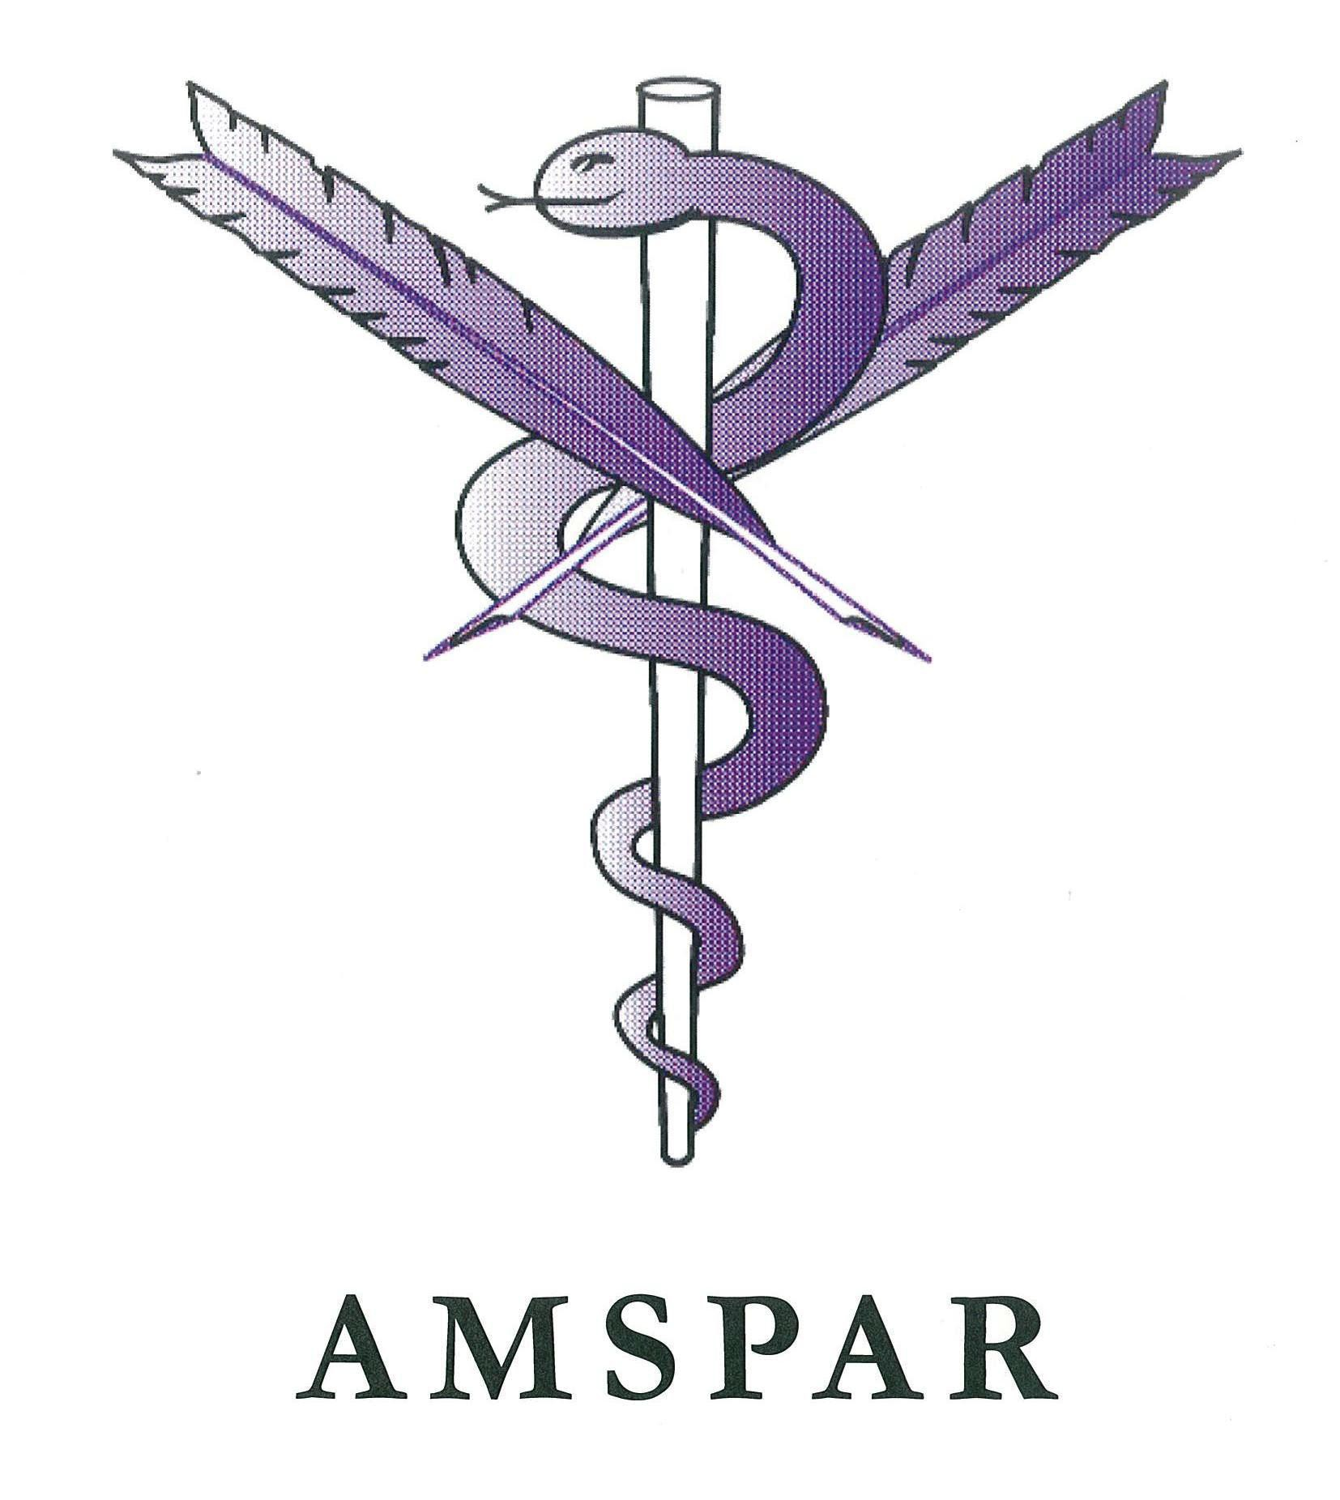

**BUSINESS ADMINISTRATION APPRENTICESHIP PATHWAY**

**LEVEL 2 & 3 DIPLOMAS IN MEDICAL ADMINISTRATION**

**QUALIFICATION FACTSHEET**

**BUSINESS ADMINISTRATION APPRENTICESHIP PATHWAY**

**LEVEL 2 & 3 DIPLOMAS IN MEDICAL ADMINISTRATION 5528-22/23**

**QCF Qualification Credit Fundable GLH QAN City & Guilds number**

Level 2 Diploma in Medical Administration 74 Yes

Level 3 Diploma in Medical Administration 80 Yes

473-577 601/3910/9 5528-22

tbc tbc 5528-22

455-541 601/3911/0 5528-23

tbc tbc 5528-23

**Qualification aim Qualification levels and definition Progression routes**

These qualifications were developed in partnership with AMSPAR (The Association of Medical Secretaries, Practice Managers, Administrators and Receptionists). They will prepare the learner to work in the field of medical administration learning skills in medical terminology and data protection.

At level 2 the qualification will cover areas such as Working in the NHS to medical terminology, where as at level 3 there will also be opportunities to learn Managing communication in a medical environment and medical

principles. Both levels incorporate the new business administration units as options.

On completion learners will gain the skills and knowledge required to work in the medical sector. Level 2 learners can progress onto the level 3 apprenticeship or onto the Level 3

Medical Administration qualifications. Where as the level 3 learners can progress onto the Level

5 in Primary Care Health Management qualification.

**Key features Key benefits**

**Structure**

**Assessment**

**Support**

Learners must complete a set of mandatory units based on core business and medical administration skills and a choice of optional units from two groups made up of medical and pure administration units.

The qualifications are assessed through a mixture of on-demand or e-volve online tests as well as assignments, all available through City & Guilds.

Our support resources include: a free Qualification Handbook and personal support.

Our vast range of optional units allows you to tailor content to suit learners' individual needs, whilst meeting the occupational requirements of the medical industry.

e-volve is designed to cut the time spent marking and reduces your paperwork. The on-demand assessment is flexible and improves success rates as candidates only complete when they are ready.

Personal support is available from the largest team of subject specific Quality

Consultants, our Customer Relations Team and dedicated Business Managers.

**Reasons to choose City & Guilds**

**Widest range and choice of qualifications**

We are the market-leading awarding organisation for qualifications in the medical administration sector.

**Industry expertise** Our partnership with AMSPAR has ensured we meet employers needs and link directly with industry. Learners can become members of AMSPAR on completion of these qualifications.

**Recognised by employers**

Our qualifications are trusted and valued both by experts and employers across the medical industry which will help you to engage with employers and provide learners with the skills and training that will allow them to succeed in employment.

**For more information call +44 (0) 844 543 0000**

[**email: centresupport@cityandguilds.com or visit www.cityandguilds.com**](http://www.cityandguilds.com/)