Level 3 Advanced Technical Diploma in Bricklaying
(7905-30)(460)

General guidance for candidates
General guidance
This is a formal assessment that you will be marked and graded on. You will be marked on the quality and accuracy of your practical performance and any written work you produce. It is therefore important that you carry your work out to the highest standard you can. You should show how well you know and understand the subject and how you are able to use your knowledge and skills together to complete the tasks.

Plagiarism
This is an assessment of your abilities, so the work must be all your own work and carried out under the conditions stated. You will be asked to sign a declaration that you have not had any outside help with the assessment.
Your tutor is allowed to give you some help understanding the assignment instructions if necessary, but they will record any other guidance you need and this will be taken into account during marking.
Plagiarism is the failure to acknowledge sources properly and/or the submission of another person’s work as if it were your own. Plagiarism is not allowed in this assignment.
Where research is allowed, your tutor must be able to identify which work you have done yourself, and what you have found from other sources. It is therefore important to make sure you acknowledge all sources and clearly reference any information taken from them.

Timings and planning
Where you have to plan your time, you should take care to make sure you have divided the time available between tasks appropriately. In some assignments, there are specified timings which cannot be changed and which need to be taken into account. You should check your plan is appropriate with your tutor.
If you have a good reason for needing more time, you will need to explain the reasons to your tutor and agree a new deadline date. Changes to dates will be at the discretion of the tutor, and they may not mark work that is handed in after the agreed deadlines.

Health and Safety
You must always work safely, in particular while you are carrying out practical tasks.
You must always follow any relevant Health and Safety regulations and codes of practice.
If your tutor sees you working in a way that is unsafe for yourself or others, they will ask you to stop immediately, and tell you why. Your tutor will not be able to reassess you until they are sure you are ready for assessment and can work safely.

Presentation of work
Presentation of work must be neat and appropriate to the task.
You should make sure that each piece of evidence including any proformas eg record/job cards are clearly labelled with your name and the assignment reference.
All electronic files must be given a clear file name that allows your tutor to identify it as your work.
Written work eg reports may be word processed but this is not a requirement.
All sketches and drawings should be neat and tidy, to scale and annotated. Calculations should be set out clearly, with all working shown, together with any assumptions made. You should use appropriate units at all times and answers must be expressed to a degree of accuracy, consistent with the requirements of the task.

Practical Observation Form (PO)
Candidate Name: Assessment ID:
Candidate Number: Centre Number
Date:

The evidence section in this PO form should consist of comments/notes that are used to record the qualities and details of performance to inform marking and moderation against the AOs; what is the candidate doing? How well are they performing? - Describe the evidence.

The form signposts how particular AO’s are relevant to each task. These AO’s are not a definitive list therefore if evidence for other AO’s can be captured this should be recorded accordingly.

This PO form should not be used to assign marks per task as marks need to be applied holistically for each AO across all tasks within the assignment.
Use the Candidate Record Form (CRF) to record the final overview of the quality of performance and the overall marks for each AO.

This form should, along with all other candidate evidence, should be uploaded to the Moderation Portal if requested or as part of a sample.

See the Observation section above for details around the types of comments

Task 1

This form shows a model answer to Task 1a). This should not be shared with candidates.

Suggested answer to Task 1 a)
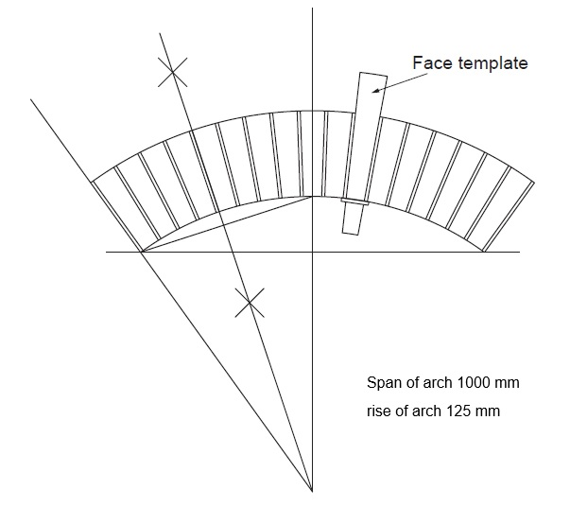

Sample drawing of segmental arch

Task 1
Information around tolerances can be found after this table.

Contextualised examples of AOs per task | Comments/notes
Produce a full size drawing of the segmental arch

AO1:
- Setting out angles other than 90º,
- geometrical setting out,
- arch terminology,
- safe method of work,
- positioning of materials and resources, drawing equipment used and its uses.
AO2:
- interpreting drawings/specifications,
- showing an understanding of the setting out processes,
- methods of work,
- applying Health & Safety legislation to planning and carrying out activities,
- showing an understanding of the correct sequence of work
AO3:
- measuring skills;
- drawing skills;
- setting out, correct use of equipment
AO4:
- applying knowledge and understanding to the tasks,
- problem solving techniques used and able to justify decision made,
- able to plan activities from information provided
- drawing techniques used appropriately,
- correct sequence of operations carried out when setting out and carrying out the work.
AO5
- checking for accuracy at each stage of completed work.

Contextualised examples of AOs per task | Comments/notes
Produce a face template

AO1:
- used tools and equipment correctly, construction techniques,
- safe method of work
AO2:
- interpreting drawings/specifications,
- showing an understanding of the setting out processes,
- methods of work,
- applying Health & Safety legislation to planning and carrying out activities, following risk assessments
- showing an understanding of the correct sequence of work
AO3:
- measuring skills;
- drawing skills; setting out,
- correct use of equipment
AO4:
- applying knowledge and understanding to the tasks,
- problem solving techniques used and able to justify decision made,
- able to plan activities from information provided
- drawing techniques used appropriately, correct sequence of operations carried out when setting out and carrying out the work
AO5:
- Checking for accuracy at each stage of completed work.

Contextualised examples of AOs per task | Comments/notes
Produce four voussoirs to present to the client

AO1:
- Use tools and equipment correctly.
AO2:
- Interpreting drawings/specifications, showing an understanding of the setting out processes,
- methods of work
- showing an understanding of the correct sequence of work
AO3:
- Measuring, drawing skill and setting out skills,
- correct use of tools, equipment and materials;
- positioning and fixing of components.
AO4:
- applying knowledge and understanding to the tasks
- problem solving techniques used and able to justify decision made
- able to plan activities from information provided
- materials and techniques used appropriately
- correct sequence of operations carried out when setting out and carrying out the work
AO5:
- checking for accuracy at each stage of completed work
- checking that work is clean and defect free

Task 2
Information around tolerances can be found after this table.

Contextualised examples of AOs per task | Comments/notes
Set out and build the wall

AO1:
- Setting out angles other than 90º
- bonding materials
- tools and equipment required
- construction techniques
- safe method of work
- positioning of materials and resources
- a range of decorative features and their applications.
AO2:
- interpreting drawings/specifications,
- showing an understanding of the setting out processes
- methods of work
- applying Health & Safety legislation to planning and carrying out activities
- risk assessments
- showing an understanding of the correct sequence of work.
AO3:
- Measuring skills
- working safely
- setting out
- gauging, levelling and plumbing skills
- correct use of tools,
- equipment and materials;
- positioning and fixing of components
AO4:
- applying knowledge and understanding to the tasks
- problem solving techniques used and able to justify decision made, able to plan activities from information provided
- materials and techniques used appropriately, correct sequence of operations carried out when setting out and carrying out the work
- safe and clean working practices demonstrated
AO5:
- checking for accuracy at each stage of completed work
- using gauge, levels and plumb consistently
- checking that work is clean and defect free
- safe and systematic approach to work and cleanliness
- considerations for other trades
Contextualised examples of AOs per task | Comments/notes
Health and safety practices

AO1:
- tools and equipment required
- safe method of work
AO2:
- applying Health & Safety legislation to planning and carrying out activities
- follow risk assessments
- showing an understanding of the correct sequence of work
AO3:
- working safely
- correct use of tools, equipment and materials
AO4:
- materials and techniques used appropriately
- correct sequence of operations carried out when setting out and carrying out the work
- safe and clean working practices demonstrated
AO5:
- checking that work is clean and defect free
- safe and systematic approach to work and cleanliness

Contextualised examples of AOs per task | Comments/notes
Housekeeping and cleanliness

AO5:
- checking for accuracy at each stage of completed work
- using levels and gauges consistently

- checking that work is clean and defect free
- safe and systematic approach to work and cleanliness
- considerations for other trades

Contextualised examples of AOs per task | Comments/notes
Overall appearance of the finished wall

AO3:
- measuring skills
- working safely
- gauging
- levelling and plumbing skills
- correct use of tools, equipment and materials
- positioning and fixing of components
AO5:
- checking for accuracy at each stage of completed work
- using levels and gauges consistently
- checking that work is clean and defect free
- safe and systematic approach to work and cleanliness
- considerations for other trades
Contextualised examples of AOs per task | Comments/notes
Timings

AO4:
- able to plan activities from information provided
- correct sequence of operations carried out when setting out and carrying out the work

Tolerances for Task 2

Setting out size of voussoirs for the whole arch | ±2 mm
Making voussoirs template | ±2 mm
Cuting four voussoirs to template | ±2 mm
Build the panel and features as per the drawing and specification | ± 4 mm
Dimensions | ± 2 mm
Gauge | ± 3 mm
Level | ± 2 mm
Plumbing points | ± 2 mm
Panel size | ± 2 mm
Features:  - Dentil course  - Banding  - Panel surround  - Curve wall  - Batter | ± 2 mm

Candidate Record Form (CRF)
Candidate Name: Assessment ID:
Candidate Number: Centre Number:

Total Mark:

All evidence across the assignment must be considered together when recording the mark given for each AO. Justifications for the awarded marks must be recorded below.
 | Summary justification | AO Mark
A01 Recall
A02 Understanding
A03 Practical/ technical skills
A04 Bringing it all together
A05 Attention to detail

Tutor/assessor signature: Date:

Declaration of Authenticity

Candidate name | Candidate number
Centre name | Centre number

Candidate:

I confirm that all work submitted for this synoptic assignment is my own, and that I have acknowledged all sources I have used.

Candidate signature | Date

Tutor:

I confirm that all work was conducted under conditions designed to assure the authenticity of the candidate’s work, and am satisfied that, to the best of my knowledge, the work produced is solely that of the candidate.

Tutor/assessor signature | Date

