Level 2 End-point Assessment for ST0095/AP03 Bricklayer

9077- 12

**November 2020, v1.2**

|  |  |  |
| --- | --- | --- |
| Version and date | Change detail | Section |
| September 2020v1 | initial input of data |  |
| November 20220v1.1 | replaced Gateway form with updated format | Gateway form |
| November 2020v1.2 | Corrected English and Math requirements from previous update | Gateway form |

Contents

Introduction 3

What is in this document 3

Guidance on how to use the recording forms 3

End-point Assessment gateway declaration form 4

Apprentice details 6

Introduction

### What is in this document

Recording forms to be used by Centres / End-point Assessment customers / Employers / Training providers:

* End-point Assessment gateway declaration form
* Declaration of authenticity form
* Portfolio evidence form
* Portfolio /centre / training provider checklist.

This document must be used alongside the **9077 -12 EPA Pack - Centres**.

### Guidance on how to use the recording forms

Centres / End-point Assessment customers / Employers / Training providers must use the forms provided by City & Guilds in the format laid out in this document.

**Gateway form**

This must be completed with the Apprentice and submitted to City & Guilds as part of the End-point Assessment booking process.

**Declaration of authenticity form**

Apprentice and employer / centre / training provider complete and include in submission.

**Portfolio evidence form**

Apprentices complete the evidence type and evidence reference columns and the employer centre/ / training provider ticks the final colum for confirmation. Refer to the example below, note that evence 002 has been used to evidence more than one criteria

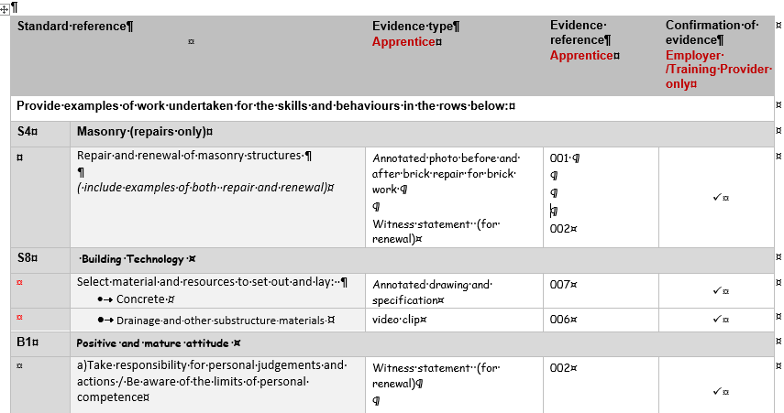

Employer / centre / training provider portfolio checklist

Must be completed, dated and signed for each portfolio to confirm contents are ready for Gateway. Include in submission.

**End-Point Assessment Gateway Declaration Form**

Please complete this form to confirm that all parties are satisfied that the apprentice has met the gateway requirements and can be put forward for end-point assessment (EPA) with City & Guilds.

|  |  |  |  |
| --- | --- | --- | --- |
| Apprenticeship Standard |  | Apprenticeship start date |  |
| **Apprentice**  **name** |  | **ULN** (Unique Learner Number) |  |

|  |  |
| --- | --- |
| Entry requirement(s) | Taken / Achieved (Yes) |
| Readiness for Independent End-point Assessment |  |
| Achieved Level 1 qualification in English and maths (or equivalent) |  |
| Atempted Level 2 qualification in English and maths (or equivalent) |  |
| Completed portfolio of evidence |  |
| **Entry requirement(s)** | **Submitted (Yes)** |
|  |  |

Providers must submit evidence of achievement to us for each gateway requirement. It is the provider’s responsibility to keep auditable evidence of these requirements. Without appropriate evidence, we will not be able to complete your booking or carry out the EPA. Customers may still be charged.

|  |  |  |
| --- | --- | --- |
| Previous EPA | | Yes / No |
| Has the apprentice taken any assessments as part of the EPA for this apprenticeship standard with any other EPA organisation? | |  |
| **If yes** | | |
| Which EPA organisation was this? |  | |
| What was the date(s) of the EPA? |  | |
| What grade(s) was issued, eg fail / pass / merit / distinction? |  | |

**Employer and provider declaration:**

**I confirm that the gateway meeting has been carried out to confirm that the apprentice:**

* **Has achieved all EPA gateway requirements as listed above and has the knowledge, skills and behaviours required by the apprenticeship standard and is eligible for EPA.**
* **Has been employed throughout their apprenticeship.**
* **Has completed a minimum of 12 months and 1 day on-programme before submitting the final gateway evidence to City & Guilds.**

|  |  |  |  |
| --- | --- | --- | --- |
| **Employer** |  | **Date** |  |
| **Training Provider**  **(if appropriate)** |  | **Date** |  |

**Apprentice declaration:**

**I confirm that I have gone through a gateway process to check that I am eligible for EPA.**

**I give City & Guilds permission to apply to the Education and Skills Funding Agency, (ESFA) and the Institute for Apprenticeships for the apprenticeship certificate on my behalf when I complete EPA.**

|  |  |  |  |
| --- | --- | --- | --- |
| **Apprentice** | Click or tap here to enter text. | **Date** | Click or tap to enter a date. |

Providers should submit the completed form to us through the EPA portal. Please refer to the [**Manual for the End-Point Assessment Service**](https://www.cityandguilds.com/~/media/cityandguilds-site/documents/apprenticeships/manual-for-the-end-point-assessment-service%20pdf.ashx) for details, including timeframes.

**Digital Credentials:**

Digital Credentials (Open Badges) are available for this standard. If you, the Apprentice, would like to receive a Digital Credential, please provide your email address below.

By providing your email address to us, you agree that City & Guilds may share your email address with its digital credentialing partner, and authorise City & Guilds to issue a Digital Credential (Open Badge) to you upon successful completion of your end-point assessment.

|  |  |
| --- | --- |
| **Apprentice email** |  |

Find out more about digital credentials here [**https://www.cityandguilds.com/digital-credentials**](https://www.cityandguilds.com/digital-credentials)

Please note that when you receive an email from City & Guilds to claim your digital credential, you will need to create a free online account with our digital credential provider, which you can unsubscribe from at any time.

Declaration of Authenticity

|  |  |  |  |
| --- | --- | --- | --- |
| Apprentice  name | Apprentice Name | Enrolment  number | 1234567 |

**Apprentice declaration:**

**I confirm that all work submitted is my own, and that I have acknowledged any sources I have used.**

|  |  |  |  |
| --- | --- | --- | --- |
| **Apprentice** | Signature | **Date** | DD/MM/YY |

**Tutor/Assessor declaration:**

**I confirm that all work was conducted under conditions designed to assure the authenticity of the Apprentice’s work, and am satisfied that, to the best of my knowledge, the work produced is solely that of the Apprentice**

|  |  |  |  |
| --- | --- | --- | --- |
| **Tutor/Assessor** | Signature | **Date** | DD/MM/YY |

Portfolio Evidence Reference Form

|  |  |  |  |
| --- | --- | --- | --- |
| Apprentice | Name | Enrolment  number | 1234567 |

|  |  |  |  |
| --- | --- | --- | --- |
| **Centre** | Signature | **Date completed** | DD/MM/YY |

|  |  |  |  |  |
| --- | --- | --- | --- | --- |
| **Standard reference** | | **Evidence type**  **Apprentice** | **Evidence reference**  **Apprentice** | **Confirmation of evidence**  **Employer /Training Provider only** |
| **Provide examples of work undertaken for the skills and behaviours in the rows below:** | | | | |
| **S4** | **Masonry (repairs only)** | | | |
|  | Repair and renewal of masonry structures  *( include examples of both repair and renewal)* |  |  |  |
| **S8** | **Building Technology** | | | |
|  | Select material and resources to set out and lay:   * Concrete |  |  |  |
|  | * Drainage and other substructure materials |  |  |  |
| **B1** | **Positive and mature attitude** | | | |
|  | a)Take responsibility for personal judgements and actions / Be aware of the limits of personal competence |  |  |  |
|  | b)Meet deadlines |  |  |  |
|  | c) Take proactive steps in solving a problem |  |  |  |
|  | d) Developing trust of customers and colleagues. Demonstrate awareness of equality and diversity |  |  |  |
| **B3** | **Effective communication** | | | |
|  | Collaborate with colleagues and others  *Note others can include e,g.. clients, architects, contract managers, other trades, clients, suppliers and the public regardless of differences in race, gender, sexual orientation, or other characteristics* |  |  |  |
|  | Effective oral communication |  |  |  |
|  | Effective written communication |  |  |  |
|  | Effective use body language and presentation |  |  |  |
| **B4** | **Self-motivation** | | | |
|  | Identify personal development needs and take action to meet those needs  *(include examples of CPD undertaken)* |  | .. |  |
|  | Keep up-to-date with best practice and new technology  *(include examples of you have come across in you)* |  |  |  |
|  | Show initiative to independently complete work and solve problems by seeking out critical information. |  |  |  |

Employer / centre / training provider portfolio checklist

|  |  |  |  |
| --- | --- | --- | --- |
| Apprentice | Name | Enrolment  number | 1234567 |

**Training Provider declaration (if appropriate):**

**I confirm that the evidenced presented by the Apprentice is ready for End-Point Assessment. It is valid, authentic, reliable and current and sufficient to meet the requirements of the relevant standard.**

|  |  |  |  |
| --- | --- | --- | --- |
| **Training Provider** | Name & Signature | **Date** | DD/MM/YY |

|  |  |  |
| --- | --- | --- |
| Portfolio of Evidence Checklist | | Tick when confirmed |
| 1. | Has declaration of authenticity been signed (handwritten or electronic) by all parties? |  |
| 2. | Is all evidence valid, authentic, current and sufficient (VACS)? |  |
| 3. | Does evidence clearly show it is the apprentice’s individual work (i.e. specific contribution in teamwork is made clear)? |  |
| 4. | Does the evidence meet all the requirements and grading criteria?  (Typically there should be around 15 pieces of evidence). |  |
| 5. | Has the evidence reference form been completed? And has all evidence been referenced? |  |
| 7. | Is the majority of the evidence holistic in its nature (ie one piece of evidence can cover more than on criteria)? |  |
| 8. | Has the portfolio been checked to make sure there is no duplication of evidence? |  |
| 9. | Does the portfolio showcase the apprentice’s best pieces of work? |  |
| 10. | Are any witness testimonies or employer references tailored to the apprentice? |  |
| 11. | Has any client/customer reference information been anonymised / permission sought? |  |
| 12. | Have all external sources of information been appropriately documented and referenced to the original source, showing clear understanding of how they relate to the criteria? |  |
| 13. | Has the appropriate stakeholder(s) checked whether the apprentice’s portfolio meets all the required skills, behaviours as listed in the evidence form? |  |
| Additional comments if necessary | | |
|  | | |