

unit 101 (1GEN1)
Maintain a safe, hygienic and secure working environment
Successful assessment of the unit proves that the learner has achieved the national occupational standard to maintain a safe, hygienic and secure working environment
August 2010 Version 1.0
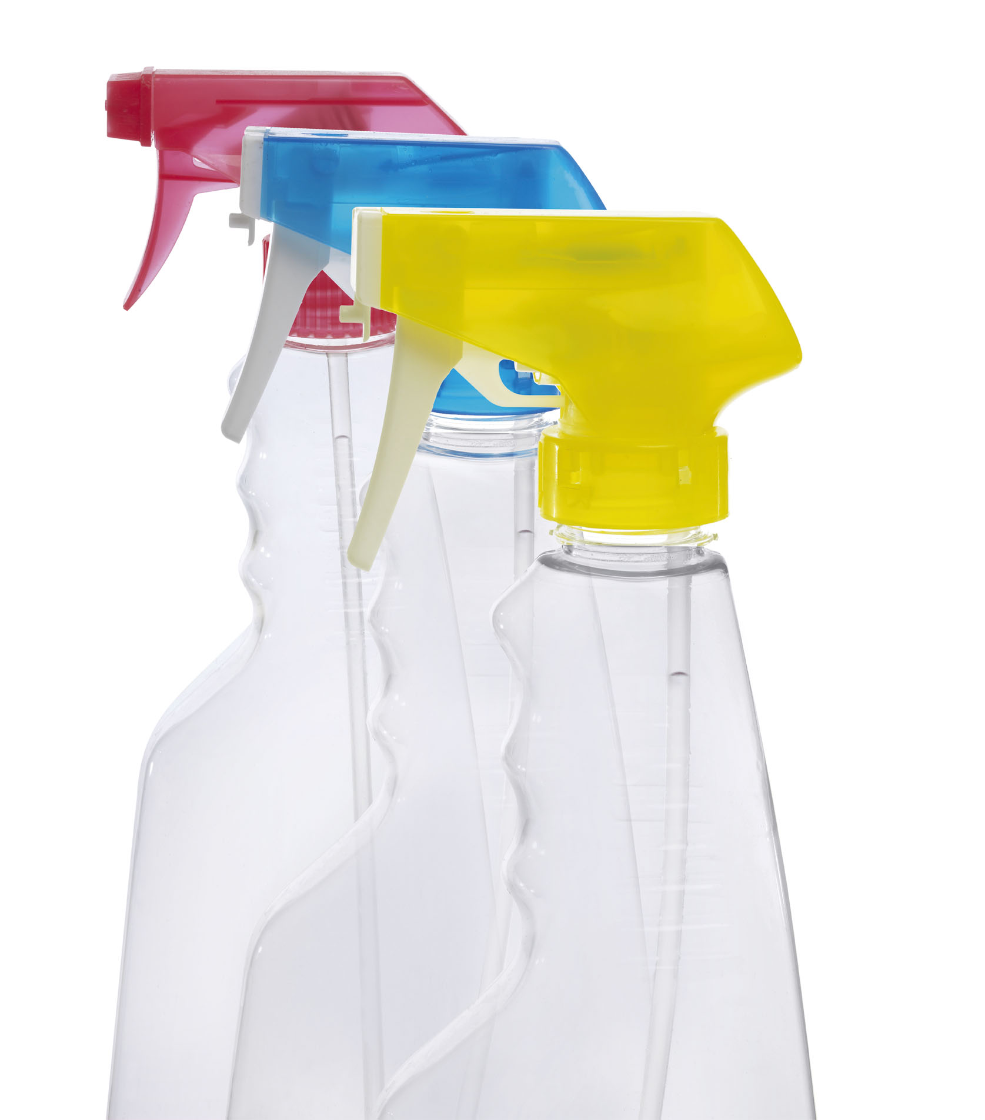
Maintain a safe, hygienic and secure working environment

This unit is about basic health, hygiene, safety and security. This includes maintaining a clean and hygienic personal appearance, getting any cuts and grazes treated and reporting illnesses and infections. The unit also covers safety and security in your workplace – helping to spot and deal with hazards and following emergency procedures when necessary

This unit has four outcomes:

Outcome 1
Be able to maintain personal health and hygiene

Outcome 2
Know how to maintain personal health and hygiene

Outcome 3
Be able to help maintain a hygienic, safe and secure workplace

Outcome 4
Know how to maintain a hygienic, safe and secure workplace

The typical day-to-day activities you might carry out for this unit include:
- keeping your personal appearance neat, tidy and hygienic
- getting cuts and scratches treated and reporting illnesses
- practising fire and other emergency procedures
- helping to keep your customers, colleagues and visitors safe by dealing with hazards
- working in a healthy and safe way
- maintaining hygiene in your work
- following security procedures

Maintain a safe, hygienic and secure working environment

Evidence
This space is to record the evidence you need to do to complete this unit. The criteria that you should be able to complete are within the learning outcomes.

No. | Method* | Summary of evidence or  portfolio reference | Assessor initials
1
2
3
4
Photocopy if required
*Assessment method key: O Observation; PD Professional discussion; Q Questioning; WP Work product; WT Witness testimony; Oth Other

Be able to maintain personal health and hygiene (Outcome 1)

What you must do
You must show that you can perform consistently to the same standard. This will be assessed by your assessor using various methods which must include observation of your performance.

Shaded numbers must be observed |  | 1 | 2 | 3 | 4
1 | Wear clean, smart and appropriate clothing, footwear and headgear |  |  |  | 
2 | Keep hair neat and tidy and wear it in line with organisational standards |  |  |  | 
3 | Make sure any jewellery, perfume and cosmetics worn are in line with organisational standards |  |  |  | 
4 | Get any cuts, grazes and wounds treated by the appropriate person |  |  |  | 
5 | Report illness and infections promptly to the appropriate person |  |  |  | 

Be able to help maintain a hygienic, safe and secure workplace (Outcome 3)

  What you must do
  You must show that you can perform consistently to the same standard. This will be assessed by your assessor using various methods which must include observation of your performance.
  Shaded numbers must be observed |  | 1 | 2 | 3 | 4
  6 | Identify any hazards or potential hazards and deal with these correctly |  |  |  | 
  7 | Report any accidents or near accidents quickly and accurately to the proper person |  |  |  | 
  8 | Follow health , hygiene and safety procedures during work |  |  |  | 
  9 | Practise emergency procedures correctly |  |  |  | 
  10 | Follow organisational security procedures |  |  |  | 
  What you must cover
  You must show that you have covered ALL of the following:
  Hazards
  All must be covered. At least 1 of these must be observed by your assessor.
  1 | Relating to equipment |  |  |  | 
  2 | Relating to areas where you work |  |  |  | 
  3 | Relating to personal clothing |  |  |  | 
  Ways of dealing with hazards
  All must be covered. At least 1 of these must be observed by your assessor.
  1 | Putting them right yourself |  |  |  | 
  2 | Reporting them to appropriate colleagues |  |  |  | 
  3 | Warning other people |  |  |  | 
  Emergency procedures
  All must be covered. At least 1 of these must be observed by your assessor.
  1 | Fire |  |  |  | 
  2 | Threat |  |  |  | 
  3 | Security |  |  |  | 

What you must know
Evidence for this section can be collected in a variety of ways. Your assessor will discuss with you how to collect and record this information.

Know how to maintain personal health and hygiene (Outcome 2) |  | Ref.
- K | State own responsibilities under the Health and Safety at Work Act
 | State general rules on hygiene that must be followed
- K | State correct clothing, footwear and headgear that should be worn at all times
- K | State the importance of maintaining good personal hygiene
- K | Describe how to deal with cuts, grazes and wounds and why it is important to do so
Know how to maintain a hygienic, safe and secure workplace  (Outcome 4) |  | Ref.
- K | State the importance of working in a healthy, safe and hygienic way
 | State where information about Health and Safety in your workplace can be obtained t
- K | Describe the types of hazard in the workplace that may occur and how to deal with these
- K | State hazards that can be dealt with personally and hazards that must be reported to someone else
- K | State how to warn other people about hazards and why this is important
 | State why accidents and near accidents should be reported and who these should be reported to
 | Describe the type of emergencies that may happen in the workplace and how to deal with these
 | State where to find first aid equipment and who the registered first-aider is in the workplace
 | State safe lifting and handling techniques that should be followed
 | State other ways of working safely that are relevant to own position and why these are important
 | Describe organisational emergency procedures, in particular fire, and how these should be followed
 | State the possible causes for fire in the workplace
 | Describe how to minimise the risk of fire
 | State where to find fire alarms and how to set them off
 | State why a fire should never be approached unless it is safe to do so
 | State the importance of following fire safety laws
 | Describe organisational security procedures and why these are important
 | State the correct procedures for dealing with customer property
 | State the importance of reporting all usual/non-routine incidents to the appropriate person

