Unit 201: Understanding the hospitality industry

Handout 1: Types of hospitality establishment
Restaurants – a restaurant is a place where you can eat a meal and pay for it. In restaurants, your food is usually served to you at your table by front of house staff. Some restaurants have takeaway facilities.
Hotels – a commercial establishment providing accommodation, meals, and other guest services.
Pubs and bars – ‘pub’ is short for ‘public house’. A pub is licensed to serve alcoholic beverages. Bar is an establishment licensed to serve alcohol beverages and is named after the counter or bar on which drinks are served.
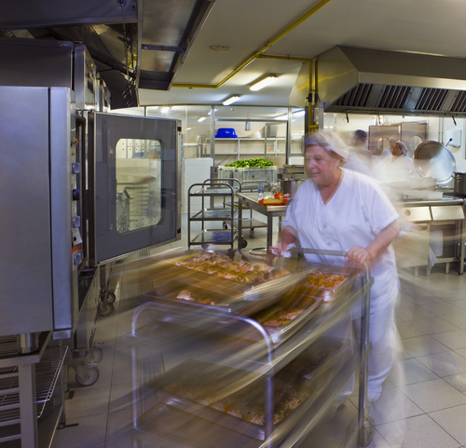

Contract catering – is a catering business that is hired by a business or organisation to provide catering services every day or on a very regular basis. e.g. hospital and school catering.
Event catering – catering for events like banquets, conferences, conventions, weddings and may be produced on-site or transported to the event's location.
Cafes and coffee shops – are small business that sells coffee, tea, cakes, sandwiches and light meals. These are found in most towns and can be chained or independently owned.
Multinational – a multi-national organisation has locations or facilities in multiple countries, but each location functions in its own way, essentially as its own entity.
Global company – a global company also has locations in multiple countries, but they are managed within a set company culture, with one set of processes that facilitate a more efficient and effective organisation; for example hotel brands such as the Hilton Group.

