Unit 207: Food safety

Handout 1: Food poisoning bacteria
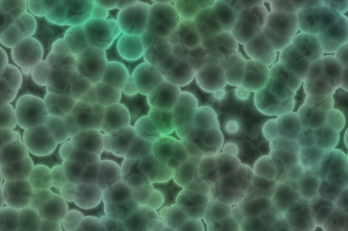
Food that is not stored, handled and prepared in the correct way can cause food poisoning. Typical symptoms of illness caused by food poisoning are diarrhoea, vomiting, nausea and stomach pains. Not only is food poisoning an unpleasant experienced it can also be life threatening particularly to vulnerable people. The onset of symptoms may appear after a couple of hours or alternatively after an interval of several days.

Bacterial reproduction is usually referred to as multiplication. Bacteria multiply by dividing in two – a process known as binary fission. Each bacteria needs 10 to 20 minutes to multiply in the right conditions, it is possible for just one bacterium to lead to the production of millions of bacteria within a few hours.

The chart below provides information about the sources of food poisoning bacteria describing both the symptoms and onset times

Organism | Source | Onset period | Symptoms
Bacillus Cereus | Widespread in environment, soil and cereals | Usually 1 - 5 hours | Abdominal pain, vomiting  Diarrhoea
Campylobacter | Wild animal and mammals | 18 - 36 hours | Abdominal pain  Bloody diarrhoea
Clostridium Botulinum | Soil, vegetables and fish | 12 - 36 hours | Difficulty in swallowing and breathing  Paralysis  Can be fatal
Clostridium Perfringens | Soil and intestines of mammals | 12 - 18 hours | Abdominal pain  Diarrhoea
E-Coli | Intestines of humans and animals  Unpasteurised milk and unpasteurised milk products | 12 - 24 hours | Abdominal pain  Diarrhoea
Listeria | Widespread in environment, soil and river water  Unpasteurised milk, unpasteurised milk products, processing plants, contaminated meats | Weeks or months | Contraction of meningitis and septicaemia  Can be fatal
Salmonella | Animal and human  Intestines  Milk and eggs | 12 - 36 hours | Abdominal pain  Vomiting  Diarrhoea
Staphylococcus Aureus | Human nose  Throat and wounds | 1 - 6 hours | Abdominal pain  Vomiting  Reduced temperature

