Unit 207: Food safety

Handout 8: Temperature controls
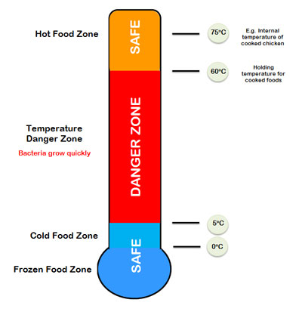
Time and temperatures are key to controlling the conditions bacteria require to multiply to levels that cause food poisoning.

Every possible step must be taken to destroy pathogenic micro-organisms before food is eaten.

Temperatures must be checked throughout the food flow and records kept to comply with legislation.

Key terms
- Core temperature – the temperature at the centre or thickest part of the food item.
- Pasteurisation – heat treatment that kills pathogenic bacteria but not spoilage bacteria
- Perishable – food likely to spoil quickly
- Danger zone – Between 5°C –63°C is the temperature range when bacteria multiply.

Controls
- Restricting the time high-risk foods are in the danger zone – no more than 2 hours
- Using low temperatures outside the danger zone by freezing high-risk foods to restrict bacteria multiplying – below 5°C
- Using high temperatures outside the danger zone by cooking food thoroughly to destroy pathogenic micro-organisms – above 63°C (minimum core temperature of 70°C for 2 minutes)
- Check temperatures of deliveries 0°C– 5°C for refrigerated foods, -22°C to -18°C for frozen foods
- Refrigerate high-risk, raw and perishable foods immediately after delivery
- Keep food refrigerated until just before they are needed for preparation / cooking
- Serve food at 63°C or hotter
- Thaw frozen food correctly to ensure the outside of the food is not in the danger zone while the inside is frozen: 0°C –5°C
- Reheating food adequately if it needs to be reheated to kill pathogenic micro-organisms – reheat to 70°C for 2 minutes
- Hot holding items are kept at a minimum core temperature of 63°C
- Cold holding items are kept at 0°C –5°C.

Food safety dangers:
- left standing at an ambient temperature
- left in sunlight – in a shop window
- heated slowly
- cooled slowly before refrigeration
- deliveries not stored immediately
- hot sauce poured over cold food
- hot food ‘topped up’.

