Unit 207: Food safety

Activity 3: Procedure for food safety (Tutor)
Learners will give a range of answers: some examples are shown below.
- Wash hands before starting work
- Check all preparation system is clean and in good repair
- Separate areas for raw and cooked foods
- Clean as you go
- Store within 15 minutes of delivery being checked
- Store chilled goods below 5ºc
- Store frozen goods between -18ºc and -25ºc
- Store dry/ambient goods in cool storeroom, off the floor
- Ensure FIFO stock control system is in operation
- Check packaging is intact and in good order
- No evidence of pests
- In date
- Temperature correct
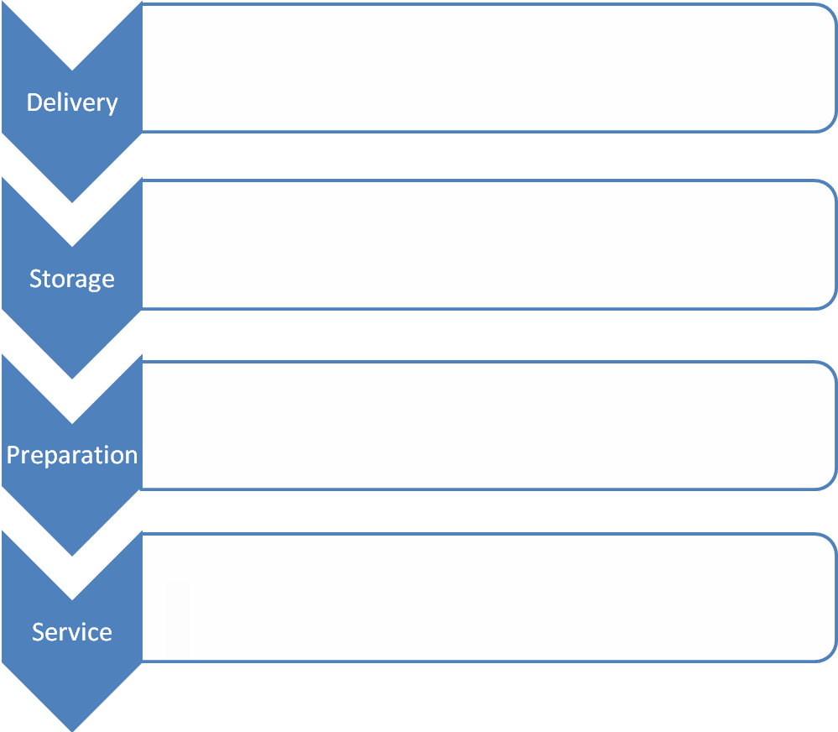
- Service area near preparation area if possible
- Wash hands prior to service
- Keep hot food above 63ºc
- Keep cold food below 4ºc
- Keep food and clean equipment away from used equipment and waste

