Unit 301: Developing opportunities for progression in the culinary industry

Handout 2: Leadership styles
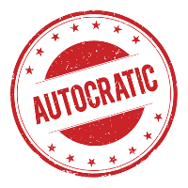
Autocratic/authoritarian
This style of leadership is where all the power is kept by the supervisor and they make all the decisions. This type of leadership can sometimes be seen as overbearing or bullying.
Leaders of the authoritarian style tell the chefs what to do and do not expect any input from them. They do not like to be questioned and their focus is on achieving the business goal at all costs.
This style of leadership can affect the morale of the workplace and, with little input from chefs, they will have no ownership of their work output.
Democratic/participative
This leadership style lends itself to teamwork, allowing chefs to be involved in decision making and supporting the supervisor to achieve
the business aims and objectives. However, the leader will still have
the final say, after listening to everyone’s views.
This style needs the involvement of the whole team to deliver the output. The supervisor is considered to be part of the team – both professionally and socially.
Laissez-faire/delegative
Laissez-faire/delegative leaders allow chefs to get on with their work
with minimum input. The leader is available if the staff require guidance or information. This style is considered to be the least effective for employees, as they feel they are not being directed.
The supervisor provides staff with the authority to make decisions and deliver output but the responsibility remains with the supervisor.
This style provides both positive and negative characteristics: Taking a hands-off approach, whilst giving authority to the team. However, the supervisor always remains responsible.

