Unit 302: Supervise and monitor own section

Handout 6: Reviewing
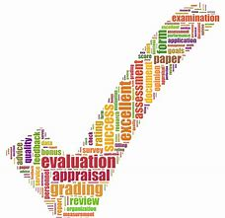
Reviewing is the practice of looking at what has happened and what can be done to improve outcomes in the future. As a supervisor, reviewing should be considered in view of the business’ and individual needs.
This includes:

- Short term – the supervisor is looking at the day-to-day activity of the workplace. Observing the practices, the output and the staff on a daily basis, then reviewing to identify areas for immediate improvement.
- Medium-term – this allows the supervisor to observe over a period of time (no more than three months) and consider the actions required to develop the team or environment for the future.
- Long-term – normally a function for management. However, the supervisor has an important role to play in advising management on what is happening on a day-to-day basis within the professional kitchen.

