Unit 303: Contribute to business success

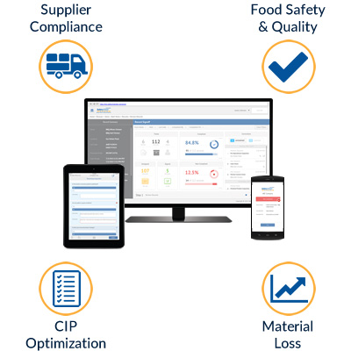
Handout 4: Kitchen technologies
Technologies are continually being developed to improve
the workflow in a professional kitchen.

Whilst high-tech kitchen equipment is seen as being more expensive that traditional equipment, it improves efficiency by:
- improving food safety
- automating repetitive tasks
- lowering labour costs.

Food safety management systems can streamline food safety regulation compliance and paperwork. The systems range from software and smartphone apps to fully connected networks of appliances that can automatically check food safety indicators.
Benefits:

- Reduced paperwork – cloud technology replaces paperwork
- Improved inspection results – digital checklists
- Decreased liability – meticulous record keeping provides robust reporting.

A network of physical appliances and devices using a digital connection to communicate with each other can create a remotely controlled kitchen. This could include a refrigerator that could track and reorder stock.
Benefits:
- Lower staff costs – a smaller team can be employed
- Improved guest experience – reduction in human error and increase preparation consistency
- Peace of mind – remote monitoring.
Kitchen display systems replace receipt printers which improves communications between the kitchen and restaurant.
Benefits:
- No time lag – orders appear immediately on a monitor/tablet
- Improved cooking time – tracked timings to produce menu items.

Cook and hold ovens are one type of a smart oven, which automatically lower the temperature to a holding temperature after cooking is complete.
Benefits:

- Reduced energy costs – use of radiant heating technology creates an even heat
- Optimised kitchen space – ventilation or extraction hoods are not required.

Smart combi ovens are three-in-one ovens that cook using convected heat, steam or a combination of both, as well as having remote control and monitoring features.
Benefits:

- Space and money saving – one oven cover most baking needs taking up less space
- Increased food safety – keeps track of critical control points, providing an audit trail
- Reduced labour costs – less staff required in the kitchen at certain times.

