Unit 304: Contribute to the guest experience

Handout 7: Lifestyle preferences: Vegetarian

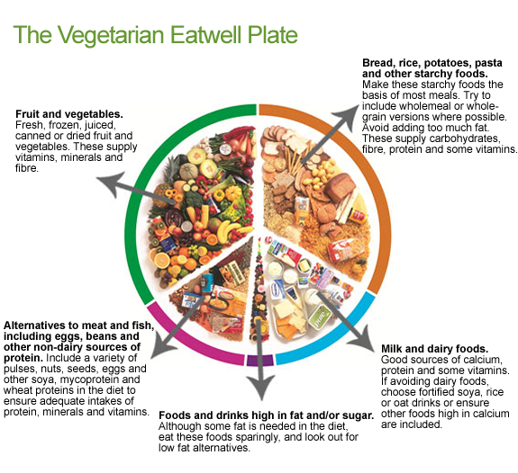

For more information, visit The Vegetarian Society: www.vegsoc.org

