Unit 304: Contribute to the guest experience

Handout 9: Considerations when planning menus
Kitchen size and the menu

- Generally, the size of the restaurant will dictate how large the menu is.
- The bigger the kitchen, the more menu items you can offer. If you try to offer a large and complex menu out of a tiny commercial kitchen (which can be done, though it isn’t easy) you may run into serious problems during busy times.
- A kitchen should be between 15-25% of the total space in the restaurant. Any smaller and you run the risk of severely limiting what you can serve during a lunch or dinner rush. Any larger and you are wasting precious space that could be used for tables and chairs.
- Creating a kitchen layout with a good flow will also make it more efficient and easier to work in.
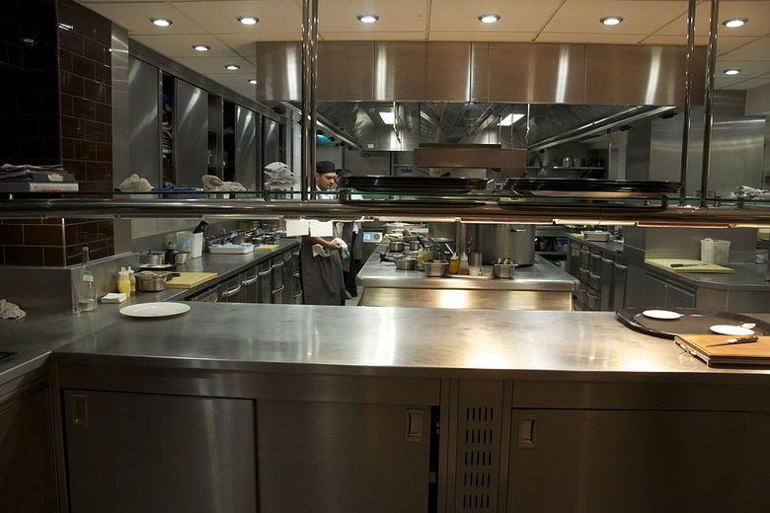
Preparation time and the menu

- Cooking is only about half of what
goes on in a restaurant kitchen.
- Preparation time is an integral part of
getting ready for breakfast, lunch or
dinner in a restaurant.
- When drafting the restaurant menu,
consider how much prep time is
needed for each menu item.

- Preparation will also dictate the types of kitchen stations you need.

Kitchen stations and the menu

- The stations in the commercial kitchen will also dictate what is on the regular menu.
- If you forgo the deep fat fryer, then French fries, onion rings, chicken fingers etc should not be a mainstay of the menu.
- If you have a huge 12-burner gas range, then you can offer plenty of sautéed dishes.
- If you want salads to play a prominent role on the menu, be sure you have enough room for a salad station. Ditto for pizzas, grilled items and desserts.
- Stations are particularly important as a way to prevent cross-contamination between foods.

