Unit 305: Sustainability in professional kitchens

Handout 1: The impact of Australian wildfires on global food supply
An article from FOX Business states that Australian wildfires could impact on beef, lamb, wheat and dairy supplies.

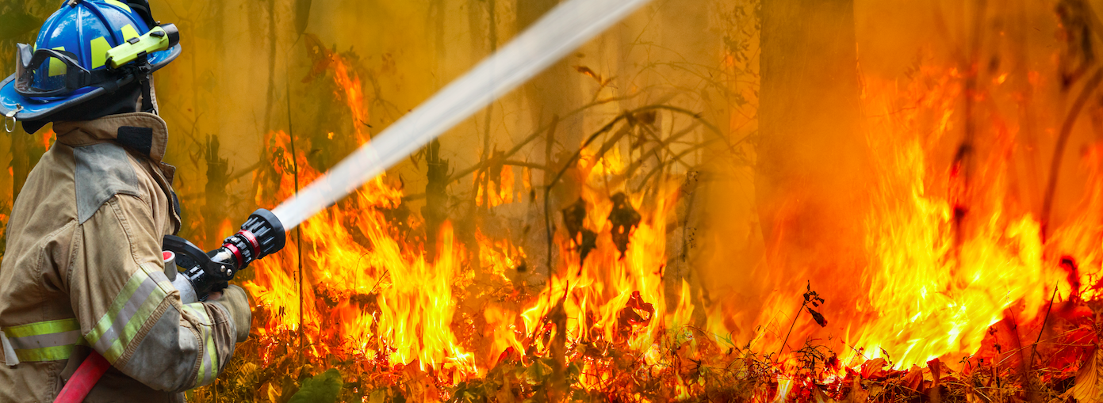

Extracts from the article are provided below:

"Typically, there are a few ways food supply can be affected by wildfires," former NASA engineer and founder of Treasure8 Timothy Childs told FOX Business. "For one, any farms, crops ... that might be in the path of the fires, clearly will be immediately annihilated.”

Australia is a major exporter of wheat, which has been destroyed in the blazes. But there are other effects from the fires on food that might appear less obvious.
"For one, pollutants released by wildfires can affect crop and vegetation growth hundreds of miles away from the actual area that has burned," Childs said… [Those pollutants can] "reduce plant growth and productivity."
It's not just plant life that could be affected by the wildfires. Up to a billion animals could die as a result of the wildfires. Since Australia is the second-largest beef and veal exporter in the world, behind Brazil, beef prices might rise, Childs said.

However, venture capitalist and environmentalist Ibrahim AlHusseini
said he doesn't anticipate a significant issue with beef or lamb since the long-term drought Australia has experienced already impacted stocking rates of the animals.
"It is climate change's exacerbation of the underlying drought that has caused the de-stocking of the Australian beef and lamb herds," AlHusseini said.
AlHusseini said the dairy industry could also be hurt by the wildfires, which are covering southern Australia, a huge producer of cheese. Two major dairy areas in the country were scorched over the new year.
"Because climate change doesn't know borders, there's a real danger that food crises could develop on several continents simultaneously," AlHusseini said.
The wildfire disaster, which is likely to continue throughout the Southern Hemisphere summer, has galvanized calls for more global action on climate change.
"We don't even really know yet the ramifications of nearby countries in terms of negative climate [or] environmental issues, which have a direct correlation on how we produce [and] grow food," Childs said.
Reference: https://www.foxbusiness.com/money/australian-wildfires-global-food-supply

