Unit 308: Produce and present advanced main course dishes using standardised recipes

Handout 3: Spring lamb with an herb crust, seasoned faggot, fondant potato, spring vegetables and carrot puree, and a port and red current jus
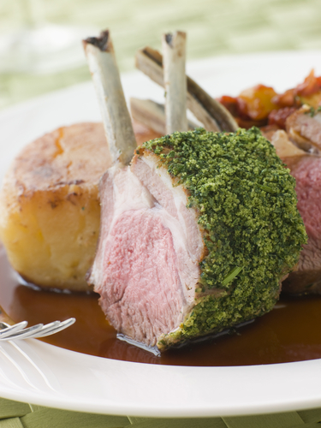

Spring herb crust – ingredients

- 6 slices of white bread
- 200gms flat leaf parsley
- 100gms fresh rosemary
- 50gms cheese
- 1 clove of garlic
- 2 teaspoons of olive oil
- salt and pepper

Spring herb crust – method

Finely grate the bread and cheese; finely chop all the herbs and garlic. Combine ingredients with a little olive oil.

Lamb loin – ingredients

- 2.5kg rack of lamb
- 15 ml of olive oil
- knob of butter
- salt and pepper

Lamb loin – method

Take the rack of lamb; remove the bark (thin skin) using either your fingers or a knife. Using a sharp knife, trim the sinew and fat attached to the loin of lamb.

Pan-fry the rack of lamb in a little butter evenly coloring the loin and season with salt and pepper.
Place into oven at 170 degrees for about 2 minutes, take the loin out and roll in the herb crust, ensuring the loin is equally covered. Place back in the oven for a further 2-3 minutes.

Rest for 4-5 minutes before slicing.

Fondant potato – ingredients

- 4 large potatoes
- sprig of rosemary
- 200gms salted butter
- 200ml chicken stock
- 2 garlic cloves
- salt and pepper

Fondant potato – method

Add the butter and potatoes in a saucepan and put onto the heat and fry until deep golden-brown on one side, about 5–6 minutes.

Turn over the potatoes and cook for a further 5-6 minutes, or until golden-brown on both sides. Carefully pour in the stock, and then add the garlic cloves and rosemary sprigs.

Place the pan into the oven at 170 degrees until tender, then remove the potatoes from the pan using a pallet knife and keep warm.

Carrot puree – ingredients

- 300gms carrots
- 50gms salted butter
- chicken stock

Carrot puree – method

Put the carrots in a saucepan and pour over just enough boiling water or stock to and cover with a lid, simmer for 15–20 minutes until soft.

Drain the carrots and place in a blender, adding some of the stock and butter, then puree until very smooth or pass through a sieve. Taste and adjust seasoning.

Spring vegetables – ingredients

- baby carrots
- peas
- beetroot
- asparagus
- shallots
- vegetable stock

Spring vegetables – method

Wash and prepare the vegetables and cut into the required size. Lightly colour in a little butter using a frying pan. Blanch baby carrots in the vegetable stock and repeat the colouring process. Adjust seasoning and keep warm.

Lamb stock – ingredients

- 5lb lamb bones, with attached meat
- 3 tablespoons olive oil
- 1 teaspoon salt
- 6 whole black peppercorns
- 5 fresh bay leaves
- 3 garlic cloves
- 1 onion, peeled and quartered
- 2 celery stalks, cut in pieces
- 1 carrot cut in pieces
- 200gms ground beef
- 2 pig trotters
- egg whites
- red wine

Lamb stock – method

Put the lamb bones and few halved brown onions and halved carrots into a large roasting dish.
Roast at 220°C until they are well browned. Turn them a few times and take care that they do not burn, as this will cause the stock to taste bitter. Transfer the bones to a large heavy-based stockpot. Fill with enough cold water so the bones are covered by about 5cm of the water.
Pour off any fat in the roasting dish. Deglaze with a little wine or water. Scrape up any sediment and cook to reduce pan juices by half. Add to the stockpot. Add pig trotters and ground beef.

Bring the stock to the boil very slowly. Greyish scum will rise to the surface as the stock comes to the boil; use a wide ladle or large spoon to skim it away. Add egg whites and then strain. Reduce stock until correct consistency and taste.

Faggot – ingredients

- 300gm lamb mince
- 1/4 teaspoon of grated nutmeg
- 2 teaspoons of chopped parsley
- pig’s caul
- salt and pepper

Faggot – method

Mince all the roughly chopped meats. If you don't have a mincer, then chop in a food processor.
Place the minced meat into a large bowl and add herbs, nutmeg and a pinch of salt and pepper. Mix thoroughly; divide the mixture into 4 and shape into balls.

Wrap each ball in pig’s caul making sure it overlaps as it will seal as it cooks and hold the faggots together.

Place the faggots onto a shallow oven proof dish and bake in the hot oven for 10 minutes.

Port and redcurrant jus – ingredients

- 200ml lamb stock
- 50ml port
- 2 tablespoons honey
- 200g redcurrant Jelly
- red food colouring
- corn starch to thicken

Port and redcurrant jus – method

Combine the port and stock over a medium-high heat. Stir and bring to the boil. Add the redcurrant jelly to the mix, and stir well. Allow to continue boiling, again until mixture is thick and just about halved – another 15–20 minutes. Stir occasionally. Once nicely thickened and reduced, turn off heat. Strain if needed making sure the consistency and seasoning is correct.

