Unit 308: Produce and present advanced main course dishes using standardised recipes

Handout 4: Sous vide chicken breast with potato gnocchi, courgette ribbons and a tomato and olive sauce

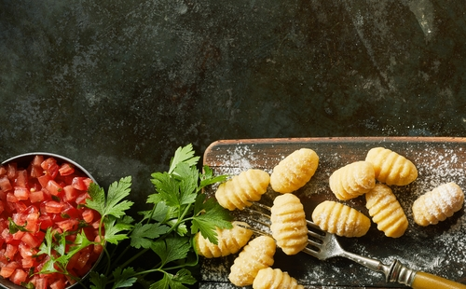

Sous vide chicken – ingredients

- 6 chicken breasts, skin-on
- 6 slices of garlic
- 7 sprigs of thyme
- 10g butter, plus extra to finish cooking the chicken

Sous vide chicken – method

Preheat a water bath to 60°C

To begin, prepare the aromatics for the chicken. Blanch the thyme in boiling water and refresh in iced water. Lay out a sheet of cling film on the bench and space out the 6 slices of garlic. Top each slice with a sprig of thyme.

Roll up the cling film and cut into six separate sachets. This allows the flavour to come out during cooking but avoids a 'hot spot' of flavour on the meat.

Remove the tenders from the chicken breasts and lay them the opposite way back onto the breasts to create a more uniform thickness. Season well and lay the sachet on the skin side. Roll tightly in cling film to form a compact cylinder but do not tie the ends.

Trim any excess cling film and then place in a vacuum bag with the butter. Seal in a chamber sealer and cook in the water bath for 30 minutes.

Remove the chicken from the bag and dry on kitchen paper. Heat a frying pan over a high heat with a little olive oil and sear the chicken. Add a knob of butter and a fresh sprig of thyme and baste.

By the time the chicken skin is crisp and the meat is lightly coloured, the core temperature of the chicken should be 70℃

Gnocchi – ingredients

- 600g Maris Piper potatoes
- 100g ‘00’ pasta flour
- 50g semolina, fine
- 10g flaky sea salt, finely ground
- 20g egg yolk

Gnocchi – method

Steam the potatoes until completely tender. Peel while still warm then push the potatoes through a ricer

Weigh out 400g of the riced potato and place on the work bench.

Sift the flours and salt together and sprinkle half over the potato. Drizzle over the egg yolk and then sprinkle on the remaining flour mix.

Use a metal dough scraper to chop the mix together, repeatedly turning it over and then chopping again. Once the mix is evenly blended, bring together by hand and knead very briefly. Divide the dough into four pieces and cover with cling film.

Working with one piece of dough at time, roll out into a 1.5 cm thick sausage shape and cut into 1cm long sections. Roll each piece into a ball then roll on a gnocchi paddle or the back of a large fork. Repeat with the remaining dough, placing the finished gnocchi on a tray dusted with semolina as you go.

Bring a large pan of lightly salted water to the boil, turn down to a simmer and add half of the gnocchi so you don't overcrowd the pan. Stir the water gently – when the gnocchi float to the surface, cook for 1 more minute then transfer to iced water.

Once all the gnocchi are blanched, drain and toss in a little olive oil.

Fry the gnocchi in a dash of oil until crispy and golden.

Courgette ribbons – ingredients

- 3 courgettes
- olive oil
- chilli, chopped
- garlic, chopped
- sea salt
- black pepper

Courgette ribbons – method

Quarter the courgettes lengthways, slice out the seeds and cut the courgette into ribbons using a peeler. Heat a little olive oil in a frying pan and fry the ribbons, finishing with a pinch of garlic and chilli. Season well with sea salt and fresh black pepper.

Tomato and olive sauce – ingredients

- 1 banana shallot, sliced
- 1 garlic clove, sliced
- 150ml of Noilly Prat vermouth
- 75g of passata
- 6 queen olives, 3 crushed, 3 diced
- 1l brown chicken stock
- 2 tomatoes
- 1 handful of flat-leaf parsley, chopped
- cornflour, to thicken

Tomato and olive sauce – method

To make the sauce, sweat the shallot and garlic in olive oil until just starting to colour. Add the Noilly Prat, reduce to a syrup then add the stock, crushed olives and passata. Reduce further until you are left with 300ml sauce.

Blanch the tomatoes for the sauce in boiling water for 1 minute then refresh in iced water. Peel away the skin, cut into 4 and remove the seeds. Dice the tomatoes into concasse and reserve.

Adjust the seasoning of the sauce using olive brine instead of salt and pass into a clean pan. Thicken with a little cornflour if necessary. Add the concasse tomato, chopped parsley and diced olive just before serving.

Plating

To serve, place a pile of courgette ribbons in the middle of each plate, slice the chicken and arrange over the top. Place 6 or 7 gnocchi around the plate, spoon over the sauce and serve.

