Unit 308: Produce and present advanced main course dishes using standardised recipes

Handout 7: Lobster with pommes purées and thermidor sauce
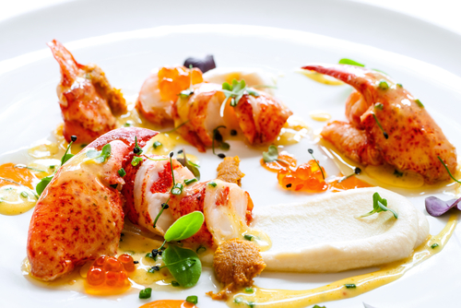

Lobster – ingredients

- 1 cooked lobster (600g)

Lobster – method

Remove the claws from the lobsters, crack and remove the meat, leaving it whole. Cut the lobsters lengthways into two. Remove and dispense with the gravel bag and intestines. Remove the flesh from the tails and cut it into neat large pieces

Cook the lobster meat in butter, mixed with a little of the sauce.

Sauce thermidor – ingredients

- 100ml Mornay sauce (cheese sauce, with the addition of eggs yolks and cayenne pepper)
- 50g shallots
- 50ml white wine
- 50ml shellfish stock
- 5g English mustard
- 50g parmesan cheese
- 1 egg
- 50ml cream
- 25g butter
- chives (chopped)
- salt (pinch)
- pepper (pinch)

Sauce thermidor – method

Peel the shallots, cut them into fine dice and cook them in a little butter. Add the white wine, fish stock and the parsley, and reduce by two thirds.

Add the reduction to the Mornay sauce and stir in the mustard.

Pommes purées – ingredients

- 500g potatoes
- 50g butter
- 50ml cream
- salt (pinch)
- pepper (pinch)
- nutmeg (pinch)

Pommes purées – method

Wash and peel the potatoes, then put them in a saucepan with salt, cover with cold water and a lid. Bring to the boil and simmer for 20 minutes until cooked.

Drain the potatoes, pass them through a sieve then mix in the butter, nutmeg and seasoning and cream.

Bring the milk to the boil, mix thoroughly into the potatoes and serve.

Plating up

Place a spoon of pommes puree at the side of a warm plate and drag through with the back of a spoon. Place the cooked lobster prices around the plate. Pour thermidor sauce around the plate, garnish with salmon roe and micro sea herbs.

