3902 Entry Level 3 & SCQF Level 3

V1.1

Assessment Pack

Entry Level 3 Certificate, Diploma in Body and Paint Maintenance and Entry Level 3 Diploma in General Vehicle Maintenance

Assessment Recording
Qualification 3902 – 02/03 Entry Level 3

SCQF Level 3 Certificate, Diploma in Introduction to Vehicle Body and Paint Maintenance and SCQF Level 3 Diploma in Introduction to General Vehicle Maintenance

Assessment Recording
Qualification 3902 – 72/73 Level 3

Candidate unit tracking assessment and verification page

Qualification: |  |  |  |  |  |  | Name of Assessor:
Candidate name: |  |  |  |  |  |  | Planned completion date: | / /
City & Guilds registration number: |  |  |  |  |  |  | Name of IV:
City & Guilds registration date: |  | / / |  |  |  |  | Date qualification completed: | / /
Centre enrolment date: | / / |  |  |  |  |  | Date qualification claimed: | / /

Unit number and title | Date unit completed | Unit number and title | Date unit completed
(Unit 013/SCQF Unit 313): Basics of vehicle body fitting |  | (Unit 018/SCQF Unit 318): Introduction to vehicle panel preparation techniques
(Unit 014/SCQF Unit 314): Basics of Vehicle Mechanical, Electrical and Trim Fittings (MET) |  | (Unit 020/SCQF Unit 320): Application of paint materials to vehicles using spray gun techniques
(Unit 015/SCQF Unit 315): Fundamental vehicle body repair techniques. |  | (Unit 021/SCQF Unit 321): Mix foundation coat materials for spray gun application
(Unit 016/SCQF Unit 316) Introduction to vehicle MAG welding techniques |  | (Unit 022/SCQF Unit 322): Manufacture single tolerance vehicle body components
(Unit 017/SCQF Unit 317): Introduction to vehicle resistance spot welding techniques |  | (Unit 023/SCQF Unit 323): Prepare vehicle body panels for foundation coat materials using masking materials and techniques

Declaration of competence:
I confirm that the candidate completed the work for this qualification to the required standard.

Signed (assessor): Date ___/___/_____

Quality assurance sampling
Internal verifier name | Units sampled | IV report reference | IV Signature and date (if sampled)
External verifier name | Units sampled | EV report reference | EV Signature and date (if sampled)

About this qualification:
The 3902 Entry Level 3/SCQF Level 3 qualification consists of ten competence based units which can be completed as stand alone units or as a complete qualification made up of a combination of units.

The aim of the qualification is to introduce learners to the skills required to complete preliminary body panel repairs and to prepare body panels for foundation coats.

Rules of combination

Framework
3902 -02
Entry Level 3 Certificate in Vehicle Body & Paint Maintenance – Accreditation Number (QAN): 501/1105/X
Full Rules of Combination – (906) Certification Module – Minimum 24 credits from (010, 012-023)

Entry Level 3 Diploma in Body & Paint Maintenance – Accreditation Number (QAN): 501/0831/1
Full Rules of Combination – (907) Certification Module – Minimum of 40 credits from (010, 012-023)

3902-03
Entry Level 3 Diploma in General Vehicle Maintenance – Accreditation Number (QAN): 501/1356/2
Full Rules of Combination – Overall minimum of 45 credits from (001-023, 101-109, 112) at least minimum 24 credits from (001-023)

SCQF
3902 -72
SCQF Level 3 Certificate in Vehicle Body and Paint Maintenance
Full Rules of Combination – (914) Certification Module – Minimum 24 credits from (310, 312-318 and 320-323)

SCQF Level 3 Diploma in Body and Paint Maintenance
Full Rules of Combination – (915) Certification Module – Minimum of 40 credits from (310, 312-318 and 320-323)

3902-73
SCQF Level 3 Diploma in Introduction to General Vehicle Maintenance
Full Rules of Combination – Overall minimum of 45 credits from (301-318, 320-323) and (401-409, 412) at least a minimum of 24 credits from (301-323)

The vehicle types
The units are flexible and are designed in a way to support all types of vehicles; evidence can come from one type or a mixture of different vehicle types, examples include:
Light vehicle
Heavy vehicles
Motorcycles and scooters
Quad and land-based
Tractors

Assessment
The vehicles used for assessment should be constructed using methods and materials that reflect current technology. Part vehicles, components and realistic vehicle rigs may also be used for training and assessment.

Tools and equipment
Centres must have the tools, equipment, vehicle and units required for the qualification. They should be in a safe and suitable condition to support learning and assessment.

Evidence submitted for assessment and verification
All units have a one page assessment document that states the skills and knowledge requirements. Assessment should be completed by a competent assessor. Knowledge can be assessed using the prepared questions (centre devised questions may also be used to suit local circumstances) either orally or in written form. A record of the candidate’s response to the knowledge questions must be kept and made available for verification.
Evidence may also be recorded using photographic or digital methods provided it is readily available and easily audited.

3902 Unit 013/SCQF Unit 313: Basics of vehicle body fitting
Candidate name: Assessor name Date assessment completed ___/___/_____

Candidates need to be observed by their assessor removing and replacing two of the following detachable body components. They are also required to correctly answer questions related to these tasks, a record of which must be kept. Indicate () below which of the components have been assessed.

Bonnet |  |  | Door |  |  |  |  |  | Tailgate |  |  |  |  |  | Bolt on wing
Vehicle details and relevant information:
Vehicle make |  |  |  |  |  |  |  |  |  | Vehicle model
Type of body |  |  |  |  |  |  |  |  |  | Number of doors
Assessment record:
Assessor to indicate () when correct use demonstrated and or knowledge confirmed
Be able to follow approved safety procedures when removing and refitting detachable vehicle body panels.
Correctly use required PPE |  |  |  |  |  | Follow approved workplace procedures |  |  |  |  |  |  | Identify potential H&S hazards and risks
Identify relevant information sources |  |  |  |  |  | State the importance of keeping records |  |  |  |  |  |  | Recycling and disposal

Be able to carry out the removal and replacement of detachable vehicle body components.
Identify the correct hand tools and check they are fit for purpose |  | Correctly use hand tools |  | Identify vehicle body panels using correct terminology
Correctly align detachable vehicle body components |  | Identify different types of fasteners |  | Securely fix detachable vehicle body components
Follow prescribed quality checks to ensure correct alignment and secure fixing
Assessors to select suitable ‘component’ based on assessment circumstances. Answers to questions should be available for verification.

- Why is it important to protect the surrounding bodywork when removing a ‘component’?
- State three checks you should complete before you remove a ‘component’?
- What should you do if you identify additional damage to the body when you have removed a ‘component’?
- How should a metal ‘component’ be disposed of?
- Why is it important to use plain and spring washers?
Assessor feedback :

3902 Unit 014/ SCQF Unit 314: Basics of Vehicle Mechanical, Electrical Trim (MET)
Candidate name: Assessor name Date assessment completed ___/___/_____

Candidates need to be observed by their assessor removing and replacing two of the following MET components. They are also required to correctly answer questions related to these tasks, a record of which must be kept. Indicate () below which of the components have been assessed.

Bumper front or rear |  |  |  | Rear lamps |  |  |  |  | Front grille/trim |  |  |  |  |  |  | Road wheel
Vehicle details and relevant information:
Vehicle make |  |  |  |  |  |  |  |  |  | Vehicle model
Type of body |  |  |  |  |  |  |  |  |  | Number of doors
Assessment record:

Assessor to indicate () when correct use demonstrated and or knowledge confirmed
Be able to follow approved safety procedures when removing and refitting MET components.
Correctly use required PPE |  |  |  |  |  | Follow approved workplace procedures |  |  |  |  |  |  |  | Identify potential H&S hazards and risks
Identify relevant information sources |  |  |  |  |  | State the importance of keeping records |  |  |  |  |  |  |  | Recycling and disposal

Be able to remove and replace MET components.
Identify the correct hand tools and check they are fit for purpose |  | Correctly use hand tools |  | Identify different types of vehicle
Identify vehicle MET using correct terminology |  | Correctly align MET components |  | Identify different types of fasteners
Securely fix detachable MET components |  | Follow prescribed quality checks to ensure correct alignment and secure fixing
Answers to questions should be available for verification.
- After raising the car with a trolley jack, what piece of equipment should be placed under the car to support it when you are removing the road wheel?
- What should be checked before you remove a rear lamp cluster?
- What type of tool should be used to check that the wheel nuts are tightened correctly?
- How should a plastic bumper be disposed of?
- What is a nyloc nut used for?
Assessor feedback:

3902 Unit 015/SCQF Unit 315: Fundamental vehicle body repair techniques
Candidate name: Assessor name Date assessment completed ___/___/_____

Candidates need to be observed by their assessor roughing out a small dent and one other task. They are also required to correctly answer questions related to these tasks, a record of which must be kept. Indicate () below which of the components have been assessed.

Roughing out small dent |  | Repair small dent in metal panel using body filler |  |  |  |  |  |  | Repair small dent in plastic panel using body filler
Vehicle details and relevant information:
Vehicle make |  |  |  |  |  | Vehicle model
Type of body |  |  |  |  |  | Number of doors
Assessment record:

Assessor to indicate () when correct use demonstrated and or knowledge confirmed
Be able to follow approved safety procedures when carrying out preliminary vehicle body repairs
Correctly use required PPE |  |  |  | Follow approved workplace procedures |  |  |  |  |  | Identify potential H&S hazards and risks
Identify relevant information sources |  |  |  | State the importance of keeping records |  |  |  |  |  | Recycling and disposal
Be able to carry out body repair techniques
Identify the correct hand tools and check they are fit for purpose |  | Correctly use hand and power tools |  | Identify panel and panel/substrate material
rough out small dents using a variety of hand tools |  | Mix and apply plastic body filler in an economical manner |  | Rub down body filler to the correct profile
Follow prescribed quality checks to ensure acceptable profile of repair

Answers to questions should be available for verification.
- What piece of PPE should you use to protect your lungs when rubbing down body filler? | - What grade of production paper should you use to remove the paint from a damaged steel body panel?
- What condition should a metal body panel be in before applying body filler? | - Why is body filler applied to a higher profile than the surrounding bodywork?
- Name two hand tools used when roughing out a steel panel prior to applying body filler?
Assessor feedback:

3902 Unit 016/ SCQF Unit 316: Introduction to vehicle MAG welding techniques
 | Candidate name: Assessor name Date assessment completed ___/___/_____
 | Candidates need to be observed by their assessor completing a lap and plug weld in 1 mm mild steel. They are also required to correctly answer questions related to these tasks, a record of which must be kept.
 | Lap weld |  |  |  |  |  |  | AND |  | Plug weld
 | Welding plant details and relevant information:
 | Wire speed |  | Wire gauge |  |  |  |  |  |  | Type of gas |  |  |  |  |  | Gas pressure
Standard of weld required:
For a minimum of half its length (lap weld) and two of the three plug welds. The welds should be linear, have a consistent form, and have adequate penetration.

Assessment record: Assessor to indicate () when correct use demonstrated and or knowledge confirmed

Be able to follow approved safety procedures when using MAG welding equipment
State the H&S requirements relevant to electric welding principles |  |  |  |  | Correctly use the required PPE |  |  |  |  |  |  | Follow approved workplace procedures
Identify potential H&S hazards and risks |  |  |  |  | Identify the relevant information sources |  |  |  |  |  |  | State he importance of keeping records
Recycling and disposal
Be able to produce MAG plug and lap welds
Complete effective tacking of materials prior to lap and plug welding |  | Complete effective lap welds |  | Complete effective plug welds

Answers to questions should be available for verification.

- State three hazards when MAG welding? | - Why should plates be tacked before welding?
- What is likely to happen if you weld too fast (speed of torch travel too high? | - What is the approximate torch angle when MAG welding (down hand lap)?
- What condition should the parent metal be in before MAG welding)? | - State why it is important to use the correct MAG welding technique?
- State the purpose of the shielding gas? | - Identify two different types distortion caused by the application of heat.
Assessor feedback:

3902 Unit 017/SCQF Unit 317: Introduction to vehicle resistance spot welding techniques
Candidate name: Assessor name Date assessment completed ___/___/_____

Candidates need to be observed by their assessor setting up a resistance spot welder, confirm correct set up by completing destructive test and complete three evenly spaced spot welds in 0.75 - 1 mm mild steel. They are also required to correctly answer questions related to these tasks, a record of which must be kept.
Set up resistance spot welder |  |  | Complete destructive test |  |  |  |  |  |  | Weld three correctly positioned spot welds
Welding plant details and relevant information:
Squeeze time |  |  |  | Weld time |  |  |  | Hold time |  |  |  |  |  | Current
Assessment record: Assessor to indicate () when correct use demonstrated and or knowledge confirmed
Be able to follow approved safety procedures when setting up and using resistance spot welding equipment
State the H&S requirements relevant to electric welding principles |  |  |  |  |  | Correctly use required PPE |  |  |  |  |  |  | Follow approved workplace procedures
Identify potential H&S hazards and risks |  |  |  |  |  | Identify the relevant information sources |  |  |  |  |  |  | State he importance of keeping records
Recycling and disposal
Be able to carry out resistance spot welds
Set up spot welding equipment |  | Adjust resistance spot welding equipment |  | Prepare materials for spot welding
Complete resistance spot welding

Answers to questions should be available for verification.
- State three hazards when resistance spot welding? | - What is the purpose of a peal test?
- Why is it important to dress the electrodes before welding? | - How should the parent metal be prepared before welding?
- What is likely to happen if you position the spot weld too close to the edge of the parent metal? | - State two factors which affect the quality of a resistance spot weld
- State two methods used to test the effectiveness of resistance spot welds | - Identify distortion caused by the application of heat when spot welding.
Assessor feedback:

3902 Unit 018/SCQF Unit 318: Introduction to vehicle panel preparation techniques
Candidate name: Assessor name Date assessment completed ___/___/_____

Candidates need to be observed by their assessor preparing a panel for paint coats by using hand flatting or by using power tools, and to complete a feather edge repair. They are also required to correctly answer questions related to these tasks, a record of which must be kept.

Hand flat body panel |  |  | Flat body panel using power tools |  |  |  |  | Feather edge repaired body panel
Vehicle details and relevant information:
Vehicle make |  |  |  |  |  | Vehicle model
Type of body |  |  |  |  |  | Panel prepared
Assessment record: Assessor to indicate ()when correct use demonstrated and or knowledge confirmed
Be able to follow approved and safe procedures when preparing vehicle body panels
Correctly use required PPE |  |  |  |  | Follow approved workplace procedures |  |  |  |  | Identify potential H&S hazards and risks
Identify the relevant information sources |  |  |  |  | State the importance of keeping records |  |  |  |  | Recycling and disposal
Be able to prepare vehicle body panels
Identify the correct hand, power tools and equipment and check they are fit for purpose |  |  |  | Correctly use hand and power tools
Hand flat vehicle body panels |  | Flat vehicle body panels using power tools |  | Feather edge a repaired body panel
Clean tools and equipment and obtain confirmation that they are left in a clean and serviceable condition

Answers to questions should be available for verification.
- State two hazards when hand flatting?
- State two hazards when flatting using power tools?
- What is meant by the term feather edging?
- Identify the types and grades of abrasive materials used for vehicle body panels.
- Identify the types of foundation coat materials used on vehicle body panels.

Assessor feedback:

3902 Unit 020/SCQF Unit 320: Application of Paint Materials to Vehicles Using Spray Gun Techniques
Candidate name: Assessor name Date assessment completed ___/___/_____

Candidates need to be observed by their assessor applying foundation coats using spray gun techniques. They are also required to correctly answer questions related to these tasks, a record of which must be kept.

Apply etch primer |  |  |  |  | AND Apply primer coat
Foundation coat details and relevant information:
Type of spay gun used |  |  |  |  |  | Position of panel on vehicle
Shape of panel painted |  |  |  |  |  | Panel material painted
Assessment record: Assessor to indicate () when correct use demonstrated and or knowledge confirmed
Be able to follow approved and safe procedures when applying foundation coat materials.
Correctly use required PPE |  |  | Follow approved workplace procedures |  |  |  |  |  |  | Identify potential H&S hazards and risks
Recycling and disposal |  |  | Identify the relevant information sources |  |  |  |  |  |  | State the importance of keeping records
State the need for fume extraction when applying foundation coat materials
Be able to apply foundation coat materials.
Use a pre-prepared spray gun to apply foundation coat materials |  | Identify the correct spray gun pattern
Clean tools and equipment and obtain confirmation that they are left in a clean and serviceable condition.

Answers to questions should be available for verification.
- State two hazards when applying foundation coats?
- State two items of PPE that should be worn when applying foundation coats?
- Why is it necessary to keep the spray gun a regular distance from the panel?
- Why is the correct spray pattern important?
- Why is it important to clean the spray gun thoroughly after use?

Assessor feedback:

3902 Unit 021/SCQF Unit 321: Mix foundation coat materials for spray gun application
Candidate name: Assessor name Date assessment completed ___/___/_____

Candidates need to be observed by their assessor preparing a panel for paint coats by using hand flatting or by using power tools, and to complete a feather edge repair. They are also required to correctly answer questions related to these tasks, a record of which must be kept.

Mix etch primer |  |  |  | AND Mix primer
Foundation coat details and relevant information:
Viscosity required |  |  |  |  | Mixing ratio used
Type of foundation coat material |  |  |  |  | Type of mixing scheme/system used
Assessment record: Assessor to indicate () when correct use demonstrated and or knowledge confirmed
Be able to follow approved and safe procedures when mixing foundation coat materials.
Correctly use required PPE |  |  | Follow approved workplace procedures |  |  |  |  | Identify potential H&S hazards and risks
Recycling and disposal |  |  | Identify the relevant information sources |  |  |  |  | State the importance of keeping records
State the importance of controlling paint shop substances which may be hazardous to health
Be able to mix foundation coat materials.
Use pre-selected technical information to support the mixing of foundation coat materials
Use hand tools for mixing foundation coat materials |  | Use measuring equipment for mixing foundation coat materials |  | Mix foundation coat materials
Clean tools and equipment and obtain confirmation that they are left in a clean and serviceable condition.
Answers to questions should be available for verification.
- State two hazards when mixing foundation coats?
- State two items of PPE that should be worn when mixing foundation coats?
- Why is it necessary to mix foundation coat materials?
- What is the purpose of an activator?
- Why is it important to clean mixing equipment after use?
Assessor feedback:

3902 Unit 022/SCQF Unit 332: Manufacture single tolerance vehicle body components
Candidate name: Assessor name Date assessment completed ___/___/_____

Candidates need to be observed by their assessor making two components that require at least four different and techniques each. They are also required to correctly answer questions related to these tasks, a record of which must be kept.
Indicate () techniques demonstrated:
Measuring |  | Marking out |  | Cutting |  | Fabrication |  | Forming |  | Drilling |  |  |  | Thread cutting |  | Filing
Standard required:
Each piece that is made must have at least one critical or key dimension. Typical tolerances being ± 1mm in sheet metal and ± 0.5mm in preformed sections. Examples of typical tools that can be manufactured as an alternative to body components are on the drawings provided.

Assessment record: Assessor to indicate () when correct use demonstrated and or knowledge confirmed
Be able to follow approved and safe procedures when manufacturing vehicle body components.
Use appropriate PPE and methods |  |  |  |  |  |  |  |  |  |  |  | Follow approved workplace procedures
Identify potential H&S hazards and risks |  |  |  |  |  |  |  |  |  |  |  | Identify the relevant information sources
State how to safely handle and dispose of used and waste materials, components and fluids |  |  |  |  |  |  |  |  |  |  |  | State the importance of keeping records
Be able to use tools and equipment to manufacture vehicle body components
Identify the workshop hand tools used for the manufacture of vehicle body components |  | Demonstrate how to check the condition and operation of the tools and equipment required for manufacturing vehicle body components
Demonstrate a range of techniques |  | Demonstrate how to prepare the tools and equipment required for manufacturing vehicle body components
Demonstrate how to check manufactured vehicle body components for compliance |  | Produce working drawings or sketches that illustrate the main features of manufactured vehicle body components

Understand the methods and techniques when manufacturing vehicle body components. Answers to questions should be available for verification.
- Why is it important to work from a datum when marking out?
- Identify the different materials used to manufacture vehicle body components including carbon steels and aluminium alloys
- State typical vehicle body component applications for the materials used
- State how materials are modified to provide strength by forming, alloying and heat treatment
- State the importance of hardness, toughness, rigidity and tensile strength as material properties

Assessor feedback:

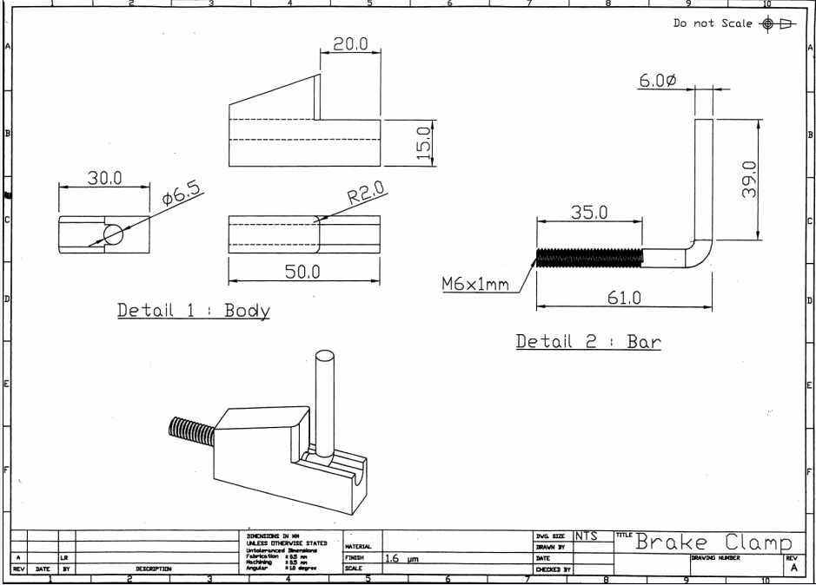

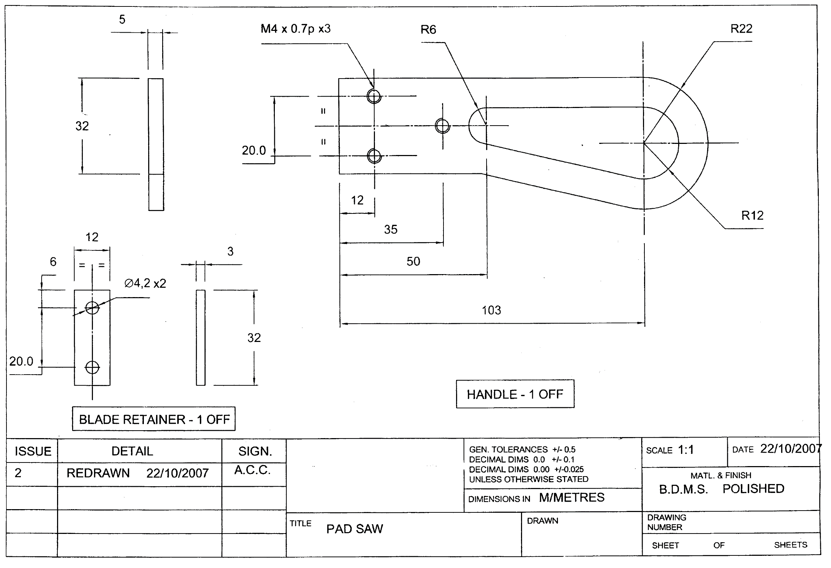

3902 Unit 023/SCQF Unit 323: Prepare vehicle body panels for foundation coat

materials using masking materials and techniques
Candidate name: Assessor name Date assessment completed ___/___/_____

Candidates need to be observed by their assessor preparing a panel for masking materials, applying and removing masking materials. They are also required to correctly answer questions related to these tasks, a record of which must be kept.

Use masking paper |  |  | OR use plastic masking sheet/film |  |  |  | AND Use masking tape
Vehicle details and relevant information:
Vehicle make |  |  |  |  | Vehicle model
Type of body |  |  |  |  | Panel prepared
Assessment record: Assessor to indicate () when correct use demonstrated and or knowledge confirmed
Be able to follow approved and safe procedures when applying masking methods.
Correctly use required PPE |  |  |  | Follow approved workplace procedures |  |  |  |  | Identify potential H&S hazards and risks
Identify the relevant information sources |  |  |  | State the importance of keeping records |  |  |  |  | Recycling and disposal
Be able to use masking materials and techniques to prepare vehicle body panels for foundation coats

Remove masking materials after foundation coat materials |  | Mask vehicle parts and components
Use suitable masking materials to mask up vehicle parts and components

Understand the methods and techniques when masking up vehicle panels components Answers to questions should be available for verification.
- List the materials used to mask vehicle parts and components
- State the importance of accurate application of masking materials
- State the importance of using the correct masking material for the application
- How to remove masking materials without damaging the vehicle
- State the importance of timely removal of masking materials

Assessor feedback:

