

Practical Assessment Workbook

Diploma in Accident Repair Body Principles at SCQF Level 5

4391 –12

Centre logo here

Training Provider

Candidate name

Start date with training provider

Registration date with City & Guilds

Expected completion date

City & Guilds Registration/ID Number

Work place or placement

Diploma in Accident Repair Body Principles at SCQF Level 5

This Diploma is made up of the following units

Unit number | Unit title | Assessment method | Entry type | Credit points
001 | Level 5 Skills in Health, Safety and Good Housekeeping | Assignment | Results entry | 7
003 | Level 6 Skills in Supporting Job Roles in the Automotive Work Environment | Assignment | Results entry | 5
004 | Level 5 Skills in Materials, Fabrication, Tools and Measuring Devices used in the Automotive Environment | Assignment | Results entry | 7
051 | Level 5 Knowledge of Health, Safety and Good Housekeeping in the Automotive Environment | Assignment | Results entry | 3
053 | Level 6 Knowledge of Support for Job Roles in the Automotive Work Environment | Assignment | Results entry | 3
054 | Level 5 Knowledge of Materials Fabrication, Tools and Measuring Devices used in the Automotive Environment | Assignment | Results entry | 4
102 | Level 5 Skills in Removing and Fitting Non-Permanently Fixed Motor Vehicle Body Panels | Assignment | Results entry | 2
105 | Level 5 Skills in Removing and Replacing Exterior Motor Vehicle Body Panels Including Permanently Fixed Components | Assignment | Results entry | 5
119 | Level 5 Skills in Body Metal Active Gas (MAG) Welding Techniques | Assignment | Results entry | 5
120 | Level 5 Skills in Motor Vehicle Body Resistance Spot Welding Operations | Assignment | Results entry | 5
152 | Level 5 Knowledge of Removing and Fitting Non Permanently Fixed Motor Vehicle Body Panels | Multiple Choice | On-line test | 2
155 | Level 5 Knowledge of Removing and Replacing Exterior Motor Vehicle Body Panels Including Permanently Fixed Components | Multiple Choice | On-line test | 6
169 | Level 5 Knowledge of Motor Vehicle Body Metal Active Gas (MAG) Welding techniques | Multiple Choice | On-line test | 5
170 | Level 5 Knowledge of Motor Vehicle Body Resistance Spot Welding Operations | Multiple Choice | On-line test | 5
176 | Level 5 Knowledge of Motor Vehicle Construction and Materials | Multiple Choice | On-line test | 5
101 | Level 5 Skills in Removing and Fitting Motor Mechanical Electrical and Trim (MET) Components to Vehicles | Assignment | Results entry | 2
106 | Level 5 Skills in Carrying Out Minor Repairs to Motor Vehicle Exterior Body Panels | Assignment | Result entry | 5
121 | Level 6 Skills in Motor Vehicle Body Metal Inert Gas (MIG) Brazing Operations | Assignment | Results entry | 5
124 | Level 5 Skills in Motor Vehicle Body Mechanical Fastening Operations | Assignment | Results entry | 2
125 | Level 6 Skills in Motor Vehicle Body Adhesive Bonding Operations | Assignment | Results entry | 2
151 | Level 5 Knowledge of Removing and Fitting Motor Mechanical, Electrical and Trim (MET) Components to Vehicles | Multiple Choice | On-line test | 2
156 | Level 5 Knowledge of Minor Motor Vehicle Exterior Body Panel Repairs | Multiple Choice | On-line test | 6
171 | Level 6 Knowledge of Motor Vehicle Body Metal Inert Gas (MIG) Brazing Operations | Multiple Choice | On-line test | 5
174 | Level 5 Knowledge of Motor Vehicle Body Mechanical Fastening Operations | Multiple choice | On-line test | 2
175 | Level 5 Knowledge of Motor Vehicle Body Adhesive Bonding Operations | Multiple Choice | On-line test | 2

Diploma assessment workbook
Candidate unit tracking assessment and verification page

PRN Number | Practical activity | Units worked upon | Assessor‘s Comments | Assessor | Date
Internal verifier _____________________Signature ____________________Date ____/____/_____

External verifier_____________________Signature ____________________Date ____/____/_____


Information

All the unit tasks can be completed as stand alone units or as a complete qualification made up of a combination of units.

Assessment

The vehicles used for assessment should have a realistic resemblance to current vehicles. Centres can use whole vehicles and specially prepared realistic vehicle rigs for training and assessment. It is expected that the technology used is similar to that used today.

Tools and equipment

Providers should have the tools and equipment to facilitate the vehicle types and units being worked upon; they should be in a safe condition to support learning and assessment.

Evidence submitted for assessment and verification

All units have a simple assessment document to cover the practical content. The knowledge element can be supported by a number of methods. Unit questions can be answered either orally, written or centre devised to support vehicle types, including photographic, video, tape and other recording methods. Product and evidence of components made during the assessment should also be made available.

Accident Repair Body Principles Skills Unit Practical Assessment Task Sheets
Purpose:  These assessment task work sheets are designed to support the light vehicle skills units. Candidates who are working towards individual skills units or following a complete qualification with rules of combination should find these units the most obvious choice.  Using them is not mandatory, some centres and candidates may prefer to use similar task activities and work sheets which also meet the same performance criteria needed to meet the skills units.  Using the workbook:  General Units – Skills (Units 001, 003, 051) By using these skills assessment task sheets, some of the necessary ‘G’ unit skills elements are integrated into the main units being undertaken. This means that evidence may be gathered for these units. For example, all of the units within this qualification incorporate Health & Safety (Unit 001). Evidence may be gathered for gathering data and information, identifying and using the correct tools and equipment, carrying out the work and recording essential test readings. Paper documentation is kept to a minimum which allows the candidates to concentrate more on quality practical learning and assessment time, (simplicity with quality).  Where it is not possible to generate evidence for the general units indicated through the technical tasks, centres will need to create additional tasks to ensure that the candidates are able to sufficiently cover the learning outcomes and assessment criteria of the unit.  General Units – Knowledge (Units 053)  City & Guilds has provided short answer questions for Units 053 which are available to download from the City & Guilds website. These may be used as is integrated whilst carrying out the relevant skills units, and candidates’ responses recorded.  The short-answer questions should be taken under supervised conditions as closed-book tests.  This means that all activities will be completed with the assessor, or other designated supervisor, present. Strict exam regulations do not apply; it is envisaged that most candidates will take the short-answer questions in their normal learning environment with their own tutor present or under full invigilated conditions.  Alternatively, assessors may prefer to ask the questions orally and record individual candidates’ responses.  General Units – Skills (Units 001, 003, 051) By using these skills assessment task sheets, some of the necessary ‘G’ unit skills elements are integrated into the main units being undertaken. This means that evidence may be gathered for these units. For example, all of the units within this qualification incorporate Health & Safety (Unit 001). Evidence may be gathered for gathering data and information, identifying and using the correct tools and equipment, carrying out the work and recording essential test readings. Paper documentation is kept to a minimum which allows the candidates to concentrate more on quality practical learning and assessment time, (simplicity with quality).  Where it is not possible to generate evidence for the general units indicated through the technical tasks, centres will need to create additional tasks to ensure that the candidates are able to sufficiently cover the learning outcomes and assessment criteria of the unit.  General Units – Knowledge (Units 053)  City & Guilds has provided short answer questions for Units 053 which are available to download from the City & Guilds website. These may be used as is integrated whilst carrying out the relevant skills units, and candidates’ responses recorded.  The short-answer questions should be taken under supervised conditions as closed-book tests.  This means that all activities will be completed with the assessor, or other designated supervisor, present. Strict exam regulations do not apply; it is envisaged that most candidates will take the short-answer questions in their normal learning environment with their own tutor present or under full invigilated conditions.  Alternatively, assessors may prefer to ask the questions orally and record individual candidates’ responses.  Training for assessments:  There is a practical training work book which supports this practical assessment skills workbook. It is not mandatory however it contains a comprehensive skills training leading to the assessment tasks. | Completing the work sheets:  1. Candidates need to agree the assessments with their assessors before starting.  2. Write in the vehicle details, tools and equipment needed,  gather and write in the vehicle data and make sure the work area is safe and risks identified  3. Carry out the assessment and complete the examination and test readings as necessary.  4. Evidence of Health & Safety, good housekeeping and  working with others will need to be initialled, in the box, by the assessor to make sure the candidate has adhered to all good working practices.  5. Both the assessor and candidate will need to sign and date the record when work is successfully completed.  Skills:  Within each unit evidence can be seen for number skills, communication, ICT, problem solving, working with others and improving own learning, including personal learning and thinking skills (PLTS).  Candidates will always be gathering data, taking numerical test readings, using computers to fault find and access vehicle data, solving vehicle faults which in turn improves their own learning.  Units 004/054 (G4):  These units can be completed by either of the two work sheets; Centres who have in place activities to support this unit can use the blank work sheet providing they meet all the criteria. The second worksheet gives the opportunity to manufacture a workshop tool which encompasses the necessary skills and criteria to meet the unit in full.

Health & Safety and Good Housekeeping
in the Automotive Environment
Units 001, 051 (G1/2)
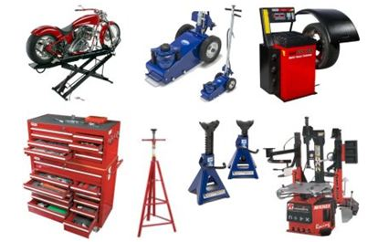
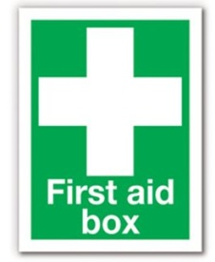
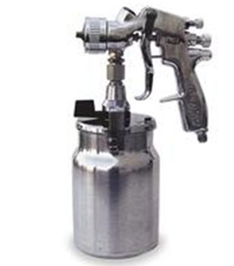

Candidate’s Name:
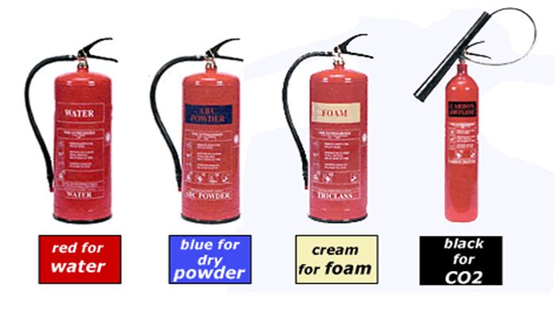



This unit is about the knowledge and skills needed to work in an automotive engineering environment. This can be in a light vehicle, heavy vehicle, motorcycle or body and paint workshop.
Outcome 1  Keeping the workshop clean, tidy and safe in preparation for the start, during and at the end of the day  Describe the procedures needed to clean the following:  - tools and equipment  - preparation for the day start and end  - general tidiness  - spillages  - removing waste  - housekeeping rules |  | List 6 main tools and pieces of equipment, used in the workshop, and describe the checks and cleaning methods needed.  - ____________________________________________________________________________________________________________________________________  - ____________________________________________________________________________________________________________________________________  - ____________________________________________________________________________________________________________________________________  - ____________________________________________________________________________________________________________________________________  - ____________________________________________________________________________________________________________________________________  - ____________________________________________________________________________________________________________________________________  What activities are required to be carried out for cleaning and maintaining the workshop at the start and finish of the day?  ___________________________________________________________________________________________________________________________________________________________________________________________________________________________________________________________________________________________________________________________________________________________________

Take a tour of the workshop and identify any areas of untidiness and state how you would normally deal with this.  State what methods you use to clean the floor, including spillages, in your workshop. |  | Describe the waste policies that are in place and what your responsibilities for them are.  Metals  Cardboard  Oils  Plastics  State three housekeeping rules which must be adhered to in the workshop:  1. _________________________________________________  2. _________________________________________________  3. _________________________________________________

Outcome 2:  Basic Health & Safety requirements  - Health & Safety legislation  - General legal duties of the employee  - General legal duties of the employer  - Current Health & Safety requirements |  | Health & Safety at Work Act: initial statements  General duties of employees at work  It shall be the duty of every employee, while at work, to take reasonable care for the Health & Safety of themselves and of other persons who may be affected by their acts or omissions at work; and as regards any duty or requirement imposed on their employer or any other person by or under any of the relevant statutory provisions, to co-operate with them so far as is necessary to enable that duty or requirement to be performed or complied with.  General duties of employers to their employees  It shall be the duty of every employer to ensure, in so far as is reasonably practicable, the health, safety and welfare at work of all their employees.  Without prejudice to the generality of an employer's duty under the preceding subsection, the matters to which that duty extends include in particular:  - the provision and maintenance of plant and systems of work that are, so far as is reasonably practicable, safe and without risks to health  - arrangements for ensuring, so far as is reasonably practicable, safety and absence of risks to health in connection with the use, handling, storage and transport of articles and substances  - the provision of such information, instruction, training and supervision as is necessary to ensure, so far as is reasonably practicable, the Health & Safety at work of their employees  - so far as is reasonably practicable as regards any place of work under the employer's control, the maintenance of it in a condition that is safe and without risks to health and the provision and maintenance of means of access to and egress from it that are safe and without such risks  - the provision and maintenance of a working environment for their employees that is, so far as is reasonably practicable, safe, without risks to health, and adequate as regards facilities and arrangements for their welfare at work.
Duties of the employer  Where is the Health & Safety at Work Act poster situated in your workplace? __________________________________  State three main duties expected of your employer.  1. ______________________________________________  2. ______________________________________________  3. ______________________________________________ |  |  |  | Duties of the employees  State three main duties expected of employees.  1. _______________________________________________________  2. _______________________________________________________  3. _______________________________________________________  What are three main Health & Safety concerns, in your workshop, with regards to the type of environment you are working in  1. _____________________________________________________  2. _____________________________________________________  3. _____________________________________________________

Outcome 3  Know about the hazards in the workshops you work in  - Potential hazards  - Reporting risks  - Precautions with vehicles and equipment  - PPE (personal protective equipment)  - Identify fire extinguishers  - Warning signs  - Product warning labels |  | State 3 main potential hazards in your workshop  1. ______________________________________________________________________  2. ______________________________________________________________________  3. ______________________________________________________________________  Who do you report risks, hazards and dangers to?  Name of person: ____________________________________________________________  List 3 precautions you should take when working with vehicles  1. ______________________________________________________________________  2. ______________________________________________________________________  3. ______________________________________________________________________  State the PPE which you use on a regular basis and state its main purpose  1. ______________________________________________________________________  2. ______________________________________________________________________  3. ______________________________________________________________________  Identify the fire extinguishers in your workplace and state where they are situated  1. ______________________________________________________________________  2. ______________________________________________________________________  3. ______________________________________________________________________  4. ______________________________________________________________________  What types of fire are each of the extinguishers, listed above, used for  1. ______________________________________________________________________  2. ______________________________________________________________________  3. ______________________________________________________________________  4. ______________________________________________________________________
In the space below sketch four main warning signs located in your workplace  1.  2.  3.  4. |  |  |  | In the space below Identify product warning labels in your workplace (toxic substances, COSHH, equipment labels, loads)  1.  2.  3.  4.

Outcome 4  Personal responsibilities  - The importance of all individuals to remain alert to Health & Safety in the workplace  - Importance of your own personal conduct in maintaining the Health & Safety of all individuals including those you work with  - The importance of your own personal presentation in maintaining Health & Safety and welfare |  | How do you make sure those activities you and others undertake support the prevention of accidents and safety concerns (list risk assessments, support work with other).  (List 3)  1. ______________________________________________________________________  2. ______________________________________________________________________  3. ______________________________________________________________________  What do you feel are the main concerns relating to personal conduct for yourself and others in your workplace  (List 3)  1. ______________________________________________________________________  2. ______________________________________________________________________  3. ______________________________________________________________________  Why do you feel it is important to present yourself in a way which maintains a safe environment? (time keeping, proper dress, behaviour, alcohol, drugs)  (List 3)  1. ______________________________________________________________________  2. ______________________________________________________________________  3. ______________________________________________________________________

Assessor’s feedback

Name/Date:

Internal verifier’s sampling

Name/Date:

External verifier’s sampling

Name/Date:


Unit 001 (G1/G2)
Health and safety and Good housekeeping
Overview  This unit is about working in an engineering workshop and being able to:  - carry out day to day workshop cleaning activities  - identify hazards and risks and comply with relevant legislation and good practice.  - work safely at all times individually and with others  Evidence requirements: VRQ 001 (G1/G2) (skills)  Essential Knowledge will be primarily tested using practical and written assignment activities or similar to cover the assessment criteria; further knowledge can be assessed by using oral questioning. At the end, the assessor must sign this form to confirm that all evidence identified above has been carried out competently by the candidate. |  |  |  |  | PRN Numbers  use boxes as appropriate
VRQ
Tick when competence observed
 | Use correct personal protection
 | Use correct vehicle protection
 | Carry out workshop cleaning
 | Use workshop cleaning materials
 | Keep tools clean and stored
 | Dispose of waste correctly
 | Identify hazards(low, medium, high)
 | Follow legal requirements
 | Manufacturer’s instructions
 | Workplace policies
 | Show good personal conduct
 | Display personal presentation
 | Direct observations PRNs
Knowledge evidence PRNs
Use as appropriate
Signing this document below by the assessor indicates that the assessor and candidate have agreed that all components of the unit have been fully completed

Assessor name ____________________________ Signature _________ date __/____/___

Internal verifier _____________________________ Signature _________ date __/____/____

External verifier ____________________________ Signature _________ date _/____/_____

Unit 003 (G3)
Support For Job Roles in the Automotive Work Environment
Overview  This unit is about developing the skills required to keep good working relationships with all colleagues and customers and being able to:  - communicate effectively  - provide effective support  Evidence requirements: VRQ 003 (G3) (Skills)  Essential Knowledge will be primarily tested using practical and written assignment activities or similar to cover the assessment criteria; further knowledge can be assessed by using oral questioning. At the end, the assessor must sign this form to confirm that all evidence identified above has been carried out competently by the candidate |  |  |  | PRN Numbers  use boxes as appropriate
VRQ
Tick when competence observed
 | Respond to requests
 | Refer customers/colleagues
 | Use manufacturer’s legal information
 | Communicate with customer/colleagues
 | Give accurate information
 | Report any delays where applicable
 | Contribute to a team
 | Show respect
 | Inform colleagues of their own work
 | Workplace policies
 | Direct observations PRNs
Knowledge evidence PRNs
Use as appropriate
Signing this document below by the assessor indicates that the assessor and candidate have agreed that all components of the unit have been fully completed

Assessor name ____________________________ Signature _________ date __/____/___

Internal verifier _____________________________ Signature _________ date __/____/____

External verifier ____________________________ Signature _________ date _/____/_____

Materials, Fabrication, Tools and Measuring Devices
in the Automotive Environment
Units 004, 054 (G4)

Candidate’s Name:

All outcomes for this assignment must be completed to gain a pass. There is no grading, however candidates must demonstrate that they have a good understanding and the ability to use the tools and equipment in a safe and proper manner.

It can be taken as a standalone unit; however it can also be integrated when completing the skills and competence units.

Outcome | Outcome Title | Assessor’s feedback
Outcome 1 | Tools used for fabricating and fitting
Outcome 2 | Measuring devices used for fabrication, fitting, and electrical testing  Use of workshop equipment
Outcome 3 | Properties, application and limitations of ferrous and non-ferrous metals
Outcome 4 | Properties, application and limitations of non-metallic materials
Outcome 5 | Terms relating to the properties of materials
Overall decision
Candidate’s Name: _____________________. Signature: ______________. Date. ___/___/____

Assessor Name: ______________________. Signature: ______________. Date. ___/___/____

Outcome 1

Common types of hand tools used for fabricating and fitting in the automotive workplace

Questions

Name three types of hand files used in the workshop.  1.  2.  3. |  | What is the name of the drill bit used before drilling the main hole?
Which way should the teeth face on a hacksaw? |  | What is a thread tap used for?  What is a thread die used for?
State a safety precaution when using a ball pein hammer. |  | What is an ‘easy-out’ and what would it be used for?
Name the screwdriver types shown:    1 2 3  4 5. 6 |  | State three tools used for marking out metal prior to cutting, filing or drilling.  1.  2.  3.
State a use for pliers. |  | How should tools be cared for and stored after use.
Name three spanner types commonly used in the workshop.

When would a centre punch be used?

Outcome 2

Types of measuring devices used for fabrication, fitting, and electrical testing in the automotive workplace.

Use of workshop equipment

Name the tool shown and state an example of its use.  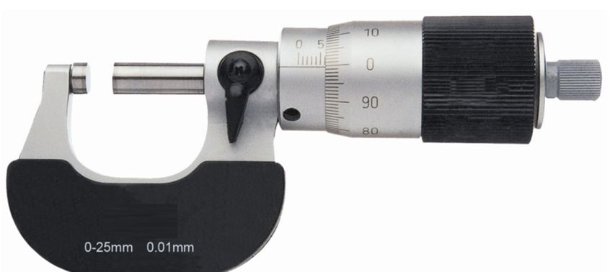 |  | Name the tool shown.  State the three units of measurement needed when using Ohm’s Law for calculations  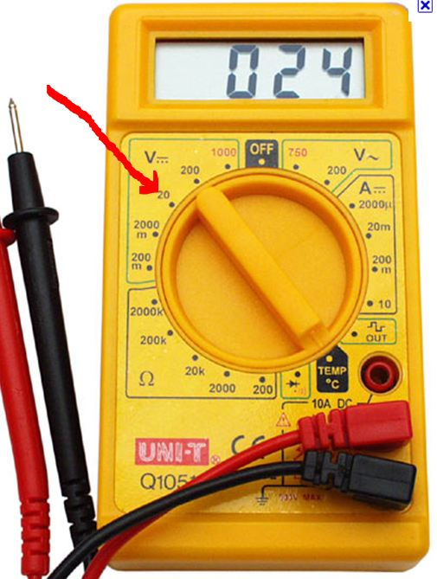  1.  2.  3.  Draw the diagram used for remembering Ohm’s Law
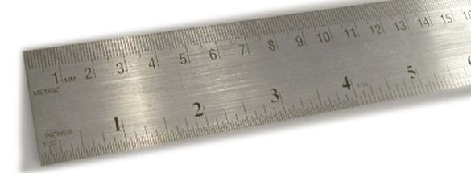
Name the tool shown and state an example of its use.

Name the tool shown and state an example of its use.   |  | 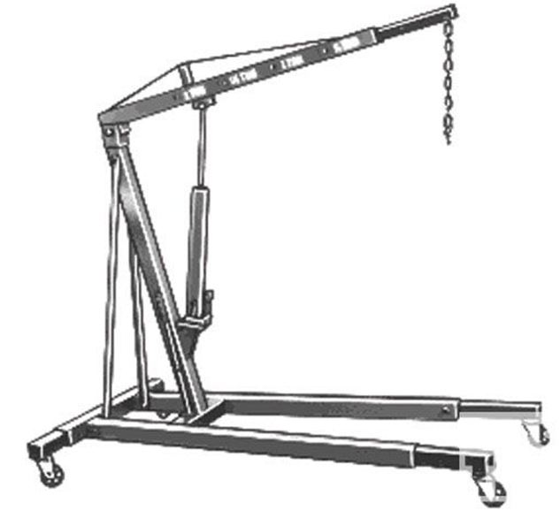  What would the equipment shown be used for?  What do the letters SWL stand for?
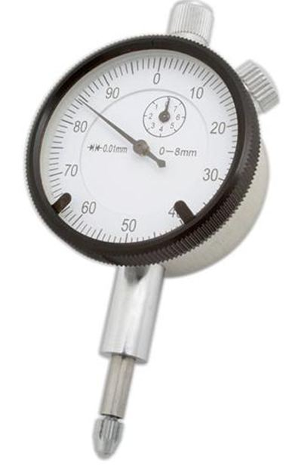  Name the tool shown and state an example of its use. |  | 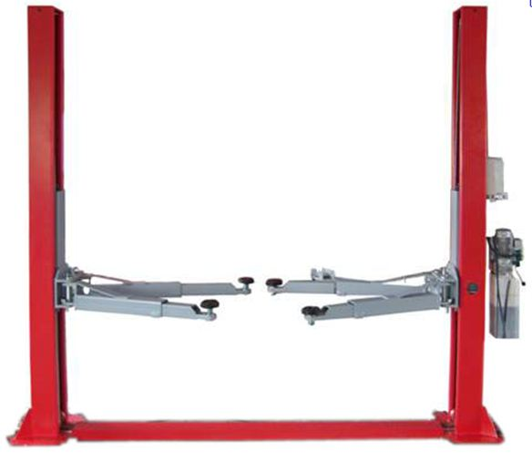  The image shows a two post ramp. State a safety  check to carry out before use.
Name the tool shown and state an example of its use.  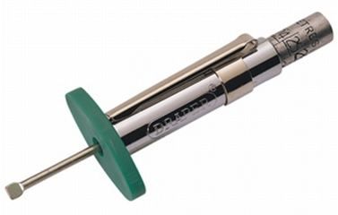 |  | 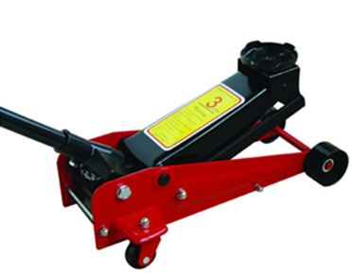  State two safety checks to carry out before using the  equipment shown.
Outcome 3

Properties, application and limitations (to include safe use) of ferrous and non-ferrous metals used when constructing, modifying and repairing vehicles and components.

Where on a motor vehicle would low carbon steel be used?  What are the properties of low carbon steel? |  | Where on a motor vehicle would aluminium alloys be used?  What are the properties of aluminium alloys?
Where on a motor vehicle would high carbon steel be used?  What are the properties of high carbon steel? |  | Where on a motor vehicle would brass be used?  What are the properties of brass?
Where on a motor vehicle would cast iron be used?  What are the properties of cast iron? |  | Where on a motor vehicle would copper be used?  What are the properties of copper?

Outcome 4

Properties, application and limitations of non-metallic materials used when constructing, modifying and repairing vehicles and components.

State the two types of glass normally used on modern vehicles.  1.  2.  What are their main properties of each type with regards to breakage and repair?  1.  2. |  | Where on a vehicle could Glass Reinforced Plastic (GRP) be used?  What is GRP made up of? |  | Where on a motor vehicle could carbon fibre be used?  What are the properties of carbon fibre?
One use of rubber, on a vehicle, is for tyres; where else can it be used?  What happens to rubber with age?  What is a typical shelf life of a vehicles tyre? |  | Where on a motor vehicle could Kevlar be used?  What are the properties of Kevlar? |  | State the main safety precautions when using GRP, glues and adhesives.

Outcome 5

Terms in connection with the properties of materials.

Name a type of metal, used in the construction of motor vehicles, which is very hard.  State two uses of this metal on a motor vehicle.  1.  2.  State a simple test to check for metal hardness. |  | What does the term malleability mean in relation to materials?  Give an example of the use of a material that has good malleability properties.
What does the term ductility mean in relation to materials?  Give an example of the use of a material that has good ductility properties. |  | What does the term elasticity mean in relation to materials?  Give an example of the use of a material that has good elasticity properties.
What does the term toughness mean in relation to materials?

Give an example of the use of a material that has good toughness properties.

Unit 054 (G4)
Knowledge of Materials, Fabrication, Tools and Measuring Devices used in the Automotive Environment

Overview  This unit is about developing the practical skills and knowledge required to safely use tools, equipment and materials in the automotive working environment.  Evidence requirements  It is expected that this evidence will be generated when carrying out practical work and assessments in a workshop.  - Candidates should list the tools and equipment normally used in the working environment on the job card.  - Candidates should state the health and safety and risk identified when using tools and equipment on the job card.  - Candidates should have the opportunity to generate practical evidence while working on projects using different materials and workshop equipment.  Observations are required to cover outcomes 1 and 2  Essential knowledge will be primarily assessed using practical observations, questions and written assignments to cover the assessment outcome criteria; further knowledge can be assessed by using oral questioning.  At the end, the assessor must sign this form to confirm that all evidence identified above has been carried out to the required standard by the candidate.  Assignments for knowledge and practical work are available for this unit |  |  |  |  |  | PRN Numbers  use boxes as appropriate
VRQ
Tick when observed competence
 | Outcomes |  |  | Practical observation  PRN number |  |  | Knowledge  PRN number
 | 1. Common hand tools
 | 2. Measuring devices
 | 3. Properties of ferrous/non ferrous metals |  |  | Covered in knowledge
 | 4. Properties of non-metallic materials |  |  | Covered in knowledge
 | 5. Terms relating to properties of materials |  |  | Covered in knowledge
 | Tools/measuring devices for outcomes 1 and 2: include others as appropriate. Highlight when used correctly
 | spanners | sockets | multi-meter |  | vehicle lift |  | tap and die
 | files | hack saw | rule |  | jack and stands |  | easy-out
 | hammer | air tool | electrical hand tool |  | torque wrench |  | screwdrivers
Signing this document below by the assessor indicates that the assessor and candidate have agreed that all components of the unit have been fully completed

Assessor name ____________________________ Signature _________ Date __/____/___

Internal verifier _____________________________ Signature _________ Date __/____/___

External verifier ____________________________ Signature _________ Date _/____/____

Light Vehicle Skills
Use of Hand Tools and Equipment in Motor Vehicle Engineering
Demonstrate the ability to file, cut, thread and drill materials Unit/s covered on this evidence record
Candidate’s name: |  |  |  |  |  |  | Date:___/___/_____ |  |  |  |  |  | (G1/2)  001 |  |  | (G3)  003 |  |  |  | (G4)  004
State the activities you demonstrated to complete this unit: This can be products made, photographic or integrated within other units.

Details of work activity
To complete this exercise you must show that you can use engineering equipment correctly and safely.
You will need to make an engineering tool which will demonstrate the skills of cutting, filing, drilling, threading, measuring and understanding drawings.
You can make a tool and or demonstrate these skills when repairing vehicle components.
Hack saw |  | Drills/bits |  | Taps/die |  |  |  | Files |  |  | Stock/wrench |  |  |  |  |  |  |  | Material types
Evidence of Health and Safety, good housekeeping and working with others. (Assessor to sign this area if the learner meets the requirements)
1. Work with others when reporting finding |  |  |  |  | 5. Clear up spillages
2. Dispose all waste correctly and safely |  |  |  |  | 6. Identify workshop policies
3. Tools tidy, cleaned, checked and put away |  |  |  |  | 7. Wear and use correct PPE
4. Sweep up |  |  |  |  | 8. Evidence of recycling and correct disposal of waste (ESDGC)
Assessor’s signature:________________________
State how you checked your work against specification, disposed of waste, recycled materials

Assessor’s knowledge questions

Assessor’s feedback on evidence provided.

I confirm that the work carried out on this evidence record meets City & Guilds’ requirements for validity, authenticity, currency and sufficiency.

Assessor’s name:________________________ Signature:________________________ Date:_____/_____/_____
Candidate’s signature:________________________ Date:_____/______/______

Light Vehicle Skills
Use of Hand Tools and Equipment in Motor Vehicle Engineering
Demonstrate the ability to File, cut, thread and drill materials Unit/s covered on this evidence record
Candidate’s name: |  |  |  |  |  |  | Date:___/___/_____ |  |  |  |  |  | (G1/2)  001 |  |  | (G3)  003 |  |  |  | (G4)  004
Details of work activity
To complete this exercise you must show that you can use engineering equipment correctly and safely.
You will need to make an engineering tool which will demonstrate the skills of cutting, filing, drilling, threading, measuring and understanding drawings.
You can make a tool and or demonstrate these skills when repairing vehicle components.
You must demonstrate that you have used all the tools listed below.
Hacksaw | Drills/bits |  | Taps/die |  |  | Files/hammer/punch |  |  |  | Stock/wrench |  |  |  |  |  |  |  | Steel
Evidence of Health and Safety, good housekeeping and working with others. (Assessor to sign this area if the learner meets the requirements)
1. Work with others when reporting finding |  |  |  |  | 5. Clear up spillages
2. Dispose all waste correctly and safely |  |  |  |  | 6. Identify workshop policies
3. Tools tidy, cleaned, checked and put away |  |  |  |  | 7. Wear and use correct PPE
4. Sweep up |  |  |  |  | 8. Evidence of recycling and correct disposal of waste (ESDGC)
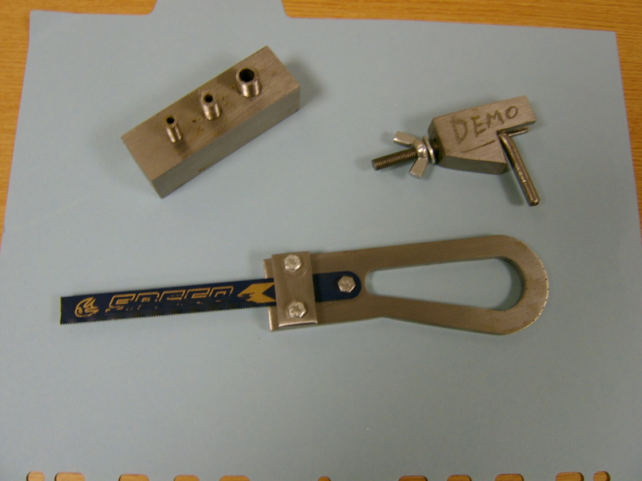 |  |  |  |  | Examples shown include:  1 pad saw  2 brake pie clamp  3. block and stud  - block and stud with easy-out hole to simulate snapped stud
Assessor’s signature:________________________
Work found that requires further attention and any action taken:

Assessor’s knowledge questions
Assessor’s feedback on evidence provided.

I confirm that the work carried out on this evidence record meets City & Guilds’ requirements for validity, authenticity, currency and sufficiency.

Assessor’s name:________________________ Signature:________________________ Date:_____/_____/_____

Candidate’s signature:________________________ Date:_____/______/______

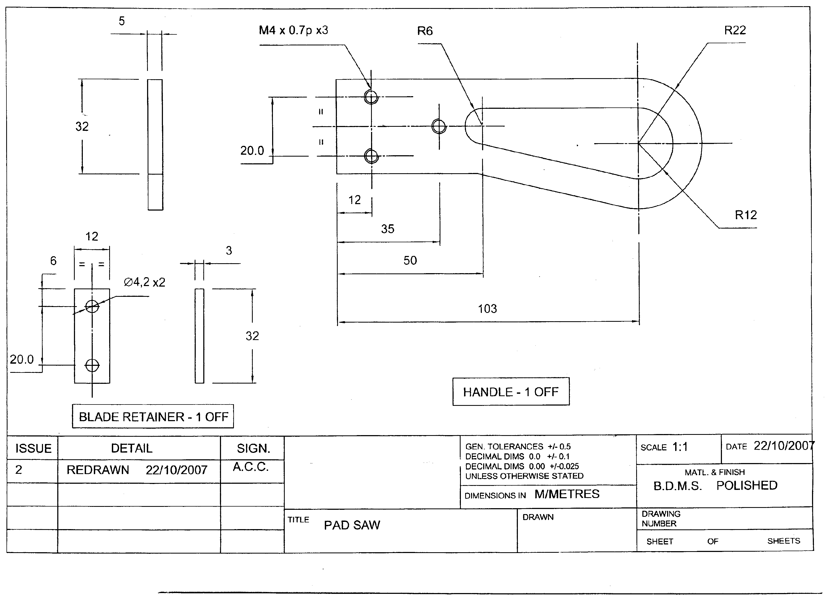

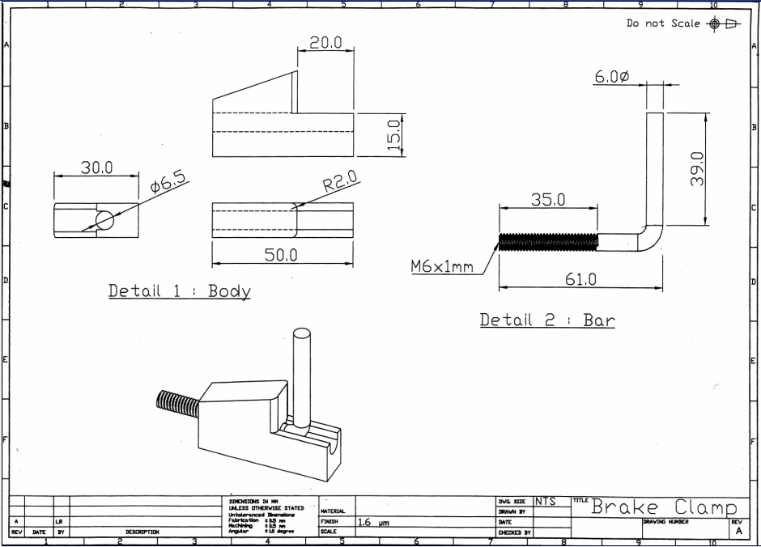
Skills in Removing and Fitting Non Permanently
Fixed Motor Vehicle Body Panels
Unit/s covered on this evidence record
Candidate’s name: |  |  | Date:___/___/_____ |  |  |  |  |  |  |  | 001 |  | 102
Vehicle
Make/Model:  _______________________ | Year of manufacture: _____________________ |  |  | Number of doors________ |  |  |  | Type of body:  _____________________
Details of work activity
Candidates need to be observed by their assessor carrying out removal and fitting of three non permanently fixed motor vehicle body panels
Indicate  below which of the components have been assessed

Wing  Door  Bonnet  Boot lid  Tailgate 

Assessment Record
Assessor to indicate  when correct use demonstrated and or knowledge confirmed

Be able to work safely when carrying out removal and replacement activities:

Use suitable personal protective equipment and vehicle coverings throughout all light vehicle engine unit
And component removal and replacement activities 

Work in way which minimises the risk of damage or injury to vehicle people and the environment 

Be able to use appropriate tools and equipment:

Select the appropriate tools and equipment necessary for carrying out removal and fitting of non-permanently fixed panels 

Ensure that equipment has been calibrated to meet manufacturers’ and legal requirements 

Use the correct tools and equipment in the way specified by manufacturers when carrying out removal and fitting
of non-permanently fixed vehicle panels 

Be able to carry out removal and fitting of non-permanently fixed vehicle panels

Carry out removal and fitting of non-permanently fixed vehicle panels 

Carry out removal and fitting of non-permanently fixed vehicle panels adhering to the correct specifications
and tolerances for the vehicle 

Ensure that the removal and fitting of non-permanently fixed panels conforms to the vehicle operating specification and
any legal requirements 

Ensure the components are realigned correctly in a way which regains their original manufactured tolerance 

Ensure no damage occurs to other components when removal and fitting of non-permanently fixed vehicle panels 

Ensure all components and panels are stored safely and in the correct location 

Be able to record information and make suitable recommendations

Produce work records that are accurate, complete and passed to the relevant person(s) promptly in the format required 

Make suitable and justifiable recommendations for cost effective repairs 

Record and report any additional faults noticed during the course of their work promptly in the format required 

Assessors to select suitable ‘component’ based on assessment circumstances.
Answers to questions should be available for verification
- How should you prepare the vehicle before removing panels.
- State how you should protect the vehicle interior when removing doors.
- State two methods of removing a seized fixing bolt.
- State three quality checks that should be carried out on a refitted wing.
- Why are cage nuts used when fitting doors, bonnets and wings?
Assessor feedback
Evidence of Health & Safety, good housekeeping and working with others. (Assessor to sign this area if the learner meets the requirements)
1. Work with others when reporting findings |  | 5. Clear up spillages
2. Dispose all waste correctly and safely |  | 6. Identify workshop policies
3. Tools tidy, cleaned, checked and put away |  | 7. Wear and use correct PPE
4. Sweep up |  | 8. Evidence of recycling and correct disposal of waste (ESDGC)
Assessor’s signature:________________________
Work found that requires further attention and any action taken:

Assessor’s knowledge questions
Assessor’s feedback on evidence provided.

I confirm that the work carried out on this evidence record meets City & Guilds’ requirements for validity, authenticity, currency and sufficiency.

Assessor’s name:____________________________ Signature:________________________ Date:_____/_____/_____

Candidate’s signature:________________________ Date:_____/______/______

Skills in Removing and Replacing Exterior Motor Vehicle Body Panels
including Permanently Fixed Components
Unit/s covered on this evidence record
Candidate’s name: |  |  | Date:___/___/_____ |  |  |  |  |  |  |  | 001 |  | 105
Vehicle
Make/Model:  _______________________ | Year of manufacture: _____________________ |  |  | Number of doors________ |  |  |  | Type of body:  _____________________
Details of work activity
Candidates need to be observed by their assessor carrying out removal and replacement of Two permanently fixed and Two non permanently fixed exterior vehicle body panel
Indicate  below which of the components have been assessed

Wing  Door  Bonnet  Boot lid  Tailgate 

Sill  Quarter panel  Welded wing  Bonded wing  Rear panel 

Assessment Record
Assessor to indicate  when correct use demonstrated and or knowledge confirmed

Be able to work safely when carrying out removal and replacement of exterior vehicle panels including permanently fixed panels

Correctly use required PPE and vehicle coverings throughout all removal and replacement activities 

Work in way which minimises the risk of damage or injury to vehicle people and the environment 

Be able to use relevant information to carry out the task

Select and use suitable sources of technical information to support motor vehicle removal and recognised fitting activities including:

Vehicle technical data 

Removal and fitting procedures 

Legal requirements 

Use technical information to support light vehicle engine unit and component removal and replacement activities 

Be able to use appropriate tools and equipment

Select and use the appropriate tools and equipment necessary for carrying out removal and fitting of non-permanently fixed vehicle panels 

Ensure that equipment has been calibrated to meet manufacturers’ and legal requirements 

Use the appropriate tools and equipment in the way specified by manufacturers when carrying removal and fitting of exterior body panels including permanently fixed vehicle panels 

Be able to carry out removal and fitting of exterior vehicle panels including permanently fixed panels

Identify prior to working on the vehicle the component materials involved that will be worked on during the repair 

Remove and re-fit adjacent exterior body panels including those that are permanently fixed 

Carry out removal and fitting of non-permanently fixed vehicle panels adhering to the correct specifications and tolerances for the vehicle 

Use and apply sealants and anti corrosion materials to the manufacturers specification 

Ensure that the replacement panels conform to the vehicle specifications for dimension, material and functional capability 

Ensure the components are realigned correctly in a way which regains their original manufactured tolerance 

Ensure any damage is minimised to mating surfaces. Any damage caused should be correctly reinstated 

Ensure permanently fixed panels are replaced without incurring damage to the vehicle systems 

Ensure all components and panels are stored safely and in the correct location 

Be able to record information and make suitable recommendations

Produce work records that are accurate, complete and passed to the relevant person(s) promptly in the format required 

Make suitable and justifiable recommendations for cost effective repairs 

Record and report any additional faults noticed during the course of their work promptly in the format required 

Assessors to select suitable ‘component’ based on assessment circumstances.
Answers to questions should be available for verification
1 State a method of protecting adjacent panels from damage when removing or replacing a bolt on wing.
2 List Two advantages of a bonded wing over a bolted on wing.
3 List Two recommended methods of removing a spot welded component.
4 State why it is important that any materials used during the repair process needs to comply with the manufactures specifications.
5 State why it is important that any damaged caused during the repair process needs to be recorded
Assessor feedback
Evidence of Health & Safety, good housekeeping and working with others. (Assessor to sign this area if the learner meets the requirements)
1. Work with others when reporting findings |  | 5. Clear up spillages
2. Dispose all waste correctly and safely |  | 6. Identify workshop policies
3. Tools tidy, cleaned, checked and put away |  | 7. Wear and use correct PPE
4. Sweep up |  | 8. Evidence of recycling and correct disposal of waste (ESDGC)
Assessor’s signature:________________________
Work found that requires further attention and any action taken:

Assessor’s knowledge questions
Assessor’s feedback on evidence provided.

I confirm that the work carried out on this evidence record meets City & Guilds’ requirements for validity, authenticity, currency and sufficiency.

Assessor’s name:____________________________ Signature:________________________ Date:_____/_____/_____

Candidate’s signature:________________________ Date:_____/______/______

Skills in Carrying Out Minor Repairs to Motor Vehicle Exterior Body Panels
Unit/s covered on this evidence record
Candidate’s name: |  |  | Date:___/___/_____ |  |  |  |  |  |  |  | 001 |  | 106
Vehicle
Make/Model:  _______________________ | Year of manufacture: _____________________ |  |  | Number of doors________ |  |  |  | Type of body:  _____________________
Details of work activity
Candidates need to be observed by their assessor carrying out minor repairs (roughing out a small dent and the use of body filler) to Five of the following motor vehicle exterior body panels
Indicate  below which of the components have been assessed

Wing  Door  Bonnet  Boot lid  Tailgate 

Sill  Quarter panel  Welded wing  Roof  Rear panel 

Assessment Record
Assessor to indicate  when correct use demonstrated and or knowledge confirmed

Be able to work safely when carrying out minor repairs to motor vehicle exterior body panels

Use suitable personal protective equipment and vehicle coverings throughout all repair activities 

Work in way which minimises the risk of damage or injury to vehicle people and the environment 

Be able to use relevant information to carry out the task

Select and use suitable sources of technical information to support motor vehicle removal and recognised fitting activities including:

Manufacturers instructions 

Vehicle technical data 

Removal and fitting procedures 

Legal requirements 

Use technical information to support light vehicle engine unit and component removal and replacement activities 

Be able to use appropriate tools and equipment

Select and use the appropriate tools and equipment necessary for carrying out repairs to motor vehicle exterior and body panels 

Check that equipment has been calibrated to meet manufacturers’ and legal requirements 

Use the correct tools and equipment in the way specified by manufacturers when carrying repairs to motor vehicle exterior body panels 

Be able to carry out minor repairs to motor vehicle exterior body panels

Identify prior to working on the vehicle the component materials involved that will be worked on during the repair 

Carry out minor repairs to motor vehicle exterior body panels so they are restored to their original contour
using hand tools and filling materials effectively 

Carry out minor repairs to motor vehicle exterior body panels adhering to specifications and tolerances for
the vehicle and following 

Replace any sealer, anti corrosion and sound deadening materials which were removed prior to the repair and conforming to the manufacturers specification 

Ensure all plastic repairs regain the strength of the original part 

Ensure any damage is minimised to mating surfaces. Any damage caused should be correctly reinstated 

Ensure all completed repairs are finished to an agreed standard ready for the refinishing process 

Be able to record information and make suitable recommendations

Produce work records that are accurate, complete and passed to the relevant person(s) promptly in the format required 

Make suitable and justifiable recommendations for cost effective repairs 

Record and report any additional faults noticed during the course of their work promptly in the format required 

Assessors to select suitable ‘component’ based on assessment circumstances.
Answers to questions should be available for verification
1 State the importance of using a dust mask when rubbing down body filler
2 State how you could protect the vehicle from further damage when carrying out minor panel repairs’.
3 List the manufactures recommended process for the removal of paint before applying body filler.
4 State a safe method of removing sound deadening material prior to a repair
5 State why it is impotent that plastic components regain the original strength after a repair has been carried out.
Assessor feedback
Evidence of Health & Safety, good housekeeping and working with others. (Assessor to sign this area if the learner meets the requirements)
1. Work with others when reporting findings |  | 5. Clear up spillages
2. Dispose all waste correctly and safely |  | 6. Identify workshop policies
3. Tools tidy, cleaned, checked and put away |  | 7. Wear and use correct PPE
4. Sweep up |  | 8. Evidence of recycling and correct disposal of waste (ESDGC)
Assessor’s signature:________________________
Work found that requires further attention and any action taken:

Assessor’s knowledge questions
Assessor’s feedback on evidence provided.

I confirm that the work carried out on this evidence record meets City & Guilds’ requirements for validity, authenticity, currency and sufficiency.

Assessor’s name:____________________________ Signature:________________________ Date:_____/_____/_____

Candidate’s signature:________________________ Date:_____/______/______

Skills in Motor Vehicle Body Metal Active Gas (MAG) Welding Techniques
Unit/s covered on this evidence record
Candidate’s name: |  |  | Date:___/___/_____ |  |  |  |  |  |  |  | 001 |  | 119
Vehicle
Make/Model:  _______________________ | Year of manufacture: _____________________ |  |  | Number of doors________ |  |  |  | Type of body:  _____________________
Details of work activity
Candidates need to be observed by their assessor carrying out metal active gas (MAG) welding techniques correctly on Three different occasions
Indicate  below which of the components have been assessed

Setting up the welding machine  Preparing the weld sample  Prepare metal surface 

Correct use of welding equipment  Produce weld samples for testing 

Assessment Record
Assessor to indicate  when correct use demonstrated and or knowledge confirmed

Be able to work safely when carrying out motor vehicle exterior body MAG welding operations

Use suitable personal protective equipment and vehicle coverings throughout all motor vehicle body MAG welding operations 

Work in way which minimises the risk of damage or injury to vehicle people and the environment 

Be able to use relevant information to carry out the task

Select and use suitable sources of technical information to support motor vehicle body MAG welding operations:

Vehicle technical data 

Welding procedures 

Legal requirements 

Use technical information to support motor vehicle body MAG welding operation activities 

Be able to use appropriate tools and equipment

Select and use the appropriate tools and equipment necessary for carrying out repairs to motor vehicle body MAG welding operations 

Ensure all tools and equipment that are required are in a safe working condition 

Set up and use the appropriate tools and equipment in the way specified by manufacturers
when carrying out motor vehicle body MAG welding operations 

Clean and store PPE and equipment in the appropriate manner 

Be able to carry out motor vehicle body MAG welding operations

Prepare surface to ensure a good MAG weld is achieved 

Ensure alignment, mating and treatment of flanges to enable a suitable join to be achieved 

Conduct MAG weld operations including

Lap plug  Lap seam  Butt joint  Fillet joint 

Conduct MAG weld operations following

Manufacturers processes, methods and procedures 

Test procedures to provide test coupons on equivalent material in accordance with Industry Standards 

Recognised researched repair methods 

Dress the weld area without reducing material thickness and protect the area to inhibit corrosion where applicable 

Recognise when the weld is not forming correctly and what action needs to be taken 

Inspect and assess quality of welds in accordance with industry standards and manufacturers specification 

Avoid damaging other components, units, panels and surfaces on the vehicle and the surrounding work area.
Any damage caused should be correctly reinstated 

Ensure no damage is incurred to other vehicle systems when MAG welding 

Be able to record information and make suitable recommendations

Produce work records that are accurate, complete and passed to the relevant person(s) promptly in the format required 

Make suitable and justifiable recommendations for cost effective repairs 

Record and report any additional faults noticed during the course of their work promptly in the format required 

Assessors to select suitable ‘component’ based on assessment circumstances.
Answers to questions should be available for verification
1 Describe the requirements for protecting the vehicle and contents from damage before, during and after the MAG welding process.
2 Describe the Fillet welding techniques used in MAG welding.
3 Describe the Plug welding techniques used in MAG welding.
4 State two advantages and two disadvantages of MAG welding over other welding methods.
5 State the importance and implications of checking and carrying out weld test pieces prior to carrying out the welding process.
Assessor feedback
Evidence of Health & Safety, good housekeeping and working with others. (Assessor to sign this area if the learner meets the requirements)
1. Work with others when reporting findings |  | 5. Clear up spillages
2. Dispose all waste correctly and safely |  | 6. Identify workshop policies
3. Tools tidy, cleaned, checked and put away |  | 7. Wear and use correct PPE
4. Sweep up |  | 8. Evidence of recycling and correct disposal of waste (ESDGC)
Assessor’s signature:________________________
Work found that requires further attention and any action taken:

Assessor’s knowledge questions
Assessor’s feedback on evidence provided.

I confirm that the work carried out on this evidence record meets City & Guilds’ requirements for validity, authenticity, currency and sufficiency.

Assessor’s name:____________________________ Signature:________________________ Date:_____/_____/_____

Candidate’s signature:________________________ Date:_____/______/______

Skills in Motor Vehicle Body Resistance Spot Welding Operations
Unit/s covered on this evidence record
Candidate’s name: |  |  | Date:___/___/_____ |  |  |  |  |  |  |  | 001 |  | 120
Vehicle
Make/Model:  _______________________ | Year of manufacture: _____________________ |  |  | Number of doors________ |  |  |  | Type of body:  _____________________
Details of work activity
Candidates need to be observed by their assessor carrying out resistance spot welding operations correctly on Three different occasions
Indicate  below which of the components have been assessed

Setting up the spot welding machine  Preparing the weld sample  Prepare metal surface 

Correct use of welding equipment  Produce weld samples for testing 

Assessment Record
Assessor to indicate  when correct use demonstrated and or knowledge confirmed

Be able to work safely when carrying out motor vehicle body resistance spot welding operations

Use suitable personal protective equipment and vehicle coverings throughout all motor vehicle body resistance spot welding operations 

Work in way which minimises the risk of damage or injury to vehicle people and the environment 

Be able to use relevant information to carry out the task

Select suitable sources of technical information to support motor vehicle body resistance spot welding operation activities including:

Vehicle technical data 

Welding procedures 

Legal requirements 

Use technical information to support motor vehicle body resistance spot welding operation activities 

Be able to use appropriate tools and equipment

Select the appropriate tools and equipment necessary for carrying out motor vehicle body resistance spot welding operations 

Ensure all tools and equipment that are required are in a safe working condition 

Set up and use the correct tools and equipment in the way specified by manufacturers
when carrying motor vehicle body resistance spot welding operations 

Clean and store PPE and equipment in the appropriate manner 

Be able to carry out motor vehicle body resistance spot welding operations

Carry out surface preparation to ensure a good resistance spot weld is achieved 

Ensure alignment, mating and treatment of flanges to enable a suitable join to be achieved 

Produce resistance spot welding operations following:

Manufacturers processes, methods and procedures 

Test procedures to provide test coupons on equivalent material in accordance with Industry Standards 

Recognised researched repair methods 

Dress and protect the area to inhibit corrosion where applicable 

Identify when the weld is not forming correctly and what action needs to be taken 

Inspect and assess all spot weld quality in accordance with industry standards and manufacturers specification 

Ensure the integrity of the weld and record the type of weld achieved on the appropriate paperwork 

Store and record all weld test pieces 

Avoid damaging other components, units, panels and surfaces on the vehicle and the surrounding work area.
Any damage caused should be correctly reinstated 

Ensure no damage is incurred to other vehicle systems when resistance spot welding 

Be able to record information and make suitable recommendations

Produce work records that are accurate, complete and passed to the relevant person(s) promptly in the format required 

Make suitable and justifiable recommendations for cost effective repairs 

Record and report any additional faults noticed during the course of their work promptly in the format required 

Assessors to select suitable ‘component’ based on assessment circumstances.
Answers to questions should be available for verification
1 State the treatment that should e carried out before replacing a spot welded panel.
2 State the fault that could occur if spot welds are placed to close together.
3 List three visual checks that could be carried out on a spot welded sample that indicates a correct weld.
4 List two defects that can occur in resistance spot welding.
5 List two advantages and two disadvantages of resistance spot welding over other welding techniques.
Assessor feedback
Evidence of Health & Safety, good housekeeping and working with others. (Assessor to sign this area if the learner meets the requirements)
1. Work with others when reporting findings |  | 5. Clear up spillages
2. Dispose all waste correctly and safely |  | 6. Identify workshop policies
3. Tools tidy, cleaned, checked and put away |  | 7. Wear and use correct PPE
4. Sweep up |  | 8. Evidence of recycling and correct disposal of waste (ESDGC)
Assessor’s signature:________________________
Work found that requires further attention and any action taken:

Assessor’s knowledge questions
Assessor’s feedback on evidence provided.

I confirm that the work carried out on this evidence record meets City & Guilds’ requirements for validity, authenticity, currency and sufficiency.

Assessor’s name:____________________________ Signature:________________________ Date:_____/_____/_____

Candidate’s signature:________________________ Date:_____/______/______
Skills in Motor Vehicle Body Metal Inert Gas (MIG) Brazing Opertaions
Unit/s covered on this evidence record
Candidate’s name: |  |  | Date:___/___/_____ |  |  |  |  |  |  |  | 001 |  | 121
Vehicle
Make/Model:  _______________________ | Year of manufacture: _____________________ |  |  | Number of doors________ |  |  |  | Type of body:  _____________________
Details of work activity
Candidates need to be observed by their assessor carrying out metal inert gas (MIG) brazing operations correctly on Three different occasions
Indicate  below which of the components have been assessed

Setting up welding equipment correctly  Weld samples produced for testing 

Correct preparation of metal surfaces  Correct welding techniques used 

Distortion control techniques used 

Assessment Record
Assessor to indicate  when correct use demonstrated and or knowledge confirmed

Be able to work safely when carrying out motor vehicle body MIG brazing operations

Use suitable personal protective equipment and vehicle coverings throughout all motor vehicle body MIG brazing operations 

Work in way which minimises the risk of damage or injury to vehicle people and the environment 

Be able to use relevant information to carry out the task

Select and use suitable sources of technical information to support motor vehicle MIG brazing operations activities including:

Vehicle technical data 

Welding procedures 

Legal requirements 

Use technical information to support motor vehicle body MIG brazing operations activities 

Be able to use appropriate tools and equipment

Select and use the appropriate tools and equipment necessary for carrying out repairs to motor vehicle body MIG brazing operations 

Ensure all tools and equipment that are required are in a safe working condition 

Set up and use the appropriate tools and equipment in the way specified by manufacturers
when carrying out motor vehicle body MIG brazing operations 

Clean and store PPE and equipment in the appropriate manner 

Be able to carry out motor vehicle body MIG brazing welding operations

Prepare surface to ensure a good MIG brazing operation is achieved 

Ensure alignment, mating and treatment of flanges to enable a suitable join to be achieved 

Carry out MIG brazing operations including

Lap plug  Lap seam  Butt joint 

Carry out MIG brazing operations following

Manufacturers processes, methods and procedures 

Test procedures to provide test coupons on equivalent material in accordance with Industry Standards 

Recognised researched repair methods 

Dress the weld area without reducing material thickness and protect the area to inhibit corrosion where applicable 

Recognise when the weld is not forming correctly and what action needs to be taken 

Inspect and assess all MIG brazing operations for quality in accordance with industry standards and manufacturers specification 

Ensure the integrity of the weld and record the type of weld achieved on the appropriate paperwork 

Avoid damaging other components, units, panels and surfaces on the vehicle and the surrounding work area,
any damage caused should be reported 

Ensure no damage is incurred to other vehicle systems when carrying out MIG brazing operations 

Be able to record information and make suitable recommendations

Produce work records that are accurate, complete and passed to the relevant person(s) promptly in the format required 

Make suitable and justifiable recommendations for cost effective repairs 

Record and report any additional faults noticed during the course of their work promptly in the format required 

Assessors to select suitable ‘component’ based on assessment circumstances.
Answers to questions should be available for verification
1 How should you prepare the vehicle before starting to weld?
2 State the correct welding technique when MIG brazing.
3 State two methods of distortion control when welding in the flat position.
4 State two advantages of MIG brazing.
5 How should you prepare the joint before welding?
Assessor feedback
Evidence of Health & Safety, good housekeeping and working with others. (Assessor to sign this area if the learner meets the requirements)
1. Work with others when reporting findings |  | 5. Clear up spillages
2. Dispose all waste correctly and safely |  | 6. Identify workshop policies
3. Tools tidy, cleaned, checked and put away |  | 7. Wear and use correct PPE
4. Sweep up |  | 8. Evidence of recycling and correct disposal of waste (ESDGC)
Assessor’s signature:________________________
Work found that requires further attention and any action taken:

Assessor’s knowledge questions
Assessor’s feedback on evidence provided.

I confirm that the work carried out on this evidence record meets City & Guilds’ requirements for validity, authenticity, currency and sufficiency.

Assessor’s name:____________________________ Signature:________________________ Date:_____/_____/_____

Candidate’s signature:________________________ Date:_____/______/______

Skills in Motor Vehicle Body Mechanical Fastening Operations
Unit/s covered on this evidence record
Candidate’s name: |  |  | Date:___/___/_____ |  |  |  |  |  |  |  | 001 |  | 124
Vehicle
Make/Model:  _______________________ | Year of manufacture: _____________________ |  |  | Number of doors________ |  |  |  | Type of body:  _____________________
Details of work activity
Candidates need to be observed by their assessor using vehicle body mechanical fasters to secure All of the following exterior body panels
Indicate  below which of the components have been assessed

Wing  Door  Bonnet  Boot lid  Tailgate 

Assessment Record
Assessor to indicate  when correct use demonstrated and or knowledge confirmed

Be able to work safely when carrying out motor vehicle body mechanical fastening operations

Use suitable personal protective equipment and vehicle coverings throughout all motor vehicle body mechanical fastening operations 

Work in way which minimises the risk of damage or injury to vehicle people and the environment 

Be able to use relevant information to carry out the task

Select suitable sources of technical information to support motor vehicle body mechanical fastening operations activities including:

Vehicle technical data 

Joining procedures 

Legal requirements 

Use technical information to support motor vehicle body mechanical fastening operations activities 

Be able to use appropriate tools and equipment

Select the appropriate tools and equipment necessary for carrying out motor vehicle body mechanical fastening operations 

Ensure all tools and equipment that are required are in a safe working condition 

Set up and use the correct tools and equipment in the way specified by manufacturers
when carrying motor vehicle body mechanical fastening operations 

Clean and store PPE and equipment in the appropriate manner 

Be able to carry out motor vehicle body mechanical fastening operations

Prepare surface to ensure a good mechanical fastening is achieved 

Ensure alignment, mating and treatment of flanges to enable a suitable join to be achieved 

Carry out mechanical fastening operations following manufacturers processes, methods and procedures 

Carry out mechanical fastening operations following recognised researched repair methods 

Dress and protect the joint area to inhibit corrosion where applicable 

Recognise when the joint is not forming correctly and what action needs to be taken 

Ensure integrity of the joint and record the type of joint achieved on the appropriate paperwork 

Avoid damaging other components, units, panels and surfaces on the vehicle and the surrounding work area.
any damage caused should be correctly reinstated 

Be able to record information and make suitable recommendations

Produce work records that are accurate, complete and passed to the relevant person(s) promptly in the format required 

Make suitable and justifiable recommendations for cost effective repairs 

Record and report any additional faults noticed during the course of their work promptly in the format required 

Assessors to select suitable ‘component’ based on assessment circumstances.
Answers to questions should be available for verification
1 State the surface preparation that should be done before joining panels with mechanical fasteners.
2 State what is the main advantage of singe sided riveting.
3 List two advantages and two disadvantages of mechanical fastening operations over other joining methods.
4 State how to use adhesives with the riveting technique.
5 State why it is important to keep accurate records.
Assessor feedback
Evidence of Health & Safety, good housekeeping and working with others. (Assessor to sign this area if the learner meets the requirements)
1. Work with others when reporting findings |  | 5. Clear up spillages
2. Dispose all waste correctly and safely |  | 6. Identify workshop policies
3. Tools tidy, cleaned, checked and put away |  | 7. Wear and use correct PPE
4. Sweep up |  | 8. Evidence of recycling and correct disposal of waste (ESDGC)
Assessor’s signature:________________________
Work found that requires further attention and any action taken:

Assessor’s knowledge questions
Assessor’s feedback on evidence provided.

I confirm that the work carried out on this evidence record meets City & Guilds’ requirements for validity, authenticity, currency and sufficiency.

Assessor’s name:____________________________ Signature:________________________ Date:_____/_____/_____

Candidate’s signature:________________________ Date:_____/______/______

Skills in Motor Vehicle Body Adhesive Bonding Operations
Unit/s covered on this evidence record
Candidate’s name: |  |  | Date:___/___/_____ |  |  |  |  |  |  |  | 001 |  | 125
Vehicle
Make/Model:  _______________________ | Year of manufacture: _____________________ |  |  | Number of doors________ |  |  |  | Type of body:  _____________________
Details of work activity
Candidates need to be observed by their assessor carrying out adhesive bonding operations correctly on Three different joint types
Indicate  below which of the components have been assessed

Preparing the metal sample  Prepare metal surface  Correct use of bonding material 

Produce bonded samples for testing 

Assessment Record
Assessor to indicate  when correct use demonstrated and or knowledge confirmed

Be able to work safely when carrying out motor vehicle body adhesive bonding operations

Use suitable personal protective equipment and vehicle coverings throughout all motor vehicle body adhesive bonding operations 

Work in way which minimises the risk of damage or injury to vehicle people and the environment 

Be able to use relevant information to carry out the task

Select suitable sources of technical information to support motor vehicle body adhesive bonding operations activities including:

Vehicle technical data 

Joining procedures 

Legal requirements 

Use technical information to support motor vehicle body adhesive bonding operations activities 

Be able to use appropriate tools and equipment

Select the appropriate tools and equipment necessary for carrying out motor vehicle body adhesive bonding operations 

Ensure all tools and equipment that are required are in a safe working condition 

Set up and use the correct tools and equipment in the way specified by manufacturers
when carrying out motor vehicle body adhesive bonding operations 

Clean and store PPE and equipment in the appropriate manner 

Be able to carry out motor vehicle body adhesive bonding operations

Prepare surface to ensure a good adhesive bonding is achieved 

Ensure alignment, mating and treatment of flanges to enable a suitable join to be achieved 

Carry out adhesive bonding operations following manufacturers processes, methods and procedures 

Carry out adhesive bonding operations following recognised researched repair methods 

Dress and protect the joint area to inhibit corrosion where applicable 

Identify when the joint is not forming correctly and what action needs to be taken 

Avoid damaging other components, units, panels and surfaces on the vehicle and the surrounding work area.
any damage caused should be correctly reinstated 

Be able to record information and make suitable recommendations

Produce work records that are accurate, complete and passed to the relevant person(s) promptly in the format required 

Make suitable and justifiable recommendations for cost effective repairs 

Record and report any additional faults noticed during the course of their work promptly in the format required 

Assessors to select suitable ‘component’ based on assessment circumstances.
Answers to questions should be available for verification
- State the properties that a structural adhesive should have.
- State two advantages of an Offset Lap joint when compared with other types of joints used in adhesive bonding process.
- State the advantages of a two pack material when compared with single pack materials.
- State two advantages and two disadvantages of adhesive bonding over other joining methods.
- State the importance and implications of checking and carrying out adhesive test pieces prior to carrying out the joining process.
Assessor feedback
Evidence of Health & Safety, good housekeeping and working with others. (Assessor to sign this area if the learner meets the requirements)
1. Work with others when reporting findings |  | 5. Clear up spillages
2. Dispose all waste correctly and safely |  | 6. Identify workshop policies
3. Tools tidy, cleaned, checked and put away |  | 7. Wear and use correct PPE
4. Sweep up |  | 8. Evidence of recycling and correct disposal of waste (ESDGC)
Assessor’s signature:________________________
Work found that requires further attention and any action taken:

Assessor’s knowledge questions
Assessor’s feedback on evidence provided.

I confirm that the work carried out on this evidence record meets City & Guilds’ requirements for validity, authenticity, currency and sufficiency.

Assessor’s name:____________________________ Signature:________________________ Date:_____/_____/_____

Candidate’s signature:________________________ Date:_____/______/______

