IEPA Portal Guidance

Contents

Summary 03
Account activation 04
Accepting or rejecting bookings 10
Updating availability 12

Summary

This simple step by step guide is designed to help IEPA’s navigate the EPA Portal.

The guide is split into three sections:

Account activation
- Checking your details and activating your account.
- Saving the EPA Portal URL

Accepting or rejecting bookings
- Checking your availability and the endpoint assessments

Updating availability
- Changing your availability or unavailability

Account activation

- Once we have received your details an activation email from the City & Guilds EPA Administrator will be sent to your email account. If you have not received your activation email, please check your spam folder before contacting the EPA Admin team. If you have not received your activation after checking your spam folder, please email the EPA Admin team - EPA@cityandguilds.com where the team will be happy to help.

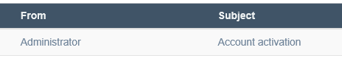

- Once you have read the email click on the hyperlink “LINK” to start the activation process.

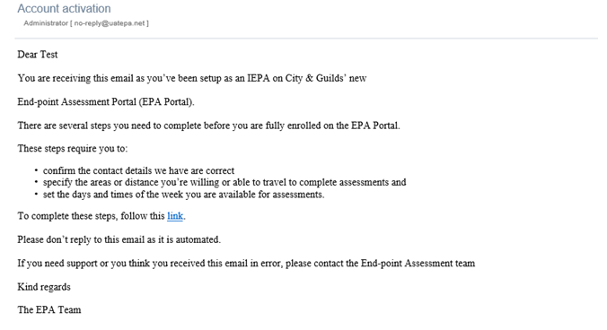

- Once you have read the introductory page click “START” to continue.

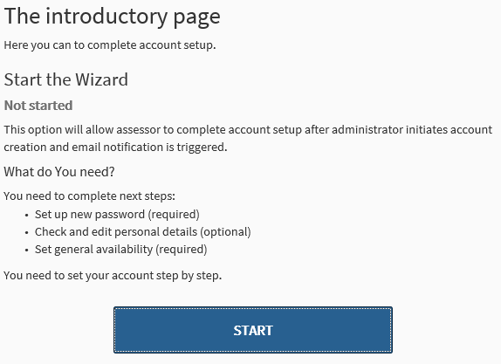

- Create your account password and click “CONTINUE”.

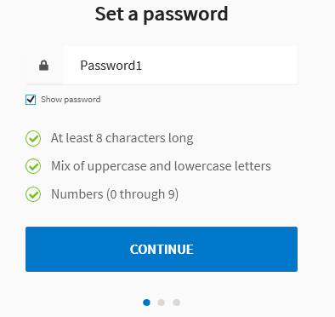

- Double check your personal details. If the details are incorrect, you can edit these by clicking on the “Edit my details” link.
- Please note you will not be able to edit your Primary role.

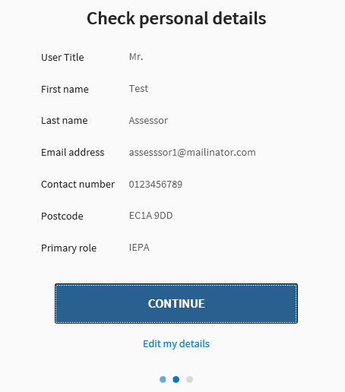

- Click “GOT IT” to set your availability.

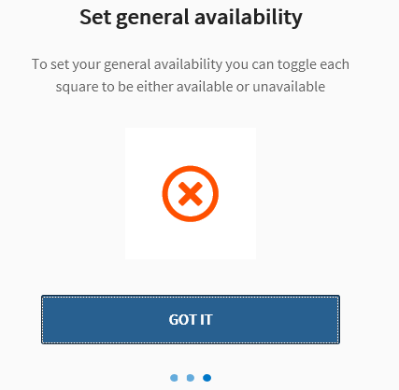

- Set your availability by selecting the day and the time of day. Each day is broken down into three session, morning, afternoon and evening.
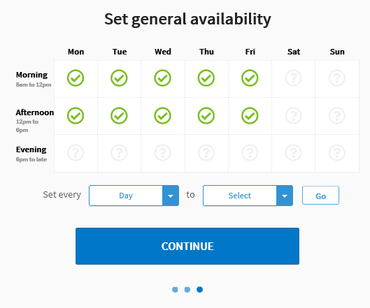

You can also automatically set all days and times as available or not unavailable by selecting the drop downs.

With the selection from the above option, all mornings of every day will be set as available.

- Once you have selected your available dates and times, you will need to change all the remaining boxes as unavailable by selecting each remaining box twice.
- If you are unsure of your availability please leave the box as undecided.

- Click “CONTINUE” to complete your activation.
- It is important that you keep your availability up to date. You can amend the availability after the activation process (see p12).

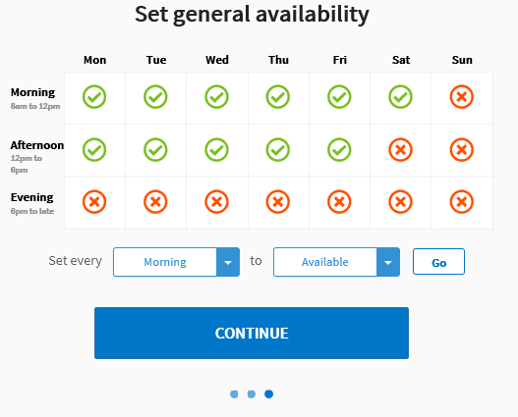

- A confirmation box will appear. Click “GET STARTED” to navigate to your account.

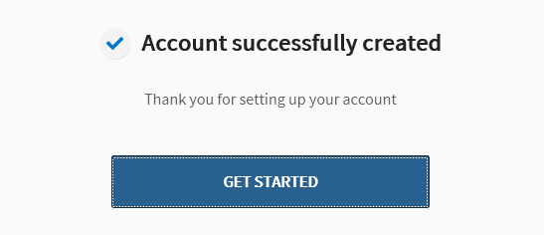

- Once registered, please note, the web address (URL) for the Assessor EPA Portal is - https://assessor.epaportal.com/login

Please save this to your favourites for easy access in the future. To add a favourite to your browser;

Google Chrome (recommended) – Click on the star in the top right of your browser and then click ‘Done’. This will then be available from the favourite selection menu.
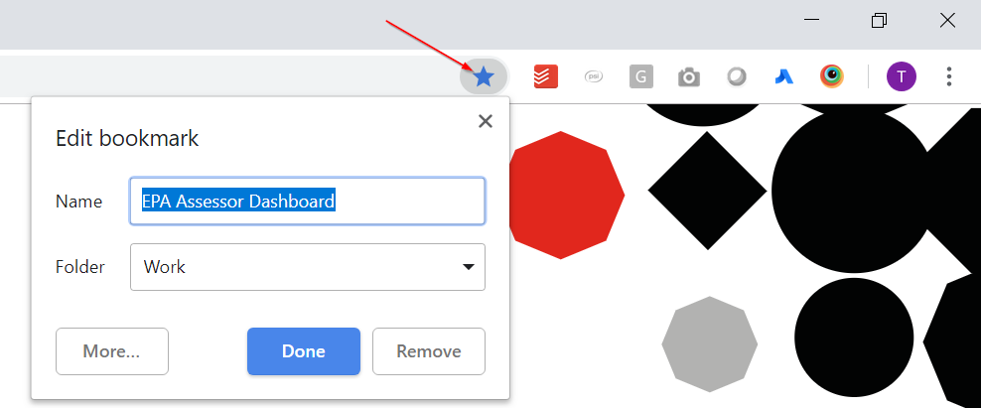
Microsoft Internet Explorer – Click on the star in the top right of your browser and then click ‘Add to favourites’. This will then be available from the favourite selection menu.
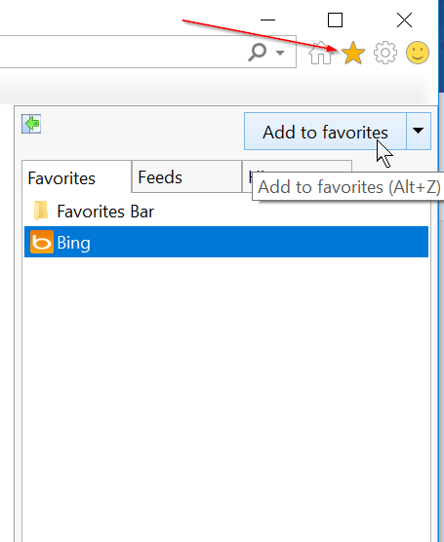

Microsoft Edge - Click on the star in the top right of your browser and then click ‘Add’. This will then be available from the favourite selection menu.
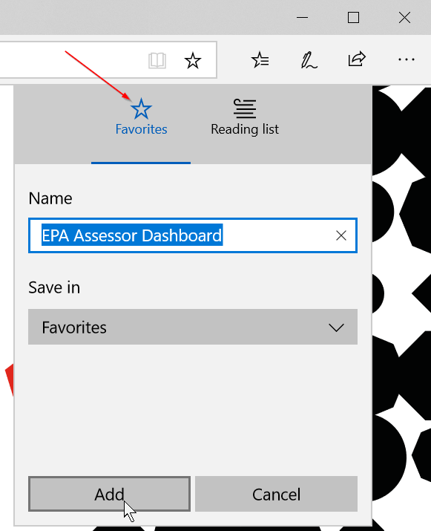

Accepting or rejecting bookings

- Once City & Guilds assign you to an assessment, you will receive a booking created email.

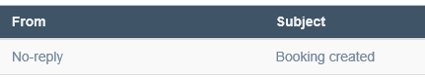

- Once you have read the email, please click the hyperlink “portal” in the email to log in to your account.

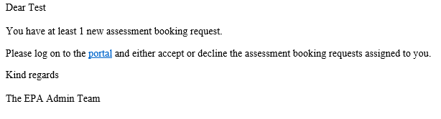

- Enter your username and password to log in.

- Under your availability calendar, you will notice a booking that is awaiting confirmation which you will need to check and choose whether to accept or reject.

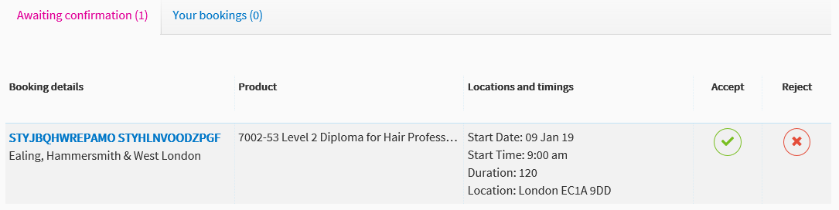

If you reject, the booking will be removed from your screen and will notify City & Guilds.

- If you accept the booking, you will notice the booking will move to the “Your bookings” tab.

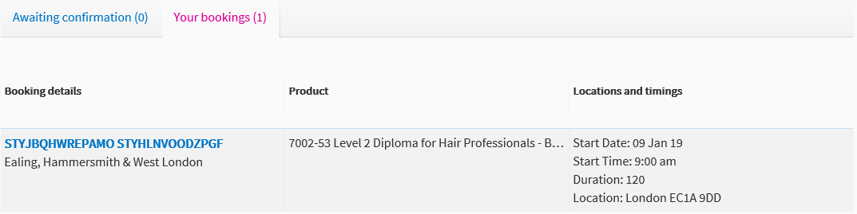

- The booking date and time will also show on your calendar marked in blue.
- Notice below the morning of the 9th is marked in blue.
- You will be unable to change the availability of time slot when a booking has been scheduled.

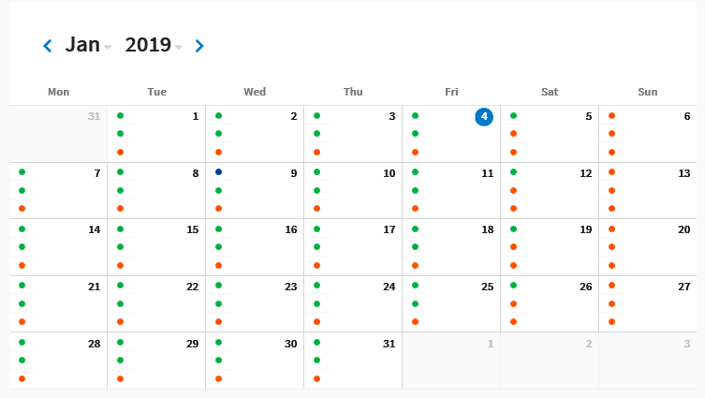

Changing Your Availability

It is really important that you keep your availability up to date. When you’ve set yourself as available an EPA Admin will book you without checking with you. When you’ve set yourself as unavailable an EPA Admin will never book you or contact you asking you if you’re available. When you’ve set yourself as negotiable, you may be called to ask if you can carry out an ad hoc assessment.

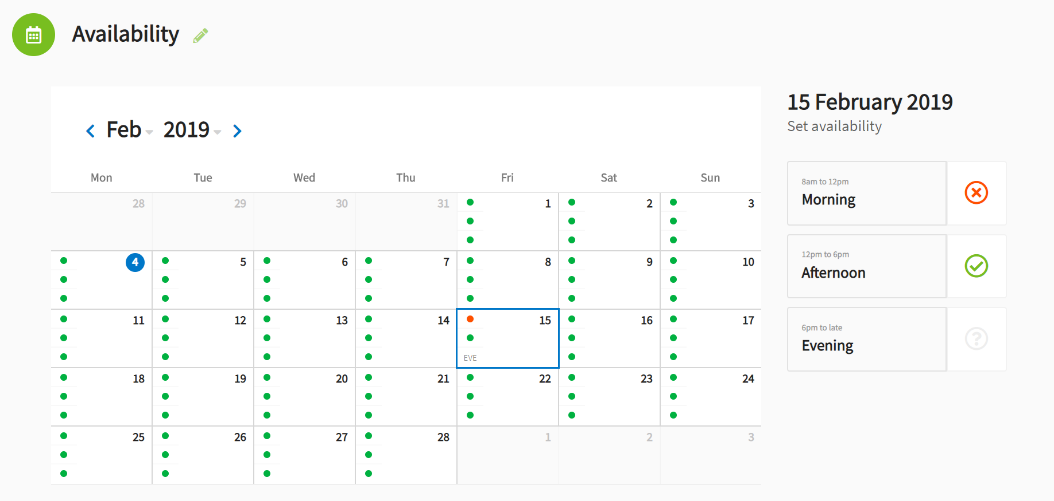

If you need to change your availability, go to your Assessor Dashboard (the home screen once logged in). Use the left mouse to click on the date you want change your availability for and a menu similar to the one you saw when setting your general availability will appear on the right side of the calendar. Each day is broken down into three session, morning, afternoon and evening.

When selecting your availability there are three options per session: available (green tick), unavailable (red cross) and negotiable (greyed out question mark).

You can also select multiple days, up to one month, by multi-selecting days on the calendar. To do this, hold down CTRL on your keyboard and left click the days you want edit and when the day session menu appears on the right of the screen, you can select the sessions for all highlighted days and they will change accordingly.

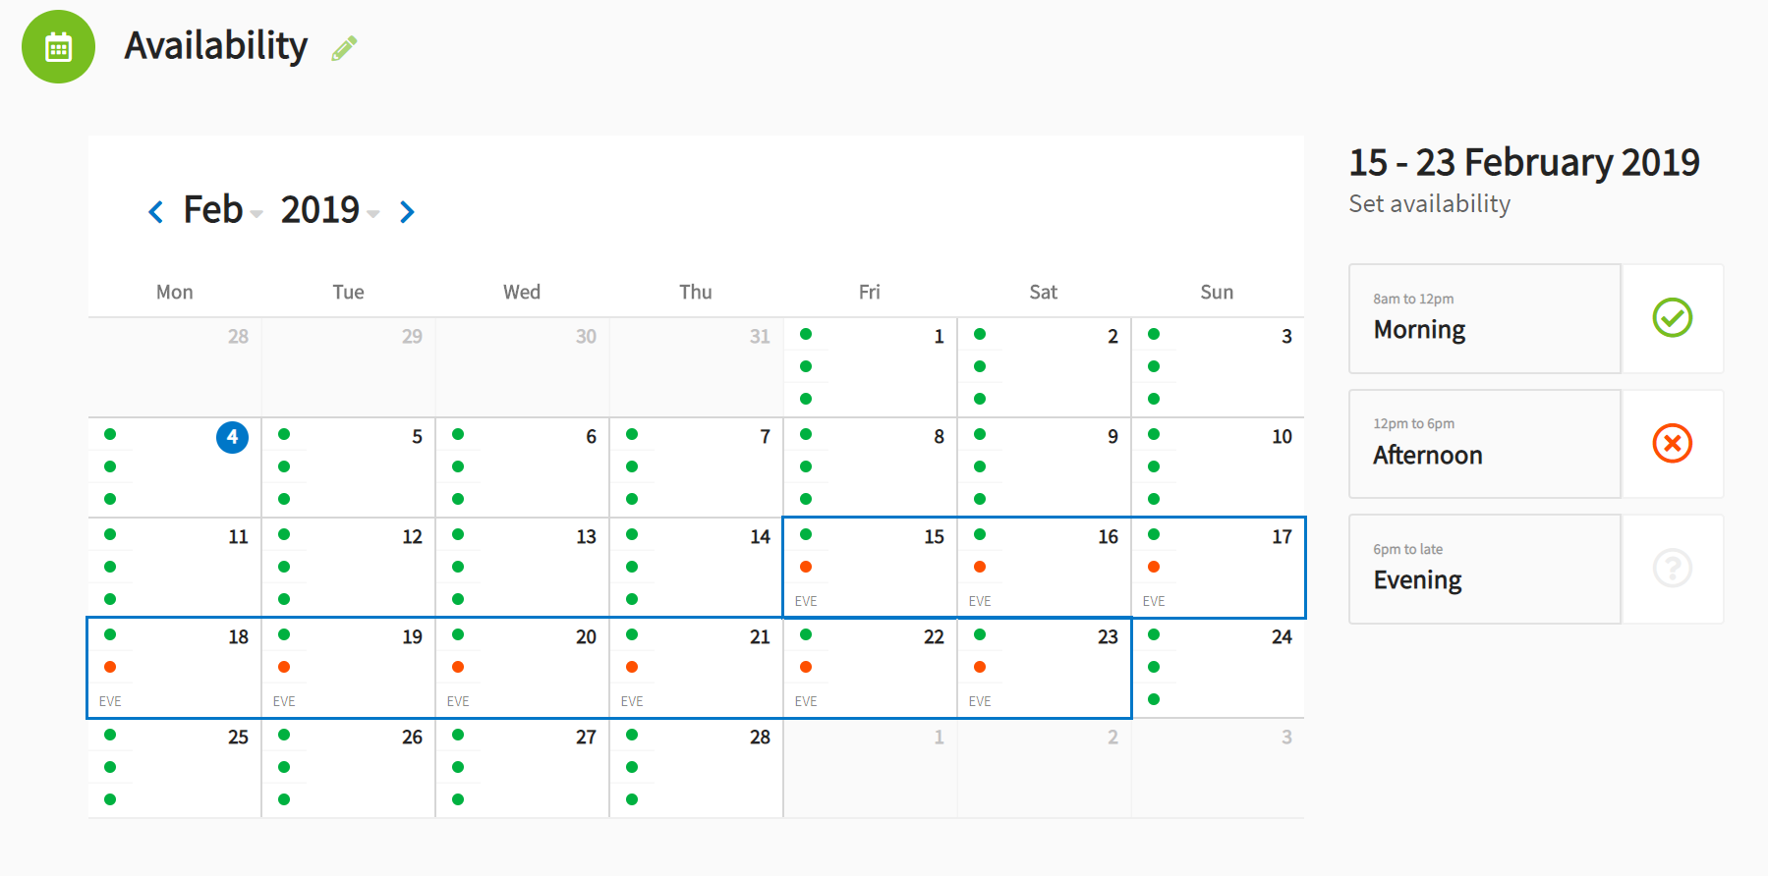

If you have previously accepted bookings for EPA events or have any training days, associate EPA meetings etc. please add these to your calendar as ‘unavailable’ to ensure you are not double booked.

Back page

Every effort has been made to ensure that the information contained in this publication is true and correct
at time of going to press. However, City & Guilds’ products and services are subject to continuous
development and improvement and the right is reserved to change products and services from time to time.
City & Guilds cannot accept responsibility for any loss or damage arising from the use of information in this publication.
©2018 The City & Guilds of London Institute. All rights reserved. City & Guilds is a trade mark of the
City & Guilds of London Institute, a charity established to promote education and training registered in
England & Wales (312832) and Scotland (SC039576).
1 Giltspur Street, London EC1A 9DD.
T +44 (0)20 7294 2468
F +44 (0)20 7294 2400
cityandguilds.com

