EPA Booking on Walled Garden
Adding Additional Info
Quick User Guide
When you are ready to add the additional
information required to complete an EPA
Booking, this guide will show you how to
access the relevant fields in Walled Garden

Quick User Guide

What mandatory information you will need to add/amend in an EPA booking for an Apprentice
on Walled Garden after placing an order.
To start | Order No
To complete  Employer tab | Employer Name (Street, Town & Postcode if need to create)
 | Employer Contact Name (+ Telephone number & Email if need to create)
 | EPA Venue Address (Street, Town & Postcode if need to create)
To complete  EPA Booking Info tab | Centre Contact Telephone Number
 | Centre Contact Email
 | EPA Event Contact Name
 | EPA Event Contact Telephone Number
 | EPA Event Contact Email
 | Access Arrangements, if any (non-mandatory)
 | Apprenticeship Start Date
 | Apprenticeship End Date
 | Funded/Unfunded

How to add/amend details for an EPA for an Apprentice on Walled Garden after placing an order

Log in to Walled Garden  Select Data Services | 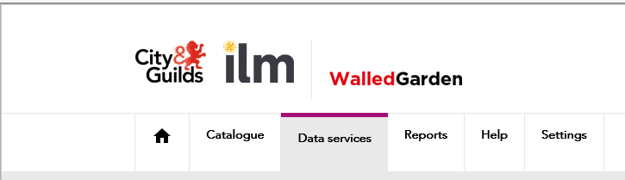

Under I want to: select EPA Employer Details  Search for order using period, date range or Order No  Click  Select Order No | 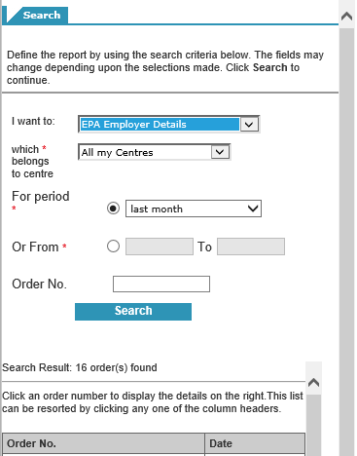
Order details are shown  Select individual candidate  or | 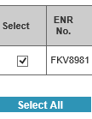
Click on  to enter Employer details | 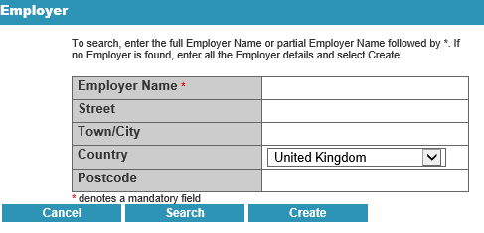
Click on  to enter other EPA Booking details | 