How to quickly identify if the apprentice has a working webcam:
When apprentice has clicked on GoToMeeting link
- Click the Camera icon to preview your feed.
- To change your camera device, click the Settings icon and use the Camera drop-down menu.
- To join the session with your camera on, click OK, I'm ready.
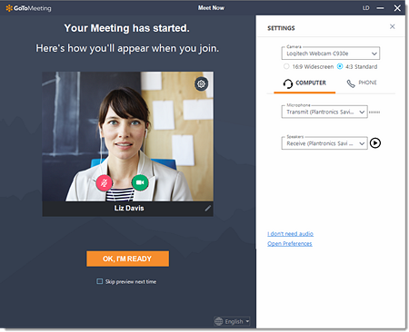
If they can see a preview, their webcam is working
How to preview your camera during the session
- While in a meeting, click the Settings (Cog) icon.
- A preview of your webcam will be displayed. You can use the drop-down menu to select a different webcam device and use the radio buttons to change the size. If you are on a Windows tablet, you may switch camera views from the front to the back view (and vice versa) with these radio buttons.
- To start sharing, click the Webcam icon at the bottom of GoToMeeting or in the Control Panel.
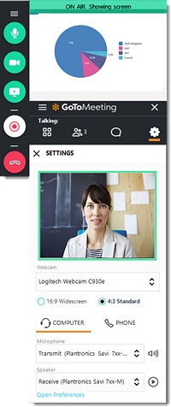
If they can see their preview, but unable to share their webcam, this could be due to local settings, restricting the webcam from being shared. This is not a GoToMeeting support enquiry follow the below steps:
What do they need to use the webcam for?
- To share their valid ID
So the quickest way to get around this is by:
- Ask the apprentice to stay on the event on their computer and join via GoToMeeting App, or using www.gotomeeting.com and entering the Meeting ID on their mobile device (Apple, Samsung, phones & tablets fully supported)
- Ask the IEPA to start recording this session
- The apprentice will be on the event twice this is fine, ask the learner to turn on their camera and the IEPA will need to determine whether they can accept the ID
- The apprentice can then disconnect on their mobile device

Test at any time (with the desktop app)
- Right-click on the Daisy (GoToMeeting Logo) icon in your system tray and click Preferences.
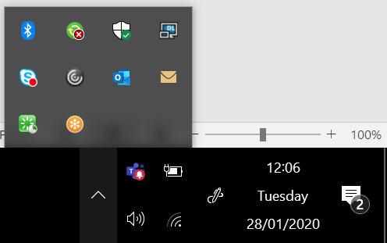
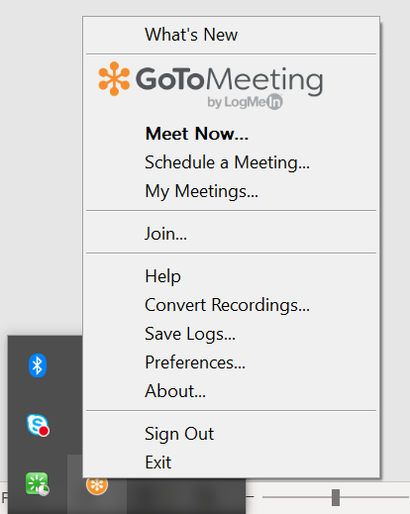
- Click Webcam in the left menu.
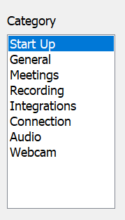

- If you have a webcam connected, a preview of your webcam will be displayed. You can use the drop-down menu to select a different webcam device and use the radio buttons to change the size.
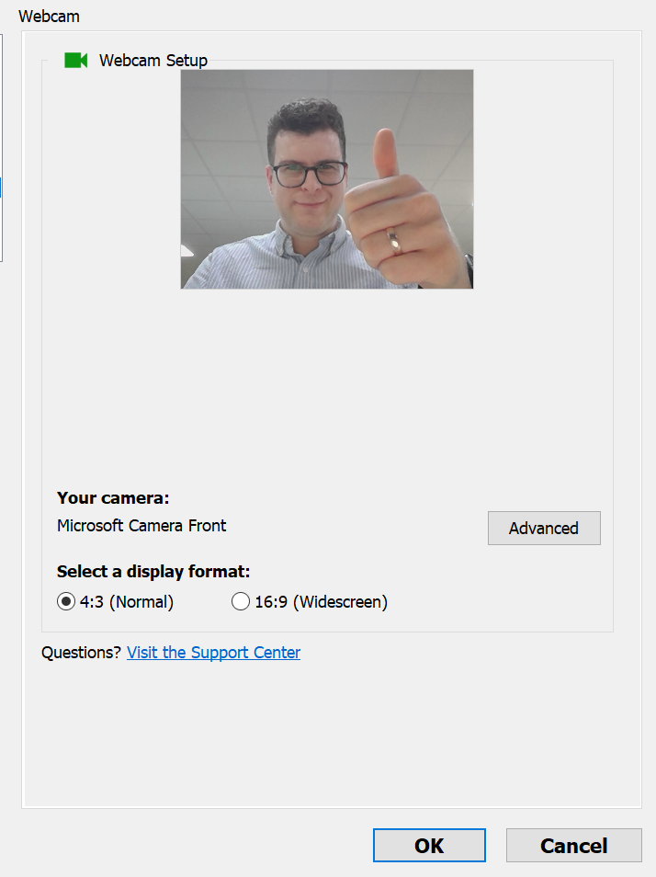
- Click Advanced if you'd like to open your webcam's software and control advanced settings
- Once set, click OK.

