Gateway declaration form: Key principles

- All three signatures must be present and dated.
- However, in response to the Covid-19 pandemic we are allowing those who cannot provide signatures to upload an employer email as an alternative (see below).
- Both pages must be completed and uploaded.
- Digital signatures will be accepted. However, we cannot process signatures which are simply typed in.
- There must be three unique signatures, unless the employer and training provider are one entity.
Covid-19 exemption
If a digital signature is not available, we will accept an employer email stating the learner is ready for EPA, as evidence to be uploaded in the Portal. Within this email the employer must state clearly that their apprentice is ready for their EPA event. We will also accept similar emails from an apprentice or training provider where they are unable to provide a signature.

What is a digital signature?
- A handwritten signature, which is scanned or photographed and transferred into the form.
- A signature generated through an online signature service.
- It is not a name typed into the form.
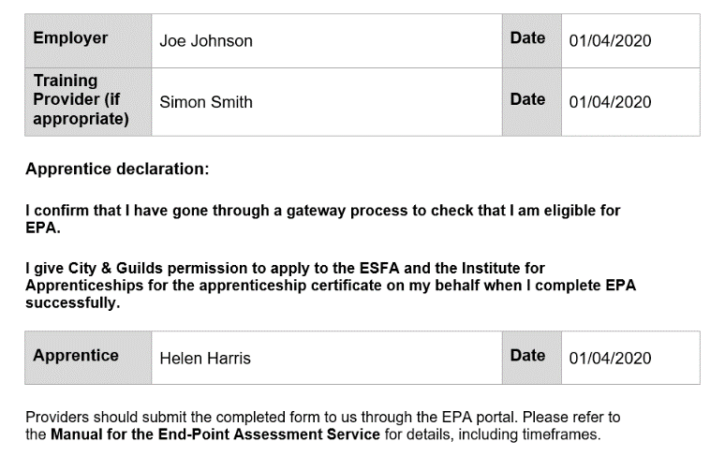
Handwritten signature
Handwritten and dated signatures will be processed.
Digital signature (typed)
We cannot accept any signature which is simply typed into the form.
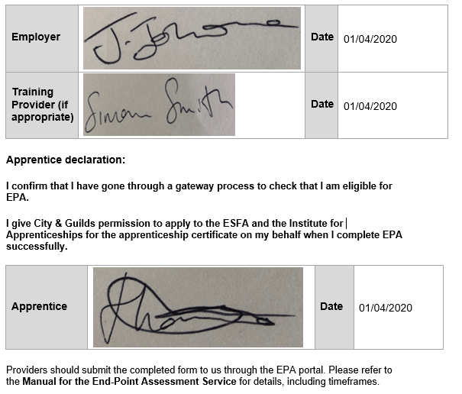
Digital signature (pasted)
Customers may provide a signature which has been copied and pasted directly into the gateway declaration form.
Handwritten signature (undated)
All forms must now be dated.

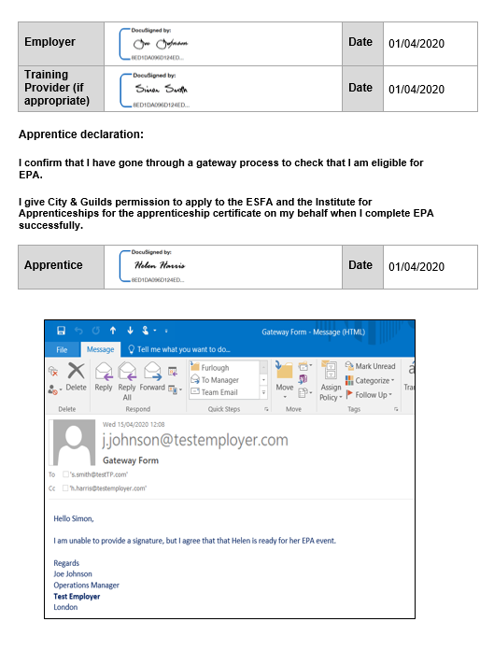
Email exemption (pasted)
Although the wording within the email is correct we are unable to process this form. Emails must be uploaded as a separate file in the EPA portal, and not pasted into the declaration form.
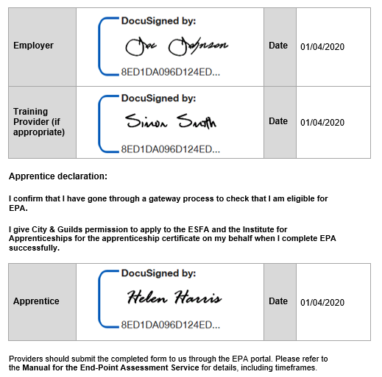
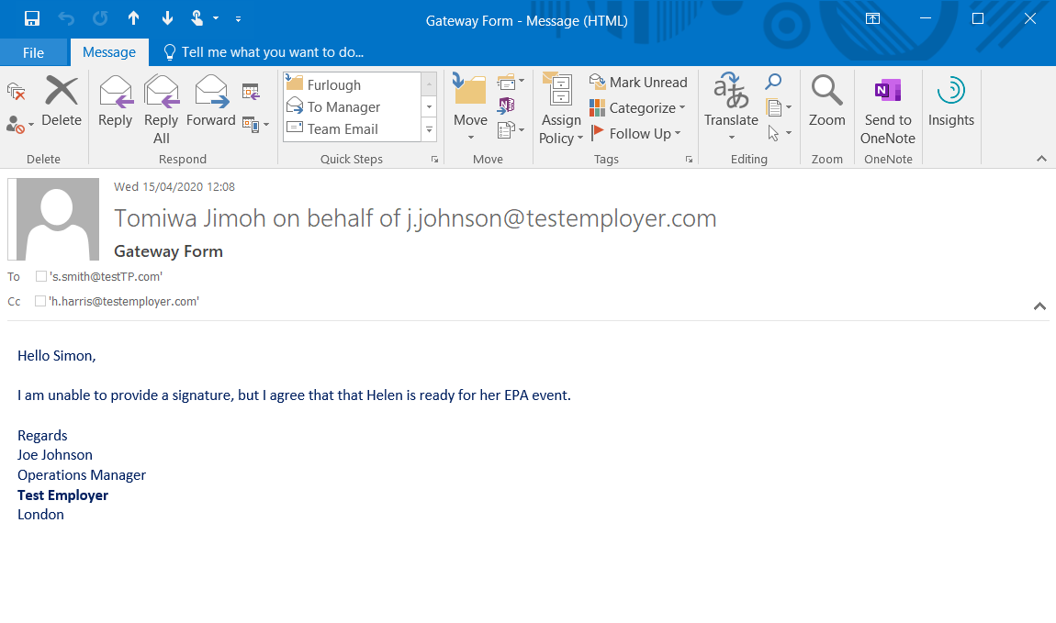
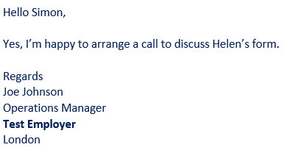
Digital signature (computer generated)
We will process signature created by an electronic signature service.
Email exemption (unclear)
We cannot accept this email as the employer hasn’t been clear about the apprentice’s readiness for her EPA event.
Email exemption
We are currently accepting a separate email uploaded directly to the EPA Portal. This should be from the employer, clearly stating the learner is ready for their EPA event.
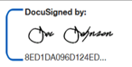
Duplicate signature
Where the training provider and employer are the one entity we will accept two signatures from the same individual.

