Remote Invigilation
GoToMeeting
Candidate Instructions

GoToMeeting working instructions

This document explains the use of GoToMeeting as a tool to invigilate remote on-screen assessments using City & Guilds on-screen e-assessment platform, e-volve.

Introduction.
GoToMeeting is an online meeting solution from LogMeIn. As a candidate you are not required to setup an account. You will be given the details of the online meeting by your invigilator/learning provider. All you will need to do is ensure you have the required equipment and a quiet, safe location where you can take your exam without being distracted.

You will need one computer with a webcam that faces you and a smart phone with a camera and the GoToMeeting app installed.

The minimum requirements can be found here

We recommend using Google Chrome web browser for the best user experience however you may need to allow Adobe Flash to run as the exam software utilises this. For information on how to enable Adobe Flash, please look here

Below we will explain the process, expectations and limitations of remote invigilation using GoToMeeting.

Process
Using GoToMeeting, you will be taking a remotely invigilated on-screen exam to the same standards that you would be had you been in a classroom or exam centre. You will be expected to confirm your ID and have a paper clear location where you can sit your exam.

The full exam conditions are displayed below

Prior to your exam date, your learning provider and/or invigilator will be in contact to confirm the details of the exam session. You will be sent an email with the meeting details within.

To successfully complete a remote invigilated exam session, the following steps need to take place
- Open the invite you were sent by your invigilator/learning provider and open the meeting URL
- Wait for the invigilator to start the meeting (if not already started)
- Request the invigilator to make you a presenter. It is important that you share Screen 1, this will mean the invigilator can see what is on your screen (use of multiple displays is forbidden)
- Set up your webcam, microphone and speakers/headphones
- Identify yourself using your webcam and appropriate ID using valid photo identification. The candidate can use their passport, driving licence or centre/employee ID badge
- Put your device into airplane mode and then just turn back on the wifi, (this is to prevent calls, WhatsApp message etc..) Set up your phone/tablet and join the same meeting session that you were emailed
- The invigilator needs to check you do not have access to any unauthorised materials. The invigilator must tell you to scan the room with your smart phone/tablet, until they are satisfied you have covered the whole room (fig 1). This should include checking the area behind the monitor, checking to ensure that no audio device is being used (hearing aids are permitted), that the area around the computer is clear and that any scrap paper is blank (fig 2)
- Place your phone/tablet in such a way as to give the widest angle of the room as possible, confirm with the invigilator that they are happy with the placement (fig 3)
- If you have a watch on, please place it on your work area
- The invigilator will check with you that you understand you are now under exam conditions and that you understand the requirements for the test
- Navigate to the evolve on-screen exam portal. This will be shared by your invigilator
- Enter your exam keycode and the invigilator will unlock the exam or give you a pin code.
- Confirm your details when prompted and start the test
- The exam takes place
- Once the exam is complete the invigilator will inform you when you can expect to receive your result. This will depend on the type of exam and the process at your place of learning. The meeting will then be ended by the invigilator

Fig 1 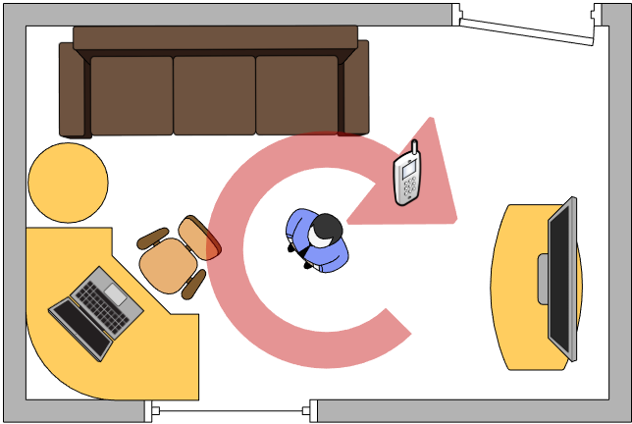
Fig 2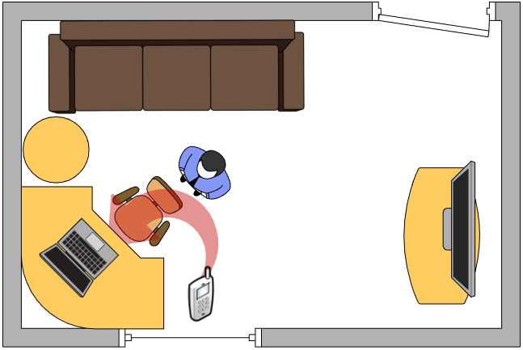
Fig 3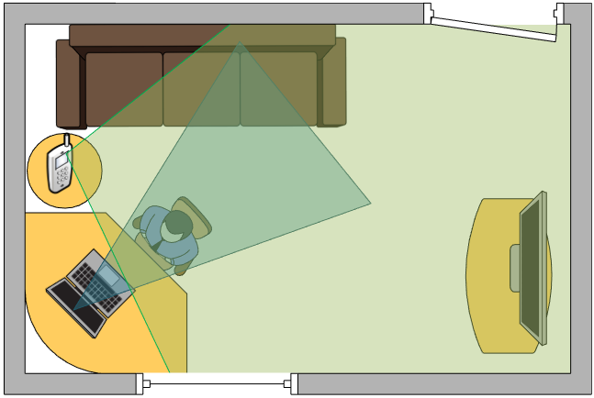

Your exam session should never be recorded.

Detailed instructions

Joining an invigilation session
You will have received an email from your invigilator/learning provider which has the details of the GoToMeeting session. Click on the link as shown below.
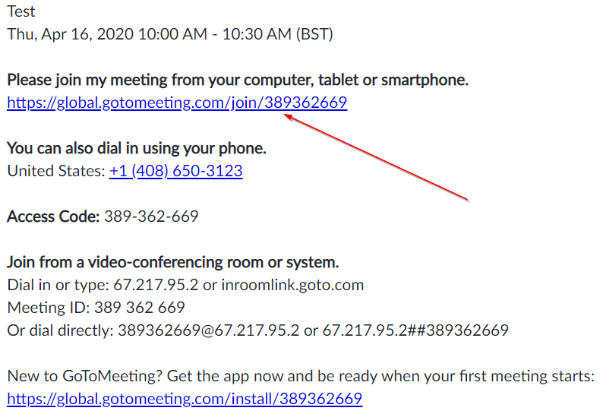

Once you click on the link you will have a few options depending on the browser you’re using. As stated above, we recommend Google Chrome for the best user experience. If you’ve used GoToMeeting before you may have the Chrome extension already installed and if so you will get the following message

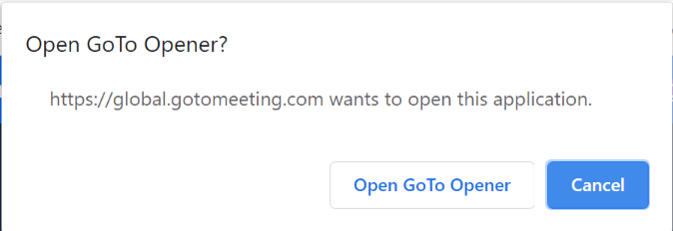
If you get the message above, click on Open GoTo Opener

If you only get the following messages, chose which option you prefer and follow the installation prompts.
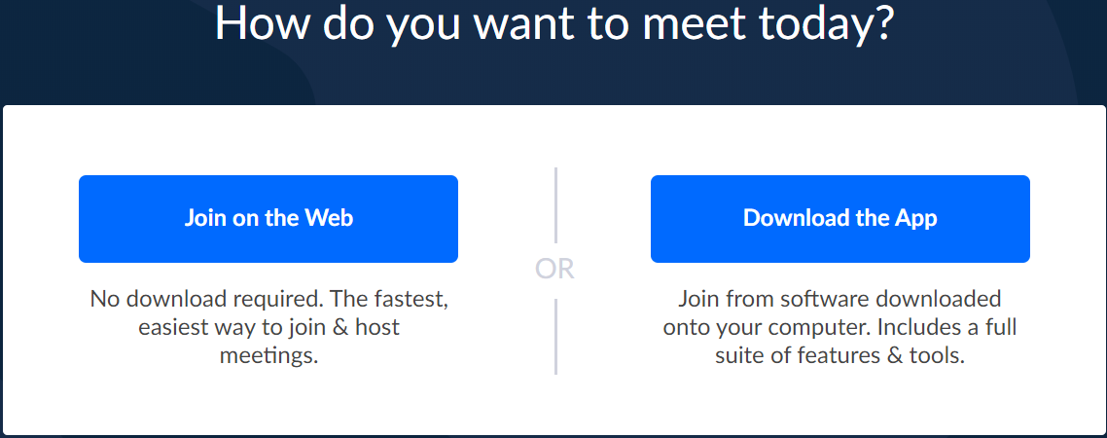
When you open the GoTo Opener you will see the initial settings for the meeting. This will allow you to set your microphone, speakers/headset and webcam.
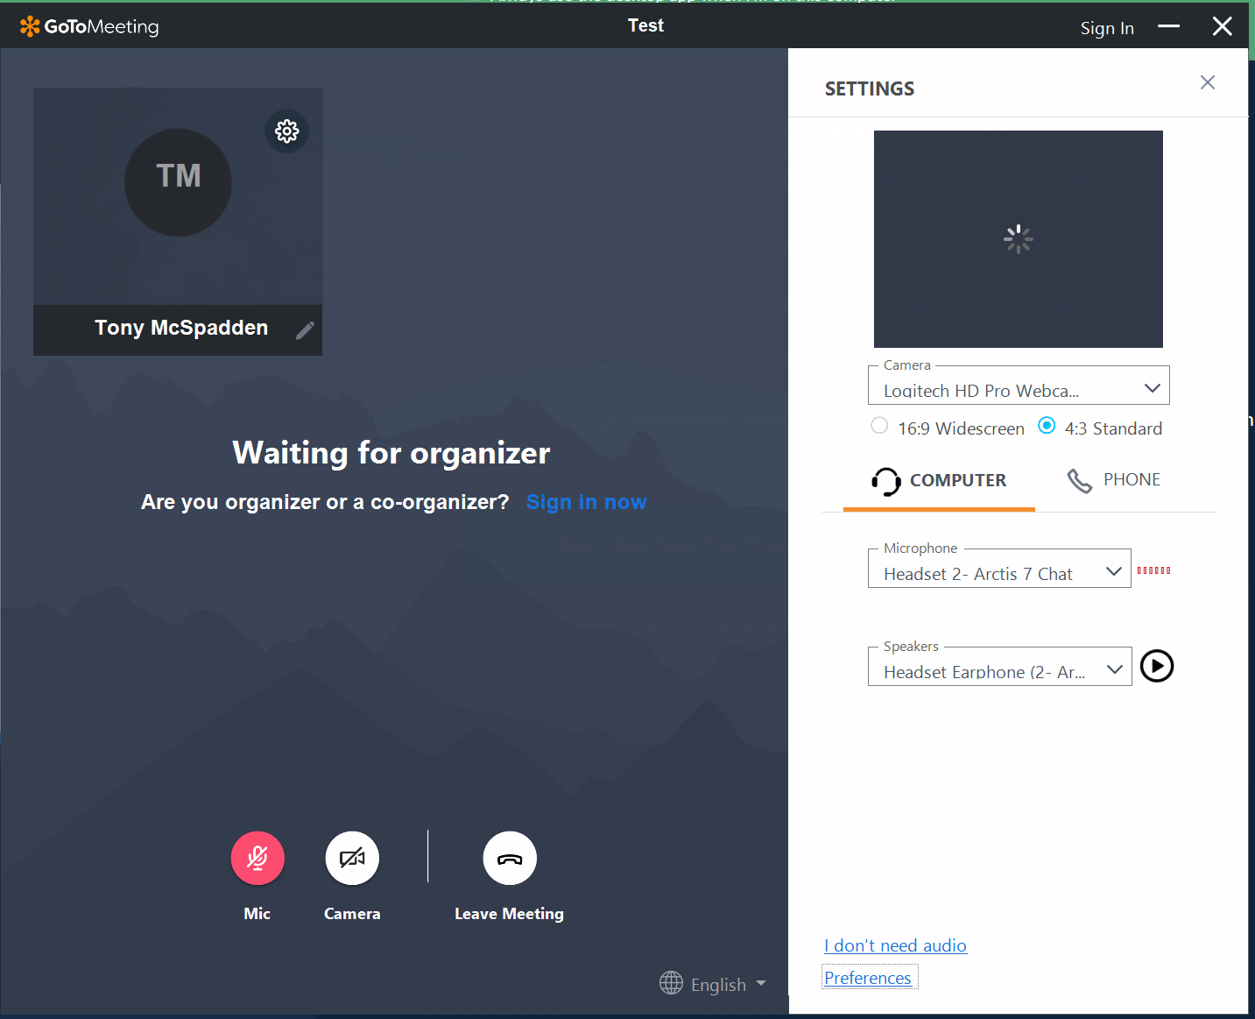

Once the invigilator has started the meeting, you will need to identify yourself by using your webcam and appropriate photo identification (passport, driving licence or place of work/college ID). You may need to verbally ask the invigilator to make you a presenter if they already haven’t. This will allow you to share your screen so the invigilator can monitor your progress through the exam. Once you share your screen (you may only have one screen on your computer) the invigilator will be able to see whatever is on your screen. Please ensure you share your desktop and not only the web browser as doing so may delay your exam session or end up invalidating your exam.

Setting up a second device for monitoring exam conditions
Using a mobile phone or tablet you will need to open the GoToMeeting app (download the GoToMeeting app from the relevant app store) and log into the meeting with the same meeting ID you received for the remote invigilated exam session. Once you have entered the meeting details ensure your camera is active and that the invigilator can see both your cameras and an acceptable angle of the room.

Finishing your remote invigilation session
Once you have concluded your test, you will need to confirm with the invigilator that you are finished and the invigilator will finish the online meeting. This will disconnect both your computer and phone/tablet meeting sessions.

Every effort has been made to ensure that the information contained in this publication is true and correct
at time of going to press. However, City & Guilds’ products and services are subject to continuous
development and improvement and the right is reserved to change products and services from time to time.
City & Guilds cannot accept responsibility for any loss or damage arising from the use of information in this publication.
©2019 The City & Guilds of London Institute. All rights reserved. City & Guilds is a trade mark of the
City & Guilds of London Institute, a charity established to promote education and training registered in
England & Wales (312832) and Scotland (SC039576).
5-6 Giltspur Street, London EC1A 9DE.
cityandguilds.com

