Remote Invigilation
GoToMeeting Invigilation Instructions

GoToMeeting working instructions

This document explains the use of GoToMeeting for the invigilation of remote on-screen assessments using City & Guilds on-screen e-assessment platform, e-volve.

Introduction.
GoToMeeting is an online meeting solution from LogMeIn. You are required to set up an account with GoToMeeting and depending on the browser you use, install a desktop app or web browser extension.

The minimum requirements can be found here
The installation guide can be found here
Further details of invigilation standards and conditions can be found here

We recommend using Google Chrome web browser for the best user experience

Once you have installed the software either through the desktop app or web extension, you are ready to invigilate candidate exams remotely.

Below we will explain the process, expectations and limitations of remote invigilation using GoToMeeting.

Process
Using GoToMeeting, you will be required to invigilate to the same standards as you would if you were in a room with the candidate. The candidate will be required to dial into the meeting on two devices, one to capture their face for identification and screen sharing purposes and another device to show the room that the candidate is in. This will allow you to ensure the candidate is safe, not receiving outside assistance during the exam or reading from pre-prepared documentation.

Scheduling an invigilation session
Log onto GoToMeeting and click on the Create Meeting button
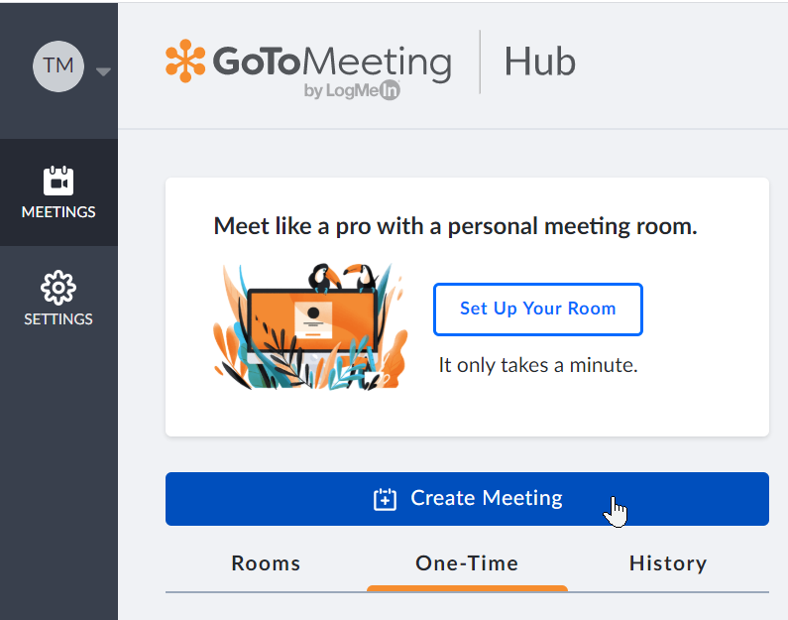

Fill in the details and select the relevant date and time for the online invigilation session and click Save.
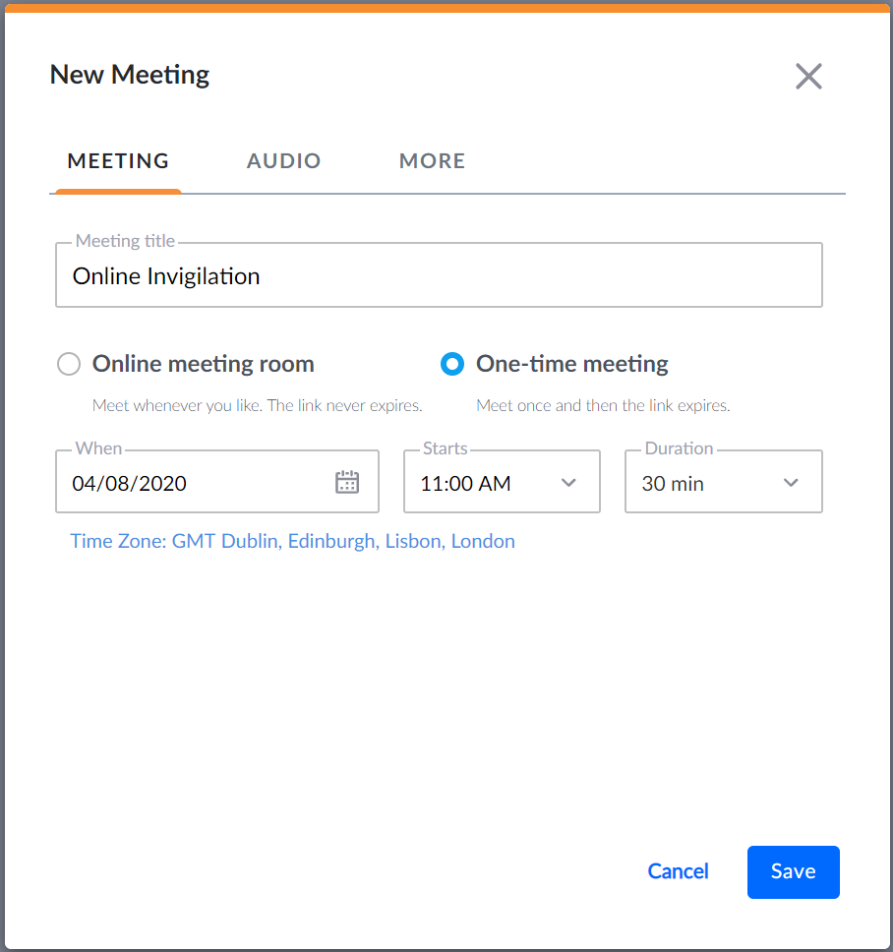

You will now be directed back on your GoToMeeting home screen where you can see your meeting details. The meeting is now arranged, the next step is to share the link with the candidate.
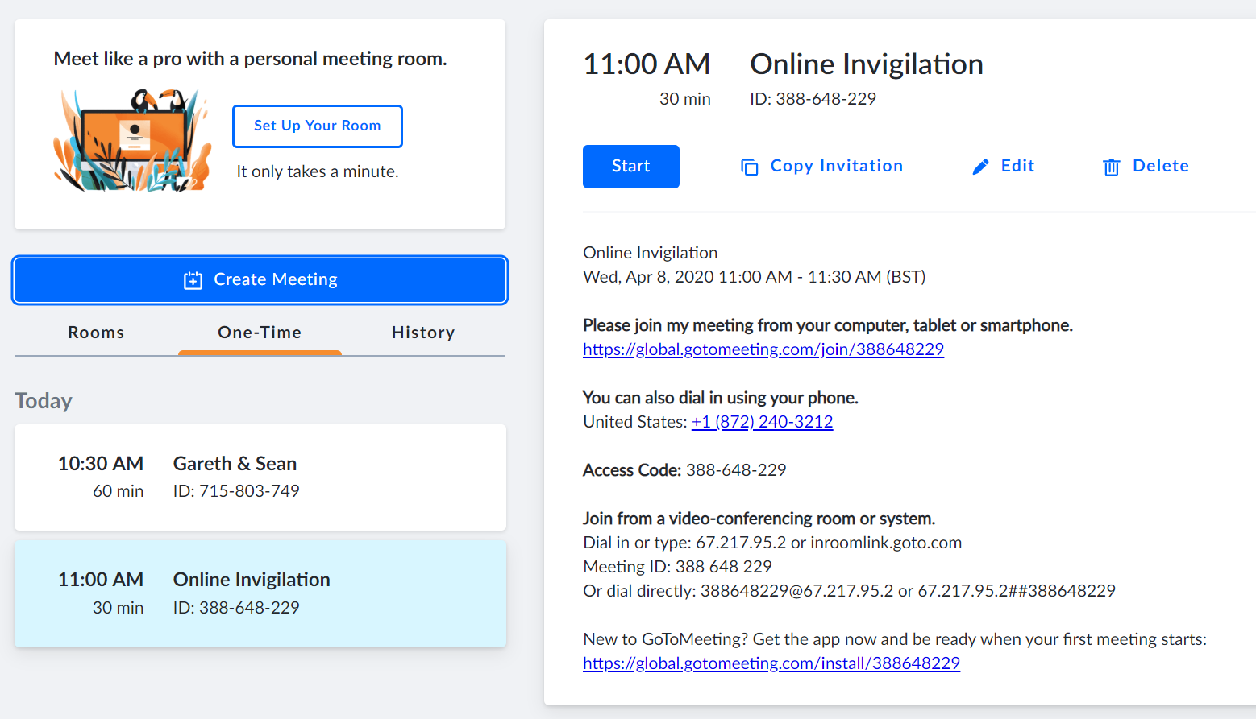

On the invitation, there is a Copy Invitation option, click this.
Open your chosen Email client e.g. Microsoft Outlook and click New Email and then paste the copied email invitation into your email and send to the candidate.
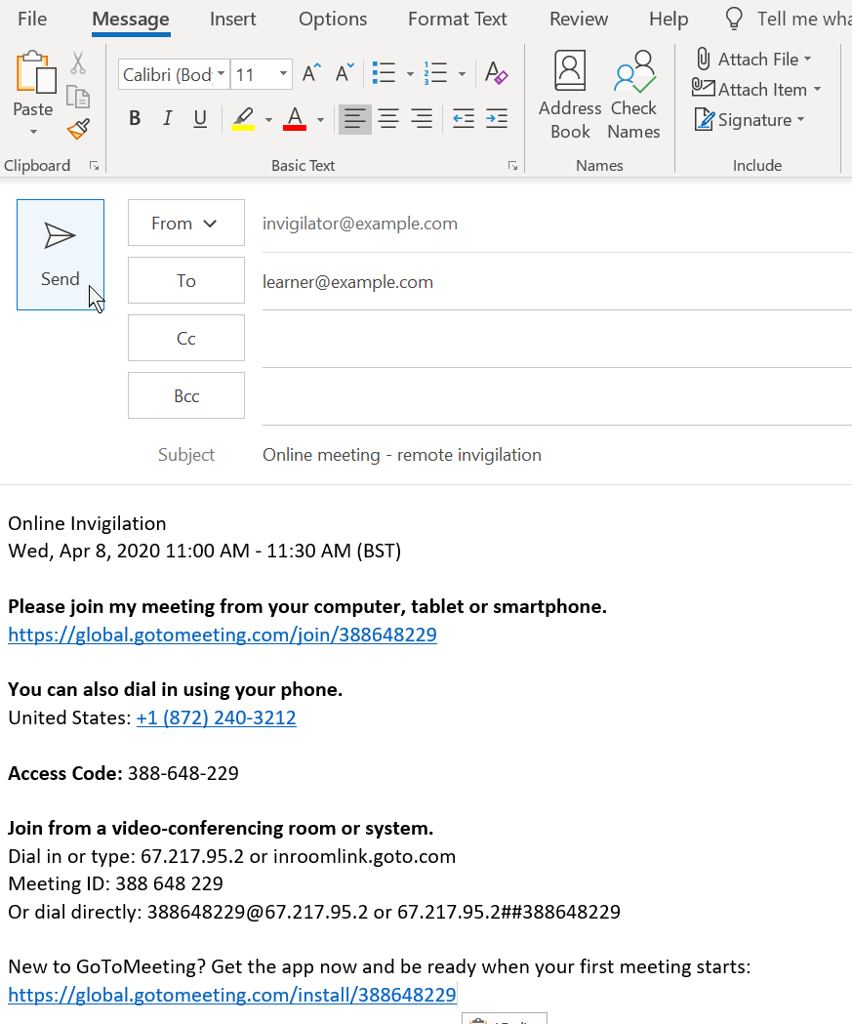

Please ensure you follow up with the candidate to ensure the agreed date and time is correct, that they have access to equipment that meets the minimum technical requirements and that they valid ID for the invigilated session.

Starting the remote invigilation session – Overall process
To successfully invigilate the exam session, the following steps need to take place
- The invigilator logs onto GoToMeeting and starts the relevant GoToMeeting session (this is covered in detail, below)
- The candidate joins the GoToMeeting session
- The invigilator makes the candidate a Presenter to allow screen sharing
- The candidate shares their screen
- The candidate turns on their webcam
- The candidate should identify themselves using valid photo identification. The candidate can use their passport, driving licence or centre/employee ID badge
- The candidate logs on to the GoToMeeting session on their mobile phone/tablet and start their phone/tablet camera if it doesn’t start automatically
- The invigilator needs to check the candidate does not have access to any unauthorised materials. The invigilator must tell the candidate to scan room with their smart phone/tablet, until they are satisfied they have covered the whole room (fig 1). This should include checking the area behind the monitor, checking for any sort of audio device that the candidate is wearing (hearing aids are permitted), that the area around the computer is clear and that any scrap paper is blank (fig 2)
- The candidate should place their phone/tablet in a location that gives as wide an angle of the room as possible (fig 3)
- If the candidate is wearing a watch, they should be asked to remove it and place it on their desk
- The invigilator should ask the candidate to confirm they understand the requirements of the test and that they are now under exam conditions
- The invigilator takes a screen shot showing their GoToMeeting screen, two views of the candidate and screen share
- The invigilator shares the URL of the on-screen exam software, e-volve
- The invigilator reads out the keycode of the exam and the candidate enters their exam keycode and the invigilator either unlocks the exam or reads out the exam pin code
- The candidate confirms their details and starts the exam
- Once the candidate has finished, the invigilator will inform the candidate when they can expect their result. This may depend on the type of exam and/or the process at your centre. If unsure, ask the candidate to contact their centre contact for confirmation. Once done, the invigilator ends the meeting and exits GoToMeeting

Fig 1 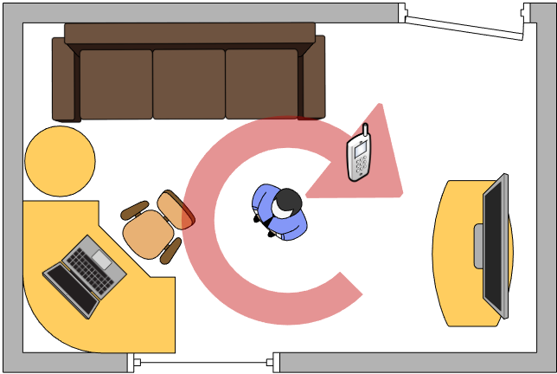
Fig 2 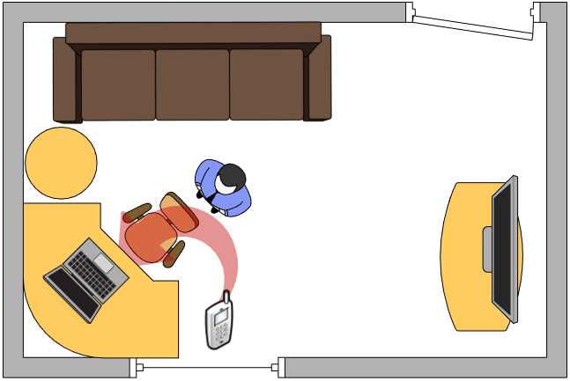
Fig 3 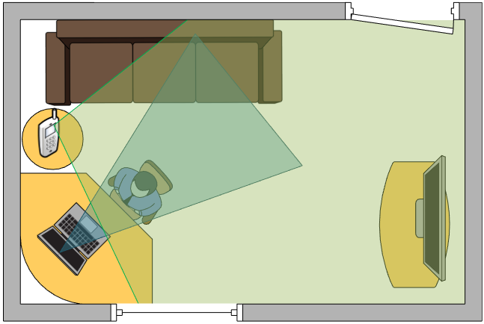

Under no condition should the exam session be recorded.

Starting the GoToMeeting session
Log into GoToMeeting and start the relevant meeting. You will be prompted to choose an audio option, for best user experience, computer audio is preferred. Now wait for the candidate to join. Once the candidate has joined you should give the candidate presenter rights, as shown below and ask them to ID, display their room setup and mobile phone/tablet.

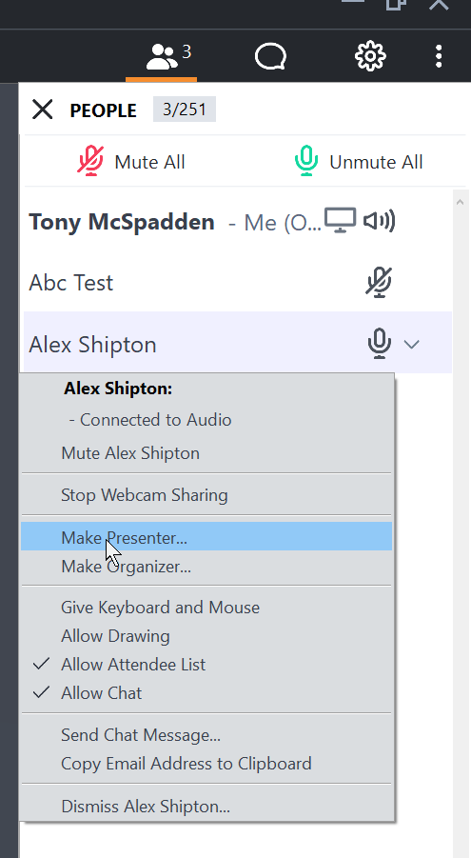
Once the meeting is setup, you should see a similar screen to below, showing two views of the candidate and what is on their screen. Please take a screen shot and save with your records.

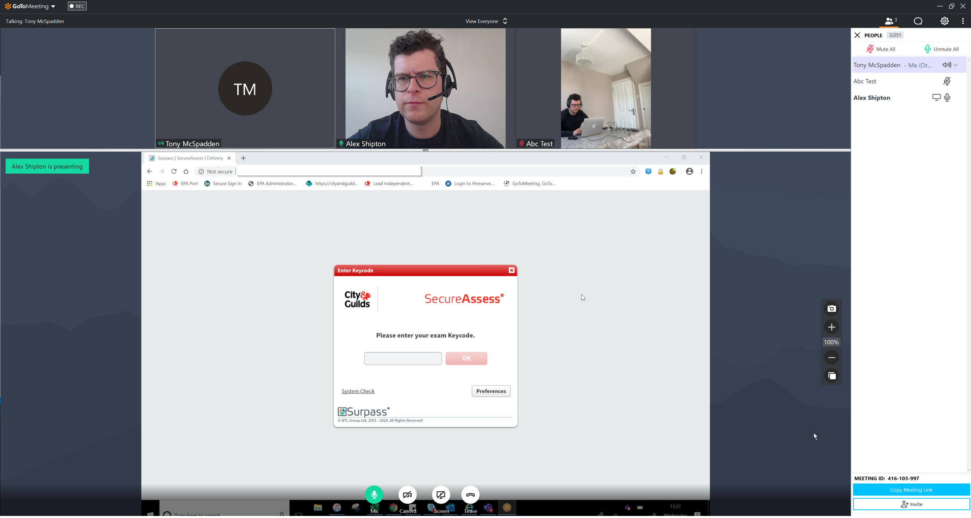

Once the exam session is over end the meeting session by clicking on the Leave meeting button.
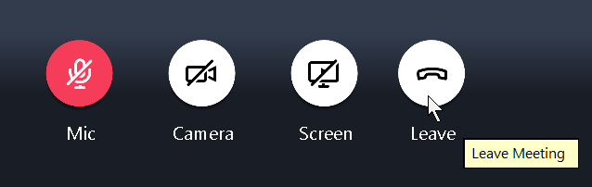

Every effort has been made to ensure that the information contained in this publication is true and correct
at time of going to press. However, City & Guilds’ products and services are subject to continuous
development and improvement and the right is reserved to change products and services from time to time.
City & Guilds cannot accept responsibility for any loss or damage arising from the use of information in this publication.
©2019 The City & Guilds of London Institute. All rights reserved. City & Guilds is a trade mark of the
City & Guilds of London Institute, a charity established to promote education and training registered in
England & Wales (312832) and Scotland (SC039576).
5-6 Giltspur Street, London EC1A 9DE.
cityandguilds.com

