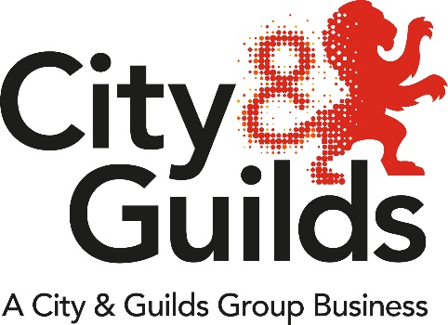
Emma and I would like to say a big welcome back to you.

The team here at City and Guilds hope that you all managed to have some time out from the COVID-19 pandemic.

This year has resulted in loss of education and training during the spring and summer terms with some public health restrictions put in place with the hair and beauty sector.

You may know that Ofqual recently published VQT mitigation consultation 2020/21, this consultation is:
- to identify mitigations to the impact of coronavirus (COVID-19) on teaching and learning in 2019/20, and any potential impact in 2020/21, in relation to the assessment of regulated qualifications in 2020/21
- As soon as we here from Ofqual, IF there will be any mitigation or flexibilities for this academic year.
So, for now, it is business as usual, we are looking forward to supporting you through 2020/2021 academic year.

Best Wishes
Sarah & Emma

Upcoming Webinars

Day | Month | Year | Start time | End time | Topic | gotowebinar link
8 | 9 | 20 | 9am | 10am | Hair & Beauty Industry England | https://attendee.gotowebinar.com  /register/3252500939123737101
9 | 9 | 20 | 4pm | 5pm | Hair & Beauty Industry England | https://attendee.gotowebinar.com  /register/3725009464090784269
16 | 9 | 20 | 4pm | 5pm | Hair & Beauty Industry  Wales | https://attendee.gotowebinar.com  /register/2367348998764365836
22 | 9 | 20 | 9am | 10am | Hair & Beauty  Technical qualification Support | https://attendee.gotowebinar.com  /register/6049748680139447565
23 | 9 | 20 | 4pm | 5pm | Hair & Beauty  Standards Support | https://attendee.gotowebinar.com  /register/3454966109774133773
1 | 10 | 20 | 2pm | 2.30 pm | Get 2 Gateway | https://attendee.gotowebinar.com/register/3543957282834659340
13 | 10 | 20 | 9am | 10am | Hair & Beauty Industry England | https://attendee.gotowebinar.com  /register/4146882180063846413
14 | 10 | 20 | 4pm | 5pm | Hair & Beauty Industry  Scotland | https://attendee.gotowebinar.com  /register/4266159400468235533

There are other webinars planned for Autumn 2020, such as End Point Assessment, Adult Education Budget, Technicals plus keep in touch webinars.
Please sign up for email alerts to receive regular updates.
https://www.cityandguilds.com/what-we-offer/centres/email-updates

Mitigation
England: VRQ and NVQ assessment mitigations. Link here.
Scotland: SVQ assessment mitigation. Link here.

Apprenticeship update
Restrictions will be lifted for the remaining “Close Contact Services” in England as of 15th August 2020.

This means, we are open for bookings for our Hair Professional – Barbering and Beauty Therapist End-Point Assessment as from Monday 17th August 2020. This does not apply to areas where there are current local lockdowns. Link here for further information:

Traineeships
Supporting the economic recovery from Covid-19 the government announced further funding opportunities for traineeships link here

Rules of Combination – 2020/21
The new version of the Hair and Beauty Rules of Combination document for August 2020 is now available to download here

Provider support - Covid-19 – returning to the workplace and staying safe
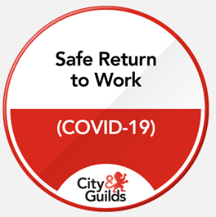

This free e-learning module enables individuals with essential health and safety knowledge for a safe return to the workplace and receive a digital credential.

Click on the digital credential badge to take our free course.

Supporting you through the current crisis
With the COVID-19 outbreak presenting an unprecedented set of challenges for all of us, we’re continuing to work closely with other organisations. Whilst we’re unable to offer any face-to-face networks or meetings for now, we have adapted the format and content of these to make them available as webinars and online meetings, please contact us direct for dedicated support.

Funding
Information to help you understand the eligibility rules for the different types of funding the government offers to improve skills. Link here.

Associate Vacancies
There are a variety of contracted associate roles you may wish to apply for, such as, an Independent End-Point Assessor, External Quality Assurer or Moderator. Find out more about the opportunities and how to apply below.

For information and to apply for LIEPA and IEPA roles, please visit
https://careers.cityandguildsgroup.com/associate-vacancies

For information and to apply for Technical Moderator roles, please visit
https://careers.cityandguildsgroup.com/associate-vacancies/moderators/

We’re here to help

Unrivalled experience and expertise from City & Guilds

Your hair & beauty team at City & Guilds has a wealth of experience. Technical Advisor, Sarah Fillaudeau, spend the bulk of her time working directly with providers delivering City & Guilds qualifications and other products.

Sarah works closely with Industry Manager Emma Mackay, who oversees City & Guilds’ entire portfolio of hair & beauty products and services.

Sarah Fillaudeau
Technical Advisor for Hair & Beauty

Email: sarah.Fillaudeau@cityandguilds.com
M: +44 (0) 7717851613
Emma Mackay
Industry Manager for Hair, Beauty, Retail & Creative
Email: emma.mackay@cityandguilds.com
M: +44 (0) 7525590183

Newsletter
We have a library of previous newsletters and support
Beauty Therapy link here
Hairdressing link here

Every effort has been made to ensure that the information contained in this publication is true and correct at time of going to press. However, City & Guilds’ products and services are subject to continuous development and improvement and the right is reserved to change products and services from time to time.

City & Guilds cannot accept responsibility for any loss or damage arising from the use of information in this publication.

©2020 The City & Guilds of London Institute. All rights reserved. City & Guilds is a trade mark of the City and Guilds of London Institute, a charity established to promote education and training registered in England & Wales (312832) and Scotland (SC039576).
Giltspur House, 5-6 Giltspur Street, London EC1A 9DE.

