`1 Giltspur Street
London
EC1A 9DD
T +44 (0)20 7294 2468
F +44 (0)20 7294 2400
www.cityandguilds.com

Every effort has been made to ensure that the information contained in this publication is true and correct at time of going to press.
However, City & Guilds products and services are subject to continuous development and improvement and the right is reserved to change
Products and services from time to time. City & Guilds cannot accept liability for loss or damage arising from the use of information in this publication. City & Guilds is a registered charity established to promote education and training.

 | Hairdressing, Barbering, Beauty, Media Make-up, Nail Services and Complementary Therapies
Qualification Number | Qualification Number 3001, 3002, 3003, 3004, 3007, 3011, 6911, 5450, 7607, 6002, 6003, 6004, 6008, 6010, 6009, 6011, 7002
News

September 2017

Contents

- Hairdressing & Barbering competition at Salon International (London) October 2017
- Technical Qualification Handbook updates
- Technicals – Exam timetable
- Technicals – Tips to get started!!
- Network Events for Hair & Beauty Technicals
- 7002 Hair Professional Apprenticeship – Important information regarding changes to evidence requirements
- Network Events for Hair & Beauty Apprenticeship Standards (England)
- End Point Assessment Services
- Network meetings in Northern Ireland
- Network meetings in Dublin
- Prison Focus Group meeting
- Smartscreen Resources
- NEW beauty employer/industry webpages
- Generic events ‘Preparing your Apprentice for End Point Assessment’

Hairdressing & Barbering competition at Salon International (London) October 2017

Calling all students or trainees in Hairdressing & Barbering

LADIES COMMERCIAL FASHION LOOK
This competition is open for all students & trainees that have a Level 2 or working towards Level 2 in Hairdressing. Round 1 please complete the application form and submit photographic evidence of your finished look. If you’re successful you will then be entered into Round 2 which will be held at Salon International on Monday 16th October, where you will need to recreate your look on the competition floor. The Colour will need to be completed prior to the day of the competition and you will have 45 minutes to blow dry your ladies commercial fashion look.
One entry per person
the image must be between 2MB and 5MB in size
Deadline: 3rd October 2017
Enter Now | Terms & Conditions

MEN'S CUT & FINISH COMPETITION
This competition is open for all students & trainees that have a Level 2 or working towards Level 2 in Hairdressing or Barbering. Round 1 please complete the application form and submit photographic evidence of your finished look. If you’re successful you will then be entered into Round 2 which will be held at Salon International on Monday 16th October, where you will need to recreate your look on the competition floor. You will have 45 minutes to cut & finish your look.
One entry per person
the image must be between 2MB and 5MB in size
Deadline: 3rd October 2017
Enter Now | Terms & Conditions

For more information please follow the link http://salonshow.co.uk/site/competitions

Technicals
Technical Qualification Handbook updates
Level 3 Beauty updates to Qualification handbooks
In response to feedback from our valued centres and in line with our policy on continual improvement, we have reviewed the unit content in the following qualifications in accordance with best practice assessment principles to ensure they are reliable, accessible and valid.

6004-30 Complementary Therapies unit 303 Knowledge of anatomy, physiology and pathology. Updated handbook and record of changes can be found on page 4 here
6003-30 Beauty and Spa Therapy. Updated handbook and record of changes can be found on page 4 here

Exam Timetable
Please follow the link below to view the updated Technical Qualification Examination timetable. http://www.cityandguilds.com/~/media/Documents/delivering-quals/exams-and-administration/Technicals%20timetable%202018%20v1.1%2030%20Aug%202018%20pdf.ashx
Other useful resources:
- Welcome pack - all information to support your delivery and booking requirements please follow this link to access all support resources http://www.cityandguilds.com/techbac/technical-qualifications/resources-and-support

- Synoptic assignments – proposed go live date 18th September 2017, you are able to access passwords via walled garden
- Teaching learning and assessment guide – http://www.cityandguilds.com/~/media/techbac/documents/deliver/J392637CG1419TeachingLearningAssessmentGuidePRINT%20pdf.ashx

Technicals – Tips to get started!!

1. Dates for their diaries – give learners both test dates, so they can have both in their diaries.
2. Split knowledge delivery into “what you need to know” and “putting theory into practice”
3. What you need to know?
a. Refer to test specification in Qualifications handbooks
b. What is critical knowledge that cannot be observed through a practical performance? Focussing on the why more than the what
c. Command verbs – what do we mean by State, List, Describe, Explain and Discuss – please refer to Teaching & Learning Guide.
d. Keep referring to key terminology during practical sessions so the candidates hear the words constantly, e.g. Anatomy & Physiology, Environmental & Sustainable working practices
e. At the start of every lesson give a couple of recap understand type questions.
f. Get learners to read the question thoroughly, get them to highlight key words within each question.
g. Use scenario/contextualised examples in your teaching to prepare learners for these style of questions.
h. Refer to Chief examiners reports on City & Guilds website, of where previous candidates have struggled (knowledge, understanding & types of questions)
ï. Start to teach learners the different question styles from day 1; they need to understand what the question is asking and how much detail is needed.
4. Building practical skills and putting theory into practice?
a. Refer to and use the Principal Moderators report and sampler assignments
b. Get learners to evaluate their performance from day 1, pair learners up with a “critical buddy” get them to take short videos of each other performance, especially during consultation and aftercare. By watching their performance back helps them to critique their performance.
ï. Did I have good body language?
ii. Did I use open and closed questions?
iii. Did I smile and make eye contact with my client?
iv. How was my time management?
v. Did anything go wrong and why?
vi. How can I improve?
c. Constantly checking learners understanding during their practical, why, why, and why?

Network Events for Hair & Beauty Technicals
City & Guilds will be holding a series of Hair & Beauty Technical Network Events to support with the delivery and preparation for end testing.
Agenda
- Qualification update
- Exam guides (subject specific), including test specifications, command verbs and question types
- Preparing for the end knowledge test – good practice – hints & tips
- Test dates
- Formative Assessments/mock assessments
- Synoptic Assessments
- Optional Units

Dates
Venue | Date | Time | Book your place
London | 4th December | 9.30 – 12.00 | https://www.eventbrite.co.uk/e/city-guilds-london-hair-and-beauty-ks5-technicals-regional-network-meeting-registration-37201212829
Cardiff | 5th December | 9.30 – 12.00 | https://www.eventbrite.co.uk/e/city-guilds-cardiff-hair-and-beauty-ks5-technicals-regional-network-meeting-registration-37202146622
Warrington | 6th December | 9.30 – 12.00 | https://www.eventbrite.co.uk/e/city-guilds-warrington-hair-and-beauty-ks5-technicals-regional-network-meeting-registration-37202875803
Wakefield | 7th December | 9.30 – 12.00 | https://www.eventbrite.co.uk/e/city-guilds-wakefield-hair-and-beauty-ks5-technicals-regional-network-meeting-registration-37203645104
London | 11th December | 9.30 – 12.00 | https://www.eventbrite.co.uk/e/city-guilds-london-hair-and-beauty-ks5-technicals-regional-network-meeting-registration-37204256934
Webinar | 12th December | 9.30 – 11.00 | https://www.eventbrite.co.uk/e/city-guilds-webinar-hair-and-beauty-ks5-technicals-regional-network-meeting-registration-37275477958
Brighton | 4th January | 9.30 – 12.00 | https://www.eventbrite.co.uk/e/city-guilds-brighton-hair-and-beauty-ks5-technicals-regional-network-meeting-registration-37841065646
Warrington | 11th January | 9.30 – 12.00 | https://www.eventbrite.co.uk/e/city-guilds-warrington-hair-and-beauty-ks5-technicals-regional-network-meeting-registration-37720731724
Wakefield | 16th January | 9.30 – 12.00 | https://www.eventbrite.co.uk/e/city-guilds-wakefield-hair-and-beauty-ks5-technicals-regional-network-meeting-registration-37275175052
Warrington | 17th January | 9.30 – 12.00 | https://www.eventbrite.co.uk/e/city-guilds-warrington-hair-and-beauty-ks5-technicals-regional-network-meeting-registration-37275332523
Durham | 18th January | 9.30 – 12.00 | https://www.eventbrite.co.uk/e/city-guilds-durham-hair-and-beauty-ks5-technicals-regional-network-meeting-registration-37618576174
London | 24th January | 9.30 – 12.00 | https://www.eventbrite.co.uk/e/city-guilds-london-hair-and-beauty-ks5-technicals-regional-network-meeting-registration-37275396715
Salt Ash | 30th January | 9.30 – 12.00 | https://www.eventbrite.co.uk/e/city-guilds-salt-ash-hair-and-beauty-ks5-technicals-regional-network-meeting-registration-37621412658
Bristol | 31st January | 9.30 – 12.00 | https://www.eventbrite.co.uk/e/city-guilds-bristol-hair-and-beauty-ks5-technicals-regional-network-meeting-registration-37622065611

Further network meetings to support delivery and assessment of Technicals
Exam team network – these events will support exam teams with booking of all external assessments and exams. Planned for Oct/Nov 2017
Principal moderator’s standardisation network meetings – these events will support the standardisation of marking and provide useful sample materials, hints & tips to support the delivery of synoptic assignments. Planned for Jan/Feb 2018

Please check the events calendar throughout the year for dates and booking. http://www.cityandguilds.com/what-we-offer/centres/improving-teaching-learning/events

7002 Hair Professional Apprenticeship
Important information change to evidence requirements.
Apologies, it has been raised by Habia & the NHF that there has been an oversight on the employer’s occupational brief on Unit 4B – Creatively set and dress hair. After checking back with the employers on the group, the Qualification handbook has now been amended, but I have highlighted the changes below. The logbook will be corrected for the next print run, but we have uploaded the amended unit onto the website. http://www.cityandguilds.com/qualifications-and-apprenticeships/hairdressing/hairdressing/7002-diplomas-for-the-hair-professionalshairdressing-and-barbering#tab=documents#

Amended range
From the range, you must show that you have:
- used all creative set and dress techniques
- used all the types of tools and equipment
- used a 3 out of 4 temporary added hair
- taken into account all factors
- used 4 out of the 8 products
- used a 4 out of 5 setting techniques
- used all sectioning and winding techniques
- used all dressing techniques and effects
- given all advice and recommendation

Network Event for Hair & Beauty Apprenticeships - ENGLAND
To support with the preparation for End point assessment, City & Guilds will be holding a series of Network Events
Agenda
- Update Level 2 Beauty Professional standard
- Hair Professional - preparing Apprentices for EPA
- Grading Criteria
- Update on Level 3 Hair & Beauty
Dates
Venue | Date | Time | Book your place
London | 4th December | 1.00 – 3.00 | https://www.eventbrite.co.uk/e/city-guilds-london-hair-and-beauty-apprenticeship-standards-regional-network-meeting-registration-37275588288
Warrington | 6th December | 1.00 – 3.00 | https://www.eventbrite.co.uk/e/city-guilds-warrington-hair-and-beauty-apprenticeship-standards-regional-network-meeting-registration-37275954383
Wakefield | 7th December | 1.00 – 3.00 | https://www.eventbrite.co.uk/e/city-guilds-wakefield-hair-and-beauty-apprenticeship-standards-regional-network-meeting-registration-37276039638
Newcastle | 10th December | 9.30 – 12.00 | https://www.eventbrite.co.uk/e/city-guilds-newcastle-hair-and-beauty-apprenticeship-standard-regional-network-meeting-registration-37387767820
London | 11th December | 1.00 – 3.00 | https://www.eventbrite.co.uk/e/city-guilds-london-hair-and-beauty-apprenticeship-standard-regional-network-meeting-registration-37308210863
Webinar | 12th December | 1.00 – 3.00 | https://www.eventbrite.co.uk/e/city-guilds-webinar-hair-and-beauty-apprenticeship-standards-regional-network-meeting-registration-37308292106
Brighton | 4th January | 1.00 – 3.00 | https://www.eventbrite.co.uk/e/city-guilds-brighton-hair-and-beauty-apprenticeship-standards-regional-network-meeting-registration-37841533044
Warrington | 11th January | 1.00 – 3.00 | https://www.eventbrite.co.uk/e/city-guilds-warrington-hair-and-beauty-apprenticeship-standards-regional-network-meeting-registration-37720746769
Wakefield | 16th January | 1.00 – 3.00 | https://www.eventbrite.co.uk/e/city-guilds-wakefield-hair-and-beauty-apprenticeship-standards-regional-network-meeting-registration-37275235232
Warrington | 17th January | 1.00 – 3.00 | https://www.eventbrite.co.uk/e/city-guilds-warrington-hair-and-beauty-apprenticeship-standards-regional-network-meeting-registration-37308487691
Durham | 18th January | 1.00 – 3.00 | https://www.eventbrite.co.uk/e/city-guilds-durham-hair-and-beauty-apprenticeship-standards-regional-network-meeting-registration-37618933242
London | 24th January | 1.00 – 3.00 | https://www.eventbrite.co.uk/e/city-guilds-london-hair-and-beauty-apprenticeship-standards-regional-network-meeting-registration-37314423445
Salt Ash | 30th January | 1.00 – 3.00 | https://www.eventbrite.co.uk/e/city-guilds-salt-ash-hair-and-beauty-apprenticeship-standards-regional-network-meeting-registration-37621587180
Bristol | 31st January | 1.00 – 3.00 | https://www.eventbrite.co.uk/e/city-guilds-bristol-hair-and-beauty-apprenticeship-standards-regional-network-meeting-registration-37622151869

End Point Assessment Services
City & Guilds new EPA page is also up and running with associated forms and information about becoming an End point assessment centre.
http://www.cityandguilds.com/apprenticeships/emerging-standards/end-assessment-service

Network meeting in Northern Ireland
26th October – 2pm – 4pm Belfast
To book your place please follow this link
https://www.eventbrite.co.uk/e/city-guilds-belfast-hair-and-beauty-regional-network-meeting-registration-37683294749

Network meetings in Dublin
27th October – 11am – 1pm
To book your place please follow this link
https://www.eventbrite.co.uk/e/city-guilds-dublin-hair-and-beauty-regional-network- meeting-registration-37736924156

Prison Focus Group meeting
5th February 2018 – City & Guilds London
To book your place please follow this link
https://www.eventbrite.co.uk/e/city-guilds-london-prison-hair-and-beauty-focus-group-network-meeting-registration-37841715590

Smartscreen Resources
The following SmartScreen packages are now available for purchase on Walled Garden:

- Title: Level 2 Hairdressing (supports 6002 and 6008)
  - Price: £350
  - Code: SS122222

- Title: Level 2 Barbering (enhanced)
  - Price: £850
  - Code: SS222222

- Title: Level 3 Hairdressing (supports 6002 and 6008)
  - Price: £350
  - Code: SS133333

- Title: Level 3 Barbering (enhanced)
  - Price: £850
  - Code: SS333333

- Title: Level 2 Diploma for Hair Professionals – Hairdressing (7002)
  - Price: £350
  - Code: SS700202-L2

- Title: Level 2 Diploma for Hair Professionals – Barbering (7002)
  - Price: £850
  - Code: SS700203-L2

- Title: Level 2 Beauty Therapy (enhanced)
  - Price: £850
  - Code: SS6003-L2

NEW Beauty industry web pages

Our new beauty employer webpages are now launched!!

You can find the pages here: http://www.cityandguilds.com/qualifications-and-apprenticeships/beauty-and-complementary-therapies#fil=uk

These pages will help to support you with your induction of learners choosing to enter the career path within this industry area.

We have included;

- An introduction to the beauty employer industry advisory board and why it is important to both C&G and the industry
- Links to professional associations/membership bodies along with logos and hyperlinks to websites
- Employer logos with hyperlinks to employer relevant webpages
- Employer/Industry Board Member photographs and bios

Barbering and hairdressing industry pages are also underway so watch this space!!

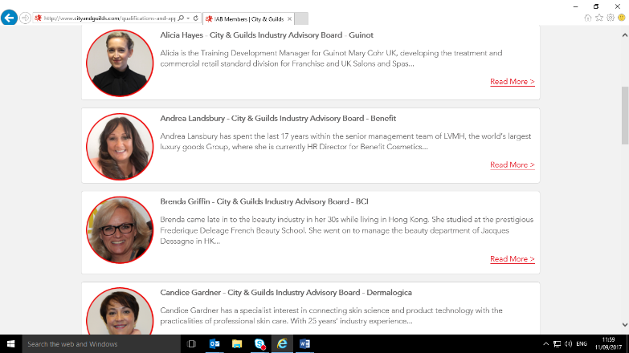
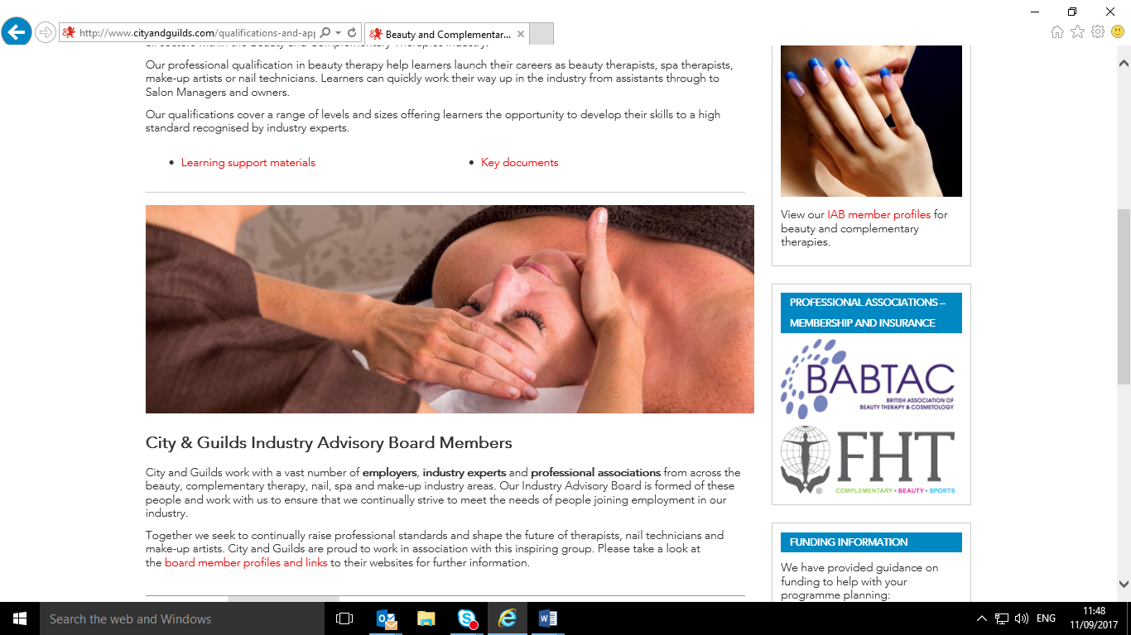

Generic events ‘Preparing your Apprentice for End Point Assessment’
Preparing your Apprentice for End Point Assessment As part of our continued support for the sector we are running a series of national quality improvement events aimed at all vocational sectors delivering new apprenticeship standards and EPA with City & Guilds.
This day of engaging practical activities, aims to provide ideas for further developing your individual and centre practice when working with new apprentices and employers.
The event is aimed at: Assessors/ Trainers, Curriculum Managers, IQAs, Apprenticeship/WBL Managers, Quality Managers and others who may have a teaching, learning and/or assessment role within the delivery of the new apprenticeship standards. Employers are also welcome to attend.
This workshop delivered over one day will cover the key themes of:
- Reviewing your current centre practice in respect of the new apprenticeship standards and related delivery
- Understanding the importance of EPA planning and preparation in the apprenticeship learner journey
- Understanding the difference and importance of 'holistic', 'formative' and 'summative' assessment strategies with the apprentice and the employer
- Exploring how apprentices can learn to 'show-case' their knowledge, skills and behaviours in front of a stranger
- Unpacking good practice in exams, tests/MCQs including marking, grasp of command verbs and providing developmental feedback to the apprentice
- Exploring 'top tips' for professional discussion, projects and portfolios which form part of the EPA process
- Understanding the City & Guilds approach and process of EPA and Grading
Individual prices at our open events: £150 per delegate
We also offer ‘Preparing your Apprentice for End Point Assessment’ as an In-house event. This means you can hold this event on your own premises, on your chosen date for up to 25 delegates. Our expert facilitator will customise your session to the specific needs of your staff, offering a uniquely tailored CPD experience.
Available in-house for up to 25 delegates: £2000
If you are interested in running this event in-house please email advance@cityandguilds.com for an application form, or with any queries you may have.
Did you know that we also run a programme of scheduled CPD events throughout the year in various locations? Full details on these events can be found here:
http://city-and-guilds.eventbrite.co.uk
http://www.cityandguilds.com/what-we-offer/centres/what-is-advance/CPD-training

Date | Location – City and Guilds offices | Eventbrite link
11th October 2017 | London  5-7 Giltspur Street  London  EC1A 9DD | https://preparing_for_epa_london.eventbrite.co.uk
17th October 2017 | Wakefield  4 Red Hall Court, Paragon Business Village  Wakefield,  West Yorkshire  WF1 2UN | https://preparing_for_epa_wakefield.eventbrite.co.uk
19th October 2017 | Warrington  Unit 4 Firecrest Court, Centre Park, Warrington,  Cheshire  WA1 1RG | https://preparing_for_epa_warrington.eventbrite.co.uk
1st November 2017 | Warrington  Unit 4 Firecrest Court, Centre Park, Warrington,  Cheshire  WA1 1RG | https://preparing_for_epa_warrington_nov.eventbrite.co.uk
8th November 2017 | London  5-7 Giltspur Street  London  EC1A 9DD | https://preparing_for_epa_london_nov.eventbrite.co.uk
16th November 2017 | Wakefield  4 Red Hall Court, Paragon Business Village  Wakefield,  West Yorkshire  WF1 2UN | https://preparing_for_epa_wakefield_nov.eventbrite.co.uk

