All about Business
Issue 2
March 2019
A newsletter from City & Guilds on education updates in the Business sector for all nations.

In this issue:

- Network meeting thanks and next meetings
- Customer Service Apprenticeships
- On-programme optional qualification update
- Level 3 Business Administrator Enhanced Smartscreen
- Apprenticeship Advice
- New EPA Exemplar materials
- Technicals Top Tips
- Our Technicals offer
- Qualifications Cross boundaries
- AEB catalogue
- Functional Skills Reforms 2019
- CPD Events 2019
- Keep in touch and up to date

Network meeting thanks

A special thank you to all the colleges who hosted network meetings throughout 2018. These include:

Leicester College,
Telford College,
Leyton Neighbourhood Centre,
Sunderland College,
Harlow College,
Lambeth College,
Honda Institute, Bracknell,
City of Plymouth College,
Bishop Auckland College

Additional thanks to all those colleges, training providers and consultants who attended and provided me with feedback for how to support you next.

We are always looking to support you as much as possible and are therefore constantly planning events. With this in mind, if any centers can offer to host please contact Dom at dominic.green@cityandguilds.com.
Keep a look out for upcoming events on Twitter and LinkedIn.

Our next event is 21st March 2019 and is kindly hosted by Runshaw College. As a City & Guilds customer our network events are free to attend. Register below via Eventbrite

https://www.eventbrite.co.uk/e/city-guilds-cust-service-pract-bus-admin-epa-network-runshaw-college-tickets-56471074504

Customer Service Specialist Level 3 Apprenticeship

Our Customer Service Specialist (9494) Level 3 offer is now up and running. To support the apprentices’ on programme journey we have several key documents in place on our website. We also have the Apprenticeship Training Manual at level 3 which can be accessed on our SmartScreen platform.
Download our Customer Service Specialist factsheet for a brief overview of the standard.

Please click HERE to follow the link to our website to find out more.

We have also produced a level 3 Diploma in Customer Service (2794-03) which is mapped across to the 9494 level 3 standard. Please click HERE to find out more about our Customer Service Diploma.

Customer Service Practitioner Level 2 Apprenticeship

Having listened to our customers we are now in the process of updating our EPA Assessment Pack for Centres which can be located on the City & Guilds website. This will offer further support and will be available very soon. We will also be hosting a Customer Service Practitioner Webinar which will provide feedback, hints and tips with regards to preparing for the End Point Assessment.

On- Programme Optional Qualification Update

2794-02 Customer Service Practitioner qualification is now available. The qualification has been developed to align to the Customer Service Practitioner Apprenticeship Standard.

2794-03 New Customer Service Specialist qualification is also now available. The qualification has been developed to align to the Customer Service Specialist Apprenticeship Standard.

https://www.cityandguilds.com/qualifications-and-apprenticeships/business-skills/customer-service-and-contact-centre/2794-diploma-for-customer-service#tab=information&acc=level2

3473-03 New Business Administrator Qualification is now available. The qualification has been developed to align to the Business Administrator Apprenticeship Standard.

https://www.cityandguilds.com/qualifications-and-apprenticeships/business-skills/business-admin-and-public-services/3473-level-3-diploma-for-the-business-administrator#tab=information

Business Administrator Level 3 Enhanced Smartscreen

The long-awaited Business Administrator Enhanced Smartscreen package is now available to order from the walled garden using the code shown below.
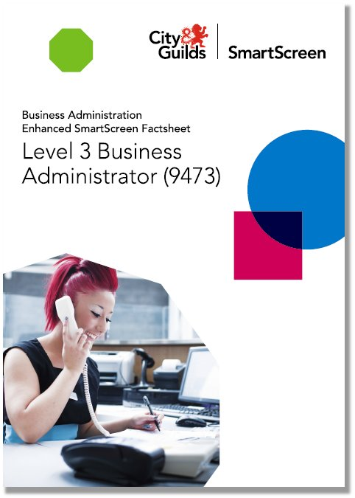

Level 3 Business Administrator Enhanced SmartScreen (9473)
Price: £850 (annual subscription) Code: SS9473-03lev
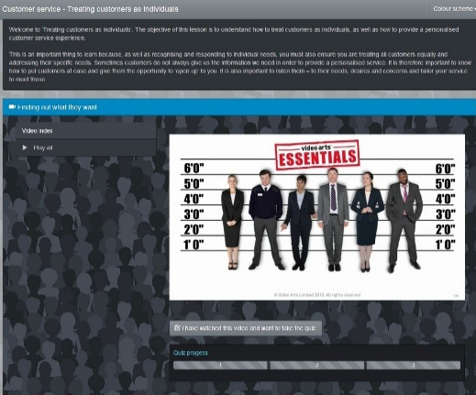
el 3 Business Administrator Enhanced SmartScreen package is now available for purchase on Walled Garden. Level 3 Business Administrator Enhanced SmartScreen (9473) Price: £850 (annual subscription) Code: SS9473-03

Apprenticeship Advice

Each issue we intend to give some additional information and advice on apprenticeship delivery to support both our centres and our employers. This issue is focused around the Business Administrator Level 3 standard.

- Use the EPA handbook (found under the documents tab, see below) to ensure you teach all the required knowledge for the evolve test in the 9473 Business Administrator standard.

- The learner must complete the Knowledge test first when completing the Business Administrator EPA.
- Access the sample question paper on our website (see screenshot above)

Our exemplar materials are only available after registering your learners with City & Guilds. They are specific to both the Customer Service Practitioner and Business Administrator standard. They are accessed via our SmartScreen platform under the EPA Preparation tab. Please contact centresupport@cityandguilds.com if you have any queries.

Alongside our exemplar materials we also have our preparation tool platform which is designed to be accessed by apprentices in order to develop their soft skills.

Click HERE for more information.

Technicals Top Tips

Each month we will be bringing you all the updated information as it is available for delivery as well as some top tips.

- Ensure you understand the synoptic requirements for this year for each technical qualification you are delivering. (passwords available on walled garden/same as last year).
- Decide who will be uploading your documentation to the moderation portal and give yourself time to do this. The date this needs to be completed by is the19th May 2019.
- Embed English skills and common verbs into all lessons.

Our Technicals offer

The Level 2 Technical Certificate in Business Support and the Level 3 Advanced Technical Diploma in Coordinating Business Support are aimed at learners aged 16 -18; 19+.

Are you T-Level ready? Our Technical offer in Business Support is the perfect stepping stone towards the upcoming T-Levels.

Learners interested in the Level 3 Advanced Technical Diploma in Coordinating Business Support (540) will study theoretical aspects of the subject and apply them to practical tasks. Learners will develop an understanding of business systems and the skills needed to coordinate business support activities including transferable skills such as communication, project management and IT. Learners would also gain an understanding of key functional areas of business, including marketing, finance, human resources together with the support services they need to be effective.

For further information access our website here

Qualifications Cross Boundaries

This leaflet gives a comparison of levels of qualifications from England, Scotland, Wales and Northern Ireland

Download leaflet here

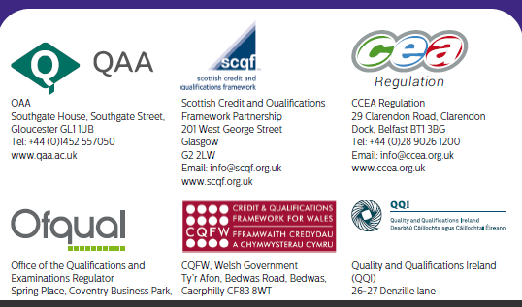
.

AEB Funding catalogue

Please see the current AEB catalogue to make full use of all funding available to you. View the Business Admin & Law tab and filter accordingly.

Adult Education Budget funded qualifications (AEB)

Functional Skills Reforms 2019

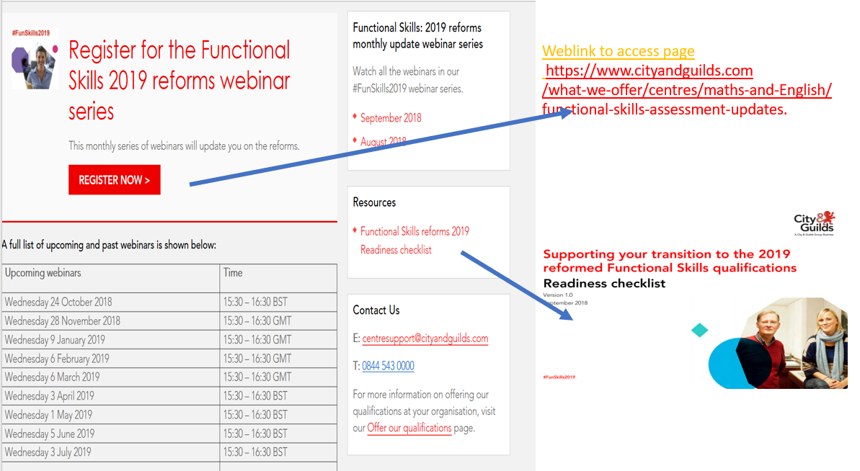
CPD Events 2018/19

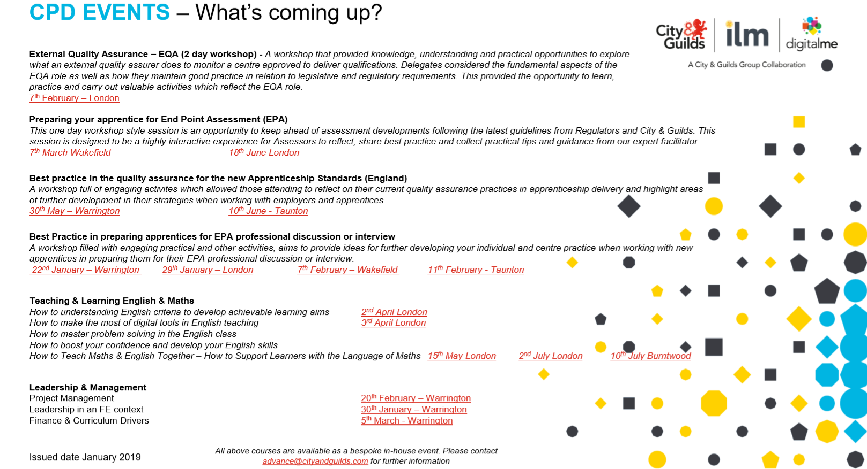
Lead Independent End Point Assessor report (LIEPA)

It’s important you familiarize yourself with the LIEPA reports linked to individual apprenticeship standards. They provide feedback surrounding IEPA practice, apprenticeship standard specific feedback, assessment pack feedback and general updates specific to that standard. Follow the links below and log into SmartScreen to view the LIEPA feedback for both:

Business Administrator Level 3

Customer Service Practitioner Level 2

Keep in touch and up to date

For regular updates and further information please follow us on:

Dom Green – Technical Advisor for Business Skills
https://www.linkedin.com/in/dominic-green-5a1834175/
https://twitter.com/candgbusiness

Mandy Slaney - Lead Industry Manager for Business Skills
https://www.linkedin.com/in/mandy-slaney-11131954/

Tell us what you think
All about Business is a newsletter that brings together all of the key developments from City & Guilds relevant to skills learning across England, Scotland Northern Ireland and Wales. It contains updates on the range of teaching and learning resources we offer, plus relevant public policy or other information we think you might be interested in.

Each edition is numbered, so we can refer back to previous issues or tell you when information has been superseded.

If there’s anything else you’d particularly like us to cover or explain more fully in future issues of All About, please feel free to drop us a line to dominic.green@cityandguilds.com or mandy.slaney@cityandguilds.com.
For specific queries and enquiries please contact our dedicated customer support team: centresupport@cityandguilds.com

Thank you for your continued support.

Every effort has been made to ensure that the information contained in this publication is true and correct at time of going to press. However, City & Guilds’ products and services are subject to continuous development and improvement and the right is reserved to change products and services from time to time. City & Guilds cannot accept responsibility for any loss or damage arising from the use of information in this publication.© 2018. The City and Guilds of London Institute. All rights reserved. City & Guilds is a trademark of The City and Guilds of London Institute, a charity established to promote education and training registered in England & Wales (312832) and Scotland (SC039576).

