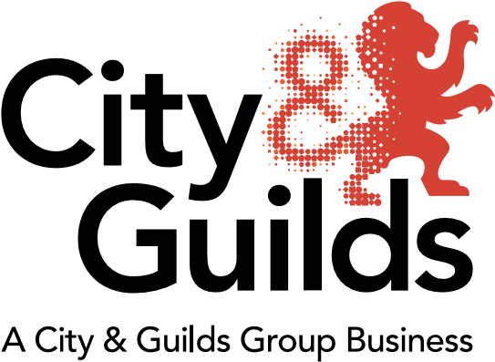

City & Guilds Construction – a summary

A rolling summary from City & Guilds on professional and technical education updates in construction for all nations.

Topics covered:
- NVQs
  - What are NVQs?
  - Incremental Reviews
  - NVQs and CSCS cards
  - The future of NVQs
- Vocational qualifications
  - What are vocational qualifications?
  - The future of vocational qualifications
- Technical qualifications
  - What is a “Technical”?
  - UCAS Points
- T levels
  - What are T levels?
  - When will T levels be available?
  - What will a T level look like?
- Apprenticeships
  - Apprenticeship Frameworks
  - New Apprenticeship Standards
  - Comparison between SASE Frameworks and Apprenticeship Standards
  - Apprenticeship Funding
  - Available standards in construction
  - Summary of Apprenticeship Standards (core trades)
  - Maths and English in apprenticeships
- Scotland
- Wales
- Support materials
- E-portfolio
- Our wider maths, English and ICT offer

Changes to document | Date of change
First edition | April 2018
Sections on Maths & English added | May 2018
T Level and Apprenticeship standards update | July 2018

City & Guilds Construction
Level | Vocational | Technicals | NVQs | More about 14-19 TechBac  More about apprenticeships
L4+ |  |  | 6578 in Site Management (L6)  6577 in Construction Site Supervision (L4)
3 | Core trades  6705 in Bricklaying  6706 in Carpentry and Joinery  6707 in Painting and Decorating  6708 in Plastering  Specialist Trades  6715 in Stonemasonry | Core trades  7905 in Bricklaying  7906 in Carpentry and Joinery  7907 in Painting and Decorating  7908 in Plastering  Construction Professions  6720 in Constructing the Built Environment | Core trades  6570 in Trowel Occupations  6571 in Wood Occupations  6572 in Painting and Decorating  6573 in Plastering  Construction Operations  6576 in Occupational Work Supervision  6565 in Accessing Operations and Rigging | Other Services:  ILM  Kineo  Employer Solutions  Digital Me  Learning Assistant  SmartScreen
2 | Core trades  6705 in Bricklaying  6706 in Carpentry and Joinery  6707 in Painting and Decorating  6708 in Plastering  Specialist Trades  6710 in Wall and Floor Tiling  6711 in Maintenance Operations  6713 in Dry Lining  6715 in Stonemasonry  6715 in Craft Masonry  6719 in Roof Slating and Tiling  Construction Operations  6709 in Construction Operations | Core trades  7905 in Bricklaying  7906 in Carpentry and Joinery  7907 in Painting and Decorating  7908 in Plastering  Construction Professions  6720 in Constructing the Built Environment | Core trades  6570 in Trowel Occupations  6571 in Wood Occupations  6572 in Painting and Decorating  6573 in Plastering  Specialist Trades  5931 in Insulation and Building Treatments  6560 in Wall and Floor Tiling  6565 in Accessing Operations and Rigging  6567 in Interior Systems  6569 in Roofing Occupations  6580 in Formwork  2455 in Steel fixing  Construction Operations  6561 in Plant Operatives  6562 in Maintenance Operations  6566 in Highways Maintenance  6574 in Construction Operations | Related Products:  6072 Health and Safety  6073 Building Information Modelling (BIM)  6157 Street works  6038 in Safe Location and Avoidance of Underground Services  6150 Confined Spaces  5546-60 Employability Skills  Maths and English  Business Skills  Leadership in Construction (ILM)
1 | Core trades  6219 in Construction Skills  6705 in Bricklaying  6706 in Carpentry and Joinery  6707 in Painting and Decorating  6708 in Plastering  Specialist Trades  6710 in Wall and Floor Tiling  6715 in Stonemasonry |  |  | Related Industries:  Building Services  Built Environment Services  Transport Maintenance  Engineering  Utilities
Entry | 6219 in Construction Skills |  |  | Quality Assurance:  Becoming a centre

NVQs
What are NVQs?
NVQs (National Vocational Qualifications) are based on the national occupational standards (NOS). The NOS, NVQ structures and the consolidated assessment strategy are all developed and maintained by CITB.

These qualifications can be taken by full-time employees, or by school and college students with a work placement or part-time job, that enables them to develop the appropriate skills in a work environment.

Incremental Reviews
CITB maintain the NOS by working closely with industry through employer-led meetings. Any agreed incremental changes or updates to the NOS are then required, by Awarding Bodies such as City & Guilds, to apply the changes to the NVQs.

NVQs and CSCS cards
Construction related NVQs, at the relevant level, qualify learners for either the Skilled Worker, Advanced Craft/Supervisory or Manager CSCS cards. For the Labourer card, candidates will need to take the Level 1 Award in Health & Safety in a Construction Environment (or CSCS approved equivalent) and pass the CITB HSE test.

CSCS cards are valid for 5 years, with the only exception being the Trainee cards, which are valid for 1 or 3 years. To renew the card, candidates must then take the appropriate CITB HSE test:
https://www.citb.co.uk/cards-testing/health-safety-environment-test/about-test/

The future of NVQs
As covered in the Apprenticeship section below, NVQs are remaining in several of the new apprenticeship standards, and SASE funding will potentially continue in several trade areas until at least 2020. For this reason, City & Guilds have recently extended their NVQ offer in construction until 2020 and will then hold another review of the NVQs to decide whether a further extension is required.

Vocational qualifications
What are vocational qualifications?
These are the awards, certificates and diplomas designed for people in full-time learning. They are classroom-based and help learners gain the knowledge and skills needed for work, or can be used as evidence towards completing an NVQ. They're assessed in a number of ways: assignments, practical tests, written exams or even online multiple choice tests.

The future of vocational qualifications
As covered in the Apprenticeship section below, vocational qualifications may still be included in the new apprenticeship standards, and SASE funding will potentially continue in several trade areas until at least 2020. For this reason, City & Guilds have recently extended their vocational qualification offer in construction until 2020 and will then hold another review of the qualifications to decide whether a further extension is required.

Technical qualifications
What is a “Technical”?
City & Guilds Technical Qualifications for 14-19 year olds are a high quality practical qualification designed with employers to give learners the technical skills and knowledge needed within a subject area. Approved by the Department for Education (DfE) to appear on Performance Tables, they are seen as being on par with GCSEs and A Levels, attracting UCAS points at Level 3.

Key Stage 4 (16-19) | Key Stage 5 (16 -19)
Level 2 | Level 2 | Level 3
- Technical Award in Designing and Planning the Built Environment  - Technical Award in Constructing and Maintaining the Built Environment | - Technical Certificate in Bricklaying  - Technical Certificate in Site Carpentry  - Technical Certificate in Architectural Joinery  - Technical Certificate in Painting and Decorating  - Technical Certificate in Plastering | - Advanced Technical Diploma in Bricklaying  - Advanced Technical Diploma in Site Carpentry  - Advanced Technical Diploma in Architectural Joinery  - Advanced Technical Diploma in Painting and Decorating  - Advanced Technical Diploma in Plastering  - Advanced Technical Certificate in Constructing the Built Environment

UCAS Points:

Grade | Level 3 Advanced  Technical Certificate  (360) | Level 3 Advanced Technical Diploma  (450) | Level 3 Advanced Technical Diploma  (540) | Level 3 Advanced Extended Technical Diploma  (720) | Level 3 Advanced Technical Extended Diploma (1080)
Distinction* | 56 | 56 | 84 | 112 | 168
Distinction | 48 | 48 | 72 | 96 | 144
Merit | 32 | 32 | 48 | 64 | 96
Pass | 16 | 16 | 24 | 32 | 48

For more information visit:
https://www.cityandguilds.com/techbac

T levels
What are T Levels?
Originating from the Government’s Post-16 Skills Plan, T levels are new technical study programmes set at Level 3 that will sit alongside apprenticeships and be equivalent in size to three A Level programmes within a reformed skills training system.

Construction is one of 15 industry routes, which will contain three pathways:
- Design, Surveying and Planning;
- Onsite Construction
- Building Services Engineering

When will T levels be available?
Design, Surveying and Planning will be among the first T levels to be developed, potentially introduced in September 2020, with the remaining construction pathways scheduled for September 2021.

Public consultation on the T levels closed on 8th February 2018. The Institute for Apprenticeships (IfA) are currently reviewing the output of the consultation before any further announcements.

What will a T level look like?
The below is a draft structure of the T level programme proposed during the public consultation:

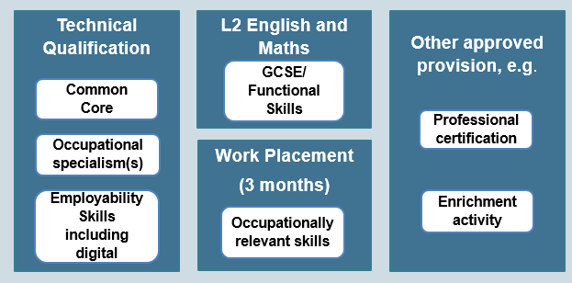

For more information visit:
https://www.cityandguilds.com/tlevels

Apprenticeships
Apprenticeship Frameworks
Apprenticeships are changing from the SASE framework (Specification of Apprenticeship Standards in England) to new, employer-led, apprenticeship standards. As standards become available there will be a cross-over period where training providers can choose to offer either frameworks or standards. However, the SASE frameworks are being discontinued and are expected to be phased out completely by 2020.

Included within SASE apprenticeship frameworks:
- On-the-job and off-the-job training through mandatory qualifications (NVQs and vocational qualifications)
- Maths and English
- Personal Learning and Thinking Skills
- Employment rights and responsibilities training

City & Guilds frameworks include:
- Construction Building (ie Bricklayers, Wood trades, Painters and Decorators)
- Construction Specialist (ie Plasterers, Floorers, Roofers)
- Construction Civil Engineering (ie Plant operatives, construction and civil engineering operatives)

New Apprenticeship Standards
Developed by individual employer groups, the new apprenticeship standards are achieved on completion of an end-point assessment. Although each standard will vary (eg some require mandatory qualifications whilst others do not), they will all follow a similar structure:
- On-programme training
  - On-the-job and off-the-job training. Qualifications may or may not be mandatory.
  - Maths and English
  - Behaviours
- End-point Assessment
  - Practical assessment (for example task based, observed by an external assessor)
  - Theory assessment (for example multiple-choice tests, short-answer tests, oral questioning, etc.)

Apprenticeship Funding
The new apprenticeship standards are funded by large employers, contributing 0.5% of their pay-bill to a national levy. Although employers with a pay-bill below £3million are not required to pay a national levy, they can still benefit by having 90% of their apprenticeship costs covered by only paying for the remaining 10%.

SASE frameworks will eventually be discontinued and are expected to be phased out completely by 2020. City & Guilds have therefore extended their NVQs and vocational qualifications in Construction for use within the SASE frameworks until 2020.

Employer groups still reserve the right to withdraw SASE funding early. For example, it is expected that SASE funding will close for both Level 2 and Level 3 Carpentry and Joinery in December 2018.

Standards approved by IfA for delivery so far:
- Carpentry and Joinery
- Advanced Carpentry and Joinery
- Bricklayer
- Plasterer
- Painter and Decorator
- Steel Fixer
- Scaffolder
- Digital Engineering Technician
- Construction Site Engineering Technician
- Surveying technician
- Chartered surveyor (degree)
- Civil engineering technician
- Civil engineer (Degree)
- Civil engineering site management (Degree)
- Geospatial Mapping and Science (Degree)
- Geospatial Survey Technician
- Lifting Technician
- Tunnelling operative

Comparison between SASE Frameworks and Apprenticeship Standards

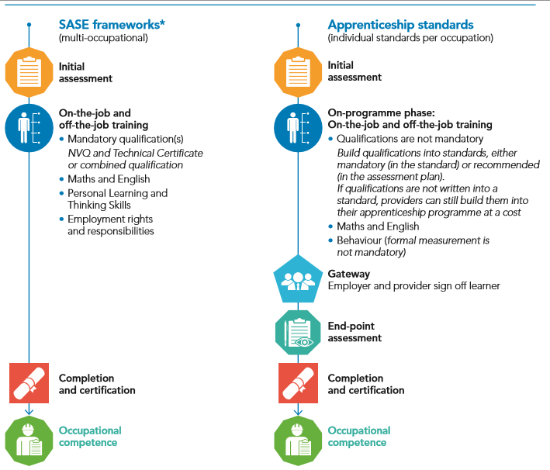

Summary of Apprenticeship Standards (core trades)
Standard |  |  |  |  | On-programme |  |  | End-point assessment |  |  | Approved by IfA?
 | Level | Number of pathways | Duration | Funding Band | NVQ | Training Spec or Technical qual | Maths & English requirement | Practical Test | Multiple- choice test | Oral Questions
Carpentry & Joinery | 2 | 2 | 18 months | £12K | Mandatory | Training Spec available. | Level 1 (achieved)  Level 2 (to have taken) | 1 day | Yes | No | Yes
Advanced Carpentry & Joinery | 3 | 2 | 12 months | £9K | Mandatory | Training Spec available. | Level 2 (achieved) | 1 day | Yes | No | Yes
Bricklaying | 2 | 1 | 30 months | £9K | Not required | Training Spec available. | Level 1 (achieved)  Level 2 (to have taken) | 1 day | Yes | Yes | Yes
Plastering | 3 | 2 | 36 months | £10K | Not required | Training Spec available. | Level 2 (achieved) | 2-3 days | Yes | Yes | Yes
Painting & Decorating | 2 | 1 | 36 months | £9K | Not required | TBD | Level 1 (achieved)  Level 2 (to have taken) | 3 days | Yes | Yes | Yes

City & Guilds are currently developing support materials to support the on-programme for the above standards, including SmartScreen learning resources, Training Manuals, and End-point Assessment preparation material.

City & Guilds will also be applying to become an end-point Assessment organisation. If you are interested in becoming an independent assessor, please contact us by filling out the form on our website.

Maths and English in apprenticeships
Details of the requirements for maths and English can be found in individual apprenticeship standards or SASE frameworks, though generally:
- Level 2 apprentices require maths and English at Level 1, and should have attempted Level 2.
- Level 3 apprentices require maths and English at Level 2.
There may be extra requirements for higher level apprenticeships or particular industry roles.

The list of qualifications that can be used to meet the requirements can be found in Annex G of this document.

Scotland

Modern Apprenticeships
Modern Apprenticeships are available to employees aged 16 or over in Scotland. Apprenticeships in Scotland contain three basic criteria:
- A relevant SVQ (or alternative competency based qualifications)
- Industry specific training
- Core Skills

The following City & Guilds qualifications have been approved for delivery as part of the Modern Apprenticeship in Construction Building at SCQF Level 6:

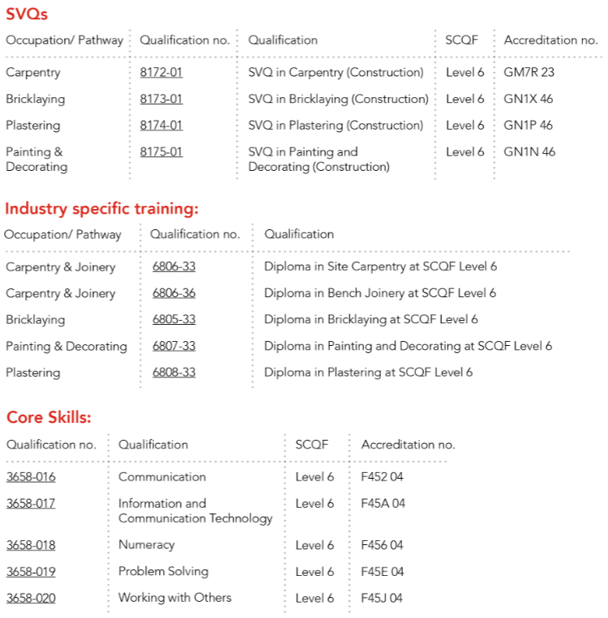

https://www.cityandguilds.com/~/media/cityandguilds-site/documents/about-us/ma_construction_flyer_january_2018%20pdf.ashx

Other SCQF qualifications and SVQs available with City & Guilds:

Level  (England) | Level  (Scotland) | SCQF qualifications | SVQs
3 | 6 | Core trades  6805 in Bricklaying  6806 in Carpentry and Joinery  6807 in Painting and Decorating  6808 in Plastering | Core trades  8172 in Carpentry and Joinery  8173 in Bricklaying  8174 in Plastering  8175 in Painting and Decorating
2 | 5 | Core trades  6805 in Bricklaying  6806 in Carpentry and Joinery  6807 in Painting and Decorating  6808 in Plastering  Specialist Trades  6810 in Wall and Floor Tiling  6811 in Maintenance Operations  Construction Operations  6809 in Construction Operations
1 | 4 | Core trades  6619 in Construction Skills  6805 in Bricklaying  6806 in Carpentry and Joinery  6807 in Painting and Decorating  6808 in Plastering  Specialist Trades  6810 in Wall and Floor Tiling
Entry | 3 | 6619 in Construction Skills

Wales
Wales currently use the same qualifications and qualifications system as England. However, in February 2018, Qualifications Wales published a sector review of Construction and the Built Environment with proposals for reform.

The review included proposals for short time actions to address some of the issues identified, and other options for longer term reform. Qualifications Wales are currently reviewing these options after the public consultation that closed on 13 April 2018.

Options for longer term reform:
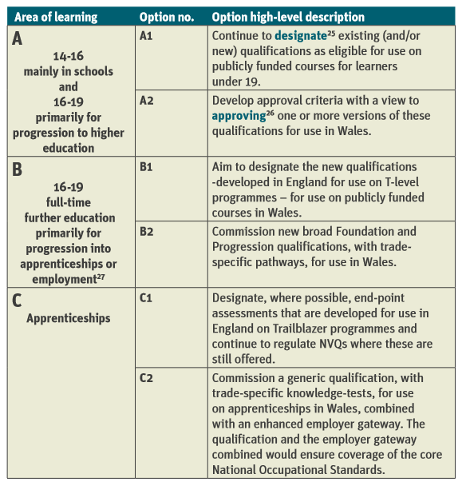

Maths, English and Essential Skills for Wales:
Essential Skills (3868)

Support Materials with City & Guilds

SmartScreen
SmartScreen provides online teaching and learning support for tutors, learners and assessors of City & Guilds’ qualifications. High quality support materials provide complementary support to the entire teaching and learning experience.
Available for:
6219 in Construction Skill (Entry level and level 1)
6705 in Bricklaying (Level 1, 2 and 3)
6706 in Carpentry and Joinery (Level 1, 2 and 3)
6707 in Painting and Decorating (Level 1, 2 and 3)
6708 in Plastering (Level 1 and 2)
6709 in Construction Operations (Level 2)
6710 in Wall and Floor Tiling (Level 1 and 2)
6711 in Maintenance Operations (Level 2)
7905 Technicals in Bricklaying (Level 2 and 3)
7906 Technicals in Carpentry and Joinery (Level 2 and 3)
7907 Technicals in Painting and Decorating (Level 2 and 3)
7908 Technicals in Plastering (Level 2 and 3)

Enhanced SmartScreen
City & Guilds has joined forces with MidKent College to develop e-learning materials for the Level 2 Bricklaying, Architectural Joinery, and Site Carpentry. These packages are made up of interactive activities and detailed animations to give learners a more engaging and rewarding learning experience.
Available for:
6705 Level 2 Diplomas in Bricklaying
6706 Level 2 Diplomas in Carpentry and Joinery
7905 Level 2 Technical Certificate in Bricklaying
7906 Level 2 Technical Certificates in Carpentry and Joinery

Training Manuals
Training Manuals are available for Level 2 Bricklaying, Architectural Joinery, and Site Carpentry. These resources provide the learner with a series of practical tasks to support their learning experience.
Available for:
6705 Level 2 Diplomas in Bricklaying
6706 Level 2 Diplomas in Carpentry and Joinery
7905 Level 2 Technical Certificate in Bricklaying
7906 Level 2 Technical Certificates in Carpentry and Joinery

Textbooks
City & Guilds textbooks are an essential resource for any learner developing their skills in the construction industry with City & Guilds. Written in-line with City & Guilds qualification specifications and assessment criteria, as well as the National Occupational Standards, this resource provides the learner with all the information required to achieve the qualification and succeed in the workplace.
Available for:
Bricklaying (Level 1, 2 and 3)
Carpentry and Joinery (Level 1, 2 and 3)
Painting and Decorating (Level 1 and 2)
Plastering (Level 1 and 2)

e-Portfolio
City & Guilds Learning Assistant is a market-leading e-portfolio system designed to enable your organisation to reach its full potential. Learning Assistant transforms the vocational education management process, allowing you to maximise productivity, increase profitability and enhance the quality of the learning experience.

Our wider maths, English and ICT offer
City & Guilds have been offering qualifications in maths, English and ICT skills for over 40 years, supporting adults and young people to succeed in all aspects of life. Our qualifications have a particular focus on developing workplace skills, while underpinning our apprenticeship and Technical qualifications. City & Guilds also offer qualifications designed to meet the requirements for each of the home nation regulators, including

- Functional Skills (3748) for England
- Essential Skills (3868) for Wales
- Workplace Core Skills (3658) for Scotland
- Essential Skills (4800) for Northern Ireland

City & Guilds offer a range of online and offline materials and packages for learners to succeed in English and maths. We also offer CPD courses for tutors to help incorporate maths and English into the apprentice journey – particularly helpful for curriculum staff not used to delivering this.

Tell us what you think
City & Guilds Construction – a summary is a rolling update that brings together all of the key products and services from City & Guilds relevant to Construction skills learning across England, Scotland, Northern Ireland and Wales. It contains a summary of the range of teaching and learning resources we offer, plus relevant public policy or other information we think you might be interested in.

If you are interested in supporting City & Guilds either as a writer, marker, assessor or as an EQA please do get in touch with us at construction@cityandguilds.com

For specific queries and enquiries please contact our dedicated customer support team: CentreSupport@cityandguilds.com

Meet the team:

Ed Shaw
Industry Manager
edward.shaw@cityandguilds.com
02072943314

Ian Roberts
Technical Advisor
Ianm.Roberts@cityandguilds.com
07826903967

Paul Brown
Technical Advisor
Paul.brown@cityandguilds.com
07872463185

Please follow us on twitter @ConstructionCG

Thank you for your continued support.

Every effort has been made to ensure that the information contained in this publication is true and correct at time of going to press. However, City & Guilds’ products and services are subject to continuous development and improvement and the right is reserved to change products and services from time to time. City & Guilds cannot accept responsibility for any loss or damage arising from the use of information in this publication.© 2018. The City and Guilds of London Institute. All rights reserved. City & Guilds is a trademark of The City and Guilds of London Institute, a charity established to promote education and training registered in England & Wales (312832) and Scotland (SC039576).

