

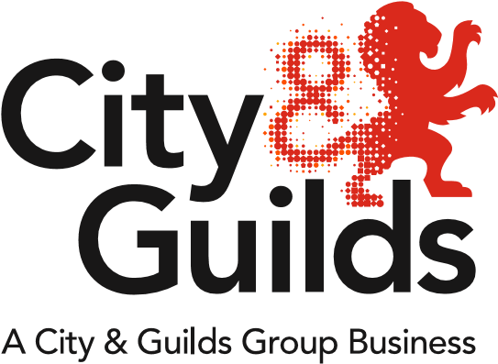

All about Hair & Beauty

**Issue 02**

**January 2019**

A newsletter from City & Guilds on education updates in hair, beauty & complementary therapies for all nations.

**In this issue:**

1. Welcome back
2. ESFA funding - Review of 16-19 study Programmes
3. Hair and Beauty Network Meeting Jan – March 2019
4. Business as usual NEW Rules of Combination (RoC)
5. **All about Technical Qualification – KS4 and KS5**

Welcome pack

Key Dates – 2018/19

Exam calendar – 2018/19

Sample Curriculum plan

FAQ

Webinars to help you in your Journey

Moderation Portal for Technical Qualifications

What is the quality assurance process? - Examples of internal quality

Coming soon - KS4 & KS5 Webinars

1. **All about Apprenticeships – England**

L2 Hair Professional Standard

L3 Senior Professional Hair Standard

L2 Beauty Standard

L3 Beauty Standard

Preparing for EPA

EPA Webinars to help you in your Journey

EPA process

EPA pricing

Gateway – prior to end‐point assessment

EPA preparation tool

Off the Job training

Become an independent end-point assessor

1. General news - AHT Competition 2019, Men’s Hairdressing Federation Barbering Competition’s for 2019,

Federation of Holistic Therapists (FHT) announces 2018 Excellence Awards Winners

1. Support resources
2. Maths & English – Functional Skills reforms
3. Adult Education Budget (AEB) Hair & Beauty
4. Digital Credentials for Hair and Barbering
5. **Welcome back**

Hello!

We want to welcome you all back ready for the new year. We are very excited to be sharing with your information about our new Beauty apprenticeship standards, including how they work and where we are up to in terms of development. Please take note the upcoming dates for our network meetings, running between February and March, providing full support and guidance on the Technical qualification and the EPA for 7002.

Remember to take a look at our amazing support resources - take advantage of our engaging Enhanced SmartScreen provisions and our brilliantly informative employer videos. As always, our team is here to support you in supporting your students. Links to resources can be found at the bottom of this newsletter as well as links for any queries or should you wish to contact us. You can also follow us on social media to keep up-to-date with all of the latest information and developments.

We look forward to working with you in the near future,

Best Wishes

Emma, Sarah & Emma

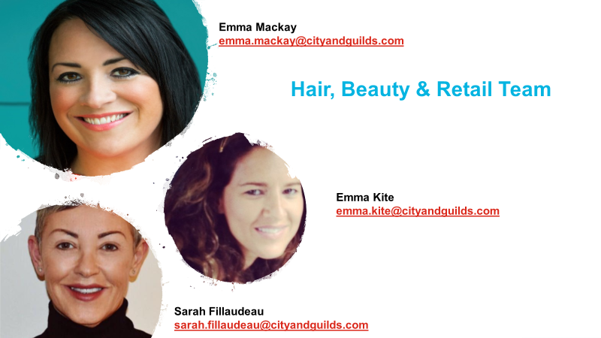

1. A screenshot of a cell phone

   Description automatically generatedDecember 2018, the ESFA announced a funding change resulting from their Review of 16-19 study Programmes.

The funding change they proposed, which would have been introduced from 1st August this year, was that students with prior attainment in English and Maths at Grade 4, or above that undertake a vocational qualification, would not be expected to be on an Entry Level or Level 1 core aim, even if they had no previous experience in the vocational area – they should undertake a core aim at Level 2 or above, except in exceptional circumstances.

**Today,** ESFA have announced that after consultation with the sector they won’t introduce the new funding rule but will consult further and decide whether to introduce the change in 2020/2021 instead.

Please sign up for **Funding Update** …. You can **sign up for funding updates on the City & Guilds website…**

**(email updates)**, please follow the link - <https://www.cityandguilds.com/what-we-offer/centres/email-updates>

1. **Hair and Beauty Network Meeting Jan –March 2019**



**Dates for your diary…….** The following events are ready to book onto via the links below and will give an update on our current offer and resources available as well as time to discuss and share good practice as well as preparing for EPA and top tips on preparing your learners for exams and synoptic end assessment.

|  |  |  |
| --- | --- | --- |
| **Date** | **Time** | **Location** |
| 11.02.2019  Central London | 9.30-1 | City & Guilds London Regional Office [*booking link*](https://www.eventbrite.co.uk/e/hair-beauty-regional-network-meeting-london-tickets-45333901921)  **Fully booked** |
| 12.02.2019  North West – Warrington | 9.30-1 | Warrington Regional Office [*booking link*](https://www.eventbrite.co.uk/e/hair-beauty-regional-network-meeting-warrington-tickets-45333789585) |
| 14.02.2019  Yorkshire – Wakefield | 9.30-1 | Wakefield Regional Office [*booking link*](https://www.eventbrite.co.uk/e/hair-beauty-regional-network-meeting-wakefield-tickets-45299761807) |
| 19.02 .2019  South West – Mid Devon  Tiverton | 9.30-1 | South West (Petroc)Mid-Devon [*booking link*](https://www.eventbrite.co.uk/e/hair-beauty-regional-network-meeting-south-west-petroc-mid-devon-tickets-55072315779) |
| 21.02.2019  Yorkshire – East Riding | 9.30-1 | East Riding College [*booking link*](https://www.eventbrite.co.uk/e/hair-beauty-regional-network-meeting-east-riding-tickets-54600553726) |
| 26.02.2019  South – Lewes | 9.30-1 | Sussex Downs (Lewis campus) [*booking link*](https://www.eventbrite.co.uk/e/hair-beauty-regional-network-meeting-south-east-tickets-55071452196) |
| 27.02.2019  North East – Durham | 9.30-1 | New Durham College [*booking link*](https://www.eventbrite.co.uk/e/hair-and-beauty-regional-network-meeting-durham-registration-37618576174) |
| 01.03.2019  Midlands – Birmingham | 9.30-1 | South City Birmingham [*booking link*](https://www.eventbrite.co.uk/e/hair-beauty-regional-network-meeting-birmingham-tickets-54601413297) |
| 05.03.2019  North East London – Tottenham | 9.30-1 | North East London The College of Haringey, Enfield and North East London [*booking link*](https://www.eventbrite.co.uk/e/hair-beauty-regional-network-meeting-north-east-london-tickets-55404121218) |
| 14.03.2019  South West - Gloucester | 9.30-1 | Llanthony Secunda Priory, Gloucester [*booking link*](https://www.eventbrite.co.uk/e/hair-beauty-regional-network-meeting-south-west-tickets-55522031892) |
| 10.04.2019  Central London | 10-1 | **Prison Focus Group – City & Guilds** London Regional Office [*booking link*](https://www.eventbrite.co.uk/e/city-guilds-hair-beauty-prison-focus-group-network-meeting-london-tickets-51083059807) |

1. **Business as usual NEW Rules of Combination (RoC)**



**Hair & Beauty**

**Rules of Combination**

June 2018

Version 2

[Click here for hyperlink](https://www.cityandguilds.com/~/media/cityandguilds-site/documents/qualifications-and-apprenticeships/beauty-and-complementary-therapies/hair-and-beauty-rules-of-combination%20pdf.ashx)

Please note that there is a new crib sheet to support you in identifying all the support material alongside each qualification at the front of the RoC

1. **All about Technical Qualification – KS4 and KS5**

**Technical Qualifications**

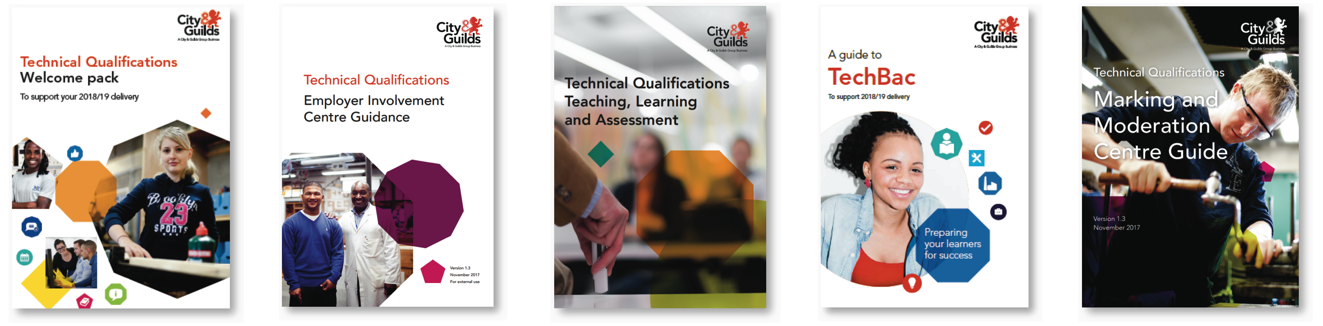

**[](https://www.cityandguilds.com/~/media/cityandguilds-site/documents/technical-qualifications/technical_qualification_welcome_pack%20pdf.ashx)**

**Hyperlink to Welcome Pack 2018/19**

**[](https://www.cityandguilds.com/~/media/cityandguilds-site/documents/technical-qualifications/deliver/technicals-fy19-checklist-for-delivery%20pdf.ashx)**

**Hyperlink to Key Dates Check List 2018/19**

**[](https://www.cityandguilds.com/~/media/cityandguilds-site/documents/delivering-our-qualifications/exams-and-administration/technicals-exams-timetable-for-2019%20pdf.ashx)**

**Hyperlink to Exams Timetable/Calendar 2018/19**

**[](https://www.cityandguilds.com/techbac/technical-qualifications/resources-and-support)**

**Hyperlink to Sample Curriculum Plan**

**[](https://www.cityandguilds.com/techbac/technical-qualifications/faqs?utm_source=City%20%26%20Guilds%20UK&utm_medium=email&utm_campaign=9728521_Seed_List_UKC_Marketing_Technicals_Level3-August6_ResultsRelease_UK&dm_i=1LRT,5SIKP,RJKNA5,MLRFS,1)Hyperlink to Technical Qualifications Frequently Asked Questions**

**Coming soon… New KS4 & KS5 Webinars will be available shortly.**



**NEW – Principal Moderator from You Tube.**

|  |  |
| --- | --- |
| Delivery of the Synoptic assessment | Part 1  <https://youtu.be/CCsRnuYMiiw> | Learner and Centre produced evidence for the synoptic assessment | Part 2  <https://youtu.be/noEiGFdzznQ> |
| Marking and standardisation | Part 3  <https://youtu.be/NH_L1uhf03w> | Submission of evidence to City & Guilds via the Moderation Portal | Part 4  <https://youtu.be/cZWqxN3nFx0> |
| Technical Qualifications- Level 3 Beauty Therapy marking and standardisation  <https://youtu.be/rEb5JCUww7s> | |

**Marking and moderation**

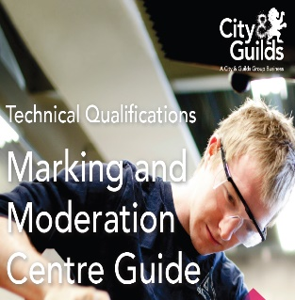All requirements of marking and moderation can be found in this guide on our [website](http://www.cityandguilds.com/)

We have included a specific link to the guide [here](https://www.cityandguilds.com/~/media/cityandguilds-site/documents/technical-qualifications/j403234markingmoderationguidev13%20pdf.ashx).

*The material below has been taken from City & Guilds Technical Qualifications – Generic On-boarding Slides, the aim is to help you understand how the generic forms are completed and to further guide you.*

**Marking of Synoptic Assessments**

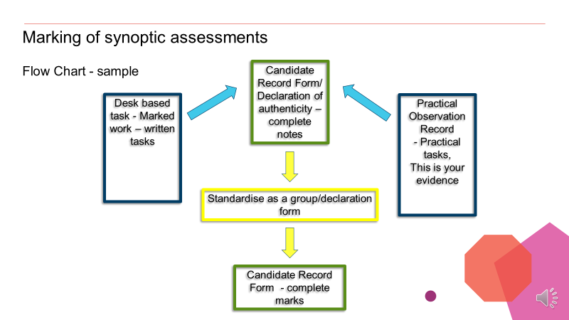

**Completing practical observation record**

Assessment objectives are related to candidate performance and assessors will be marking in relation to these

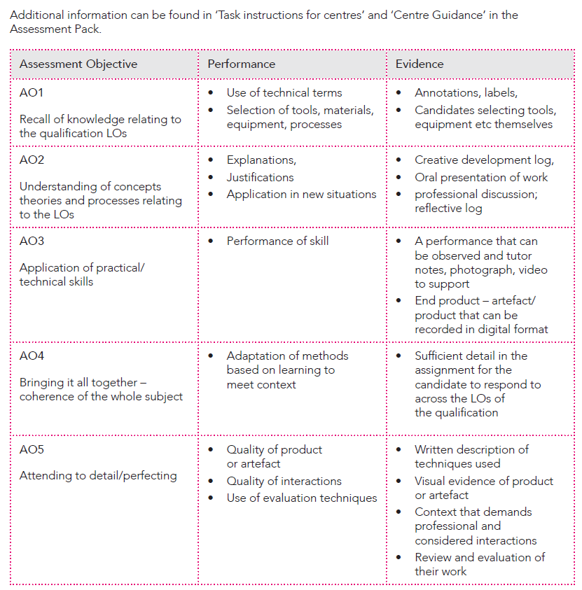

**Completing practical observation record**

*We are using an example from the 8202 sample of practical observation record taken from another industry to demonstrate good practice in recording information.*

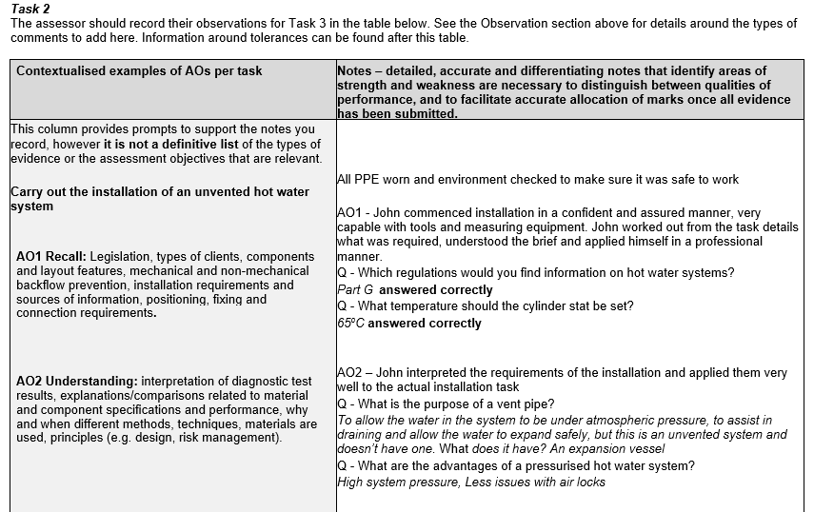

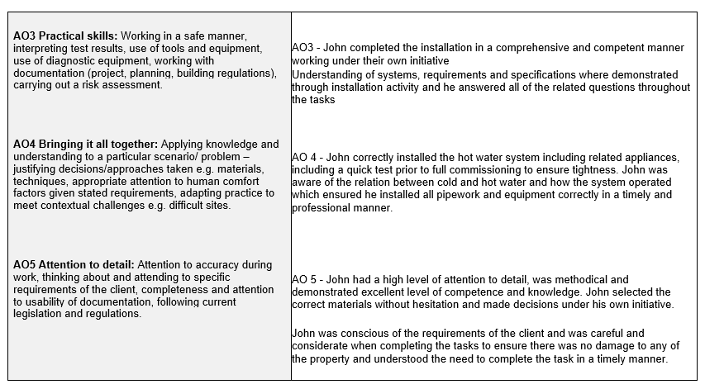

**Completing practical observation record**

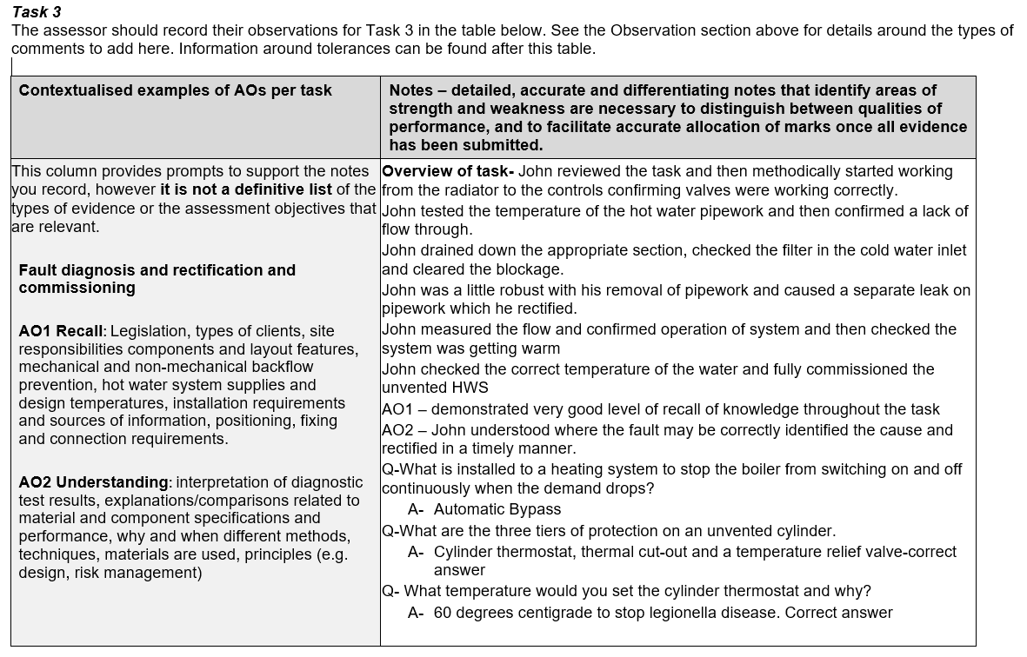

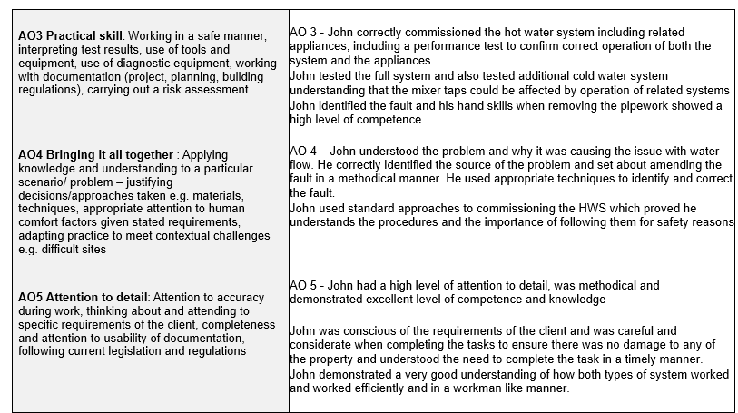

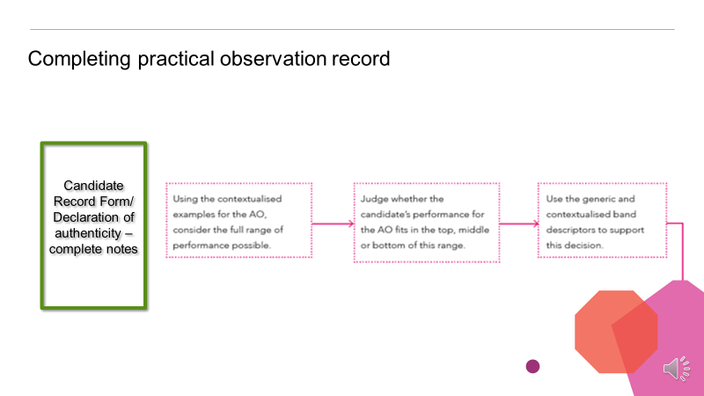**Completing practical observation record**

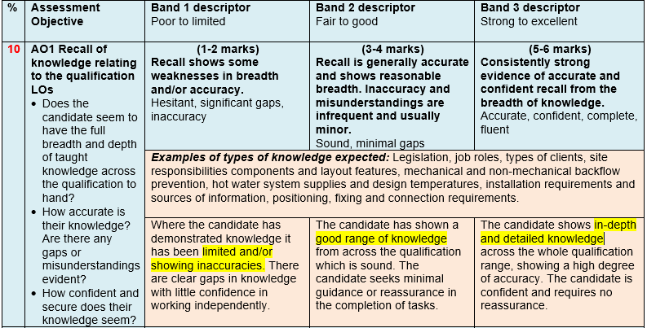**Completing a Candidate Record Form**

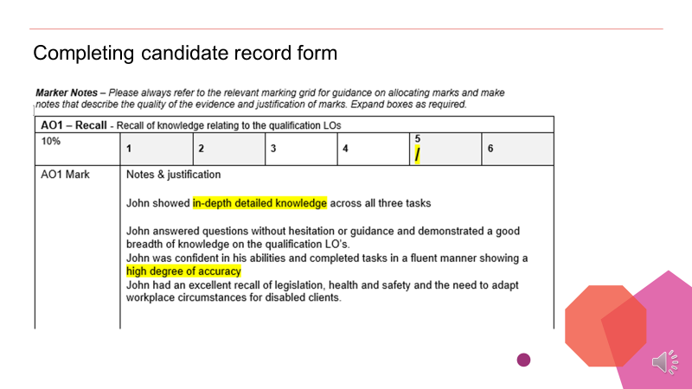

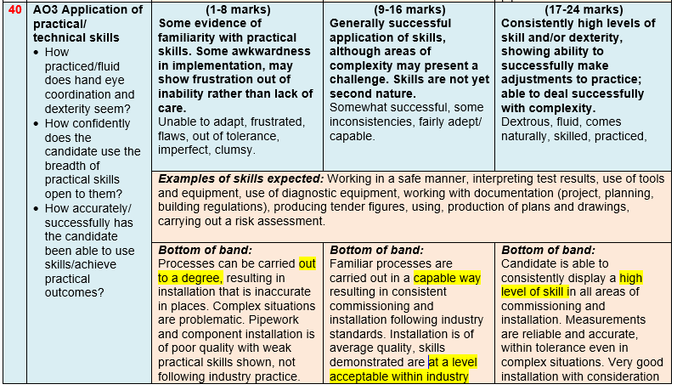

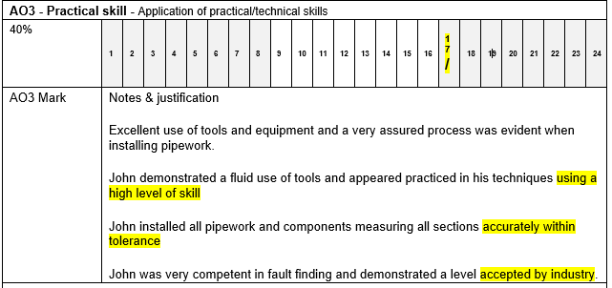

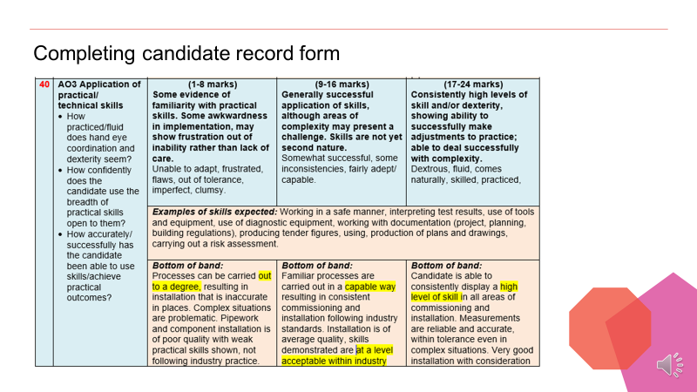

**Standardisation**

Standardise as a group/declaration form

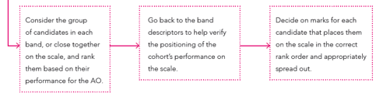

**Marking and moderation – centre forms**

**Note - It is important to be aware of these forms.**

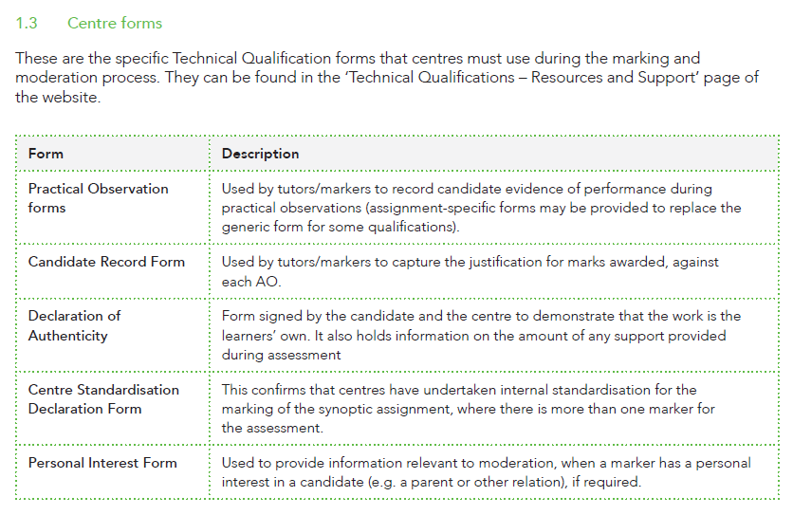

**Marking and moderation – standardisation for marking**

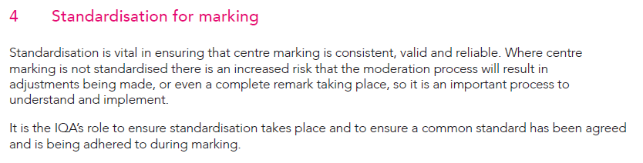

**Do we carry out IQA?**

Yes – standardisation of assessment is still very important even if the next stage is moderation rather than an EQA visit

**Note** – check the assignment brief for the evidence requirements – ensure you cover the correct range of evidence and correct type of photos

**What is the Quality Assurance process?**

Technical Qualifications are subject to quality assurance monitoring in the following ways:

* External moderation of practical synoptic assessment
* External quality assurance of other centre assessed components, e.g. optional units
* External marking of externally set examinations
* External sampling of Employer Involvement (at Key Stage 5 only).

**The quality assurance process is rigorous, and follows the following processes:**

At Key Stage 4 (13-16) and Key Stage 5 (16+), all centres wishing to offer the qualifications will receive a centre visit from one of our EQAs as part of the qualification approval process

At Key Stage 5, qualification approval will also include a review of the centre’s plans for Employer Involvement at approval. Moderation will also involve a sampling exercise of Employer Involvement, towards the end of the Technical Qualification delivery.

**Examples of internal quality**

Not all technical qualifications have optional units, if the qualification does have optional units then these units need to go through your quality assurance processes as normal.

Each centre has its own internal quality assurance processes and systems, at City & Guilds we use the moderation and standisation approach to quality assurance.

**Suggested approach;**

1. The lead internal quality assurer holds a standardisation meeting at the beginning of the academic year with all teachers and markers, teachers and markers need to familiarise themselves with the handbook, exam guide and synoptic assignment.
2. Agreed dates for mock assessment/trade tests forming part of your quality assurance/standardisation processes.
3. Mock assessment/trade tests take place before October half term, before Christmas and after Christmas and maybe the last one beginning of March.
4. Two markers and the lead quality assurer mark independently, after the mock assessment/trade tests team to standardise marks.

**Examples of Standardisation - Quality Assurance activities;**​

* Internal standardisation meetings ​

**Practical**​

* Practical standardisation activities across all markers to ensure consistent approach e.g. Mock

assessments ​

* Marking against Assessment Objectives ensuring consistent approach to completing City & Guilds paper

work ​

**Knowledge**​

* Mock tests – using Exam guides ​
* Past test papers ​
* Scenario type questions using indicative content as a guide ​
* Exam guides on preparing ​
* Vocabulary of the exam: use of ‘command’ verbs ​
* Question types ​
* Extended response questions​

**Optional units**​

For internally marked work (Optional Units) the Centre is required to conduct internal standardisation to ensure that all work at the Centre has been marked to the same standard. It is the Internal Quality Assurer’s (IQA’s) responsibility to ensure that standardisation has taken place, and that the training includes the use of reference and archive materials such as work from previous years as appropriate.

**City & Guilds requirements**​

​

City & Guilds will only look at the end point and not the learner’s journey – Ofsted requirements still apply to tracking & monitoring of the learners progress – The Learner Journal is a perfect tool to capture the learner’s progress, but City & Guilds Moderators will not ask to see this as formal evidence.​

​

**ONLY: -** Optional units – externally set and internally marked and graded assignments require IQA activity, the IQA sampling plan should reflect the CAMERA method of QA.

When the above has been taken into account then the IQA will use the principles of

‘**CAMERA**’ to ensure that the sample is representative. This means that the sample plan must take into account each of the following:

**C**andidates/Learners – **A**ssessors - **M**ethods of assessment – **E**vidence – **R**ecords - **A**ssessment sites

**Moderation**

**There are two types of moderation**

1. **Visiting moderation** - will be an observation of assessment practice by an external moderator.
2. **Sampling** - will require evidence uploaded to the portal for moderators.

**Note –** all centres require sampling, sample size as shown. Please check your qualification requirements for [visiting moderation](https://www.cityandguilds.com/-/media/cityandguilds-site/documents/technical-qualifications/technical-qualifications/cg-moderation-visits-pdf.ashx?la=en&hash=189D709076B5265264714A34B5940D1CB05C0111)

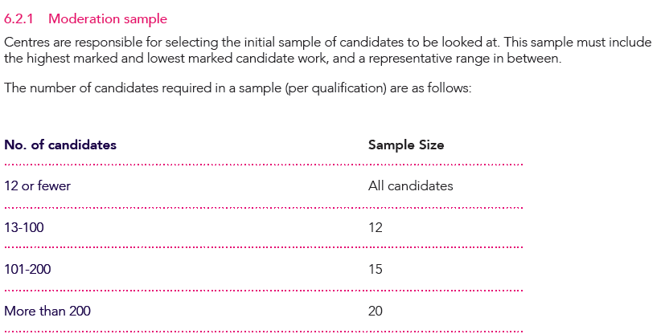

**Marking and moderation - do you have access to the portal?**

**The moderation portal is required for the uploading of candidate evidence. Further guidance on the** [website](https://www.cityandguilds.com/techbac/technical-qualifications/resources-and-support)

**The Moderation Portal**

The Moderation Portal is the online administration platform used to facilitate the submission of marks and evidence and the moderation of the synoptic assignment, Centre assessed components and employer involvement for Technical Qualifications.

You can download a copy of the [Moderation Portal Centre User Guide](https://www.cityandguilds.com/~/media/cityandguilds-site/documents/technical-qualifications/moderationportalcentreuserguidev20%20final%20pdf.ashx) which explains the process for your Centre on how to upload marks and evidence.

|  |
| --- |
| **Moderation Portal Centre User Guide** |
| [*Click here*](https://www.cityandguilds.com/~/media/cityandguilds-site/documents/technical-qualifications/moderation-portal-centre-user-guide-v2.1%20pdf.ashx) |

1. **All about Apprenticeships – England**



**7002 - Level 2 Hair Professional**

|  |  |
| --- | --- |
| **Route** | **QAN** |
| City & Guilds Level 2 Diploma for Hair Professionals – Barbering | 603/1380/8 |
| City & Guilds Level 2 Diploma for Hair Professionals – Hairdressing | 603/1379/1 |

**Level 3 Advanced Hair Professional *standard still under development**

|  |
| --- |
| **Advanced and Creative Hair Professional Standard*standard still under development** |
| Use fashion forward trends in hair, creative and precision techniques to create a collection of hairstyle looks |
| Smoothing and Strengthening services |
| Advanced creative colour conversion |

**Occupational profile for advanced and creative hair professional**





**This apprenticeship standard is now ready!! We are pleased to inform you that we have been approved for EPA.**

**7003 - Level 2 Beauty Professional**

|  |  |
| --- | --- |
| **Route** | |
| City & Guilds Level 2 Diploma for Beauty Professionals – Beauty Therapist | 603/3459/9 |
| City & Guilds Level 2 Diploma for Beauty Professionals – Nail Services Technician | 603/3892/1 |
| City & Guilds Level 2 Diploma for Beauty Professionals – Beauty and Make-up Consultancy | TBC |

**Link to 7003 - Level 2 Beauty Professional;** <https://www.cityandguilds.com/qualifications-and-apprenticeships/beauty-and-complementary-therapies/beauty/7003-beauty-professional-qualifications#tab=information>

**Level 2 Diploma for Beauty Professionals ‐ Beauty Therapist (7003‐12) Qualification Handbook**

<https://www.cityandguilds.com/qualifications-and-apprenticeships/beauty-and-complementary-therapies/beauty/7003-beauty-professional-qualifications#tab=documents>

**Nail Services Technician – documentation still under development at City & Guilds and is not yet ready for use.**

The City & Guilds Level 2 Diploma for Beauty Professionals – Nail Services Technician qualification, goes live 01 March 2019.

**Beauty and Make- Up Consultancy – documentation still under development at City & Guilds and is not yet ready for use. TBC.**

**Level 3 Advanced Beauty Standard – *This apprenticeship standard is in development and is not yet ready for use.**

**[](https://www.cityandguilds.com/~/media/cityandguilds-site/documents/apprenticeships/epa-10-step-guide%20pdf.ashx)**

**EPA process in a “nutshell” @ Level 2**

Before an apprentice can carry out their EPA, all Gateway evidence needs to be completed.

Therefore, the following must be evident:

1. The apprentice must have been on programme for a minimum of 366 days. This relates to the overarching funding guidance from ESFA. The EPA can, however, be booked before day 366.
2. Claimed components of on programme qualification, for Hairdressing or Barbering, all Mandatory units and 1 optional unit for hairdressing, for barbering all Mandatory units
3. Achieved Level 1 Maths & English or equivalent GCSE grade 2 or above
4. Sat the exam for Maths & English Level 2 or have an equivalent GCSE grade 4 or above, but doesn’t not have to have passed their Level 2 Maths & English.



**EPA Webinars to help you in your Journey**

**[](https://www.cityandguilds.com/~/media/cityandguilds-site/documents/apprenticeships/epa-10-step-guide%20pdf.ashx)**

**10 Steps to EPA**

**Hyperlink to 10 Steps to EPA**

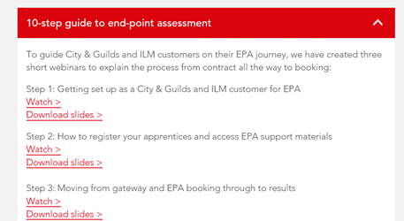

3 bite sized webinars – slides and webinars can be found on this page: <https://www.cityandguilds.com/apprenticeships/events-and-webinars>

|  |  |
| --- | --- |
| The EPA journey – supporting you every step of the way webinar  <https://youtu.be/JMEz_cSf8aU> | 10-step guide to end-point assessment  <https://youtu.be/k6_c985EU8Y> |
| Get to know our EPA preparation tool  <https://youtu.be/DM2uAQkHl8E> | Apprenticeships policy and funding changes 2018/19 – What you really need…  <https://youtu.be/mA7nms-r_Ow> |

****Our City & Guilds EPA team is already supporting employers, colleges and training providers through EPA events and we constantly update our service based on feedback and the changing regulation

 On programme

**What’s in these document (You need to know)**

* Hair Professional Standard
* End‐point assessment guidance on grading
* Resource requirements for end‐point assessment
* Task instructions for centres/employers/End‐point assessment customer
* Task instructions for apprentice

***These document should be used in conjunction with the recording forms document.***

Gateway



|  |
| --- |
| Manual for End-Point Assessment Services v3.0 September 2018 – [click here](https://www.cityandguilds.com/~/media/cityandguilds-site/documents/apprenticeships/manual-for-the-end-point-assessment-service%20pdf.ashx) |

EPA

**7002 Hair Professional – Preparing for EPA**

City & Guilds have now started to see Apprentices go through the Gateway to EPA. EPA bookings are increasing for the New Year, so City & Guilds would like to make sure that we are helping you to prepare your apprentices to shine like a star!

City & Guilds is here to support you, we have recently updated our FAQ’s and we have some great resources on the EPA preparation tool which are invaluable in preparing your apprentices.

On the EPA preparation tool City & Guilds have videoed the EPA process for Hairdressing and Barbering which talks the apprentice through what to expect on the day.

**Link to FAQs**

<https://www.cityandguilds.com/qualifications-and-apprenticeships/hairdressing/hairdressing/7002-diplomas-for-the-hair-professionalshairdressing-and-barbering#tab=documents>

**Link to EPA preparation tool**

<https://www.youtube.com/watch?v=DM2uAQkHl8E&index=4&list=WL&t=2s>

**Are you ready?**

* Remember the five P’s: Planning and Preparation Prevent Poor Performance
* Practice makes perfect, so practice, practice and do some more good practice!

**Tip 1**: Put in the effort! Take the time to look at the skills required to be demonstrated as part of your end-point assessment (EPA). Then practice, practice and practice some more.

*“Share with your apprentices what is a pass and distinction and also what would be a fail.”*

**Tip 2:** Get ready to shine like a star! You would have already chosen your models wisely to be able to showcase your skills to the best of your ability. The IEPA will ask you questions at the end of your service about your choices of techniques, products, tools and equipment. Be prepared write a service plan with explanations of your choices of techniques and products so you are ready to answer these questions confidently. Once you feel ready, it may help to ask your employer or tutor to test you and provide some feedback. By practicing a few common examples, your responses will flow more naturally, and you will feel more confident during the EPA.

**Tip 3:** Preparing for the practical observation There are some important details you need to know prior to arriving for your practical test, so that you are prepared to give a star performance.

*“Check with your assessor/employer that the models are suitable to meet the requirement of the assessment brief.”*

**Tip 4:** Timings Time yourself when you practice or when you do a mock assessment. Did you complete your assessment within the time allocated when practicing? If not, ask yourself the following questions: • Did you carry out the task in the most logical order? • Were you fully prepared before starting the task? • Did you have all of your equipment and products ready?

**Tip 5**: Your choice of models is vital!!! As you are allowed to choose your models, make sure they going to give you the best opportunity to showcase your talent and skills. Don’t try something new on the day that you haven’t already practiced and perfected. When working with models, check whether they are aware of the expectations and importance of your end-point assessment.

**Hair and Barbering handbooks, on-programme assessors guide and EPA Assessment Packs**

**Level 2 Diploma for Hair Professionals ‐ Hairdressing (7002‐02) Qualification Handbook**

<https://cdn.cityandguilds.com/ProductDocuments/Hairdressing/Hairdressing/7002/Centre_documents/7002-02-l2-dip-for-hair-pros-hairdressing-qhb-v1-5.pdf>

**Level 2 Diploma for Hair Professionals – Barbering (7002-03) Qualification Handbook**

<https://cdn.cityandguilds.com/ProductDocuments/Hairdressing/Hairdressing/7002/Centre_documents/7002-03-l2-dip-for-hair-pros-barbering-qhb-v1-3.pdf>

**Level 2 Diplomas for Hair Professionals (7002) On-programme Assessor Guide**

<https://cdn.cityandguilds.com/ProductDocuments/Hairdressing/Hairdressing/7002/Centre_documents/7002-assessor-guidance-v1-1.pdf>

|  |
| --- |
| Level 2 Diploma for Hair Professionals – Hairdressing/Barbering (7002-52/53 Version 2 July 2018  <https://www.cityandguilds.com/qualifications-and-apprenticeships/hairdressing/hairdressing/7002-diplomas-for-the-hair-professionalshairdressing-and-barbering#tab=documents>  **Level 2 Diploma for Hair Professionals – Hairdressing (7002‐52) – End‐Point Assessment Pack For Centres/End‐Point Assessment Customers/Employers**  <https://cdn.cityandguilds.com/ProductDocuments/Hairdressing/Hairdressing/7002/Assessment_materials/7002-52-ctr-epa-pack-v1-0.pdf>  **Level 2 Diploma for Hair Professionals – Barbering (7002‐53) – End‐Point Assessment Pack For Centres/End‐Point Assessment Customers/Employers**  <https://cdn.cityandguilds.com/ProductDocuments/Hairdressing/Hairdressing/7002/Assessment_materials/7002-53-ctr-epa-pack-v1-0.pdf>  **End‐point assessments**  Apprentices will be asked to complete a number of end‐point assessments to conclude their apprenticeship. The end‐point assessment (EPA) is a formal summative assessment that concludes the apprenticeship programme and is assessed in a number of ways to provide a clear indication of the apprentices’ knowledge and skills. These methods of EPA will be: **practical tasks and oral questioning**.  This pack contains specific guidance around the assessments of the specific occupation, for an overview summary of all assessment methods that could be used as part of end‐point assessment please see the Independent End‐Point Assessor Manual.  **Grading**  This apprenticeship is graded Pass/Distinction. End‐point assessments will be assessed and graded by  City & Guilds Independent End‐point Assessors (IEPAs); more information about how each assessment is graded and how the overall apprenticeship grade is determined can be found in later sections of this document.  **Entry requirements for End Assessment**  To be eligible for End‐point assessment the apprentice must have successfully achieved the following:   * must have been on programme for at least 12 months plus one day (366) days and have achieved a minimum of a pass for the on‐Programme part of the Level 2 Diploma for Hair Professionals. This can be evidenced at the gateway by providing certificates of achievement from the Awarding Organisation who carried out the external quality assurance of these assessments, for example City & Guilds CUCs.   Achieved Level 1 Mathematics and Level 1 English qualifications (or relevant equivalent) either during or before their apprenticeship taken the assessment for a Level 2 qualification (or equivalent) in Maths and English, however they do not have to achieve English and Maths at this level prior to completing their apprenticeship.    **Gateway – prior to end‐point assessment**  When all on‐programme content has been completed, the employer and provider are required to sign off the apprentice as being ready to undertake the end‐point assessment. In order to do this, they will be required to submit a **City & Guilds EPA Gateway Declaration form**. This confirms that the apprentice has acquired the required knowledge, skills and behaviours, along with any mandatory qualifications.  Each occupation has a specific Gateway Declaration form, a copy of this form for this occupation can be found in the appendices of this document.  The gateway form can be found in **End‐point Assessment Recording Forms** document. Completed Gateway Declaration forms are submitted to City & Guilds as part of the booking process and are checked by the end‐point assessment team, prior to the allocation of an IEPA to undertake the assessments. |

|  |  |  |  |  |
| --- | --- | --- | --- | --- |
| |  |  |  |  | | --- | --- | --- | --- | | |  |  |  | | --- | --- | --- | | |  | | --- | |  | |  | | | |
| **EPA Preparation Tool**  EPA preparation toolOur experience delivering the new EPA service has shown that apprentices can have the competence to pass assessment but lack the confidence to show it. Preparation is key to overcoming this.    [Click here](https://www.youtube.com/watch?v=DM2uAQkHl8E&feature=youtu.be)  **What support can my apprentice expect?** |

|  |  |  |  |  |  |  |  |  |  |  |  |  |  |  |  |  |  |  |  |  |  |  |  |  |  |  |  |  |  |  |  |  |  |  |  |  |  |  |  |  |  |  |  |  |  |  |  |  |  |  |  |  |  |  |  |  |
| --- | --- | --- | --- | --- | --- | --- | --- | --- | --- | --- | --- | --- | --- | --- | --- | --- | --- | --- | --- | --- | --- | --- | --- | --- | --- | --- | --- | --- | --- | --- | --- | --- | --- | --- | --- | --- | --- | --- | --- | --- | --- | --- | --- | --- | --- | --- | --- | --- | --- | --- | --- | --- | --- | --- | --- | --- |
| |  |  |  |  |  |  |  |  |  |  |  |  |  |  |  |  |  |  |  |  |  |  |  |  |  |  |  |  |  |  |  |  |  |  |  |  |  |  |  |  |  |  |  |  |  |  |  |  |  |  |  |  |  |  |  |  | | --- | --- | --- | --- | --- | --- | --- | --- | --- | --- | --- | --- | --- | --- | --- | --- | --- | --- | --- | --- | --- | --- | --- | --- | --- | --- | --- | --- | --- | --- | --- | --- | --- | --- | --- | --- | --- | --- | --- | --- | --- | --- | --- | --- | --- | --- | --- | --- | --- | --- | --- | --- | --- | --- | --- | --- | | |  |  |  |  |  |  |  |  |  |  |  |  |  |  |  |  |  |  |  |  |  |  |  |  |  |  |  |  |  |  |  |  |  |  |  |  |  |  |  |  |  |  |  |  |  |  |  |  |  |  |  |  |  |  |  | | --- | --- | --- | --- | --- | --- | --- | --- | --- | --- | --- | --- | --- | --- | --- | --- | --- | --- | --- | --- | --- | --- | --- | --- | --- | --- | --- | --- | --- | --- | --- | --- | --- | --- | --- | --- | --- | --- | --- | --- | --- | --- | --- | --- | --- | --- | --- | --- | --- | --- | --- | --- | --- | --- | --- | | |  |  |  |  |  |  |  |  |  |  |  |  |  |  |  |  |  |  |  |  |  |  |  |  |  |  |  |  |  |  |  |  |  |  |  |  |  |  |  |  |  |  |  |  |  |  |  |  |  |  |  |  |  |  | | --- | --- | --- | --- | --- | --- | --- | --- | --- | --- | --- | --- | --- | --- | --- | --- | --- | --- | --- | --- | --- | --- | --- | --- | --- | --- | --- | --- | --- | --- | --- | --- | --- | --- | --- | --- | --- | --- | --- | --- | --- | --- | --- | --- | --- | --- | --- | --- | --- | --- | --- | --- | --- | --- | | Our video summarises the EPA process and how you can prepare for it – it’s for learning providers, employers and apprentices.   |  |  |  |  |  |  |  |  |  |  |  |  |  |  |  |  |  |  |  |  |  |  |  |  |  |  |  |  |  |  |  |  |  |  |  |  |  |  |  |  |  |  |  | | --- | --- | --- | --- | --- | --- | --- | --- | --- | --- | --- | --- | --- | --- | --- | --- | --- | --- | --- | --- | --- | --- | --- | --- | --- | --- | --- | --- | --- | --- | --- | --- | --- | --- | --- | --- | --- | --- | --- | --- | --- | --- | --- | | |  |  |  |  |  |  |  |  |  |  |  |  |  |  |  |  |  |  |  |  |  |  |  |  |  |  |  |  |  |  |  |  |  |  |  |  |  |  |  | | --- | --- | --- | --- | --- | --- | --- | --- | --- | --- | --- | --- | --- | --- | --- | --- | --- | --- | --- | --- | --- | --- | --- | --- | --- | --- | --- | --- | --- | --- | --- | --- | --- | --- | --- | --- | --- | --- | --- | | |  |  |  |  |  |  |  |  |  |  |  |  |  |  |  |  |  |  |  |  |  |  |  |  |  |  |  |  |  |  |  |  |  |  |  |  |  |  | | --- | --- | --- | --- | --- | --- | --- | --- | --- | --- | --- | --- | --- | --- | --- | --- | --- | --- | --- | --- | --- | --- | --- | --- | --- | --- | --- | --- | --- | --- | --- | --- | --- | --- | --- | --- | --- | --- | | |  | | --- | | **﻿﻿**Our new EPA preparation tool   * User-friendly technology accessible on any device, at any time. * Material that's personalised to the apprentice's standard and confidence levels. * Varied content delivery (videos, articles, podcasts and documents). * Covers professional discussion, presentation skills, revision and more. * Free resource - comes as part of our EPA service. |      |  | | --- | |  | | **Three easy steps to access our EPA preparation tool** | | |  |  |  |  |  |  |  |  |  |  |  |  |  |  |  |  |  |  |  |  |  |  |  |  |  |  |  |  |  |  |  |  | | --- | --- | --- | --- | --- | --- | --- | --- | --- | --- | --- | --- | --- | --- | --- | --- | --- | --- | --- | --- | --- | --- | --- | --- | --- | --- | --- | --- | --- | --- | --- | --- | | |  |  |  |  |  |  |  |  |  | | --- | --- | --- | --- | --- | --- | --- | --- | --- | | |  |  |  |  |  |  |  |  | | --- | --- | --- | --- | --- | --- | --- | --- | | |  |  |  |  |  |  |  | | --- | --- | --- | --- | --- | --- | --- | | |  |  |  |  |  |  | | --- | --- | --- | --- | --- | --- | | |  | | --- | | **One** |      |  |  |  |  | | --- | --- | --- | --- | | |  |  |  | | --- | --- | --- | | |  |  | | --- | --- | | |  | | --- | | Register your apprentice for their EPA on Walled Garden. | | | | | | | | | |  |  |  |  |  |  |  |  |  |  | | --- | --- | --- | --- | --- | --- | --- | --- | --- | --- | | |  |  |  |  |  |  |  |  |  | | --- | --- | --- | --- | --- | --- | --- | --- | --- | | |  |  |  |  |  |  |  |  | | --- | --- | --- | --- | --- | --- | --- | --- | | |  |  |  |  |  |  |  | | --- | --- | --- | --- | --- | --- | --- | | |  | | --- | | **Two** |      |  | | --- | |  | | |  |  |  | | --- | --- | --- | | |  |  | | --- | --- | | |  | | --- | | After three days you'll get an email with a link, username and password for SmartScreen (our tutor and learner support platform) where you load your apprentice’s name and email and assign the EPA preparation tool. | | | | | | | | | |  |  |  |  |  |  |  |  |  |  | | --- | --- | --- | --- | --- | --- | --- | --- | --- | --- | | |  |  |  |  |  |  |  |  |  | | --- | --- | --- | --- | --- | --- | --- | --- | --- | | |  |  |  |  |  |  |  |  | | --- | --- | --- | --- | --- | --- | --- | --- | | |  |  |  |  |  |  |  | | --- | --- | --- | --- | --- | --- | --- | | |  | | --- | | **Three** |      |  | | --- | | **https://i.emlfiles4.com/cmpimg/t/s.gif** | | |  |  |  | | --- | --- | --- | | |  |  | | --- | --- | | |  | | --- | | SmartScreen immediately sends the apprentice an email with a link, username and password. All they have to do is login and away they go! | | | | | | | | | |  |  | | --- | |  | | | | **New Off the job training.**   | | https://assets.publishing.service.gov.uk/government/uploads/system/uploads/attachment_data/file/769720/Off-the-job_training_TOP_5_MYTHS.pdf | |  | | |  | | https://assets.publishing.service.gov.uk/government/uploads/system/uploads/attachment_data/file/621565/OTJ_training_guidance.pdf  **Become an independent end-point assessor**  We’re recruiting for suitable, qualified people to become independent end-point assessors.  To maintain customers’ trust in our rigorous assessment, we want people with the right background and then we make sure we give them the training and support to do well: please follow the link;  **Apply now**  <https://www.cityandguilds.com/apprenticeships/independent-end-assessor> **Support for your training** We’ll provide introductory training sessions for all our new independent end-point assessors, giving you the structure, policy and procedures, and regulatory requirements.  We provide on-going help and support to all our assessors with updates, webinars and briefings. This will keep you up-to-date with quality assurance and qualification requirements.  As an independent end-point assessor, you’ll be contracted on an annual basis although it won't be possible to guarantee set amounts of work. **What we’re looking for** The role of our independent end-point assessors is to assess apprentices against industry-specific competences. **We want to hear from you if you:**  * Have no connections with the assessment centre and/or apprentice (to maintain objectivity) * Have current technical or occupational understanding in areas being assessed * Are fully conversant with the standards and criteria being assessed * Occupationally competent, hold a relevant occupational qualification above the level being assessed and have relevant occupational experience within the last two years * Have experience in interviewing techniques * Can work independently * Have good time management skills   **Qualification Requirements and Age Restrictions for Beauty Treatments**  **Qualification Requirements and Age Restrictions for Beauty Treatments**  **Qualifications & Age Restrictions Fact sheet**  Please see link to the age restriction and qualifications requirements guide from NBF;  <https://www.nhf.info/documents/qualifications-and-age-restrictions-fact-sheet/>  A close up of a sign  Description automatically generated  **CPD Events**  [A screenshot of a cell phone  Description automatically generated](https://www.cityandguilds.com/what-we-offer/centres/cpd-training)  <https://www.cityandguilds.com/what-we-offer/centres/cpd-training>   1. **General News and Competitions….**   **Regional and National Competitions:**  Membership of the Association of Hairdressers and Therapists (AHT) gives you entitlement to enter students and apprentices into the Regional and National Competitions. Competitors enter their chosen competitions, of which there are 17 to choose from and are offered in any of the 7 regions shown below:   |  |  |  |  | | --- | --- | --- | --- | | **North West area, date and venue;**  Monday 4th February 2019 at Winter Gardens, Blackpool. | **Midlands area, date and venue;**  Wednesday 6th February 2019 at Borderville Sports Centre, Stamford. | **North East area, date and venue;**  Tuesday 5th February 2019 at Federation Brewery | **Wales area, date and venue;**  Monday 28th January 2019 at Sir Gar College | | **Southern area, date and venue;**  Monday 11th February at John Ruskin College | **Scotland North area , date and venue;**  Wednesday 13th February at North east Scotland College, Aberdeen | **Scotland South area, date and venue;**  Monday 11th February at Edinburgh College, Granton Campus | ***AHT National Finals***  *Monday, March 11th, 2019**in the Ballroom, at the Winter Gardens, Blackpool.* |   ***The top 3 competitors in each competition, then go on to the AHT National Finals held Monday , March 11th, 2019 in the Ballroom, at the Winter Gardens , Blackpool.***  ***There are fabulous prizes for the winners of these competitions, and they are sponsored by some leading names in the industry and educational world:***  ***City and Guild, Habia***  ***Hairdressing Council Barbering Council***  ***VTCT Hidden Talents***  ***MFED Cengage***  ***ND Make Up Avlon Industries***  ***The London School of Barbering ……….. and many more***  **Direct Competitions:**  If you feel there is not enough time for you to be ready for the Regional Heats, you can always enter the Direct Competitions.  These competitions are held just at the Winter Gardens, Blackpool on Sunday March 10th and Monday March 11th, 2019 and have **NO Preliminary Heats**. There are 22 competitions to choose from, covering all skill areas.  *These competitions provide students and apprentices with an opportunity to showcase and further develop their skill, whilst gaining further confidence. Statements from past winners substantiate this.*  Last year the AHT decided to initiate new competitions; two for beauty and one for hairdressing.  The aim and emphasis for these competitions was to help prepare the trainee to develop the range of skills required for **Worldskills UK**.  On completion of the competition, a Worldskills judge gave feedback to the competitor and trainer/tutor. This was so successful we have decided for 2019, to increase the beauty to 4 competitions, these are:  AHT Skills Facial  AHT Skills Manicure  AHT Skills Eye Treatments  AHT Skills Massage  For the first time in 2019, and AHT history, we are offering 6 Direct Competitions, that can be entered by Professionals working in either Hair, Barbering, Beauty, Media Make Up or Nail Skill areas.  *By Professionals, we mean that the competitors fully qualified, in one of the skill areas above.*  These competitions have been organised, due to the demand from past competitors requesting a need for competitions suitable for stylists, barbers and therapists, who have qualified in their skill area and still wish to enter competitions or for ‘new’ entrants from the industry to have the opportunity.  **There are 6 Professional Competitions available, all held on Sunday March 10th, 2019, these include.**  Competition 2: Professional Barbering Freestyle  Competition 6: Professional Advance Nail Art  Competition 8: Professional Team Bridal  Competition 12: Current trends in Men with Beards  Competition 14: Professional Cut and Finish  Competition 15 Professional Fantasy  There are also 12 other wide-ranging skill area Direct Competitions, available for students and apprentices to choose from.  Over the 2 days there are a total of 39 Competitions running, if you are not competing then come along and watch the competitions, you never know may get the bug to compete next year, in 2020.  City and Guilds and other awarding bodies, along with Habia, will attend the National Competitions, giving you the chance to discuss any topics or an opportunity to discuss any areas you need clarification on.  So, come along in March and experience the World of Competition work, either by entering or just being a spectator.  Further information from:  [denisejohnsonAHTcompetitions@outlook.com](mailto:denisejohnsonAHTcompetitions@outlook.com)  or the AHT website  [www.aht-uk.com](http://www.aht-uk.com)  **One of our main areas of work is to promote and stage Hair & Beauty competitions.** These competitions allow any trainees in the Hair and Beauty Industry, the opportunity to enter AHT competitions.  Promoting competitions gives Centres the opportunity of embedding competition work into their curriculum, in turn this provides positive outcomes for the provider and their trainees.  When trainees enter competitions, we know it helps build confidence in their abilities as well as increasing their level of skills and quality of the work they produce. Testaments to this can be read in the 'real' life stories from last year’s competitors (attached) These can be used in tutorials to help raise interest in entering the competitions.  Each year the ***AHT*** hold Regional competitions throughout GB. This then leads up to a National Event, which is held over two consecutive days at The Winter Gardens, Blackpool.  ***The 2019 Grand Finals - Sunday 10th March and Monday 11th March***will see finalists from each region competing for National Trophies.  During these 2 days there will be a variety of trainee 'Direct Entry' competitions. This will give any trainees, ***on either of the two days,*** an opportunity to enter a wide range of competitions. The competitions will cover all aspects of Hair and Beauty Skills. *Further information can be seen on the attached flier, or by visiting the AHT website.*  In addition to this; we are also introducing our 'New' direct entry competitions, designed specifically for **'Fully'** T**rained Hair & Beauty Professionals**. A variety of competitions will be available which will cover a wide range of Hair & Beauty skills. ***These competitions will only be available on Sunday March 10th***  ***WorldskillsUK:*** For the 2nd year running we are excited to be holding two 'WorldskillsUK' related competitions. Competitors entering either of these two competitions will gain valuable experience and a view of the requirements that are needed in order to compete in heats for ***WorldskillsUK.*** The AHT are fortunate to have on board a WorldskillsUK associate who will be providing 'on the day' feedback to those competitors and their trainer/trainers'.  ***AHT Membership and Competition Entry:***  **Annual Fee:** Annually £25.00. Runs September to September  *A Centre can enter 2 competitors in any competition, via a paid up member of the AHT*.  **Advantages to joining**: See attached flier for further Information from:  **National Competition Director:** Denise Johnson, [deeray-1983@hotmail.com](mailto:deeray-1983@hotmail.com)  **Membership**: Jonathan Putt, [jputt011@gmail.com](mailto:jputt011@gmail.com) **- website**: [www.aht-uk.com](http://www.aht-uk.com/)    **City & Guilds in collaboration with The Men’s Hairdressing Federation** - **Trainee Barber of the Year competition and Barber of the Year competition 2019**  **Judging to take place 13th Feb 2019 in London…………….**  **What’s the Prize!**  https://www.athertoncox.co.uk/image/desmond-murray-jpg  Front Cover for the Barber of the Year and 2 pages inside the Barber NV Magazine for the Trainee Barber of the Year. **Desmond Murray** - the Photographer, Stylist, Barber, Colour Desmond Murray is an award-winning hairdresser. Throughout his career, Desmond has constantly pushed himself to achieve new heights and as a result is being recognised for his dedication, passion and creative work in both hairdressing and photography.  Already housed in British Hairdressing Award’s Hall of Fame in recognition of his award-winning hair artistry, 2009 found Desmond accepting an additional award from the British Hairdressing Awards citing him Men’s Hairdresser of the year. This was followed by an international award from the A.I.P.P. which named Desmond Murray’s collection as the ‘Best Photographic Collection of the Year’. This being an accolade not only for his hairdressing skills, but his dexterity as an award-winning photographer  **C:\Users\sarahfi\AppData\Local\Microsoft\Windows\INetCache\Content.Outlook\PC130LXI\2018 FHT Excellence Awards logo.png**  FHT Excellence Awards Winners 2018, please see link to open the FHT brochure with news on the winners.  <https://www.fht.org.uk/fs/s/v/2018_fht_excellence_awards_winners_brochure_compressed.pdf>  The winners of the 2018 FHT Excellence Awards were announced at a special integrated healthcare conference held at The King’s Fund, London, in November last year. As well as bringing these individuals some much-deserved recognition, the case studies behind each award serve as an inspiration to other professional therapists and will hopefully encourage healthcare professionals to ‘think outside the box’ as they discover how different complementary, beauty and sports therapies can be used alongside conventional care, to support the nation’s health and wellbeing. To learn more, read the [2018 FHT Award Winners Guide](https://protect-eu.mimecast.com/s/wZqJCKOgzUWE5XhMrSn8?domain=fht.org.uk)   1. **Hair & Beauty Qualification Support Resources –** *please contact your Business Manager for further information.* | | | | |

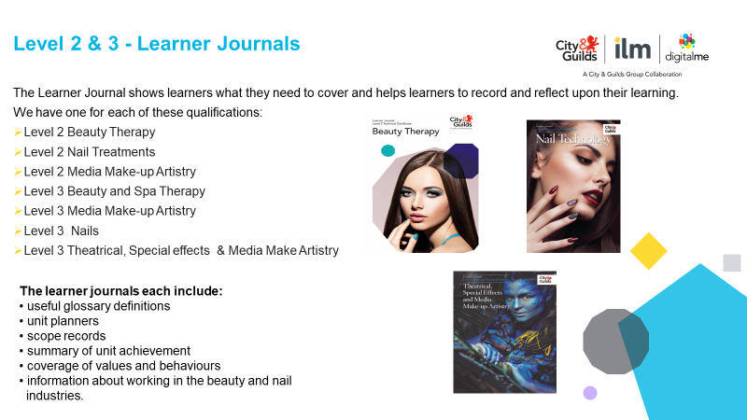

**[](https://www.youtube.com/watch?v=4JRUl9LJD_o&feature=youtu.be)Employer videos**

**Introducing employers we work with in the**

**Hair, Beauty & Barbering Industries.**

[Click here](https://www.youtube.com/watch?v=4JRUl9LJD_o&feature=youtu.be%20%20%20%20%20%20%20%20%20%20%20%20%20%20%20%20%20%20%20%20%20%20%20%20%20%20%20%20%20%20%20%20%20%20%20%20%20%20%20%20%20https://www.youtube.com/watch?v=4JRUl9LJD_o&feature=youtu.be)

Some of the leading voices from the hair, beauty and barbering industries share their perspectives on the future of apprenticeship training and technical education.

Key contributors of the Industry Advisory Board (IAB) for hairdressing, beauty and barbering, these employers have been part of our journey in shaping the future development of our education and training programmes to ensure that the content of our qualifications and training reflect industry needs.  
As well as tips for learners starting out, these professionals also share their perspectives on what they look for when employing new learners into the field.

1. **Maths and English e-Toolkit**

The Maths & English Toolkit includes a wealth of multi-media resources providing you with a blended learning solution to support and enhance math and English teach across your entire organisation.

Referenced to national standards the Maths and English e-Toolkit supports a wide range of Maths and English qualifications and learning programmes, including those provided by other awarding organisations.   
Click here to [book your free, no obligation demonstration today.](https://www.cityandguilds.com/what-we-offer/centres/maths-and-english/maths-and-english-etoolkit/book-a-demo)

**Functional Skills Reforms Updates**

**Reformed Functional Skills qualifications available for first teaching from September 2019.**

**“Did you know that Functional Skills is changing?**

The reformed Functional Skills qualifications will be available for teaching with effect from September 2019, to find out what this means for your delivery and the impact on your apprentices, join our monthly webinars to keep up to date.

Visit the Functional Skills updates page for further information and the link to register for the webinars:

<https://www.cityandguilds.com/what-we-offer/centres/maths-and-english/functional-skills-assessment-updates>”

Stay in touch with the Maths and English team… For more information about all aspects of our maths and English offer, please go to;

[cityandguilds.com/mathsandenglish](http://www.cityandguilds.com/mathsandenglish).

For the latest on Functional Skills reform, please visit our [Functional Skills updates](https://www.cityandguilds.com/what-we-offer/centres/maths-and-english/functional-skills-assessment-updates) pages.

Use **#FunSkills2019** to join the social media conversation.

You can also follow us:

* Paul – [@PaulSceeny_CG](https://twitter.com/PaulSceeny_CG)
* Katherine – [@KatherineC_CG](https://twitter.com/KatherineC_CG)

1. **AEB Funded Qualifications – Hair and Beauty**

|  |  |  |  |  |  |  |  |
| --- | --- | --- | --- | --- | --- | --- | --- |
| Learn Aim Ref | Qual Title | Qual Level | GLH min/max | Local Flex | Funding | LSDN | Assessment Method |
| 5006325X | City & Guilds Entry Level Certificate in an Introduction to the Hair and Beauty Sector (Entry 3) | E3 | 114 /130 | Yes | £941 | 31/07/2018 | Assignment results entry method |
| 50063455 | City & Guilds Level 1 Award in an Introduction to the Hair and Beauty Sector | 1 | 72 /80 | Yes | £585 | 31/07/2018 | Assignment results entry and online UPK test |
| 50064332 | City & Guilds Entry Level Award in an Introduction to the Hair and Beauty Sector (Entry 3) | E3 | 62 / 70 | Yes | £390 | 31/07/2018 | Assignment results entry and online UPK test |
| 50087897 | City & Guilds Level 2 Award in Creating an Image based on a theme in the Hair and Beauty Sector | 2 | 60 | Yes | £390 | 31/07/2018 | Assignment results entry method |
| 50087113 | City & Guilds Level 2 Award in Nail Art | 2 | 24 | Yes | £195 | 31/07/2018 | Assignment results entry |
| 50063479 | City & Guilds Level 1 Certificate in an Introduction to the Hair and Beauty Sector | 1 | 129/140 | Yes | £941 | 31/07/2018 | Assignment results entry and online UPK test |
| 50086522 | City & Guilds Level 2 Award in Make-up | 2 | 42 | Yes | £195 | 31/07/2018 | Assignment results entry |
| 50086844 | City & Guilds Level 2 Award in Nail Technology | 2 | 46 | Yes | £390 | 31/07/2018 | Assignment results entry |
| 50086911 | City & Guilds Level 1 Award in Nail Art and Make up | 1 | 60 | Yes | £390 | 31/07/2018 | Assignment results entry |
| 50087137 | City & Guilds Level 2 Award in Manicure | 2 | 48 | Yes | £195 | 31/07/2018 | Assignment results entry |
| 50087599 | City & Guilds Level 2 Award in Cutting Men's Hair | 2 | 53 | Yes | £390 | 31/07/2018 | Assignment results entry |

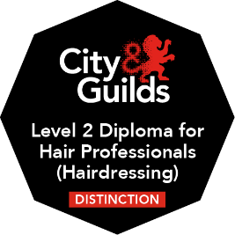**Digital Credentials** for Hair and Barbering has shown to be very popular since receiving the first email request on 17 October 2018.

We have received very positive feedback from all centres involved.

Following the success of the Pilot, Digital Credentials have extended their offer to other areas of the business.

Digital Credentials (or Open Badges) provide an exciting new way to motivate and reward Apprentice on-programme progression, helping apprentices to take the lead in their own skills development and driving accountability and independence. (see more here <https://www.cityandguilds.com/digital-credentials>)

**Keep in touch and up to date**

For regular updates and further information please follow us on:

**Sarah Fillaudeau - Twitter Link**

**Sarah Fillaudeau - Linkedin Link**

[Sarah.fillaudeau@cityandguilds.com](mailto:Sarah.fillaudeau@cityandguilds.com)

**Emma.kite@cityandguilds.com**

[](https://www.linkedin.com)[](https://twitter.com/)**[](https://www.facebook.com/CGhairbeauty1/)**

**Tell us what you think**

*All About Hair & Beauty* is a newsletter that brings together all of the key developments from City & Guilds relevant to *Hair & Beauty* skills learning across England, Northern Ireland and Wales. It contains updates on the range of teaching and learning resources we offer, plus relevant public policy or other information we think you might be interested in.

Each edition is numbered, so we can refer back to previous issues or tell you when information has been superseded.

**Thank you for your continued support.**

Every effort has been made to ensure that the information contained in this publication is true and correct at time of going to press. However, City & Guilds products and services are subject to continuous development and improvement and the right is reserved to change Products and services from time to time. City & Guilds cannot accept liability for loss or damage arising from the use of information in this publication. City & Guilds is a registered charity established to promote education and training.