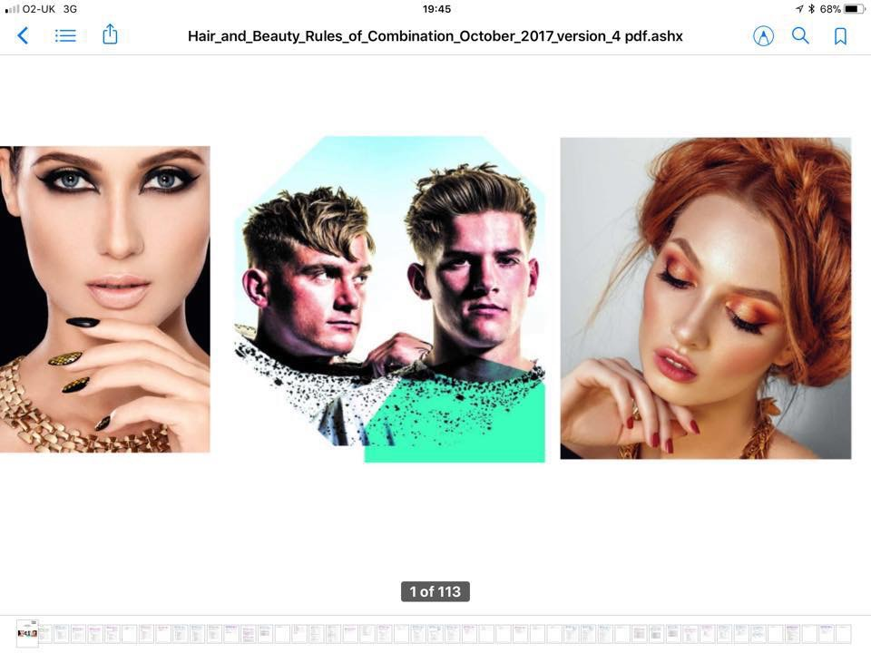



All about Hair & Beauty

**Issue 03**

**May 2018**

A newsletter from City & Guilds on education updates in hair, beauty & complementary therapies for all nations.

**In this issue:**

1. Uploading evidence for Technical Qualifications
2. Resits dates for Technical Qualifications
3. Technical Qualification Key Dates – 2017/18
4. Update KS4 Technical Award in Hair & Beauty Studies Webinar
5. Update Beauty Apprenticeships (England) Webinar
6. Update Hair Apprenticeships (England) Webinar
7. Hair & Beauty Regional Network meetings 2018

(England)

(Cardiff)

(Scotland)

(North/South Ireland)

1. EPA pricing
2. EPA preparation tool
3. Employer videos
4. English & Math’s
5. AEB Hair & Beauty
6. **Uploading evidence for Technical Qualifications**

The Moderation Portal is the online administration platform used to facilitate the submission of marks and evidence and the moderation of the synoptic assignment, Centre assessed components and employer involvement for Technical Qualifications.

You can download a copy of the [Moderation Portal Centre User Guide](https://www.cityandguilds.com/~/media/cityandguilds-site/documents/technical-qualifications/moderationportalcentreuserguidev20%20final%20pdf.ashx) which explains the process for your Centre on how to upload marks and evidence.

**Moderation Portal Centre User Guide**

[*Click here*](https://www.cityandguilds.com/~/media/cityandguilds-site/documents/technical-qualifications/moderationportalcentreuserguidev20%20final%20pdf.ashx)

Following our network events during April for the Moderation Portal, for those of you who were not able to attend you can view the slides from this event [*here*](https://www.cityandguilds.com/~/media/cityandguilds-site/documents/technical-qualifications/moderation%20portal%20networking%20event%20customer%20facing%20pdf.ashx)

1. **Resits dates for Technical Qualifications**

**Please follow the link to the Spring News Letter**

[*Click here*](https://www.cityandguilds.com/~/media/cityandguilds-site/documents/technical-qualifications/technical%20qualifications/onboarding_programmespring_newsletter-final%2020march18%20pdf.ashx)



1. **Technical Qualification Key Dates – 2017/18**

Here is a list of the key dates for the delivery of Technical Qualifications:

|  |  |
| --- | --- |
| Event | Date |
| Results of 1st spring exam series | 23 Apr 2018 |
| Deadline for booking summer (May) exam series | 27 Apr 2018 |
| Results of 2nd spring exam series | 14 May 2018 |
| Deadline for submitting marks and evidence to the Moderation Portal for synoptic assignments | 18 May 2018 |
| Deadline for booking summer (June) exam series | 25 May 2018 |
| Summer exam series | 21 May to 28 June 2018 |
| Deadline for submitting evidence to the Moderation Portal on optional assignments and any other centre-assessed components (if applicable) and employer involvement (KS5 only) | 15 June 2018 |
| Final results, including summer exams, synoptic assignments and qualification grades available for Level 3 | 6 August 2018 |
| Final results, including summer exams, synoptic assignments and qualification grades available for Level 2 | 13 August 2018 |

1. **Update KS4 Technical Award in Hair & Beauty Studies Webinar**



**Register for the Webinar**

**9th May 2018**

**1.30 – 2.30pm**

[*Click here*](https://attendee.gotowebinar.com/register/7632574813936639491)

Update for 2020 Performance Tables

Qualification details

Success so far

Flexibility of delivery

1. **Update Beauty Apprenticeships Webinar (England)**

City & Guilds will be holding the following webinars to update Centre's on the New Beauty Professional Apprenticeship standards;

Level 2 Diploma in Professional Beauty and Make-up consultancy

Level 2 Diploma in Professional Beauty Therapy

Level 2 Diploma in Professional Nail Services

Level 3 Beauty Therapy Standard

Level 3 Holistic Therapist Standard

**Register for the Webinar**

**9th May 2018**

**11.30 – 1.00pm**

[*Click here*](https://attendee.gotowebinar.com/register/4631886635239316737)



**Register for the Webinar**

**12th June 2018**

**9.30 – 11.00am**

[*Click here*](https://attendee.gotowebinar.com/register/284563894059585025)

1. **Update Hair Apprenticeships Webinar (England)**

City & Guilds will be holding the following webinars as a follow up from our recent Winter Network meetings - "Preparing for End Point Assessment (EPA) Hairdressing & Barbering"



**Register for the Webinar**

**9th May 2018**

**9.30 – 11.00pm**

*[Click here](https://register.gotowebinar.com/register/459341162898941441)*

**Register for the Webinar**

**12th June 2018**

**11.30 – 1.00pm**

[*Click here*](https://attendee.gotowebinar.com/register/973125354372656641)

1. **Hair & Beauty Regional Network Meetings**



**Dates for your diary…….** The following events are ready to book onto via the links below and will give an update on our current offer and resources available as well as time to discuss and share good practice as well as preparing for EPA and top tips on preparing your learners for exams and synoptic end assessment.

**Wales**

**Register for the Cardiff Regional Network Meeting**

**27th June 2018 @ 10.00 – 13.00**

[*Click here*](https://www.eventbrite.co.uk/e/city-guilds-hair-beauty-network-meeting-tickets-44789087366)

**Scotland**

**Register for the Glasgow Regional Network Meeting**

**24th October 2018 @ 10.00 – 13.00**

*[Click here](https://www.eventbrite.co.uk/e/city-guilds-hair-beauty-regional-network-meeting-glasgow-tickets-45614124073)*

**England England**



**Register for the Wakefield Regional Network Meeting**

**4th October 2018**

**10.00 – 13.00**

[*Click here*](https://www.eventbrite.co.uk/e/city-guilds-hair-beauty-regional-network-meeting-wakefield-tickets-45299114872)

**Register for the Warrington Regional Network Meeting**

**3rd October 2018**

**10.00 – 13.00**

[*Click here*](https://www.eventbrite.co.uk/e/city-guilds-hair-beauty-regional-network-meeting-warrington-tickets-45299984473)



**Register for the London**

**Regional Network Meeting**

**16th October 2018**

**10.00 – 13.00**

[*Click here*](https://www.eventbrite.co.uk/e/city-guilds-hair-beauty-regional-network-meeting-london-tickets-45333901921)

**Register for the London**

**Regional Network Meeting**

**10th October 2018**

**10.00 – 13.00**

[*Click here*](https://www.eventbrite.co.uk/e/city-guilds-hair-beauty-regional-network-meeting-london-tickets-45333842744)



**Register for the Wakefield Regional Network Meeting**

**6th November 2018**

**10.00 – 13.00**

[*Click here*](https://www.eventbrite.co.uk/e/city-guilds-hair-beauty-regional-network-meeting-wakefield-tickets-45299761807)

**Register for the Warrington Regional Network Meeting**

**29th October 2018**

**10.00 – 13.00**

[*Click here*](https://www.eventbrite.co.uk/e/city-guilds-hair-beauty-regional-network-meeting-warrington-tickets-45333789585)

**Coming soon!**

**South West England, Midlands, North East and Ireland**

**Dates to be confirmed**

1. **EPA Assessment Service**

**What support can my team expect?**

Our City & Guilds EPA team is already supporting employers, colleges and training providers through EPA events and we constantly update our service based on feedback and the changing regulations. As well as email and phone support, we deliver resources to help you through on-programme to gateway and onto EPA.

**End-Point Assessment Service**

[*Click here*](https://www.cityandguilds.com/apprenticeships/emerging-standards/end-assessment-service)

**Manual for End-Point Assessment Service V1 2018**

[*Click here*](https://www.cityandguilds.com/~/media/cityandguilds-site/documents/apprenticeships/manual_for_the_end_point_assessment_service-30_jan_18%20pdf.ashx)



1. **EPA Pricing**

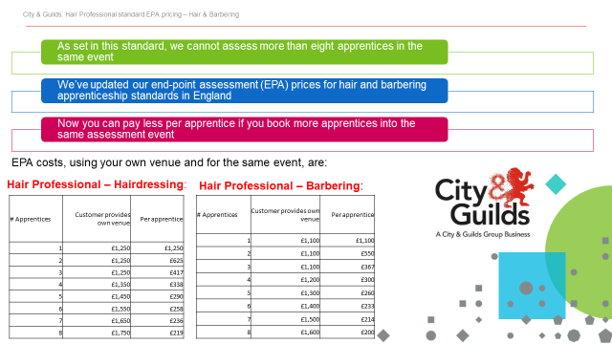

|  |  |  |  |  |  |  |  |  |  |  |  |  |  |  |  |  |  |  |  |  |  |  |  |  |  |  |  |  |  |  |  |  |  |  |  |  |  |  |  |  |  |  |  |  |  |  |  |  |  |  |  |  |  |  |  |  |  |  |  |  |  |  |
| --- | --- | --- | --- | --- | --- | --- | --- | --- | --- | --- | --- | --- | --- | --- | --- | --- | --- | --- | --- | --- | --- | --- | --- | --- | --- | --- | --- | --- | --- | --- | --- | --- | --- | --- | --- | --- | --- | --- | --- | --- | --- | --- | --- | --- | --- | --- | --- | --- | --- | --- | --- | --- | --- | --- | --- | --- | --- | --- | --- | --- | --- | --- |
| |  |  |  |  |  |  |  |  |  |  |  |  |  |  |  |  |  |  |  |  |  |  |  |  |  |  |  |  |  |  |  |  |  |  |  |  |  |  |  |  |  |  |  |  |  |  |  |  |  |  |  |  |  |  |  |  |  |  |  |  |  |  | | --- | --- | --- | --- | --- | --- | --- | --- | --- | --- | --- | --- | --- | --- | --- | --- | --- | --- | --- | --- | --- | --- | --- | --- | --- | --- | --- | --- | --- | --- | --- | --- | --- | --- | --- | --- | --- | --- | --- | --- | --- | --- | --- | --- | --- | --- | --- | --- | --- | --- | --- | --- | --- | --- | --- | --- | --- | --- | --- | --- | --- | --- | | |  |  |  |  |  |  |  |  |  |  |  |  |  |  |  |  |  |  |  |  |  |  |  |  |  |  |  |  |  |  |  |  |  |  |  |  |  |  |  |  |  |  |  |  |  |  |  |  |  |  |  |  |  |  |  |  |  |  |  |  |  | | --- | --- | --- | --- | --- | --- | --- | --- | --- | --- | --- | --- | --- | --- | --- | --- | --- | --- | --- | --- | --- | --- | --- | --- | --- | --- | --- | --- | --- | --- | --- | --- | --- | --- | --- | --- | --- | --- | --- | --- | --- | --- | --- | --- | --- | --- | --- | --- | --- | --- | --- | --- | --- | --- | --- | --- | --- | --- | --- | --- | --- | | |  |  |  |  |  |  |  |  |  |  |  |  |  |  |  |  |  |  |  |  |  |  |  |  |  |  |  |  |  |  |  |  |  |  |  |  |  |  |  |  |  |  |  |  |  |  |  |  |  |  |  |  |  |  |  |  |  |  |  |  | | --- | --- | --- | --- | --- | --- | --- | --- | --- | --- | --- | --- | --- | --- | --- | --- | --- | --- | --- | --- | --- | --- | --- | --- | --- | --- | --- | --- | --- | --- | --- | --- | --- | --- | --- | --- | --- | --- | --- | --- | --- | --- | --- | --- | --- | --- | --- | --- | --- | --- | --- | --- | --- | --- | --- | --- | --- | --- | --- | --- | | |  |  |  |  |  |  |  |  |  | | --- | --- | --- | --- | --- | --- | --- | --- | --- | | |  |  |  |  |  |  |  |  | | --- | --- | --- | --- | --- | --- | --- | --- | | |  |  |  |  |  |  |  | | --- | --- | --- | --- | --- | --- | --- | | |  |  |  |  |  |  | | --- | --- | --- | --- | --- | --- | | |  |  |  |  |  | | --- | --- | --- | --- | --- | | |  | | --- | |  | | |  |  | | --- | --- | | |  | | --- | |  | | | | | | | | 1. **EPA Preparation Tool**   EPA preparation toolOur experience delivering the new EPA service has shown that apprentices can have the competence to pass assessment but lack the confidence to show it. Preparation is key to overcoming this.    [Click here](https://www.youtube.com/watch?v=DM2uAQkHl8E&feature=youtu.be)  **What support can my apprentice expect?** |   Our video summarises the EPA process and how you can prepare for it – it’s for learning providers, employers and apprentices.   |  |  |  |  |  |  |  |  |  |  |  |  |  |  |  |  |  |  |  |  |  |  |  |  |  |  |  |  |  |  |  |  |  |  |  |  |  |  |  |  |  |  |  |  |  | | --- | --- | --- | --- | --- | --- | --- | --- | --- | --- | --- | --- | --- | --- | --- | --- | --- | --- | --- | --- | --- | --- | --- | --- | --- | --- | --- | --- | --- | --- | --- | --- | --- | --- | --- | --- | --- | --- | --- | --- | --- | --- | --- | --- | --- | | |  |  |  |  |  |  |  |  |  |  |  |  |  |  |  |  |  |  |  |  |  |  |  |  |  |  |  |  |  |  |  |  |  |  |  |  |  |  |  |  |  |  |  |  | | --- | --- | --- | --- | --- | --- | --- | --- | --- | --- | --- | --- | --- | --- | --- | --- | --- | --- | --- | --- | --- | --- | --- | --- | --- | --- | --- | --- | --- | --- | --- | --- | --- | --- | --- | --- | --- | --- | --- | --- | --- | --- | --- | --- | | |  |  |  |  |  |  |  |  |  |  |  |  |  |  |  |  |  |  |  |  |  |  |  |  |  |  |  |  |  |  |  |  |  |  |  |  |  |  |  |  |  |  |  | | --- | --- | --- | --- | --- | --- | --- | --- | --- | --- | --- | --- | --- | --- | --- | --- | --- | --- | --- | --- | --- | --- | --- | --- | --- | --- | --- | --- | --- | --- | --- | --- | --- | --- | --- | --- | --- | --- | --- | --- | --- | --- | --- | | |  | | --- | | **﻿﻿**Our new EPA preparation tool   * User-friendly technology accessible on any device, at any time. * Material that's personalised to the apprentice's standard and confidence levels. * Varied content delivery (videos, articles, podcasts and documents). * Covers professional discussion, presentation skills, revision and more. * Free resource - comes as part of our EPA service. |      |  | | --- | |  | | **Three easy steps to access our EPA preparation tool** | | |  |  |  |  |  |  |  |  |  |  |  |  |  |  |  |  |  |  |  |  |  |  |  |  |  |  |  |  |  |  |  |  | | --- | --- | --- | --- | --- | --- | --- | --- | --- | --- | --- | --- | --- | --- | --- | --- | --- | --- | --- | --- | --- | --- | --- | --- | --- | --- | --- | --- | --- | --- | --- | --- | | |  |  |  |  |  |  |  |  |  | | --- | --- | --- | --- | --- | --- | --- | --- | --- | | |  |  |  |  |  |  |  |  | | --- | --- | --- | --- | --- | --- | --- | --- | | |  |  |  |  |  |  |  | | --- | --- | --- | --- | --- | --- | --- | | |  |  |  |  |  |  | | --- | --- | --- | --- | --- | --- | | |  | | --- | | **One** |      |  |  |  |  | | --- | --- | --- | --- | | |  |  |  | | --- | --- | --- | | |  |  | | --- | --- | | |  | | --- | | Register your apprentice for their EPA on Walled Garden. | | | | | | | | | |  |  |  |  |  |  |  |  |  |  | | --- | --- | --- | --- | --- | --- | --- | --- | --- | --- | | |  |  |  |  |  |  |  |  |  | | --- | --- | --- | --- | --- | --- | --- | --- | --- | | |  |  |  |  |  |  |  |  | | --- | --- | --- | --- | --- | --- | --- | --- | | |  |  |  |  |  |  |  | | --- | --- | --- | --- | --- | --- | --- | | |  | | --- | | **Two** |      |  | | --- | |  | | |  |  |  | | --- | --- | --- | | |  |  | | --- | --- | | |  | | --- | | After three days you'll get an email with a link, username and password for SmartScreen (our tutor and learner support platform) where you load your apprentice’s name and email and assign the EPA preparation tool. | | | | | | | | | |  |  |  |  |  |  |  |  |  |  | | --- | --- | --- | --- | --- | --- | --- | --- | --- | --- | | |  |  |  |  |  |  |  |  |  | | --- | --- | --- | --- | --- | --- | --- | --- | --- | | |  |  |  |  |  |  |  |  | | --- | --- | --- | --- | --- | --- | --- | --- | | |  |  |  |  |  |  |  | | --- | --- | --- | --- | --- | --- | --- | | |  | | --- | | **Three** |      |  | | --- | | **https://i.emlfiles4.com/cmpimg/t/s.gif** | | |  |  |  | | --- | --- | --- | | |  |  | | --- | --- | | |  | | --- | | SmartScreen immediately sends the apprentice an email with a link, username and password. All they have to do is login and away they go! | | | | | | | | | |  |  | | --- | |  |  |  | | --- | |  | | |  |  |  | | --- | --- | --- | |  | |  | | --- | |  | | | | | | |  | | **The City & Guilds Textbook - Level 2 Diploma for Hair Professional for Apprenticeships in**  **Professional Hairdressing and Professional Barbering** |  |  | | --- | |  |  |  | | --- | |  | | | | |

1. **[](https://www.youtube.com/watch?v=4JRUl9LJD_o&feature=youtu.be)Employer videos**

**Introducing employers we work with in the**

**Hair, Beauty & Barbering Industries.**

[Click here](https://www.youtube.com/watch?v=4JRUl9LJD_o&feature=youtu.be%20%20%20%20%20%20%20%20%20%20%20%20%20%20%20%20%20%20%20%20%20%20%20%20%20%20%20%20%20%20%20%20%20%20%20%20%20%20%20%20%20https://www.youtube.com/watch?v=4JRUl9LJD_o&feature=youtu.be)

Some of the leading voices from the hair, beauty and barbering industries share their perspectives on the future of apprenticeship training and technical education.

Key contributors of the Industry Advisory Board (IAB) for hairdressing, beauty and barbering, these employers have been part of our journey in shaping the future development of our education and training programmes to ensure that the content of our qualifications and training reflect industry needs.  
As well as tips for learners starting out, these professionals also share their perspectives on what they look for when employing new learners into the field.

1. 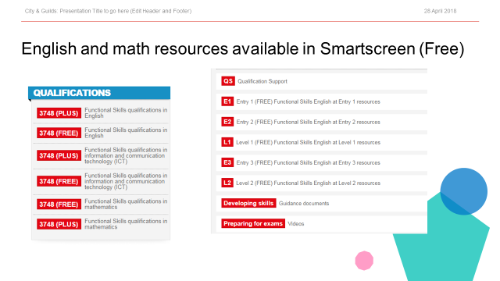**Maths and English e-Toolkit**

Math’s and English are vital skills we all need to develop and keep using throughout life. Almost every job requires the ability to communicate and use numbers confidently, along with the capacity to problem solve and use technology effectively. Please click on the button to explore our offer in more detail.

[](https://www.cityandguilds.com/what-we-offer/centres/maths-and-english/maths-and-english-etoolkit)

[Click here](https://www.cityandguilds.com/what-we-offer/centres/maths-and-english/maths-and-english-etoolkit)

1. **AEB Funded Qualifications – Hair and Beauty**

**SSA – 7.3 Service Enterprise**

|  |  |  |  |  |  |  |  |
| --- | --- | --- | --- | --- | --- | --- | --- |
| Learn Aim Ref | Qual Title | Qual Level | GLH min/max | Local Flex | Funding | LSDN | Assessment Method |
| 5006325X | City & Guilds Entry Level Certificate in an Introduction to the Hair and Beauty Sector (Entry 3) | Entry Level | 114 /130 | Yes | £941 | 31/07/2018 | Assignment results entry method |
| 50063455 | City & Guilds Level 1 Award in an Introduction to the Hair and Beauty Sector | Level 1 | 72 /80 | Yes | £585 | 31/07/2018 | Assignment results entry and online UPK test |
| 50064332 | City & Guilds Entry Level Award in an Introduction to the Hair and Beauty Sector (Entry 3) | Entry Level | 62 / 70 | Yes | £390 | 31/07/2018 | Assignment results entry and online UPK test |
| 50087897 | City & Guilds Level 2 Award in Creating an Image based on a theme in the Hair and Beauty Sector | Level 2 | 60 | Yes | £390 | 31/07/2018 | Assignment results entry method |
| 50087113 | City & Guilds Level 2 Award in Nail Art | Level 2 | 24 | Yes | £195 | 31/07/2018 | Assignment results entry |
| 50063479 | City & Guilds Level 1 Certificate in an Introduction to the Hair and Beauty Sector | Level 1 | 129/140 | Yes | £941 | 31/07/2018 | Assignment results entry and online UPK test |
| 50086522 | City & Guilds Level 2 Award in Make-up | Level 2 | 42 | Yes | £195 | 31/07/2018 | Assignment results entry |
| 50086844 | City & Guilds Level 2 Award in Nail Technology | Level 2 | 46 | Yes | £390 | 31/07/2018 | Assignment results entry |
| 50086911 | City & Guilds Level 1 Award in Nail Art and Make up | Level 1 | 60 | Yes | £390 | 31/07/2018 | Assignment results entry |
| 50087137 | City & Guilds Level 2 Award in Manicure | Level 2 | 48 | Yes | £195 | 31/07/2018 | Assignment results entry |
| 50087599 | City & Guilds Level 2 Award in Cutting Men's Hair | Level 2 | 53 | Yes | £390 | 31/07/2018 | Assignment results entry |

**[](https://www.facebook.com/CGhairbeauty1/)Keep in touch and up to date**

For regular updates and further information please follow us on:

**Diane Mitchell & Sarah Fillaudeau - Twitter Link**

**Diane Mitchell & Sarah Fillaudeau - Linkedin Link**

**Tell us what you think**

*All About Hair & Beauty* is a newsletter that brings together all of the key developments from City & Guilds relevant to *Hair & Beauty* skills learning across England, Northern Ireland and Wales. It contains updates on the range of teaching and learning resources we offer, plus relevant public policy or other information we think you might be interested in.

Each edition is numbered, so we can refer back to previous issues or tell you when information has been superseded.

**Thank you for your continued support.**

Every effort has been made to ensure that the information contained in this publication is true and correct at time of going to press. However, City & Guilds products and services are subject to continuous development and improvement and the right is reserved to change Products and services from time to time. City & Guilds cannot accept liability for loss or damage arising from the use of information in this publication. City & Guilds is a registered charity established to promote education and training.