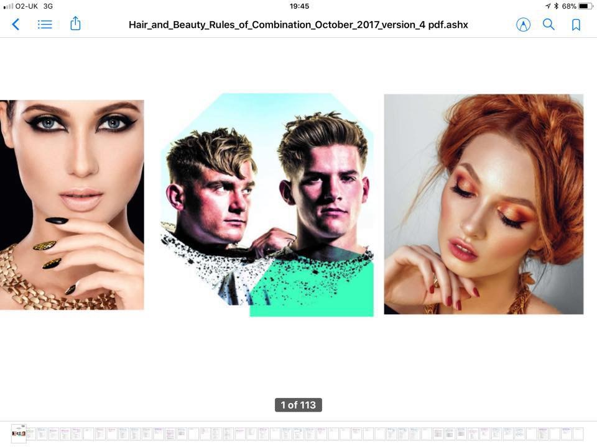

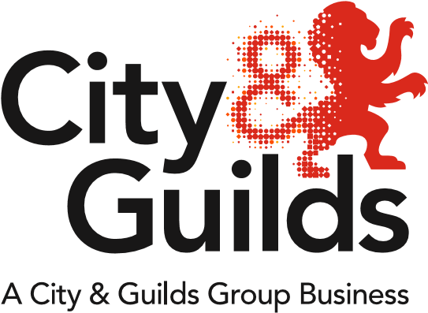

All about Hair & Beauty

**Issue 01**

**September 2019**

A newsletter from City & Guilds on education updates in hair, beauty & complementary therapies for all nations.

**In this issue:**

1. Welcome back
2. Industry update from Emma Mackay – Industry Manager
3. Business as usual NEW Rules of Combination (RoC)
4. Hair & Beauty Regional Network meetings 2018
5. College collaboration & bespoke network for Scotland
6. Ofsted events
7. City & Guilds funding update
8. **All about Technical Qualification – KS4 and KS5**

Welcome pack

Key Dates – 2019/20

Exam calendar – 2019/20

Grade Prediction Calculator – link

Webinars – links

New contact details for quality assurance and moderation

1. **All about Apprenticeships – England**

L2 Hair Professional

L3 Advanced Creative Hair Professional

L2 Beauty Therapist Standard

L2 Nail Technician Standard

L3 Advanced Beauty Therapist standard

EPA preparation tool

Webinar link

Link FAQs – LIPEA report

1. **Coming soon –**

MHFed -Men’s Hairdressing Federation Barbering Competition’s for FY20

AHT Competition and sponsorship for FY20

NHF & NBF Hair and Beauty business awards sponsorship for FY20

SHABA – Scottish Hair and Beauty Awards

1. **Economic Impact Report**
2. **Maths & English**
3. **Social Media links/blogs**
4. **Support & Recourses - Enhanced SmartScreen**

**Welcome back**

Hello!

The team here at City and Guilds hope that you all have had a peaceful, restful summer. It was well deserved after last terms hard work and fantastic achievements.

We want to welcome you all back to the new academic year. We are very excited to be sharing with you our news on upcoming events and developments in the world of hair and beauty. Please take note the upcoming dates for our network meetings, running between September and November, providing full support and guidance on EPA. We will be holding a Northern and Southern Technical only network dates to follow.

These events will also inform you on the work behind the scenes at City and Guilds.

Remember to look at our amazing support resources - take advantage of our engaging Enhanced SmartScreen provisions and our brilliantly informative employer videos. As always, our team are here to support you in supporting your students. Links to resources can be found at the bottom of this newsletter as well as links for any queries or should you wish to contact us. You can also follow us on social media to keep up-to-date with all of the latest information and developments.

We look forward to working with you in the near future,

Best Wishes

Sarah & Emma

**The Hair and Beauty Industry – From Emma Mackay Industry Manager**

The hair and beauty industry, in terms of education, continues to move at an incredibly fast pace! Currently, small and micro business are predominant with the industry employing an estimated 250k employees. On average, hair and beauty businesses continue to turnover an average of £5 billion per year even though our industry comprises of a high proportion of self-employed workers.

With this in mind, all of the teams here at City & Guilds are incredibly busy behind the scenes! We work regularly with government offices, funding agencies and of course a vast number of employers and stakeholders across the hair and beauty industries, to ensure that our products and services meet demands to ensure those seeking employment are able to do so.

Over the last 12 months we have seen a great spike in both registrations onto our Level 2 Hair Professional apprenticeship standard mandatory on-programme qualification and bookings for the relative end point assessments for both hairdressing and barbering. We launched our Level 2 Beauty Therapist and Nail Technician apprenticeship standard on-programme qualification offers and are busy working to launch Beauty and Make-up Consultancy.

A big surprise for us was the ‘earlier than expected’ DfE consultation around the proposed T Level Content for the Hair & Beauty Route. We worked with a group of industry experts to review and, in turn, made relevant recommendations and suggestions. It’s evident that a great deal of work has gone into the initial proposal document and therefore thank all involved for their efforts!

As Industry Manager I am currently spending a great deal of time at Apprenticeship steering group meetings, working with our City & Guilds internal teams on all projects, supporting our EPA teams and focusing on growing and maintaining relationships with an abundance of hair and beauty employers and stakeholders.

Many thanks for continuing to work with City & Guilds and hope to see you all soon

Best Wishes

Emma

**Business as usual NEW Rules of Combination (RoC)**

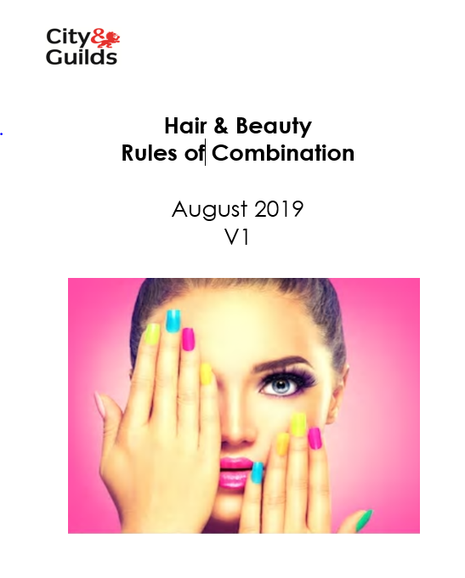

For all the guidance on the NEW rules of combination please click [here](https://www.cityandguilds.com/-/media/cityandguilds-site/documents/qualifications-and-apprenticeships/beauty-and-complementary-therapies/hair-and-beauty-rules-of-combination.ashx?la=en&hash=3E54647A9B204C6710313995C4D79B8FAA6556EA)

**Hair and Beauty Network Meetings Sept – Nov 2019**



**Dates for your diary…….** The following events are ready to book onto via the links below and will give an update on our current offer and resources available as well as time to discuss and share good practice.

|  |  |  |
| --- | --- | --- |
| **Date** | **Time** | **Location** |
| 22.10.2019 | 10-1 | **Prison Focus Group –** Askham Grange Link to tickets <https://www.eventbrite.co.uk/e/prison-focus-group-hair-and-beauty-tickets-68787265563> |
| **Hair & Beauty - Agenda:**   * 1. Prison Home Page ​   2. Introduction  ​   3. Hair, Beauty and Barbering curriculum offer ​   4. Quality processes   5. How to find HB&B​   6. Key documents ​   7. Maths and English (Katherine Cooper)​   8. Support resources (Amy Lang)​   9. Employer endorsement ​   10. Career paths ​   11. **Dermalogica - Jacquie Slater**​   12. Good news stories ​   13. **Guest speaker - TBC**​   14. Prison newsletter ​   15. Questions | | |

**Dates for your diary…….** The following events are ready to book onto via the links below and will give an update on our current offer and resources available as well as time to discuss and share good practice as well as preparing for EPA and top tips on preparing your learners for exams and synoptic end assessment.

|  |
| --- |
| **Hair & Beauty - Agenda:**   1. Hair Professional – Hair and Barbering EPA Event 2. Agenda 3. Welcome – introduction TAs 4. Industry update – general update JJCP – Steering groups – stakeholder – sponsorships – competitions - T Levels 5. Processes – how to book - 8 steps 6. LIPEA Report – (overall performance to date – areas of good performance – areas for development – additional information) 7. Preparing for EPA – (environment – client – apprentice – staff/employers on the day – safe working practices – paper work) 8. Activity – understanding the assessment plan (hair or barbering) scenario based 9. 20% off the Job 10. FAQs |

|  |  |  |  |
| --- | --- | --- | --- |
| **Region** | **Planned Centre/Office** | **Date** | **Eventbrite** |
| North West | Warrington Office | 16th Sept | <https://www.eventbrite.co.uk/e/hair-professional-hair-and-barbering-epa-network-tickets-67993007917> |
| Midlands | Burntwood Office | 23rd Sept | <https://www.eventbrite.co.uk/e/hair-professional-hair-and-barbering-epa-network-tickets-68003443129> |
| Yorkshire | Wakefield Office | 9th Oct | <https://www.eventbrite.co.uk/e/hair-professional-hair-and-barbering-epa-network-tickets-68105837393> |
| North East | New Durham College | 10th Oct | <https://www.eventbrite.co.uk/e/hair-professional-hair-and-barbering-epa-network-tickets-68106200479> |
| London | CONEL College | 16-Sep | <https://www.eventbrite.co.uk/e/hair-professional-hair-and-barbering-epa-network-venue-tbc-tickets-68469946453> |
| London | CONEL College | 24th Sept | <https://www.eventbrite.co.uk/e/hair-professional-hair-and-barbering-epa-network-venue-tbc-tickets-68443015903> |
| South West / Cornwall | TBC (Cornwall College St A) | 9th Oct | <https://www.eventbrite.co.uk/e/hair-professional-hair-and-barbering-epa-network-venue-tbc-tickets-68476245293> |
| South West / Devon | TBC (PETROC) | 10th Oct | <https://www.eventbrite.co.uk/e/hair-professional-hair-and-barbering-epa-network-veunue-tbc-tickets-68476764847> |
| Gloucester | Gloucester | 24th Oct | <https://www.eventbrite.co.uk/e/hair-professional-hair-and-barbering-epa-network-gloucester-venue-tbc-tickets-68482152963> |
| South West Training | South West Training | 23rd October | <https://www.eventbrite.co.uk/e/hair-professional-hair-and-barbering-epa-network-south-east-venue-tbc-tickets-68478923303> |

**How to prepare for Ofsted**

14Oct London - <https://www.eventbrite.co.uk/e/supporting-employers-prepare-for-ofsted-monitoring-visits-london-tickets-66658578603>

22 Oct Wakefield - <https://www.eventbrite.co.uk/e/supporting-employers-prepare-for-ofsted-monitoring-visits-wakefield-tickets-66659154325>

26 Nov Manchester- <https://www.eventbrite.co.uk/e/supporting-employers-prepare-for-ofsted-monitoring-visits-manchester-tickets-68604037523>

**Funding - to ensure you are fully aware of all funding updates, please check your email preferences include funding.**



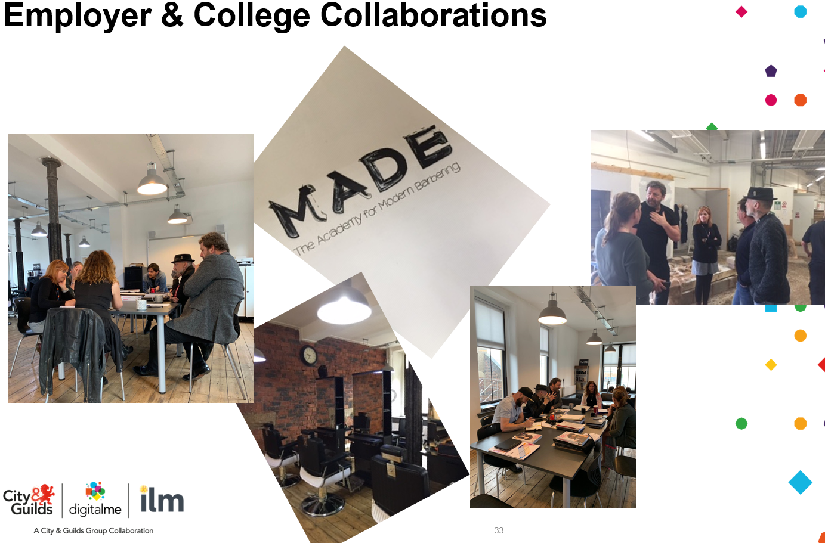

**Bespoke event hosted by Made Academy 11th September in Glasgow**

City and Guilds Hair,Beauty and Barbering Network with special guest Dermalogica https://www.dermalogica.co.uk and Rebel Rebel, http://www.rebelbarber.co.uk/ hosted by Made Academy Glasgow http://rebelbarber.co.uk/made-academy. This event will offer an update on industry from City and Guilds provide an overview of qualifications and quality processes. Special guest Dermalogica will be showcasing the work they do with Colleges. Presentation from Made. This event is for college lecturers who will also have the opportunity to gain some free CPD from Dermalogica and Rebel Rebel.

<https://www.eventbrite.co.uk/e/hair-beauty-and-barbering-network-glasgow-tickets-63740795435>

For future events in Nation’s please contact Emma or Sarah to be put on our mailing list.

1. **All about Technical Qualification – KS4 and KS5 Technicals**

**New Contact details !!!**

Technicals and Moderation Support  
E: [moderationsupport@cityandguilds.com](mailto:moderationsupport@cityandguilds.com)

T: 0300 303 5352 (option 2 then option 3)

**Key Stage 4**

To help support centres delivering KS4 Technical Awards we have organised two regional networks which are now live on Eventbrite. These networks are specifically aimed at teachers and lecturers delivering KS4 Technical Awards.

One network is being held in **Wakefield** on October 16th  2019  link <https://www.eventbrite.co.uk/e/city-guilds-ks4-technical-awards-regional-network-for-teacherslecturers-tickets-71375460925>

The other is a repeat of the Wakefield network being held in **London** on November 22nd. 2019  link  <https://www.eventbrite.co.uk/e/city-guilds-ks4-technical-awards-regional-network-for-teacherslecturers-tickets-71480765895>

**Key Stage 5**

**Hyperlinks to supportive documentation**

**Please click on the links below.**

**Grade Prediction Calculator**

**New**

[](https://www.cityandguilds.com/techbac/resources-and-support)

[Click here for grade calculator](https://www.cityandguilds.com/techbac/resources-and-support)

**All about Apprenticeships – England**

**Removal of Apprenticeship frameworks**

The government will move from apprenticeship frameworks to standards by 2020. We can now confirm that all frameworks will be withdrawn by 2020 to 2021 academic year, as we expect that employers and providers will have completed the transition by this date. For further guidance follow the link.

<https://www.gov.uk/government/publications/removal-of-apprenticeship-frameworks>

[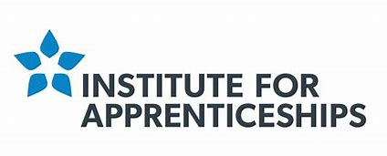](https://www.bing.com/images/search?view=detailV2&ccid=l5iMud9Y&id=2F4AF34658ADBE3729C7051CE88B3CB827B3E770&thid=OIP.l5iMud9YpGY4E55dAJR2vAHaC0&mediaurl=https%3a%2f%2fassets.publishing.service.gov.uk%2fgovernment%2fuploads%2fsystem%2fuploads%2forganisation%2flogo%2f1214%2f6.2614_DFE_IfA_Identity_Master_logo_RGB_AW.jpg&exph=793&expw=2080&q=institute+for+apprenticeships+gov&simid=608044660957252318&selectedIndex=0)

**To stay updated sign up to the IFA newsletter**

<https://www.instituteforapprenticeships.org/about/newsletter/>

**7002 - Level 2 Hair Professional**

|  |  |
| --- | --- |
|  | **QAN** |
| City & Guilds Level 2 Diploma for Hair Professionals – Barbering | 603/1380/8 |
| City & Guilds Level 2 Diploma for Hair Professionals – Hairdressing | 603/1379/1 |

**Level 3 Advanced and Creative Hair Professional *standard still under development and is not yet ready for use.**

|  |
| --- |
| **Advanced and Creative Hair Professional Standard*standard still under development** |
| Use fashion forward trends in hair, creative and precision techniques to create a collection of hairstyle looks |
| Smoothing and Strengthening services |
| Advanced creative colour conversion |
| Hair and scalp specialist service * |

**7003 - Level 2 Beauty Therapy Standard and Nail Services Technician. Beauty and Make-Up Consultancy apprenticeship standard is in development and is not yet ready for use.**

|  |  |
| --- | --- |
|  | |
| City & Guilds Level 2 Beauty Therapist | 603/3459/9 |
| City & Guilds Nail Services Technician | 603/3892/1 |
| City & Guilds Beauty and Make-up Consultancy | TBC |

**Level 3 Advanced Beauty Standard – *This apprenticeship standard is in development and is not yet ready for use.**

√ Proposal approved

√ Standard approved

X Assessment plan approved

X Funding band assigned

We have seen a record month of EPA with so much success, we have a LIEPA (lead end point assessor) reports that identify learner’s skills that show how they are achieving distinctions. This report also identifies common pitfalls like poor model choice. It is very important to use these reports to best prepare your learners and to inform them how they can move from pass to distinction. Follow the link to access the report.

<https://www.cityandguilds.com/-/media/productdocuments/hairdressing/hairdressing/7002/end-point_assessment_epa/7002_hair_professional_liepa_report_june_2019-pdf.ashx>

**8 Steps to EPA**

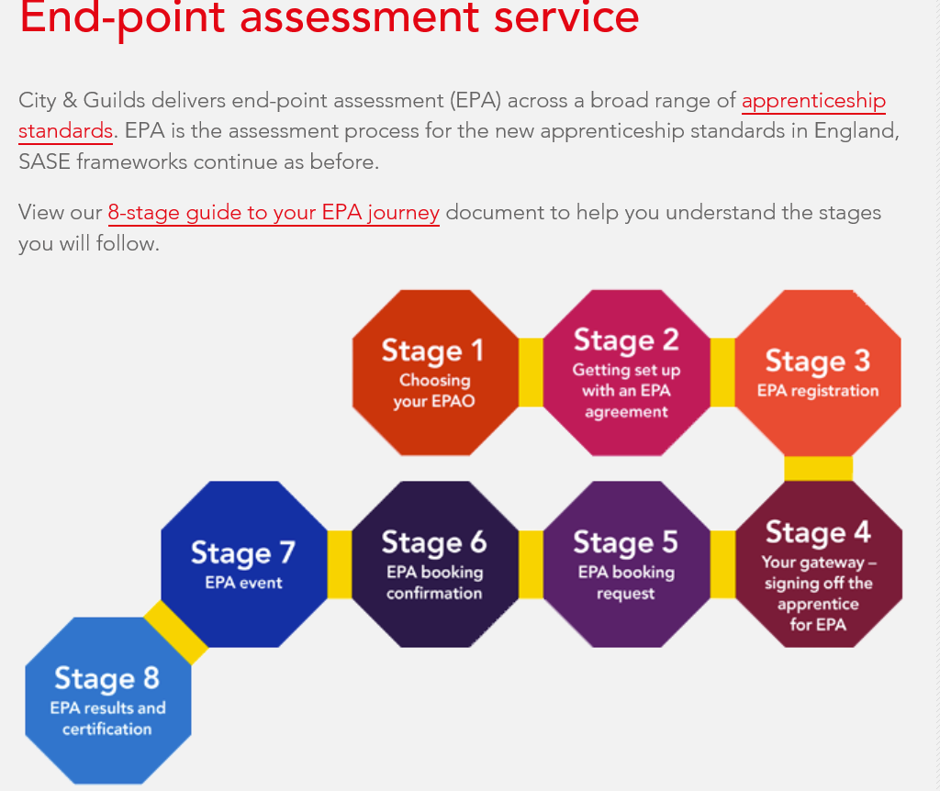

**Click here** [EPA](https://www.cityandguilds.com/-/media/cityandguilds-site/documents/apprenticeships/city-and-guilds-and-ilm-the-8-step-guide-to-your-epa-journey-pdf.ashx?la=en&hash=AD39898AA25742E504CFFBD3D5B2CD24CA53C330) **-8 steps**

**What support can my apprentice expect?**

To help your apprentice, once they are registered for our EPA, we give them access to our EPA preparation tool. This is online content to help them feel ready for their EPA experience. User-friendly technology takes the apprentice through a series of questions, to suggest material personalised to their apprenticeship standard and their confidence levels.

The content is curated from across the web and covers areas like revision and exam skills, multiple choice test strategies, professional discussion and interview skills. You can [watch our short video](https://www.youtube.com/watch?v=DM2uAQkHl8E) to learn more.

|  |  |  |  |  |  |  |  |  |  |  |  |  |  |  |  |  |  |  |
| --- | --- | --- | --- | --- | --- | --- | --- | --- | --- | --- | --- | --- | --- | --- | --- | --- | --- | --- |
| |  |  |  |  |  |  |  |  |  |  |  |  |  |  |  |  |  |  | | --- | --- | --- | --- | --- | --- | --- | --- | --- | --- | --- | --- | --- | --- | --- | --- | --- | --- | | |  |  |  |  |  |  |  |  |  |  |  |  |  |  |  |  |  | | --- | --- | --- | --- | --- | --- | --- | --- | --- | --- | --- | --- | --- | --- | --- | --- | --- | | |  |  |  |  |  |  |  |  |  |  |  |  |  |  |  |  | | --- | --- | --- | --- | --- | --- | --- | --- | --- | --- | --- | --- | --- | --- | --- | --- | | |  | | --- | |  | | **EPA Preparation Tool**  **EPA preparation tool** |   Our video summarises the EPA process and how you can prepare for it – it’s for learning providers, employers and apprentices.   |  |  |  |  |  |  |  |  | | --- | --- | --- | --- | --- | --- | --- | --- | | |  |  |  |  | | --- | --- | --- | --- | | |  |  |  | | --- | --- | --- | | About three days after you register your apprentice for our EPA on Walled Garden, we’ll email the EPA contact you assigned when you applied to use our EPA. They’ll get a welcome email with a link. This link goes to our tutor and learning platform, SmartScreen, where they load the apprentice’s name and email address  As soon as that person loads and saves the apprentice’s information, your apprentice will get an email with a link to the EPA preparation tool and a username and password. Once the apprentice has logged in and they’ve had their name assigned to the EPA preparation tool, that’s it! They can start using it.  There’s no additional charge for the tool and it does not need a license to use SmartScreen.  **How do my apprentices sign up for your EPA preparation tool?**   |  | | --- | |  |  |  | | --- | |  | | | | **What support can my team expect?**  Our City & Guilds EPA team is already supporting employers, colleges and training providers through EPA events and we constantly update our service based on feedback and the changing regulations. As well as email and phone support, we deliver resources to help you through on-programme to gateway and onto EPA. Whichever part of an apprenticeship you choose to work with us on, we want the employer, tutor and apprentice journey to be as smooth as possible  .  Jo is the team leader in the new success team and her role is to guide and support you through your EPA journey.  **Jo Howell**  **EPA Customer Success Team Leader**  [epasupport@cityandguilds.com](mailto:epasupport@cityandguilds.com) | |  | |  | | |  | | **Myth Busting** – No, you don’t need to have had an EQA visit before you submit this evidence. This qualification was a low risk and DCS was transferred from the old Hair qualification – you **MUST** have applied for the approval of the new qualification through Walled Garden. If you did not have direct claim status for 6008 the old framework you will however need a EQA visit.  **Access Arrangements** are pre-examination adjustments for candidates based on evidence of need and normal way of working.  **Follow the link below for guidance on access arrangements**    Click [here](https://www.cityandguilds.com/delivering-our-qualifications/centre-development/centre-document-library/policies-and-procedures/access-arrangements-reasonable-adjustments)    In this section you will find polices on   * Malpractice * Results * Appeals * Conflict of interest   Click [here](https://www.cityandguilds.com/apprenticeships/endpoint-assessment-service) for the link to the page  **AHT Competitions**  Some of you may not be aware of the Association of Hairdressers and Therapists (AHT). We are a professional organisation who work in partnership with ***City and Guilds, Habia, MFed, Worldskills UK*** and other industry associations that help shape today’s Hair and Beauty learning, training and qualifications***. AHT membership*** is open to professionals in Colleges, Private Training and other providers.  We cover England, Ireland, Scotland and Wales.    One of our main areas of work is to promote and stage Hair & Beauty competitions. These competitions allow any trainees in the Hair and Beauty Industry, the opportunity to enter AHT competitions.  Promoting competitions gives Centres the opportunity of embedding competition work into their curriculum, in turn this provides positive outcomes for the provider and their trainees.  When trainees enter competitions, we know it helps build confidence in their abilities as well as increasing their level of skills and quality of the work they produce. Testaments to this can be read in the 'real' life stories from last year’s competitors (attached) These can be used in tutorials to help raise interest in entering the competitions.  Each year the ***AHT*** hold Regional competitions throughout GB. This then leads up to a National Event, which is held over two consecutive days at The Winter Gardens, Blackpool.  ***The 2020 Grand Finals - Sunday 15th March and Monday 16th March***will see finalists from each region competing for National Trophies.  During these 2 days there will be a variety of trainee 'Direct Entry' competitions. This will give any trainees, ***on either of the two days,*** an opportunity to enter a wide range of competitions. The competitions will cover all aspects of Hair and Beauty Skills. *Further information can be seen on the attached flier, or by visiting the AHT website.*    **SHABA Competitions**    City and Guilds would like to congratulate all of the finalist for the SHABA awards.  City and Guilds sponsored the Barber Apprentice of the year and the winner was Martin Desta from Rebel Rebel Barbers.          **City & Guilds in collaboration with The Men’s Hairdressing Federation** - **Trainee Barber of the Year competition and Barber of the Year competition 2020**  Both competitions are photographic digital evidence entry only – application forms, competition briefs and rules and regulations will made available on the MHFed webpage  Photographic evidence to be uploaded to the MHFed webpage.  **Trainee Barber comp:** Applicants must submit evidence along with a testimonial from their education provider to confirm that they are still active within their training.  This can be at any level and on any type of qualification. Before and after photographs will be required for submission.  **Barber comp:** A copy of the applicant’s qualification certificate is required alongside submission (any AO) Before and after photographs will be required for submission.  Official launch date will be 28th October 2019  Closing date for applications 3rd February 2020  Judging to take place 12th February 2020 at City & Guilds Head Office  **What’s the Prize….**  Front Cover for the Barber of the Year and 2 pages inside the Barber NV Magazine for the Trainee Barber of the Year. https://www.athertoncox.co.uk/image/desmond-murray-jpg**Desmond Murray** - the Photographer, Stylist, Barber, Colour Desmond Murray is an award-winning hairdresser. Throughout, Desmond has constantly pushed himself to achieve new heights and as a result is being recognised for his dedication, passion and creative work in both hairdressing and photography. Already housed in British Hairdressing Award’s Hall of Fame in recognition of his award-winning hair artistry, 2009 found Desmond accepting an additional award from the British Hairdressing Awards citing him Men’s Hairdresser of the year. This was followed by an international award from the A.I.P.P. which named Desmond Murray’s collection as the ‘Best Photographic Collection of the Year’. This being an accolade not only for his hairdressing skills, but his dexterity as an award-winning photographer. |     **New !!!**   |  | | --- | |  | |  | | **City and Guilds were pleased to attend Parliament to support the Hair and Barber Council.**  **The Economic Impact Assessment Report for Hairdressing & Beauty.** | | | | |

**Hair and Beauty Industry to be included in the Labour Party Manifesto!**

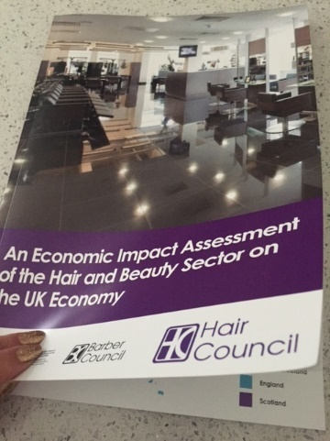 

|  |
| --- |
| **Following the launch of the much-anticipated Hair and Barber Council's Economic Impact Assessment report on May 22 in the Palace of Westminster, into the value of the Hair and Beauty Industry to the UK economy, I am delighted to report that we have been contacted by the Labour Party asking us to open dialogue with their Labour Business Chair, to ensure our cause to mandatory registration and the industry will form part of their manifesto! This is an incredible step forward and one we are actively pursuing!**  **In addition, a statement was received via the Labour Party on June 10, stating;**  ***"The Hair and Barber Council's report is a milestone in positioning the Hair and Beauty sector as a political force to be reckoned with."***  **This launch, together with the data survey we commissioned 18 months ago, now gives us all the information successive Governments have asked for and has greatly spearheaded our cause higher up the political agenda!**  **If you would like a copy of this report please log onto the website**[www.haircouncil.org.uk](https://protect-eu.mimecast.com/s/vaMpCzmrQHMqKY7sge4dW?domain=haircouncil.org.uk)**where you can order a copy. P&P is £3.** |

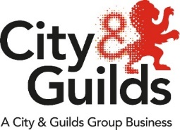**Functional Skills reform: are you ready?**

## **Reformed qualifications now available for first teaching**

## **No further registrations possible for legacy qualifications**

The previous (legacy) Functional Skills Mathematics and English qualifications are now closed to new candidate registrations. Any learners already registered for these (ie 3748-01 for FS English or 3748-02 for FS Mathematics) may still work towards these, although the legacy qualifications’ assessments will start to be withdrawn from April 2020 and must be certificated by 31 August 2020.

**Have you applied for your 4748 approval?**

If you're a centre that is currently approved to deliver our legacy Maths and English Functional Skills qualifications (3748), you'll need to apply for fast track approval to deliver our reformed maths and English Functional Skills[(4748)](https://www.cityandguilds.com/qualifications-and-apprenticeships/skills-for-work-and-life/english-mathematics-and-ict-skills/4748-functional-skills#tab=information) qualifications.

[**Instructions for completing fast track or QAP approval process**](https://www.cityandguilds.com/qualifications-and-apprenticeships/skills-for-work-and-life/english-mathematics-and-ict-skills/-/media/204885e7618447a88cf68dd3b342cc41.ashx) **(PDF)**

For more information, visit [cityandguilds.com/mathsandenglish](https://cityandguilds.com/mathsandenglish) and follow the links to our Functional Skills pages.

**Don’t miss out on the latest news and events from City & Guilds. Sign up today for your email updates and we will send them straight to your inbox.**

Use #FunSkills2019 to join the social media conversation about the Functional Skills reforms.

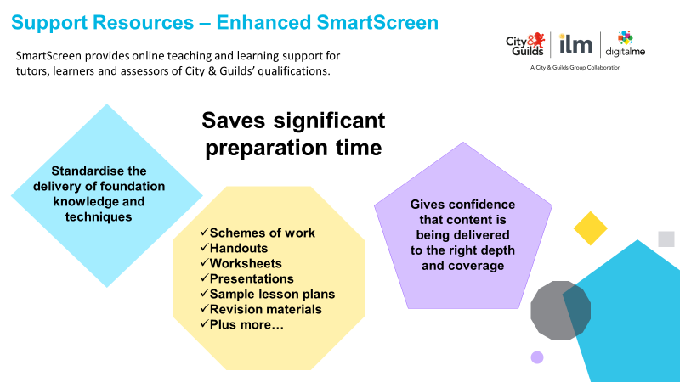

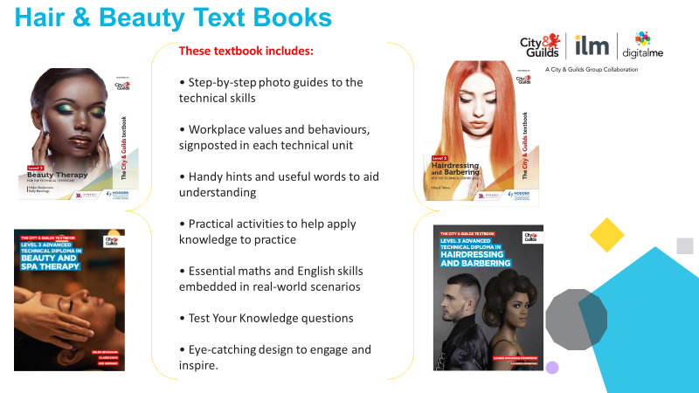

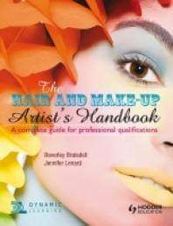Bev has worked in excess of 30 Years in a variety of fields within the Beauty, Nail & Make-Up industries. She is an Author of renowned book; 'The Hair & Make Up Artists Handbook' Published by *(Hodder).*

She is the Co-owner of the Make Up Company 'I'm Made Up', completing make up services on many events, festivals, films & celebrity clients. In addition, she owns 'The Beverley Braisdell Spa & Salon Consultancy', with renowned client's such as Mere Golf Resort & Spa, Knutsford.

A Curriculum Leader in Media Make Up in an FE college and also teaches at University level where she wrote the Foundation Degree & Level 6 in Media Make Up. Beverley has also taught in Athens, Greece for the Misel School and Dubai Production City.

A HABIA Forum Member*,* occasional Feature Writer *("The Voice of FE" (nails) Scratch Magazine),* Guest Speaker & Judge for the National Nail Competition in Athens Greece and Guest Speaker at Excel & Olympia Trade Shows. Make Up Artist & Designer for Houston Jones Entertainment for short Films & music videos, TV *(Britain's Got Talent, short films for the BBC & ITV) and* Theatre *(Micheal - O2 Academy London, Sweeney Todd, Our House & Sister Act)*. She has worked with acts from Cirque Du Soleil, Main Stage acts at Kendal Calling Festival, Cream Classical, Priscilla Queen of the Desert, fashion brands on Etsy, I am Attitude and ASOS amongst others. Beverley is a passionate advocate for high standards in the industry.

Website

[www.purpleuniverse.co.uk/im-made-up-1/](http://www.purpleuniverse.co.uk/im-made-up-1/)

Instagram

www.instagram.com/immadeup_/

## **Keep in touch and up to date**

For regular updates and further information please follow us on:

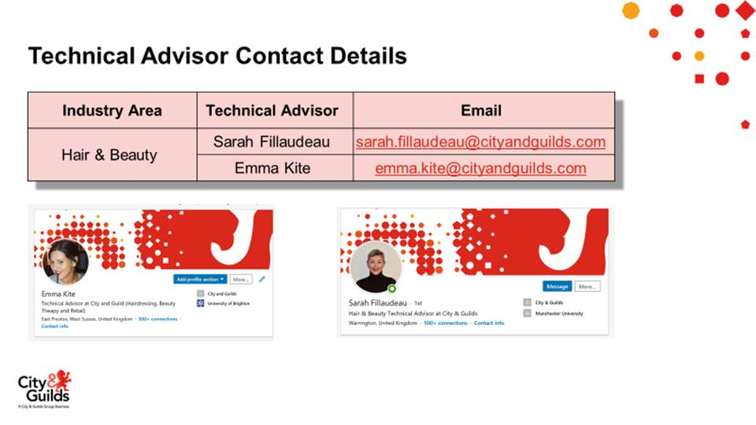

[](https://www.linkedin.com)[](https://twitter.com/)**[](https://www.facebook.com/CGhairbeauty1/)**

**Tell us what you think**

*All About Hair & Beauty* is a newsletter that brings together all of the key developments from City & Guilds relevant to *Hair & Beauty* skills learning across England, Northern Ireland and Wales. It contains updates on the range of teaching and learning resources we offer, plus relevant public policy or other information we think you might be interested in.

Each edition is numbered, so we can refer back to previous issues or tell you when information has been superseded.

**Thank you for your continued support.**

Every effort has been made to ensure that the information contained in this publication is true and correct at time of going to press. However, City & Guilds products and services are subject to continuous development and improvement and the right is reserved to change Products and services from time to time. City & Guilds cannot accept liability for loss or damage arising from the use of information in this publication. City & Guilds is a registered charity established to promote education and training.