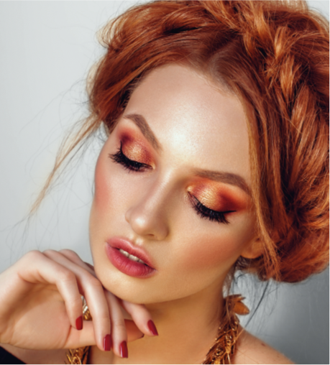

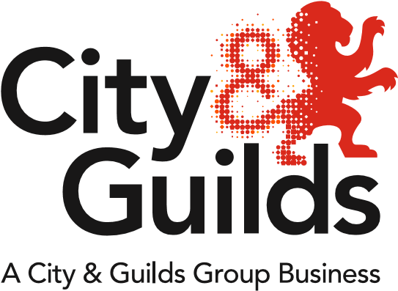

All about Hair & Beauty

**Issue 01**

**January 2018**

A newsletter from City & Guilds on education updates in hair, beauty & complementary therapies for all nations.

**In this issue:**

1. Welcome to the new Hair & Beauty Advisor – Sarah Fillaudeau
2. Principal Moderators – Sharing best practice & marking synoptic assessment
3. Technical Newsletter
4. KS5 Hair & Beauty Technicals – support and updates
5. KS4 Hair & Beauty Technicals Webinar
6. Hair & Beauty Apprenticeships (England)
7. Prison Focus Group meeting
8. Hair & Beauty Regional Network meeting (Glasgow)
9. NEW EPA preparation tool
10. 7002 – Hair Professional Text book
11. Qualification extensions
12. AHT – Association of Hairdressers and Therapists

**Welcome to the new Hair & Beauty Advisor – Sarah Fillaudeau**

City & Guilds are really pleased to welcome Sarah Fillaudeau who has now joined the Hair & Beauty team as another full time Hair & Beauty Technical Advisor. Sarah will be working closely with Diane Mitchell and Emma Mackay the Industry Manager for Hair, Beauty & Retail.

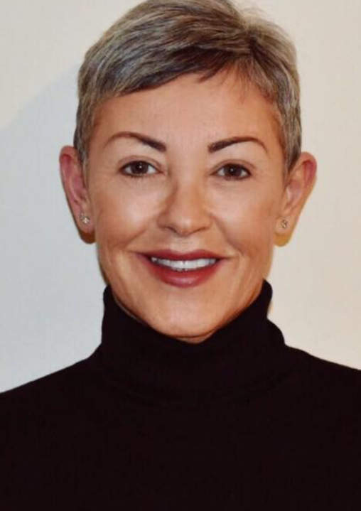

**Principal Moderators – Sharing best practice & marking synoptic assessment**

These webinars will be delivered by the Quality Assurance and Improvement Team along with principal moderators of Technical Qualifications.  
  
The webinars will cover lots of information surrounding synoptic assessments, including:

* An overview of the synoptic assignment
* An explanation of the requirements for evidence submission
* A look at the process of marking synoptic assignments using City & Guilds documentation
* A description of the role of the centre within the marking process
* Sharing best practice for centre quality assurance and marker standardisation.

Please see below a list of dates and times for each Qualification Specific webinar and click the links below to register your place.

|  |  |  |
| --- | --- | --- |
| Webinar Title | Dates & Times | To Book |
| KS4 Level 2 Hair and Beauty Marking and Standardisation Support | Thursday 25th of January 2018  12:00pm -13:00pm  1:00pm – 2:00pm | [Click Here](https://attendee.gotowebinar.com/rt/7121113888480560899) |
| Level 3 Media Makeup Artistry Marking and Standardisation Support | Tuesday 30th of January 2018  11:00am -12:00pm  2:00pm – 3:00pm | [Click Here](https://attendee.gotowebinar.com/rt/8407576577839187459) |
| Level 3 Hairdressing Marking and Standardisation Support | Thursday 1st of February 2018  12:00pm – 1:00pm  1:30pm – 2:30pm | [Click Here](https://attendee.gotowebinar.com/rt/1218719966299325187) |
| Level 3 Beauty Therapy Marking and Standardisation Support | Tuesday 6th of February 2018  11:00am – 12:00pm  2:00pm – 3:00pm | [Click Here](https://attendee.gotowebinar.com/rt/7437432388675257347) |

**Technical Newsletter**

A quarterly communication full of key dates, operational updates, and the latest information about our Technical Qualifications.

**Please follow this link to access the Autumn Newsletter -** <https://www.cityandguilds.com/~/media/techbac/documents/Technical%20Qualifications/Autumn%20Newsletter%202017%20pdf.ashx>

Please follow this link to access the Winter Newsletter –

<https://www.cityandguilds.com/~/media/techbac/documents/OnBoarding_ProgrammeWinter_Newsletter_v2%20pdf.ashx>

**KS5 Hair & Beauty Technicals – support and updates**

**6002-23 Level 2 Technical Certificate for Hair Colouring Services (012)**

In response to feedback from our valued centres and in line with our policy on continual improvement, we have reviewed the assignment brief for the above technical assignment to incorporate further clarification and detail on the requirements for the task to further support candidates and centres in preparing for the assignment.

**Please see below links to the Technical Exam guides**

|  |  |
| --- | --- |
| **Technical – Award – Certificates – Diplomas** | |
| **Qualification number and title** | **Exam Guides** |
| 3038-21 Level 2 Award in Hair & Beauty Studies | [3038-21 Technical Exam Guide](https://cdn.cityandguilds.com/ProductDocuments/Beauty_and_Complementary_Therapies/Beauty/3038/Level_2/Assessment_Materials/3038-21_Technicals_exam_document_2018_v1-1.pdf) |
| 6002-21 Level 2 Certificate in Hairdressing | [6002-21 Technical Exam Guide](https://cdn.cityandguilds.com/ProductDocuments/Hairdressing/Hairdressing/6002/6002_Level_2/Assessment_materials/6002-21_Technicals_exam_document_2018_v1-0.pdf) |
| 6002-22 Level 2 Certificate for Cutting & Styling Services | [6002-22 Technical Exam Guide](https://cdn.cityandguilds.com/ProductDocuments/Hairdressing/Hairdressing/6002/6002_Level_2/Assessment_materials/6002-22_Technical_exam_document_2018_v1-0.pdf) |
| 6002-23 Level 2 Certificate for Hair Colouring Services | [6002-23 Technical Exam Guide](https://cdn.cityandguilds.com/ProductDocuments/Hairdressing/Hairdressing/6002/6002_Level_2/Assessment_materials/6002-23_Technical_Exam_document_2018_v0-1.pdf) |
| 6002-31 Level 3 Advanced Diploma in Hairdressing | [6002-31 Technical Exam Guide](https://cdn.cityandguilds.com/ProductDocuments/Hairdressing/Hairdressing/6002/6002_Level_3/Assessment_materials/6002-31_Technicals_exam_document_2018_v1-0.pdf) |
| 6002-20 Level 2 Certificate in Barbering | [6002-20 Technical Exam Guide](https://cdn.cityandguilds.com/ProductDocuments/Hairdressing/Hairdressing/6002/6002_Level_2/Assessment_materials/6002-20_Technical_Exam_document_2018_v1-0.pdf) |
| 6002-30 Level 3 Advanced Diploma in Barbering | [6002-30 Technical Exam Guide](https://cdn.cityandguilds.com/ProductDocuments/Hairdressing/Hairdressing/6002/6002_Level_3/Assessment_materials/6002-30_Technical_exam_document_2018_v1-0.pdf) |
| 6003-20 Level 2 Certificate in Beauty Therapy | [6003-20 Technical Exam Guide](https://cdn.cityandguilds.com/ProductDocuments/Beauty_and_Complementary_Therapies/Beauty/6003/6003_Level%202/Assessment_Materials/6003-20_Technicals_exam_document_2018_v1-0.pdf) |
| 6003-30 Level 3 Advanced Diploma in Beauty & Spa Therapy | [6003-30 Technical Exam Guide](https://cdn.cityandguilds.com/ProductDocuments/Beauty_and_Complementary_Therapies/Beauty/6003/6003_Level%203/Assessment_Materials/6003-30_Technicals_exam_document_2018_v1-0.pdf) |
| 6003-22 Level 2 Certificate in Nail Treatments | [6003-22 Technical Exam Guide](https://cdn.cityandguilds.com/ProductDocuments/Beauty_and_Complementary_Therapies/Beauty/6003/6003_Level%202/Assessment_Materials/6003-22%20Technicals_exam_document_2018_v1-0.pdf) |
| 6003-32 Level 3 Advanced Diploma in Nail Technology | [6003-32 Technical Exam Guide](https://cdn.cityandguilds.com/ProductDocuments/Beauty_and_Complementary_Therapies/Beauty/6003/6003_Level%203/Assessment_Materials/6003-32%20Technicals_exam_document_2018_v1-0.pdf) |
| 6004-30 Level 3 Advanced Diploma in Complementary Therapies | [6004-030 Technical Exam Guide](https://cdn.cityandguilds.com/ProductDocuments/Beauty_and_Complementary_Therapies/Complementary_Therapies/6004/6004_Level_3/Assessment_materials/6004-030_Technicals_exam_document_2018_v1-0.pdf)  [6004-032 Technical Exam Guide](https://cdn.cityandguilds.com/ProductDocuments/Beauty_and_Complementary_Therapies/Complementary_Therapies/6004/6004_Level_3/Assessment_materials/6004-032_Technicals_exam_document_2018_v1-0.pdf) |
| 6010-20 Level 2 Certificate in Make-up Artistry | [6010-20 Technical Exam Guide](https://cdn.cityandguilds.com/ProductDocuments/Beauty_and_Complementary_Therapies/Beauty/6010/6010_Level_2/Assessment_materials/6010-20_Technicals_exam_%20document_2018_v1-0.pdf) |
| 6010-30 Level 3 Diploma in Media Make-up Artistry | [6010-30 Technical Exam Guide](https://cdn.cityandguilds.com/ProductDocuments/Beauty_and_Complementary_Therapies/Beauty/6010/6010_Level_3/Assessment_materials/6010-30_Level_3_Advanced_Technical_Diploma_in_Media_Make-up_Artistry/6010-30_Technicals_exam_%20document_2018_v1-0.pdf) |
| 6010-31 Level 3 Diploma in Theatrical, Special Effects & Media Make-up Artistry | [6010-31 Technical Exam Guide](https://cdn.cityandguilds.com/ProductDocuments/Beauty_and_Complementary_Therapies/Beauty/6010/6010_Level_3/Assessment_materials/6010-31_Level_3_Advanced_Technical_Diploma_in_Theatrical_Special_Effects_and_Media_Make-up_Artistry/6010-31_Technicals_exam_%20document_2018_v1-0.pdf) |

**Please see below links to the Technical Synoptic recording forms**

|  |  |
| --- | --- |
| **Qualification number and title** | **Synoptic Recording Forms** |
| 3038-21 Level 2 Technical Award in Hair & Beauty Studies | [3038-21/3038-001 Synoptic Recording Forms docx](https://cdn.cityandguilds.com/ProductDocuments/Beauty_and_Complementary_Therapies/Beauty/3038/Level_2/Assessment_Materials/3038-001%20L2%20Hair%20and%20Beauty%20Synoptic%20Recording%20forms.docx) |
| 6002-21 Level 2 Technical Certificate in Hairdressing | [6002-21/6002-008 Synoptic Recording Forms docx](https://cdn.cityandguilds.com/ProductDocuments/Hairdressing/Hairdressing/6002/6002_Level_2/Assessment_materials/6002-008%20L2%20Hairdressing%20Synoptic%20Recording%20forms.docx) |
| 6002-22 Level 2 Technical Certificate for Cutting & Styling Services | [6002-22/6002-010 Synoptic Recording Forms docx](https://cdn.cityandguilds.com/ProductDocuments/Hairdressing/Hairdressing/6002/6002_Level_2/Assessment_materials/6002-010%20L2%20Cutting%20and%20Styling%20Synoptic%20Recording%20forms.docx) |
| 6002-23 Level 2 Technical Certificate for Hair Colouring Services | [6002-23/6002-012 Synoptic Recording Forms docx](https://cdn.cityandguilds.com/ProductDocuments/Hairdressing/Hairdressing/6002/6002_Level_2/Assessment_materials/6002-012%20L2%20Hair%20Colouring%20Synoptic%20Recording%20forms.docx) |
| 6002-31 Level 3 Advanced Technical Diploma in Hairdressing | [6002-31/6002-033 Synoptic Recording Forms docx](https://cdn.cityandguilds.com/ProductDocuments/Hairdressing/Hairdressing/6002/6002_Level_3/Assessment_materials/6002-033%20L3%20Hairdressing%20Synoptic%20Recording%20forms.docx) |
| 6002-20 Level 2 Technical Certificate in Barbering | [6002-20/6002-006 Synoptic Recording Forms docx](https://cdn.cityandguilds.com/ProductDocuments/Hairdressing/Hairdressing/6002/6002_Level_2/Assessment_materials/6002-006%20L2%20Barbering%20Synoptic%20Recording%20forms.docx) |
| 6002-30 Level 3 Advanced Technical Diploma in Barbering | [6002-30/6002-031 Synoptic Recording Forms docx](https://cdn.cityandguilds.com/ProductDocuments/Hairdressing/Hairdressing/6002/6002_Level_3/Assessment_materials/6002-031%20L3%20Barbering%20Synoptic%20Recording%20froms.docx) |
| 6003-20 Level 2 Technical Certificate in Beauty Therapy | [6003-20/6003-021 Synoptic Recording Forms docx](https://cdn.cityandguilds.com/ProductDocuments/Beauty_and_Complementary_Therapies/Beauty/6003/6003_Level%202/Assessment_Materials/6003-021%20L2%20Beauty%20Therapy%20Synoptic%20Recording%20forms.docx) |
| 6003-21 Level 2 Technical Certificate in Beauty Retail | [6003-21/6003-023 Synoptic Recording Forms docx](https://cdn.cityandguilds.com/ProductDocuments/Beauty_and_Complementary_Therapies/Beauty/6003/6003_Level%202/Assessment_Materials/6003-023%20L2%20Beauty%20Retail%20Synoptic%20Recording%20forms.docx) |
| 6003-30 Level 3 Advanced Diploma in Beauty & Spa Therapy | [6003-30/6003-031 Synoptic Recording Forms docx](https://cdn.cityandguilds.com/ProductDocuments/Beauty_and_Complementary_Therapies/Beauty/6003/6003_Level%203/Assessment_Materials/6003-031%20L3%20Beauty%20Synoptic%20Recording%20forms.docx) |
| 6003-22 Level 2 Technical Certificate in Nail Treatments | [6003-22/6003-025 Synoptic Recording Forms docx](https://cdn.cityandguilds.com/ProductDocuments/Beauty_and_Complementary_Therapies/Beauty/6003/6003_Level%202/Assessment_Materials/6003-025%20L2%20Nail%20Technology%20Synoptic%20Recording%20forms.docx) |
| 6003-32 Level 3 Advanced Diploma in Nail Technology | [6003-32/6003-035 Synoptic Recording Forms docx](https://cdn.cityandguilds.com/ProductDocuments/Beauty_and_Complementary_Therapies/Beauty/6003/6003_Level%203/Assessment_Materials/6003-035%20L3%20Nail%20Technology%20Synoptic%20Recording%20forms.docx) |
| 6004-30 Level 3 Advanced Diploma in Complementary Therapies | [6004-30/6004-031 Synoptic Recording Forms docx](https://cdn.cityandguilds.com/ProductDocuments/Beauty_and_Complementary_Therapies/Complementary_Therapies/6004/6004_Level_3/Assessment_materials/6004-032%20L3%20Complementary%20Therapies%20Synoptic%20Recording%20forms.docx) |
| 6010-20 Level 2 Technical Certificate in Make-up Artistry | [6010-20/6010-21 Synoptic Recording Forms docx](https://cdn.cityandguilds.com/ProductDocuments/Beauty_and_Complementary_Therapies/Beauty/6010/6010_Level_2/Assessment_materials/6010-021_Synoptic_Recording_forms_2018.docx) |
| 6010-30 Level 3 Technical Diploma in Media Make-up Artistry | [6010-30/6010-031 Synoptic Recording Forms docx](https://cdn.cityandguilds.com/ProductDocuments/Beauty_and_Complementary_Therapies/Beauty/6010/6010_Level_3/Assessment_materials/6010-30_Level_3_Advanced_Technical_Diploma_in_Media_Make-up_Artistry/6010-031_Synoptic_Recording_forms_2018.docx) |
| 6010-31 Level 3 Technical Diploma in Theatrical, Special Effects & Media Make-up Artistry | [6010-31/6010-034 Synoptic Recording Forms docx](https://cdn.cityandguilds.com/ProductDocuments/Beauty_and_Complementary_Therapies/Beauty/6010/6010_Level_3/Assessment_materials/6010-31_Level_3_Advanced_Technical_Diploma_in_Theatrical_Special_Effects_and_Media_Make-up_Artistry/6010-034_Synoptic_Recording_forms_2018.docx) |

**Network Events for Hair & Beauty Technicals**

City & Guilds will be holding a series of Hair & Beauty Technical Network Events to support with the delivery and preparation for end testing.

**Agenda**

* Qualification update
* Exam guides (subject specific), including test specifications, command verbs and question types
* Preparing for the end knowledge test – good practice – hints & tips
* Test dates
* Formative Assessments/mock assessments
* Synoptic Assessments
* Optional Units

**Dates**

|  |  |  |  |
| --- | --- | --- | --- |
| **Venue** | **Date** | **Time** | **Book your place** |
| **London** | **24th January** | **9.30 – 12.00** | <https://www.eventbrite.co.uk/e/city-guilds-london-hair-and-beauty-ks5-technicals-regional-network-meeting-registration-37275396715> |
| **Salt Ash** | **30th January** | **9.30 – 12.00** | <https://www.eventbrite.co.uk/e/city-guilds-salt-ash-hair-and-beauty-ks5-technicals-regional-network-meeting-registration-37621412658> |
| **Bristol** | **31st January** | **9.30 – 12.00** | <https://www.eventbrite.co.uk/e/city-guilds-bristol-hair-and-beauty-ks5-technicals-regional-network-meeting-registration-37622065611> |
| **Derby** | **1st February** | **9.30 – 12.00** | <https://www.eventbrite.co.uk/e/city-guilds-derby-hair-and-beauty-ks5-technicals-regional-network-meeting-registration-38004021050> |

**KS5 Webinar for City & Guilds** **Hair & Beauty Technical Network Events**

If you were unable to join the Webinar in December and would like to access the recording, please follow the link below.

<https://www.youtube.com/watch?v=LdTmyL0jApQ&feature=youtu.be>

**KS4 Webinar for City & Guilds Level 2 Technical Award in Hair & Beauty Studies**

If you were unable to join the Webinar in December and would like to access the recording, please follow the link below.

This webinar was aimed at tutors that are delivering the City & Guilds Level 2 Technical Award in Hair and Beauty Studies (3038-21).

<https://www.youtube.com/watch?v=Iaf5qQP4QuY&feature=youtu.be>

**Network Event for Hair & Beauty Apprenticeships - ENGLAND**

To support with the preparation for End point assessment, City & Guilds will be holding a series of Network Events

**Agenda**

* Update Level 2 Beauty Professional standard
* Hair Professional - preparing Apprentices for EPA
* Grading Criteria
* Update on Level 3 Hair & Beauty

|  |  |  |  |
| --- | --- | --- | --- |
| **Venue** | **Date** | **Time** | **Book your place** |
| **London** | **24th January** | **1pm– 3pm** | <https://www.eventbrite.co.uk/e/city-guilds-london-hair-and-beauty-apprenticeship-standards-regional-network-meeting-registration-37314423445> |
| **Saltash** | **30th January** | **1pm– 3pm** | <https://www.eventbrite.co.uk/e/city-guilds-salt-ash-hair-and-beauty-apprenticeship-standards-regional-network-meeting-registration-37621587180> |
| **Bristol** | **31st January** | **1pm– 3pm** | <https://www.eventbrite.co.uk/e/city-guilds-bristol-hair-and-beauty-apprenticeship-standards-regional-network-meeting-registration-37622151869> |
| **Derby** | **1st February** | **1pm– 3pm** | <https://www.eventbrite.co.uk/e/city-guilds-derby-hair-and-beauty-apprenticeship-standards-regional-network-meeting-registration-38004435289> |

**Webinar for City & Guilds** **for Hair & Beauty Apprenticeships - ENGLAND**

If you were unable to join the Webinar in December and would like to access the recording, please follow the link below.

<https://www.youtube.com/watch?v=-d6MS3rmIwU&feature=youtu.be>

Prison Focus Group meeting

5th February 2018 – City & Guilds London

To book your place please follow this link <https://www.eventbrite.co.uk/e/city-guilds-london-prison-hair-and-beauty-focus-group-network-meeting-registration-37841715590>

**Network Meeting Scotland**

**15th March 10am – 1pm**

**City & Guilds**

**144 West George Street Glasgow G2 2HG**

This free regional network event will focus on supporting centres to deliver and assess City & Guilds Hair & Beauty qualifications.

To book your place please follow this link

<https://www.eventbrite.co.uk/e/hair-beauty-regional-network-glasgow-tickets-42194260168>

**New EPA support for your apprentices**

We know that colleges, providers and employers all want effective ways for apprentices to prepare for end-point assessment (EPA). That’s why we’re rolling out our brand new EPA preparation tool from the end of January.

As soon as you register an apprentice for our EPA on Walled Garden, we give them access to this easy-to-use, web-based tool. They just need to sign in to access this whenever they want, from any device. User-friendly technology takes the apprentice through a short set of questions, to create personalised material based on their apprenticeship standard and their confidence levels. They can work through this to help them feel ready for their EPA experience.

The content, which includes videos, articles and blogs, is curated from across the web and covers areas like revision and exam skills, multiple choice test strategies, and professional discussion and interview skills.

Don’t forget you can read more about our EPA process and support on our EPA page. We’ll soon put a short video (the voiceover is by an apprentice too) on the page to let you get a feel for the tool so do check back there.

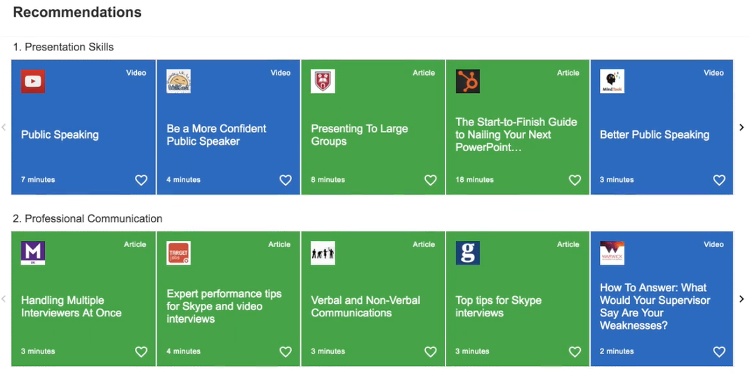

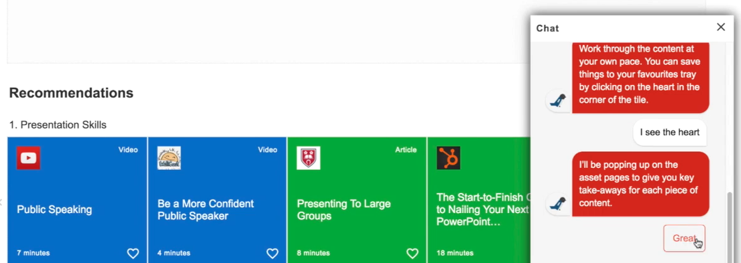

**7002 – Level 2 Diploma for Hair Professionals**



**Qualification extensions**

Some of City & Guilds qualifications which had been built historically without evolve, have now been discontinued, but these qualifications are still available under the evolve route, for example 3003-23 Level 2 Diploma in Beauty Therapy is now not available, but it can be accessed through 3003-63 Level 2 Diploma In Beauty Therapy.

**The Association of Hairdressers and Therapists**

[www.aht-uk.com](http://www.aht-uk.com)

You may know the association better as the **AHT.**

It was founded in 1963 by a group of hairdressing teachers as a National Network of ‘like - minded’ educational specialists who exchanged good practice and support. Members are tutors, trainers or assessors in hairdressing, barbering, beauty therapy, nails, spa, media make-up or therapist subjects who hold or are working towards teaching/assessing qualifications.

By joining the AHT you will have the entitlement to enter students into Regional and National Competitions for Hairdressing, Barbering, Body Painting, Nails and Beauty Therapy Competitions. The National two -day event at Blackpool Winter Gardens, has grown and grown in popularity with Centres represented from all 4 nations. This event provides students with the opportunity to show case and further develop their skills, whilst gaining further confidence.

For the first time this year we have also organised two Beauty and one Hairdressing Competition the emphasis on considering the development of skills required for Worldskills UK, whilst also raising their skill standards. Feedback will be given to both the competitor and tutor, by a Worldskills judge.

The AHT also organises an annual weekend seminar, content examples include:

Leading speakers delivering on current topical issues, such as Managing Behaviour, Ofsted Inspections.

Updates from each Awarding Organisations.

Hands on CPD.

Updates and decisions on themed competitions for the following years competitions, held during the AGM.

Networking and question and answer sessions.

Each seminar is designed around members needs and wishes with the challenges faced in mind.

The association also works in partnership with Habia and Awarding Organisations with executive members attending meetings to let your voice be heard and importantly help influence the future for industry and up and coming students in all skill areas.

**Tell us what you think**

*All About Hair & Beauty* is a newsletter that brings together all of the key developments from City & Guilds relevant to *Hair & Beauty* skills learning across England, Northern Ireland and Wales. It contains updates on the range of teaching and learning resources we offer, plus relevant public policy or other information we think you might be interested in.

Each edition is numbered, so we can refer back to previous issues or tell you when information has been superseded.

Thank you for your continued support.

Every effort has been made to ensure that the information contained in this publication is true and correct at time of going to press. However, City & Guilds products and services are subject to continuous development and improvement and the right is reserved to change Products and services from time to time. City & Guilds cannot accept liability for loss or damage arising from the use of information in this publication. City & Guilds is a registered charity established to promote education and training.