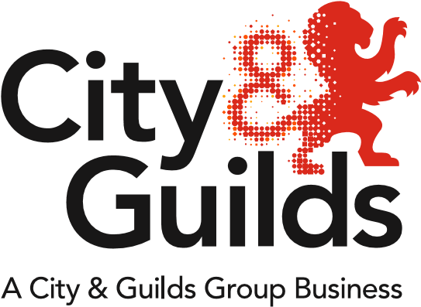

All ABOUT HEALTH AND CARE

All about Health and Care - Winter 2019
Welcome to our first centre Newsletter for Health & Care. We produced a separate newsletter for Childcare in the Summer and this can be found on Childcare Key Documents webpage. Here are some things we think would be good share about Health and Care. In 2020 we will be aiming to provide newsletters in Summer and Winter.

Meet the team
Geraldine Donworth  Industry Manager | Paul Robottom  Technical Advisor  England | Suzi Gray  Technical Advisor  N. Ireland, Wales and England

What's New in England?
We’ve been really busy developing new products and services that are designed to support new qualifications and apprenticeships in Adult Care, Dental Nursing and Health. Here’s a reminder of what our offer looks like.
Qualifications in Health & Care
The 3095-21 Level 2 Diploma in Care
This can be delivered as a standalone qualification or as the mandatory qualification in Adult Care Worker apprenticeship standard and an optional qualification for employers in the Healthcare Support Worker apprenticeship standard. A mapping document is available showing how the Diploma links to the adult care apprenticeship standard. The password for this is on Walled Garden.
The 3095-21 L2 Diploma in Care qualification is endorsed by both Skills for Care and Skills for Health.
The 3095-31 Level 3 Diploma in Adult Care can be delivered as a standalone qualification or as a mandatory qualification in the Lead Adult Care Worker apprenticeship standard. A mapping document is also available showing how the Diploma links to the apprenticeship standard. The password for this is on Walled Garden.
The 3095-31 L3 Diploma in Adult Care qualification is endorsed by Skills for Care.
4222-34 Level 4 Diploma in Adult Care
The Level 4 Diploma in Adult Care has been approved by Skills for Care. It is expected to be recognised as a mandatory qualification for the Level 4 Lead Practitioner in Adult Care apprenticeship standard and has been added to the list of qualifications eligible for Skills for Care Workforce Development Funding (WDF).
We have extended the qualification so that the end registration date will be 31 August 2020 and we plan to extend this further as the Lead Practitioner in Adult Care Level 4 standard is getting closer to publication. We’ve been working with the Trailblazer group to finalise the assessment plan.
You will find the qualification handbook on the 4222 web page
Skills for Care Workforce Development Funding for our Health & Social Care qualifications in England can be found on the Skills for Care website
The 3080-50 Level 5 Diploma in Leadership & Management for Adult Care (England)
The L5 Diploma qualification is endorsed by Skills for Care. It is expected to be recognised as a mandatory qualification in the Level 5 Leader in Adult Care apprenticeship. The new qualification is now live for delivery as a standalone qualification. As with the level 4 apprenticeship, we have been working closely with the Trailblazer group to finalise the assessment plan, which is just now waiting for ministerial sign off of the funding before Leader in Adult Care will be published by IfATE.

New Adult Care Texts Books available from Hodder endorsed by City & Guilds
The following new publications are excellent resources for learners, tutors and assessors to support teaching and learning.
Level 2 Diploma in Care
Where to order Where to order Where to order
Level 3 Diploma in Adult Care
Where to order Where to order Where to order

L5 Leadership and Management in Adult Care
Available now, a new Textbook to support the City & Guilds Level 5 Diploma in Leadership and Management for Adult Care (England) (3080-50)
Order here

SmartScreen to support the L2 and L3 3095 Diploma qualifications
Fact sheets are available here
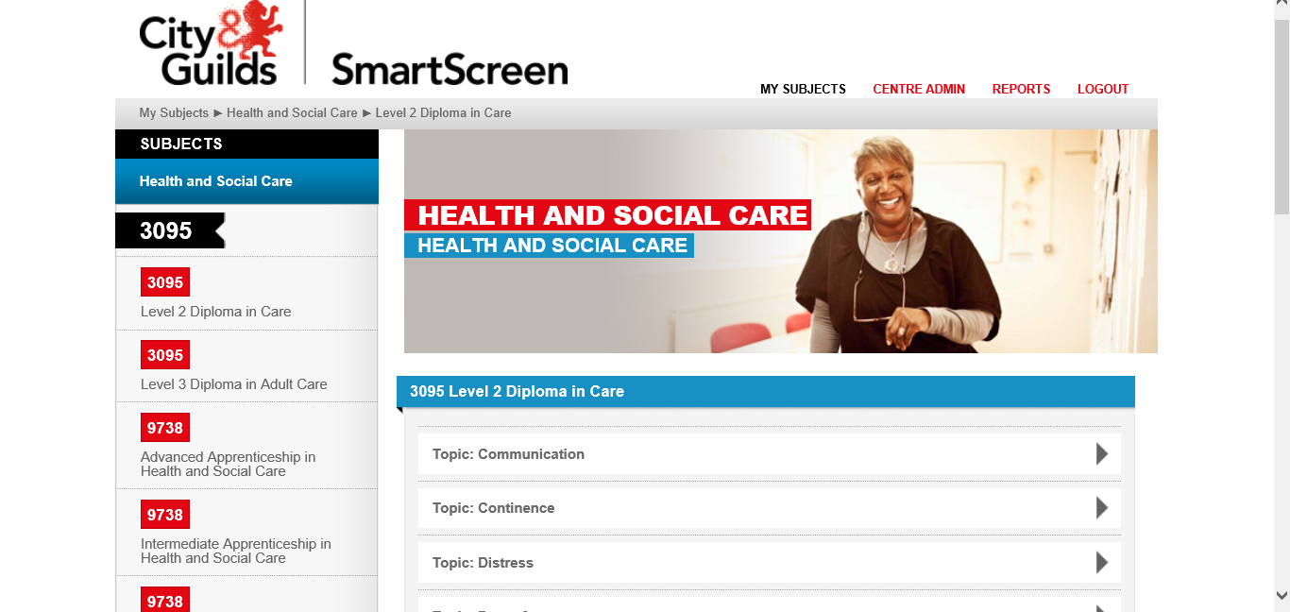

Health
We are developing a product called Get to Gateway to support the on-programme delivery of the Healthcare Support Worker standard, which does not contain a mandatory qualification.
For more details on this, please contact the Digital Solutions Team digitalsales@cityandguilds.com
More information on Get to Gateway can be found Here
Our 4345-31 Level 3 Diploma in Healthcare Support (England) has been designed to support the Level 3 Senior Healthcare Support Worker apprenticeship standard. The 4345-31 qualification is endorsed by Skills for Health.

Our 3576-05 Level 5 Diploma for Assistant Practitioners in Healthcare is available to use as the mandatory qualification for the Healthcare Assistant Practitioner apprenticeship standard or as a standalone qualification. A mapping/evidence log document designed in line with the apprenticeship standard is also available on the 3576 web page.
Dental Nursing
The 5234-01 Level 3 Diploma in Dental Nursing remains a mandatory qualification in the Dental Nurse apprenticeship standard. It’s worth mentioning here that we offer end point assessment for both versions of the assessment plan. We are the only EPAO to do this. There are more details below in the section on apprenticeships.
The dental nursing network in Wakefield on the morning of 12 February is full BUT there are still places available in the afternoon
Book your place - Dental Nursing Network pm 12 Feb 2020
Additional networks are being planned in the south of England and in Cardiff. Look out for more news in January on these.
Apprenticeships update
Children’s Residential Care
There are two published standards on the IfATE website Here
We have qualifications available, which meet the mandatory requirements for 3 of the 4 options
Children Young People & Families Practitioner level 4
Children’s Residential Care Option - 4340-31 Level 3 Diploma for Residential Childcare (England) is a mandatory qualification in this standard. Details of the qualification can be found on the 4340 web page.
Community - This option requires a Higher Education Certificate at Level 4, which you would need to source from a Higher Education Institution
Children Young People & Families Practitioner Level 5
Children’s Residential Care Option – 4340-51 Level 5 Diploma in Leadership and Management for Residential Childcare (England). Qualification details can be found on the 4340 web page
Community – 4978-52 Level 5 Diploma in Leadership for Health and Social Care and Children and Young People's Services - Children and Young People's Management (England) This qualification is being extended and details can be found on the 4978 web page

We are not planning to offer end point assessment for these standards over this year but would like to be able to gauge interest from centres, so please do get in touch with Geraldine about this.

Pharmacy Qualifications
Centres offering the following qualifications should have received a specific update. If this is not the case then please get in touch with Geraldine

5355-02 | Level 2 NVQ Certificate in Pharmacy Service Skills
5355-03 | Level 3 NVQ in Pharmacy Service Skills
5355-92 | Level 2 NVQ Certificate in Pharmacy Service Skills (unit route)
5355-93 | Level 3 NVQ Diploma in Pharmacy Service Skills
5356-02 | Level 2 Certificate in Pharmaceutical Science
5356-03 | Level 3 Diploma in Pharmaceutical Science

Other qualifications
For those qualifications with an end registration date of 2020 or 2021, a review of the end registration dates of the Health & Care portfolio will be carried out in January. Decisions will be made during this review regarding whether to allow the qualifications to close for registrations or to extend them further. Please keep an eye on the Walled Garden/Catalogue.
Independent Advocacy
There have been a number of enquiries regarding the future of this suite of qualifications. We are currently working on a level 4 Independent Advocacy qualification for Wales and therefore reviewing the whole advocacy portfolio particularly in the light of Mental Capacity (Amendment) Bill.
The Level 2 Award is not affected and will be extended. There will be more news in the spring.

The following qualifications have closed and have been replaced
 |  | Replaced in Wales by: | Replaced in Northern Ireland by:
3623-12 | Level 2 Award in Social Care Induction - Adults (Wales) | Level 2 H&S: Core Adults  8040-02 | N/A
3623-12 | Level 2 Award in Social Care Induction - Children and Young People (Wales) | Level 2 H&SC: Core (Children and Young People)  8040-02 | N/A
4222-22 | Level 2 Diploma in Health and Social Care (Adults) for Wales and Northern Ireland | Level 2 H&SC: Practice  8040-04 | Level 2 Diploma in H&SC (Northern Ireland)  3086-02
4222-32 | Level 3 Diploma in Health and Social Care (Adults) for Wales and Northern Ireland | Level 3 H&SC: Practice (Adults)  8040-05 | Level 3 Diploma in H&SC (Northern Ireland)  3086-03
4222-33 | Level 3 Diploma in Health and Social Care (Children and Young People) for Wales and Northern Ireland | Level 3 H&SC:: Practice (Children and Young People)  8040-06 | Not replaced in Northern Ireland

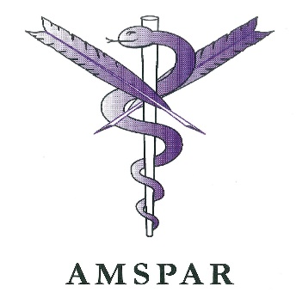
Medical Administration
5519
5519-02 Level 2 Award in Medical Terminology may be of interest to health employers as a CPD offer to their staff or to enhance the healthcare apprentice experience.
5519-13 Level 3 Certificate in Medical Terminology
5528
These qualifications are currently included in the Business Administration SASE and SASW apprenticeship frameworks
5528-22 Level 2 Diploma in Medical Administration
5528-23 Level 3 Diploma in Medical Administration
4419-06 Level 5 Certificate and Diploma in Primary Care and Health Management
All these qualifications will have an end registration date of 30 September 2022.

Apprenticeships in England/End Point Assessment (EPA)
Become an independent assessor - find out more here
We have launched End Point Assessment (EPA) products to support the following apprenticeship standards. Click on the numbers below to take you to the webpages.
Adult Care Worker 9040-12
Lead Adult Care Worker 9042-12
Healthcare Support Worker - 9041-12
Senior Healthcare Support Worker – Adult Nursing Support 9043 . There are 2 products for EPA for this standard. 9043-12 supports version 1 of the assessment plan and 9043-22. This supports version 2 of the assessment plan.
Healthcare Assistant Practitioner 9576-12
Dental Nurse 9752 There are 2 products available for EPA 9572-12 which supports version 1 of the assessment plan and 9752-22 which supports version 2.
For each of the above EPA products you will find support materials such as sample test papers, recording forms and an EPA centre pack containing guidance for centres and apprentices about each specific end point assessment. Exemplar materials and our End Point Assessment Preparation Tool are available on Smartscreen for apprentices who are registered on our end point assessment products.

Functional Skills Reform
Our Functional Skills qualifications have been replaced by the 4748 suite.
Please visit our website to learn about how we can support delivery of maths and English
Here is a link to the web page where you will find the latest update
Functional Skills Updates

Full timeKS5 L2 and L3 Technical qualifications at City & Guilds (England) (16-19yrs, 19+)
For our latest full time technical KS5 L2 and L3 offer for full time 16-19yrs and 19+ students in Health and Care, Childcare and Dental please see the following;
3625-20 Level 2 Technical Certificate Health, Care and Childcare
3134-20 Level 2 Technical Certificate in Working in Dental Settings
3625 Level 3 Technicals in Health & Care

Here are Paul and Anna Fritz, one of our Senior Management Team with colleagues from FE Colleges who took part in our Technical Qualifications annual review meeting
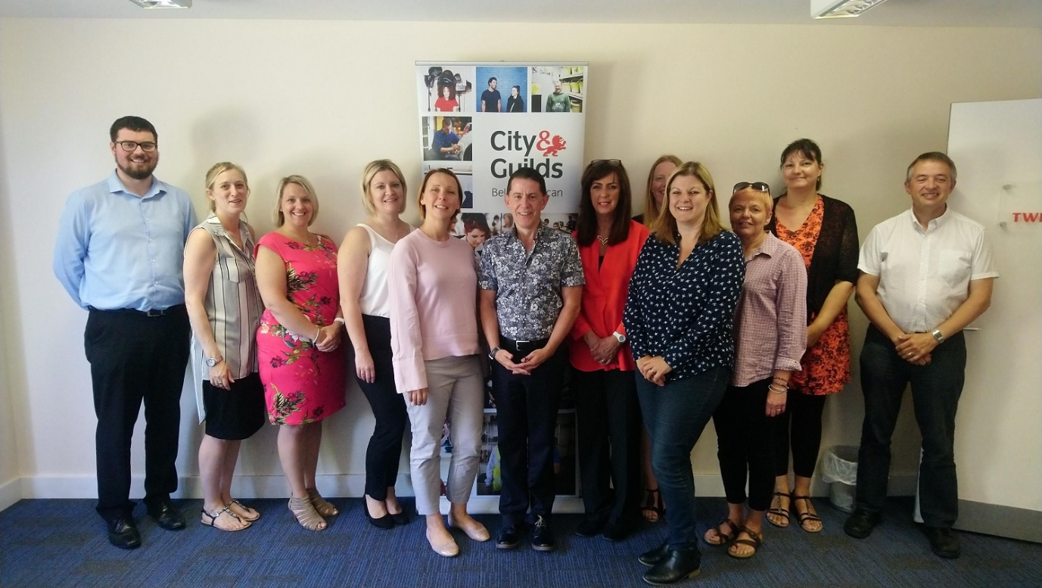

Join our Social Media groups
Recently launched on LinkedIn, the Adult Care Apprenticeship Support Group is growing in its membership. Designed to enable us and members to share best practice in apprenticeship delivery, raise issues for further discussion or receive communications from us, we hope membership will grow further, so please join.
https://www.linkedin.com/groups/13600520/
There is also a Dental Nursing LinkedIn group. Connect with Geraldine on LinkedIn and ask to be invited to join the group.

Focus on Northern Ireland
Introducing the New 3086 Level 2 and Level 3 Diplomas in Health and Social Care (Northern Ireland)
We have worked closely with the Northern Ireland Social Care Council (NISCC), the key membership organisations and stakeholder groups, and representatives from FE to develop a new set of H&SC qualifications.
The new Level 2(3086-02) and Level 3 (3086-03) Diplomas for Health and Social Care are now available and the qualification handbooks can be found on the 3086 web page .
Both of the Diplomas include mandatory content that is presented in large units or themes together with a broad collection of optional units designed to accommodate those working in domiciliary and residential services with vulnerable adults including learning disability, dementia care and palliative care.
Learners must be at least 16 years old to complete these qualifications. Assessment is by portfolio of evidence including direct observation by an occupationally competent and qualified assessor.
Preparing of Leadership Qualifications
Both of the current Level 4 ILM Certificate in Principles of Leadership and Management for Adult Care (Northern Ireland) and the Level 4 City & Guilds Diploma in Adult Care (Northern Ireland) qualifications, are exclusive to ILM and City & Guilds, are available and can be viewed via the following links:
ILM Certificate
Level 4 Diploma in Adult Care (Northern Ireland)
The following level 5 qualifications will be available until 31 August 2020.
- Level 5 Diploma in Leadership for Health and Social Care Services (Children and Young People's Advanced Practice) Wales & NI (3978-63)
- Level 5 Diploma in Leadership for Health and Social Care Services (Adults' Residential Management) Wales & NI (3978-64)
- Level 5 Diploma in Leadership for Health and Social Care Services (Adults' Management) Wales & NI (3978-65)
- Level 5 Diploma in Leadership for Health and Social Care Services (Adults' Advanced Practice) Wales & NI (3978-66)

Focus on Wales
City & Guilds and our partners WJEC (the Consortium) were delighted to be successful in the competitive tender issued by Qualifications Wales to develop an exclusive new suite of innovative qualifications for the Health and Social Care, and Childcare sector in Wales.
We continue to work collaboratively with Social Care Wales, Health Education and Improvement Wales and others stakeholders to ensure the qualifications meet the needs of the sector in Wales.
We have a specific website for the new qualifications for Wales, which can be found Here.

The whole suite of qualifications currently looks like this:
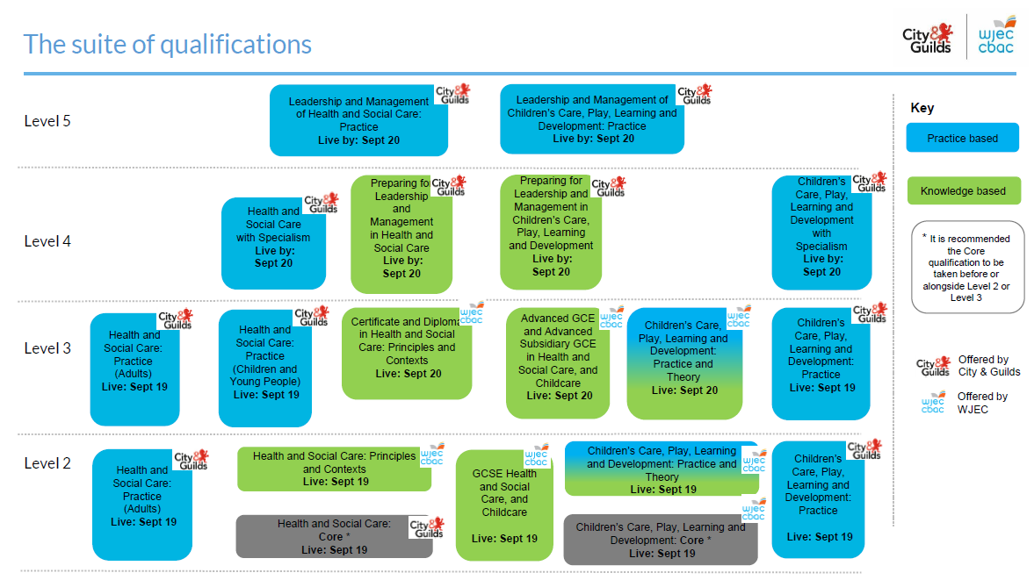
There will be some changes made to some of the HSC Level 4 qualifications and some changes in titling which we can update through the website at the link above.
The following Health and Social Care qualifications have been approved by Qualifications Wales and have been available for first teaching since 01 September 2019:

Level 2 Health and Social Care: Core (8040 -02)
HSC Core qualifications
This qualification aligns to the knowledge aspects of the All Wales Induction Framework for Health and Social Care and includes 3 pathways – the learner completes one of these relevant to their work role:
HSC Adults pathway for those working with vulnerable adults at home or in residential settings (8040-21)
HSC Children & Young People – for those working with vulnerable young people in residential setting (8040-20)
HSC Adults and Children & Young People (combined pathway) – for those working with both adults and CYP in residential settings (8040-22)
Level 2 HSC: Practice (8040-04) Web page
Level 3 HSC: Practice (Adults) (8040-05) Web page
Level 3 HSC: Practice (Children and Young People) (8040-06) Web page

We are still busy developing the content for the new Level 4 and Level 5 qualifications and we hope to be able to share further information about these qualifications soon.
The Consortium has been supporting Qualifications Wales and Social Care Wales during recent engagement events with centres and employers. We have now completed the main centre preparation events for the new Level 2 and Level 3 qualifications and so please visit the Health and Care Learning Wales website to access the qualification handbooks and assessment packs.
Our future events calendar will feature a number of different kinds of events including centre support events and activities to support preparations for the new Level 4 and Level 5 and will also include the first series of centre network events.
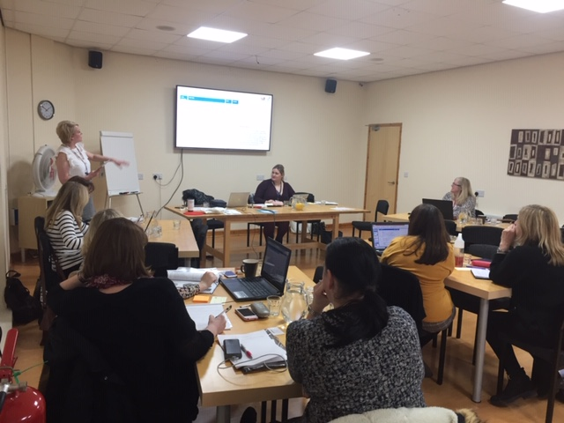
It was all excellent. The resources being prepared are superb.” Attendee at event

“Excellent presentations and in depth of knowledge of trainer” Attendee at event

Don’t worry if you were unable to attend any of our events – we have provided a series of recorded webinars that can be accessed via the hclw website.

Please ensure that you register your interest in the new qualifications via the HCLW website so that we can contact you with key information about these developments and any associated events or activities. You can also receive updates and news from our Twitter account account @HCL_Wales
We are currently seeking occupationally expert people who would like to become more involved in our developments and in the External Quality Assurance of the qualifications.
If you are interested in this work please contact Geraldine Donworth.
Funding Updates
You will find information on a range of funding streams available on our Funding for Qualifications webpage
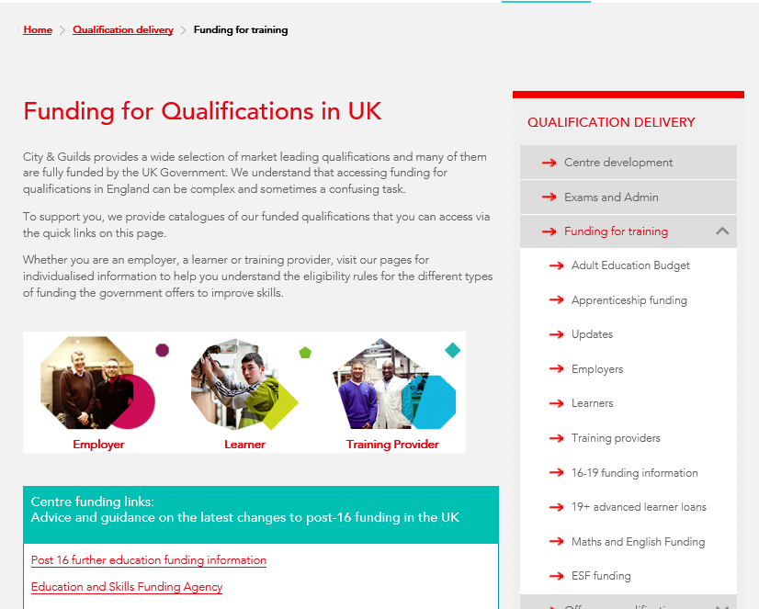

Vacancies at City & Guilds
We are always looking to extend our range of consultants for Health & Care as we move into another very busy year at City & Guilds.
If you have experience of developing content, multiple choice questions or assessment materials, please email geraldine.donworth@cityandguilds.com with your CV outlining your occupational experience and expertise in producing content and/or assessment materials and your details well be passed on to the relevant development team.
If you are interested in becoming an examiner, moderator and quality assurance consultant, take a look at the links below:
Examiner Vacancies
Moderator Vacancies
Assured vacancies

Contact details
Geraldine geraldine.donworth@cityandguilds.com
Follow me on Twitter @g_donworth
Connect on LinkedIn: https://www.linkedin.com/in/geraldine-donworth-bsc-hons-rgn-afcgi-48160352/
Suzi suzi.gray@cityandguilds.com
Paul paul.robottom@cityandguilds.com

We have a specific Twitter account, which you can follow if you are interested in the qualifications we are designing specifically for Wales
@HCL_Wales

Which team should I contact? | Speak to this team about… | Contact details
Sales team | Information about our EPA service | E: directsales@cityandguilds.com.com  T: 01924 206 709
EPA application team | Getting set up as an EPA customer | E: epaapplications@cityandguilds.com  T: 01924 206 719.
EPA customer success team | Support throughout your EPA journey with us once you’ve completed the application process .  The EPA customer success team will be in touch with you ensure you have everything in place for a smooth booking process. | E: epasupport@cityandguilds.com  T: (0)20 7294 3201
Technical Advisors | Sector specific technical guidance. | Contact details for all advisors: https://www.cityandguilds.com/what-we-offer/centres/technical-advisors
EPA bookings team | Specific enquiries about your EPA booking once you have started your EPA booking request (stage 5). | E: epa@cityandguilds.com
Customer services | Support with our platforms including Walled Garden, SmartScreen and  e-volve. | E: centresupport@cityandguilds.com  T: 0844 543 000*  *calls to 0844 numbers cost 7p per minute plus your phone company’s access charge.
Customer Support | For any of the suite of qualifications being developed for Wales in Children’s Care Play Learning & Development or Health & Social Care | E: hclw.customer@cityandguilds.com  T: 0844 543 0033 (option 3)

