

|  |
| --- |
| Senior Healthcare Support Worker – Adult Nursing Support End-point Assessment(9043-12) |

**Sept 2018 V1**

|  |  |  |
| --- | --- | --- |
| Version and date | Change detail | Section |
| Sept V1 | Initial input of data | Document |

Contents

1 Introduction 4

What is in this document 4

How to use forms 4

End-Point Assessment Gateway Declaration Form 6

Assessment 701/751: Learning Journal 8

Learning Journal reference form 8

Reflective Account A 12

Reflective Account B 14

Reflective Account C 16

Instructions for the Apprentice 18

1. Introduction

### What is in this document

Recording forms to be used by End-point Assessment customers/Employers/Training providers

* Gateway declaration form
* Learning journal reference form
* Reflective account forms A-C
* Instructions to the apprentice – Learning journal

This document must be used alongside the Assessment Pack for Centres/ End-point Assessment Customers.

### How to use forms

Centres / End-point assessment customers must use the forms provided by City & Guilds in the format laid out in this document.

**Gateway form**

This must be completed with the Apprentice and submitted to City & Guilds as part of the end-point assessment booking process.

**Learning journal reference form**

This form should be completed by the apprentice in conjunction with the instructions to apprentice which are located at the end of this pack.

In the evidence type column the apprentice should state what the evidence is i.e. Reflective account; notes from supervision meeting etc

In the evidence reference column they should provide a clear reference to the piece of evidence that links to the area of the standard, this could be file name, or other e.g. Reflective account A.

Refer to Image 1 as an example. The EPA pack provides further guidance on the quantity of evidence required.

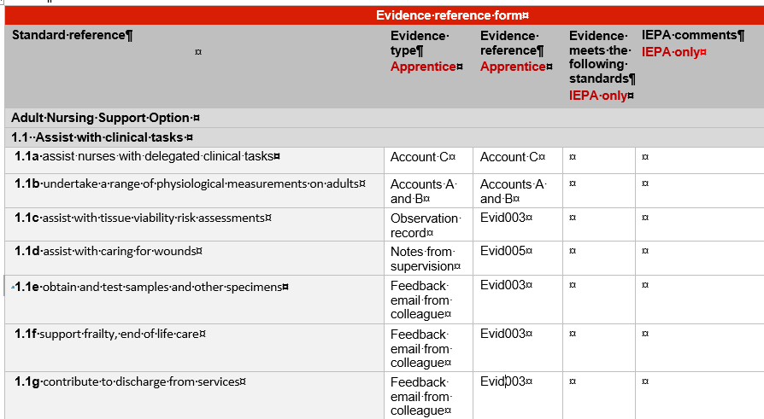

It is the responsibility of the IEPA to complete the last two columns.

If the EPA customer/apprentice is asked by the IEPA or City & Guilds to review the evidence that has been submitted, they should add to and amend the form originally submitted

If the apprentice is resitting the assessment they should only complete the sections for any new evidence submitted

**Reflective Accounts**

Refer to instructions to the apprentice.

End-Point Assessment Gateway Declaration Form

Please complete this form to confirm that all parties are satisfied that the apprentice has met the gateway requirements and can be put forward for end-point assessment (EPA) with City & Guilds.

|  |  |  |  |
| --- | --- | --- | --- |
| Apprenticeship Standard |  | Start date |  |
| **Apprentice**  **name** |  | **Enrolment**  **number** |  |

|  |  |
| --- | --- |
| **Entry requirement(s)** | **Achieved (Yes/No)** |
| Achievement of the  Level 3 Diploma in Healthcare Support  Or  Level 3 Diploma in Clinical Healthcare Support |  |
| Complete induction based on the 15 Care Certificate standards |  |
| Achievement of level 2 English and maths (equivalent to GCSEs at grades A* to C) |  |
| Completed learning journal |  |

Providers must submit evidence of achievement to us for each gateway requirement. It is the provider’s responsibility to keep auditable evidence of these requirements. Without appropriate evidence, we will not be able to complete your booking or carry out the EPA. Customers may still be charged.

|  |  |  |
| --- | --- | --- |
| **Any previous End-Point Assessments** | | |
| Has the Apprentice previously taken any assessments that form part of the EPA for this Apprenticeship Standard with any other Assessment Organisation? | |  |
| **If yes** | | |
| What Assessment Organisation was the End-Point Assessment carried out by? |  | |
| What date(s) was the End-Point Assessment taken? |  | |
| What grade(s) (eg fail/pass/merit/distinction) was issued? |  | |

**Employer and provider declaration:**

**I confirm that the gateway meeting has been carried out to confirm that the apprentice:**

1. **Has achieved all EPA gateway requirements as listed above and has the**

**knowledge, skills and behaviours required by the apprenticeship standard and**

**is eligible for EPA.**

**2. Has been employed throughout their apprenticeship.**

**3. Will have completed a minimum of 12 months and 1 day on-programme before**

**the first EPA assessment with City & Guilds.**

|  |  |  |  |
| --- | --- | --- | --- |
| **Employer** |  | **Date** |  |
| **Training Provider (if appropriate)** |  | **Date** |  |

**Apprentice declaration:**

**I confirm that I have gone through a gateway process to check that I am eligible for EPA.**

**I give City & Guilds permission to apply to the ESFA and the Institute for Apprenticeships for the apprenticeship certificate on my behalf when I complete EPA**

|  |  |  |  |
| --- | --- | --- | --- |
| **Apprentice** |  | **Date** |  |

Providers should submit the completed form to us through the EPA portal. Please refer to the [Manual for the End-Point Assessment Service](https://www.cityandguilds.com/~/media/cityandguilds-site/documents/apprenticeships/manual-for-the-end-point-assessment-service%20pdf.ashx) for details, including timeframes

Assessment 701/751: Learning Journal

Learning Journal reference form

|  |  |  |  |
| --- | --- | --- | --- |
| Apprentice |  | Enrolment  number |  |

**Apprentice declaration:**

**I confirm that the sources I have submitted are from my own work.**

|  |  |  |  |
| --- | --- | --- | --- |
| **Apprentice** |  | **Date** |  |

**Line manager declaration:**

**I confirm that, to the best of my knowledge, the sources submitted are based on the sole work of the apprentice**

|  |  |  |  |
| --- | --- | --- | --- |
| **Line manager** |  | **Date** |  |

**Training Provider declaration (if appropriate):**

**I confirm that the evidenced presented by the Apprentice is ready for End-Point Assessment. It is valid, authentic, reliable and current and sufficient to meet the requirements of the relevant standard.**

|  |  |  |  |
| --- | --- | --- | --- |
| **Training Provider** |  | **Date** |  |

|  |  |  |  |  |
| --- | --- | --- | --- | --- |
| **Evidence reference form** | | | | |
| **Standard reference** | **Evidence type**  **Apprentice** | **Evidence reference**  **Apprentice** | **Evidence meets the following standards**  **IEPA only** | **IEPA comments**  **IEPA only** |
| **Adult Nursing Support Option** | | | | |
| **1.1 Assist with clinical tasks** | | | | |
| **1.1a** assist nurses with delegated clinical tasks |  |  |  |  |
| **1.1b** undertake a range of physiological measurements on adults |  |  |  |  |
| **1.1c** assist with tissue viability risk assessments |  |  |  |  |
| **1.1d** assist with caring for wounds |  |  |  |  |
| **1.1e** obtain and test samples and other specimens |  |  |  |  |
| **1.1f** support frailty, end of life care |  |  |  |  |
| **1.1g** contribute to discharge from services |  |  |  |  |
| **1.1h** monitor and maintain the environment, equipment and resources; perform first line calibration on clinical equipment and manage stock control |  |  |  |  |
| **1.1i** recognise limitations in mental capacity and respond appropriately |  |  |  |  |
| **1.2 Activities of daily living** | | | | |
| **1.2a** support adults to develop and maintain skills for everyday life, continuing recommended therapies and activities and encouraging them to take responsibility for their own health and wellbeing; support carers to meet the needs of the adult; advise and inform adults on managing their own condition |  |  |  |  |
| **1.2b** support or enable adults to eat, drink |  |  |  |  |
| **1.2c** support or enable adults to wash and dress and use the toilet |  |  |  |  |
| **1.2d** support adults to be mobile, rest, sleep, keep safe or express their sexuality |  |  |  |  |

|  |
| --- |
| **IEPA only** |
| **IEPA any comments pertaining to the reflective accounts e.g. do they meet the word count and reference values and behaviours.** |
|  |
| **IEPA Any overall comments and notes of any themes or areas to follow up around in professional discussion**  **IEPA only** |
|  |



Reflective Account A

|  |  |  |  |
| --- | --- | --- | --- |
| **Apprentice Name** |  | **Enrolment**  **number** |  |
| **Using a reflective model write about a work-based event.** | | | |
| **1. Outline what happened** | | | |
|  | | | |
| **2. What were you feeling?** | | | |
|  | | | |
| **3. What went well and what didn’t go well?** | | | |
|  | | | |
| **4. What was your analysis of the situation?** | | | |
|  | | | |
| **5. What else could have been done?** | | | |
|  | | | |
| **6. What have you learnt in relation to your practice that you will do differently next time?** | | | |
|  | | | |

**Line manager /training provider declaration:**

**I confirm that the above reflective account is authentic and that individual/s referenced in account A have been in receipt of care provided by the apprentice.**

|  |  |  |  |
| --- | --- | --- | --- |
| **Line manager/**  **training provider** | Signature | **Date** | DD/MM/YY |



Reflective Account B

|  |  |  |  |
| --- | --- | --- | --- |
| **Apprentice Name** |  | **Enrolment**  **number** |  |
| **Using a reflective model write about a work-based event.** | | | |
| **1. Outline what happened.** | | | |
|  | | | |
| **2. What were you feeling?** | | | |
|  | | | |
| **3. What went well and what didn’t go well?** | | | |
|  | | | |
| **4. What was your analysis of the situation?** | | | |
|  | | | |
| **5. What else could have been done?** | | | |
|  | | | |
| **6. What have you learnt in relation to your practice that you will do differently next time?** | | | |
|  | | | |

**Line manager /training provider declaration:**

**I confirm that the above reflective account is authentic and that individual/s in account B have been in receipt of care provided by the apprentice.**

|  |  |  |  |
| --- | --- | --- | --- |
| **Line manager/**  **training provider** | Signature | **Date** | DD/MM/YY |



Reflective Account C

|  |  |  |  |
| --- | --- | --- | --- |
| **Apprentice Name** |  | **Enrolment**  **number** |  |
| **Using a reflective model write about a work-based event.** | | | |
| **1. Outline what happened.** | | | |
|  | | | |
| **2. What were you feeling?** | | | |
|  | | | |
| **3. What went well and what didn’t go well?** | | | |
|  | | | |
| **4. What was your analysis of the situation?** | | | |
|  | | | |
| **5. What else could have been done?** | | | |
|  | | | |
| **6. What have you learnt in relation to your practice that you will do differently next time?** | | | |
|  | | | |

**Line manager /training provider declaration:**

**I confirm that the above reflective account is authentic and that individual/s in account C have been in receipt of care provided by the apprentice.**

|  |  |  |  |
| --- | --- | --- | --- |
| **Line manager/**  **training provider** | Signature | **Date** | DD/MM/YY |



Instructions for the Apprentice

Compiling a Learning Journal

At the end of your apprenticeship you will be required to take part in a professional discussion with an Independent End-point Assessor. In preparation for this you are required to complete a learning journal. The learning journal must consist of:

* Three reflective accounts which must total around 900-1100 words
* Additional evidence which has supported your development during the apprenticeship

Your line manager/tutor will provide you with copies of the following:

* A learning journal reference form
* 3 Reflective accounts forms
* Senior Healthcare Support Worker Standard – Adult Nursing Support Option

The reflective accounts are looking at how you apply the skills, knowledge and behaviours from the Senior Healthcare Support Worker standard in your everyday practice. The accounts should focus on:

* The skills and knowledge of Adult Nursing Support section of the standards listed in the learning journal reference form
* The values and behaviours from the standard

In addition to the reflective accounts you will be required to provide additional evidence that supports your accounts and provides an insight into your development during your apprenticeship. The evidence you submit should be concise and and reflect your best performance. Once you have completed the reflective accounts and provided samples of your best evidence you will record these in the learning journal reference form indicating how they maps to the standard.

Examples of evidence that you might include in your journal might be:

* Records /copies of appraisals and/or supervision
* Feedback from colleagues/supervisor/line manager from activities and training undertaken
* Testimonies/feedback from service users
* Records of observations in addition to those used in your on-programme qualification

**You must ensure that**

1. The reflective accounts are submitted on the forms provided
2. All forms are signed and verified by your line manager/tutor
3. Service users/patients/ individuals are **not** identified by name or by any other information