
NVQ Certificate/Diploma in Hospitality (7131-7132-7133) - Framework version
www.cityandguilds.com
April 2010
Version 1.0

Guidance document/recording forms


About City & Guilds
City & Guilds is the UK’s leading provider of vocational qualifications, offering over 500 awards across a wide range of industries, and progressing from entry level to the highest levels of professional achievement. With over 8500 centres in 100 countries, City & Guilds is recognised by employers worldwide for providing qualifications that offer proof of the skills they need to get the job done.

City & Guilds Group
The City & Guilds Group includes City & Guilds, ILM (the Institute of Leadership & Management, which provides management qualifications, learning materials and membership services), City & Guilds NPTC (which offers land-based qualifications and membership services), City & Guilds HAB (the Hospitality Awarding Body), and City & Guilds Centre for Skills Development. City & Guilds also manages the Engineering Council Examinations on behalf of the Engineering Council.

Equal opportunities
City & Guilds fully supports the principle of equal opportunities and we are committed to satisfying this principle in all our activities and published material. A copy of our equal opportunities policy statement is available on the City & Guilds website.

Copyright
The content of this document is, unless otherwise indicated, © The City and Guilds of London Institute and may not be copied, reproduced or distributed without prior written consent.

However, approved City & Guilds centres and learners studying for City & Guilds qualifications may photocopy this document free of charge and/or include a PDF version of it on centre intranets on the following conditions:
- centre staff may copy the material only for the purpose of teaching learners working towards a City & Guilds qualification, or for internal administration purposes
- Learners may copy the material only for their own use when working towards a City & Guilds qualification

The Standard Copying Conditions (which can be found on the City & Guilds website) also apply.

Please note: National Occupational Standards are not © The City and Guilds of London Institute. Please check the conditions upon which they may be copied with the relevant Sector Skills Council.

Publications
City & Guilds publications are available from our website or from our Publications Sales department, using the contact details shown below.

Every effort has been made to ensure that the information contained in this publication is true and correct at the time of going to press. However, City & Guilds’ products and services are subject to continuous development and improvement and the right is reserved to change products and services from time to time. City & Guilds cannot accept liability for loss or damage arising from the use of information in this publication.

City & Guilds
1 Giltspur Street
London EC1A 9DD
T +44 (0)844 543 0033 www.cityandguilds.com
F +44 (0)20 7294 2413 learnersupport@cityandguilds.com

NVQ Certificate/Diploma in Hospitality (7131-7132-7133) - Framework version
Guidance document/recording forms
www.cityandguilds.com
April 2010
Version 1.0

Contents
1 About your logbook
1.1 Contact details
1.2 Introduction to the logbook
2 About NVQs and SVQs
2.1 What are NVQs and SVQs?
2.2 The structure of NVQs and SVQs
3 About your centre
3.1 Types of centres
3.2 Assessment roles
4 About N/SVQ Learners
5 The assessment process
5.1 Before you start your N/SVQ
6 Completing your logbook
Your CV
Skill scan/Initial assessment
Expert / Witness Status list
Expert Witness Record
Summary of Unit Achievement
Appendix 1 Summary of City & Guilds assessment policies
Appendix 2 Observation sheets

About your logbook

Contact details
Learner name
Learner enrolment no
Centre name
Centre number
Start date

Keep a record of relevant contact details in the space provided below. You may find it helpful to make a note of phone numbers and e-mail addresses here.

Your Assessor(s)

Your Internal Verifier
Your centre contact

1 About your logbook

Introduction to the logbook
This logbook will help you complete your Qualifications Credit Framework National Vocational Qualification (NVQ) or Scottish Vocational Qualification (SVQ). It contains
- the units you need to achieve to complete your qualification
- information about your responsibilities as a Learner
- forms you can use to record and organise your evidence.

It will also tell you:
- about NVQs and SVQs
- what you need to do to complete your NVQs and SVQs
- who will help you.

About City & Guilds
City & Guilds is your awarding organisation for this qualification. City & Guilds is the UK’s leading awarding organisation for vocational qualifications.

Information about City & Guilds and our qualifications is available on our website www.cityandguilds.com.

About NVQs and SVQs

What are NVQs and SVQs?
National Vocational Qualifications (NVQs) and Scottish Vocational Qualifications (SVQs) are nationally recognised qualifications gained in the workplace or in a realistic working environment. They are based on National Occupational Standards, which are standards written by employers and experts in your industry.

When you achieve your qualification it will prove that you can work to the standards expected by employers in your industry. Your qualification will show you are competent to do a job and have the skills, knowledge and understanding needed to do it well.

N/SVQs are work based qualifications, so you should choose the qualification that best matches the type of work you already carry out, or expect to carry out in the future. If you are not in work, your centre will need to arrange a work placement for you to gain the necessary skills and to be assessed.

Choosing your qualification
There are different levels of qualifications. The table gives a brief description of the different N/SVQ levels. You don’t always have to start at level 1 as you can start at the level that best matches your work or role.

Level | What you have to show to achieve the qualification
1 | Achievement at Level 1 reflects the ability to use relevant knowledge, skills and procedures to complete routine tasks. It includes responsibility for completing tasks and procedures subject to direction or guidance.
2 | Achievement at level 2 reflects the ability to select and use relevant knowledge, ideas, skills and procedures to complete well defined tasks and address straight forward problems. It includes taking responsibility for completing tasks and procedures and exercising autonomy and judgement subject to overall direction or guidance.
3 | Achievement at Level 3 reflects the ability to identify and use relevant understanding, methods and skills to complete tasks and address problems that, while well defined, have a measure of complexity. It includes taking responsibility for initiating and completing tasks and procedures as well as exercising autonomy and judgement within limited parameters. It also reflects awareness of different perspectives or approaches within an area of study or work.
2 About NVQs and SVQs

The structure of NVQs and SVQs

How is an N/SVQ made up?
Each N/SVQ is made up of a number of units. Each unit covers a different work activity and a credit value attached to the unit. To achieve the full qualification you have to complete a set number of units outlined within the qualification.

Your centre will explain which units you need to take and help you choose those that best match your job.

Mandatory units
You will have to complete all of these units to get your qualification

Optional units
You may be able to choose from a number of optional units. You will be helped to choose the best optional units to match your job or interests.

If you are taking an apprenticeship then you must take Unit 666 entitled Employment rights and responsibilities in the hospitality, leisure, travel and tourism sector (PERR/10).

Structure of a unit
Units describe what you must be able to do to show you can competently perform activities in your job. Units are broken down into
- outcomes – these are either related to tasks you must be able to do or knowledge you must know or understand
- what you must do – which describe what you have to do to for each practical task
- what you must know how to – describing what you need to know and understand
- what you must cover/range statements – describe the situations in which you must be able to perform the tasks

About your centre

Types of centres
Assessment for your qualification will be carried out at your centre. Your centre may be your place of work, a college, training provider or a combination of these.

City & Guilds approves centres to offer qualifications and regularly monitors them to make sure they meet our quality standards and follow our assessment policies.

Centre responsibilities
Your centre is responsible for the administration of your qualification. Centre staff will
- register you with City & Guilds
- give you your City & Guilds enrolment number
- apply for your certificate(s) when you have completed your N/SVQ or units.

Centres are also responsible for supporting you as you work towards your qualification. Centres will
- carry out an initial assessment with you
- tell you about any learning or training (and resources) you will need to help you complete your qualification
- provide an induction programme to explain how the assessment process works
- produce an assessment plan for you.

3 About your centre

Assessment roles
Who will be involved in your qualification?
Assessment for your qualification is carried out at your centre. Your centre may be your place of work, a college, training provider or a combination of these. The people involved in the assessment process are listed below.

The assessor
This may be your manager or supervisor at work or maybe someone specifically sent into your workplace to carry out the assessment. They will
- carry out an initial assessment of the tasks you do as part of your job role and check these against the qualification content
- observe you carrying out your job over a period of time
- ask you questions about the work you do
- assess when you are competent and meet the national standards

The internal verifier
- is employed by your centre to maintain the quality of the occupational assessment

The external verifier
- is employed by City & Guilds to ensure that your centre meets the required national standard

Witnesses
- Witnesses do not determine your overall competence but may provide evidence of your work for your assessor to judge.

Which qualification should you choose?
You should choose an NVQ that best matches the kind of work you already carry out. You don’t always have to start at level 1 and the NVQ should reflect the job role that you currently do or intend to do.

How is an NVQ made up?
Each NVQ is made up of a number of units each covering a different work activity. Each unit also has a credit value, following the qualification rules you must achieve the minimum number of credits required. You will be required to undertake a combination of mandatory and optional units.

Mandatory Units – You will have to achieve all of these to get your NVQ. You may also have to achieve some optional units.

Optional Units – You may be able to choose from a number of optional units. You will be helped to choose the best optional units to match your job or interests.

About N/SVQ Learners

Learner role and responsibilities
Your responsibilities as a City & Guilds learner are to
- provide your centre with your personal details so you can be registered with City & Guilds
- participate in an initial assessment and induction
- agree a personal assessment plan with your assessor
- collect and organise your evidence as agreed in your assessment plan
- attend regular meetings with your assessor to discuss your progress and to amend your plan when required
- meet with other centre and City & Guilds staff to talk about your qualification and evidence
- make sure you understand and comply with Health and Safety law and regulations
- be clear about your right of appeal if you feel the assessment is not fair

Your centre may ask you to agree and sign a learning contract with them to show how you will be assessed for your qualification.

Learner enrolment number
Make sure you keep a note of your unique City & Guilds enrolment number on the front page of this logbook.

You will need this number again if you take any other City & Guilds qualifications. Using the same enrolment number helps City & Guilds keep a record of every unit and qualification you complete.

Moving to a new centre
If you change jobs or move to a new centre before you complete your N/SVQ, you may be able to complete it at a new centre. Ask your centre to apply for any certificates of unit credit for you before you leave, and add them to your N/SVQ records.

A new centre will need your Learner Enrolment Number, your assessment records and evidence to help you complete your qualification.

The assessment process

Before you start your N/SVQ

The assessment process
Once you have chosen your units you will make and agree an assessment plan with your assessor. This will show
- the units that the plan covers
- when you will be assessed
- where the assessment will take place
- what you will be doing
- what evidence you will produce

The plan should also indicate the methods of assessment to be used to collect your evidence. For example;
- Observation
- Work product – photographs, videos
- Projects and assignments
- Questioning
- Candidate peer reports
- Witness testimonies
- Expert witness
- Professional discussion
- Simulation – is allowed only where stated in the unit

Your assessor will find tasks which you do and agree the best method of assessment from the above list some tasks will produce evidence for more than one unit. If you don’t meet the standards the first time you are assessed, you can take time to improve your skills and be assessed again when you are ready.

You and the assessor will agree what you need to do for each unit and will record this in your assessment and review plan.

Completing your logbook

Recording forms
City & Guilds has developed these recording forms, for new and existing centres to use as appropriate. Although it is expected that new centres will use these forms, centres may devise or customise alternative forms, which must be approved for use by the external verifier before they are used. Alternatively, City & Guilds endorses various electronic e-portfolios.

Learner and centre contact details
This form can be used to record candidate and centre details and the NVQ being assessed. It is the first page of the candidate portfolio.

CV
This can be used if the candidate does not have an appropriate Curriculum Vitae (CV) for inclusion in the portfolio. The CV helps to indicate “inference of competence over time” by showing what jobs have previously been undertaken by you the learner.

Skill scan/Initial assessment
This can be used to record the skills and knowledge which the learner already has as part of an initial action plan.

Expert/witness status list
This is used to record the details of all those that have witnessed learner evidence.

Expert witness record
This is used to record details of the individual expert witnesses.

Unit record
A unit record summaries all the activities and tasks undertaken to complete the unit.

Unit assessment and verification declaration
This written declaration should be completed at the end of each unit to meet the QCA requirement for a statement on authenticity. It is signed by the assessor and learner and states that the evidence is authentic and that the assessment was conducted under specified conditions or context.

Summary of Unit achievement
The unit declaration sheet can be completed as an ongoing process. Once all the units that make up your qualification have been completed, you along with your assessor must complete the form by signing and dating the declaration statement that all of the evidence meets the required criteria.

Please photocopy forms as required

Your CV
If you already have your own CV you can use that instead of this form.

Name

Address

Telephone Number

Date of birth

Education (school attended and dates)

Qualifications (gained and dates)

Employment history and/or voluntary work

Current work role and main responsibilities

Courses attended in the last 5 years

Interests

Skill scan/Initial assessment
Level ____ NVQ in ___________________________________________

Credits required to achieve qualification________________________
Activities undertaken – do you |  |  |  | often | Sometimes | Never | Comments/Action
Mandatory Units – Title
Optional units –

Assessment Site………………………………………………………………………………………..........

Learner Signature………………………… Learner Name (Print)……………………………............

Assessor Signature……………………………………………..

Date……………………………………...

Expert / Witness Status list

Learner name………………………………………………...................................................

Name and Witness Signature | Status * | Professional relationship to Learner ** | Unit or elements witnessed
* Status
1 Occupational expert meeting specific requirements for role of expert witness | 3 Non expert familiar with the standards
2 Occupational expert not familiar with the standards | 4 Non expert not familiar with the standards
** Professional relationship to Learner
Manager = M | Supervisor = S | Colleague = Coll | Customer = Cus | Other (please specify)

Expert Witness Record

An Expert Witness has contributed to the evidence included in this learner’s Unit Records.

Expert Witness details

Surname |  | First name

Job title |  | Name of workplace

Relationship to candidate | manager supervisor Subject matter expert: specify:

I confirm that I fully understand the standards that I will be providing an expert opinion on to confirm the technical competency of the learner.

Witness signature |  | Date

Assessor details

Surname |  | First name

I confirm that the Expert Witness, detailed above, is:
(please tick)

- technically competent in all of the areas they will be providing an expert opinion on
- has been fully briefed on the role of an Expert Witness
- has been briefed on and understands the occupational standards
- has been briefed on and understands how to record their evidence

Assessor’s signature |  | Date
This completed form should be inserted into the front of the learner’s Unit Records file
.
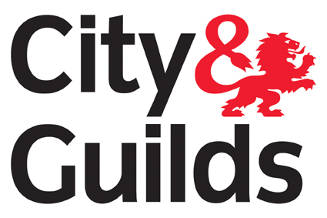

Unit record – Example 1

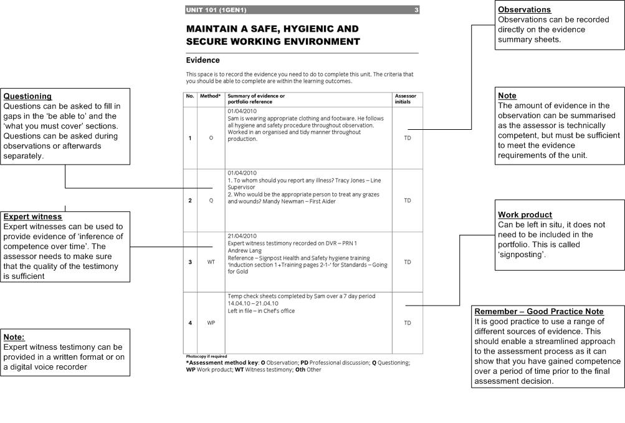

Unit record – Example 2

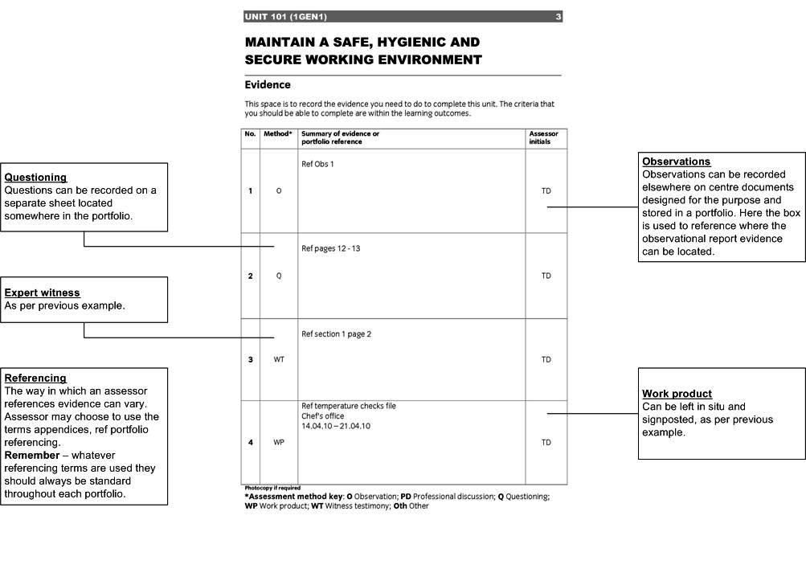

Unit record – Example 3

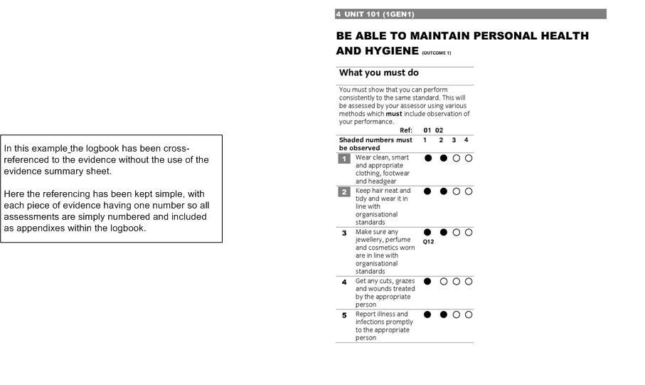

Summary of Unit Achievement
Certificate/Diploma in _________________________

Level_____ Total credit required to achieve _____________

By signing this summary of unit achievement we are confirming that all learning outcomes for these units have been completed and that evidence is authentic and has been obtained under specified conditions for which certification is now requested. | Learner name:
 | Learner enrolment number:
Centre number:
(If required)

Qualification outcomes |  |  |  | Signatures
Units | Credit | Date achieved | Assessor |  | Learner | IV (if sampled)
Total Credits Achieved

Note: City & Guilds unit numbers are shown in brackets. These numbers are to be used for results entry purposes, confirming achievement of units for which certification is requested.
- Summary of City & Guilds assessment policies

Health and Safety
All N/SVQ centres have to make sure that they provide a safe and healthy environment for training, including induction and assessment. City & Guilds external verifiers check this when they visit assessment sites.

You are responsible for making sure that you understand, and comply with, the Health and Safety practice and policies in the workplace where you will be assessed. Your assessment may be stopped if you do not comply, and your assessor will explain the reason why to you. You may need to retake your assessment at a later date.

Equal Opportunities
Your centre will have an equal opportunities policy. Your centre will explain this to you during your induction, and may give you a copy of the policy.

City & Guilds equal opportunities policy is available from our website www.cityandguilds.com, City & Guilds Customer Relations Team or from your centre.

Access to assessment
City & Guilds qualifications are open to all learners, whatever their gender, race, creed, age or special needs. Some learners may need extra help with their assessment, for example, a person with a visual impairment may need a reader.

If you think you will need alternative assessment arrangements because you have special assessment requirements, you should discuss this with your centre during your induction, and record this on your assessment plan. City & Guilds will allow centres to make alternative arrangements for you if you are eligible and if the qualification allows for this. This must be agreed before you start your qualification.

City & Guilds guidance and regulations document Access to assessment and qualifications is available on the City & Guilds website www.cityandguilds.com, from the City & Guilds Customer Relations Team or your centre.

Complaints and appeals
Centres must have a policy and procedure to deal with any complaints you may have. For example, you may feel you have not been assessed fairly, or may want to appeal against an assessment decision if you do not agree with your assessor.

These procedures will be explained during induction and you will be provided with information from the Quality Assurance Co-ordinator within your centre who is responsible for this.

Most complaints and appeals can be resolved within the centre, but if you follow the centre procedure and are still not satisfied you can contact City & Guilds.

Our complaints policy is on our website www.cityandguilds.com or is available from the City & Guilds Customer Relations Team or your centre.
- Observation sheets
Observation sheet - Food and Beverage Service
Learner: | Assessor: | Ref:
Activity observed

101/1GEN1   1 Personal Hygiene(204.1)   1,2 Clean smart footwear   3.Clean smart headgear   8.Follow health, hygiene and safety practices | 104/1GEN4   4.Plan work/tasks   5.Organise work effectively   6.Clean tidy work areas   7.Keep waste to a minimum   9.Work to deadlines
201/2GEN1   2.Greet customers   3.Respect/friendly   3.Customer valued   4. Customer expectation identified   5.Courteous   6.Keep informed   7.Adapt to different behaviour   8.Respond promptly and positively   14.Provide information  15. Check customer understanding | 204/2GEN4   4.Wash hands   3.Change clothes   8.Surfaces and equipment are clean   15 Food within use by date & undamaged   16.Store food correctly   20.Follow stock rotation   23.Protect food from hazards   25.Maintained time temperature for food safety
Duration of assessment Service period Breakfast Lunch Dinner Function
Number of covers Type of service a la carte Table d hote Function Counter……

Observation sheet - Food and Beverage Service
Questions asked during observation with answers

Feedback

Learner signature…………………………………………………

Assessor signature………………………………………………….. Date: …………………
Observation sheets - Cookery

Observation sheet -Candidate: | Assessor: |  | Ref:
Activity observed

101/1GEN1   1 Personal Hygiene(204.1)   1,2 Clean smart footwear   3.Clean smart headgear   8.Follow health, hygiene and safety practices |  | 104/1GEN4   4.Plan work/tasks   5.Organise work effectively   6.Clean tidy work areas   7.Keep waste to a minimum   9.Work to deadlines
102/1GEN2   2. Clean knives   3.Sharpen knives   4. Knife appropriate to task   6.Knives used safely   7.Knives cleaned and stored correctly  OPTIONAL UNITS   1. Check ingredients are fir for preparation/cooking  2. Check & use correct techniques ,tools and equipment   3. Combine the food to meet requirements  4 Cook food to meet requirements of the dish   5/7Finish food as required for the dish   6. Ensure dish is at correct temperature for holding& storing  8. Safely store food not for immediate use |  | 203/2GEN3   5.Wash hands   4..Change clothes   9.Surfaces and equipment are clean   10.Clean clothes used   18. Food within use by date & undamaged   20.Prepare food for storage   21. Store food quickly   23 Avoid cross contamination   27 Check food for hazards   29. Avoid allergic contamination   30. Prevent contamination across different types of food   31. Time and temperature
Duration of assessment Service period Breakfast Lunch Dinner Function
Number of covers Type of service a la carte Table d hote Function Counter……

Observation sheets - Cookery
Questions asked during observation with answers

Feedback

Learner signature…………………………………………………

Assessor signature………………………………………………….. Date: …………………

Observation sheet – Front of House - Reception
Candidate: | Assessor: |  | Ref:
Activity observed

101/1GEN1   1 Personal Hygiene(204.1)   1,2 Clean smart footwear   3.Clean smart headgear   8.Follow health, hygiene and safety practices |  | 104/1GEN4   4.Plan work/tasks   5.Organise work effectively   6.Clean tidy work areas   7.Keep waste to a minimum   9.Work to deadlines
201/2GEN1
 2.Greet customers
 3.Respect/friendly
 3.Customer valued
 4. Customer expectation identified
 5.Courteous
 6.Keep informed
 7.Adapt to different behaviour
 8.Respond promptly and positively
 14.Provide information
15. Check customer understanding
Duration of assessment Activity Check in Check out
Number of customers
Observation sheet – Front of House - Reception
Questions asked during observation with answers

Feedback

Learner signature…………………………………………………

Assessor signature………………………………………………….. Date: …………………

Observation sheet – Diploma in Housekeeping

Candidate: | Assessor: |  | Ref:
Activity observed

101/1GEN1   1 Personal Hygiene(204.1)   1,2 Clean smart footwear   3.Clean smart headgear   8.Follow health, hygiene and safety practices |  | 104/1GEN4   4.Plan work/tasks   5.Organise work effectively   6.Clean tidy work areas   7.Keep waste to a minimum   9.Work to deadlines
264/2HK1
 1. Prepare bathroom/toilet area
 2. Select equipment & materials
 3. Clean toilet correct sequence
 4 Clean bathroom correct sequence
 5. Clean floors, walls &other areas correct sequence
 8 Prepare furnished area
 11. Clean floor/furnishing
 17. PPE worn
 18. Dispose of waste
 19 Sanitise waste containers
Duration of assessment
Number of rooms serviced Type of service new arrival Stay over
Observation sheet – Diploma in Housekeeping
Questions asked during observation with answers

Feedback

Learner signature………………………………………………… Date:..........................
Assessor signature………………………………………………….. Date: …………………

Useful contacts

UK learners  General qualification information | T: +44 (0)844 543 0033  E: learnersupport@cityandguilds.com
International learners  General qualification information | T: +44 (0)844 543 0033  F: +44 (0)20 7294 2413  E: intcg@cityandguilds.com
Centres  Exam entries, Registrations/enrolment, Certificates, Invoices, Missing or late exam materials, Nominal roll reports, Results | T: +44 (0)844 543 0000  F: +44 (0)20 7294 2413  E: centresupport@cityandguilds.com
Single subject qualifications  Exam entries, Results, Certification, Missing or late exam materials, Incorrect exam papers, Forms request (BB, results entry), Exam date and time change | T: +44 (0)844 543 0000  F: +44 (0)20 7294 2413  F: +44 (0)20 7294 2404 (BB forms)  E: singlesubjects@cityandguilds.com
International awards  Results, Entries, Enrolments, Invoices, Missing or late exam materials, Nominal roll reports | T: +44 (0)844 543 0000  F: +44 (0)20 7294 2413  E: intops@cityandguilds.com
Walled Garden  Re-issue of password or username, Technical problems, Entries, Results, GOLA, Navigation, User/menu option, Problems | T: +44 (0)844 543 0000  F: +44 (0)20 7294 2413  E: walledgarden@cityandguilds.com
Employer  Employer solutions, Mapping, Accreditation, Development Skills, Consultancy | T: +44 (0)121 503 8993  E: business_unit@cityandguilds.com
Publications  Logbooks, Centre documents, Forms, Free literature | T: +44 (0)844 543 0000  F: +44 (0)20 7294 2413

If you have a complaint, or any suggestions for improvement about any of the services that City & Guilds provides, email: feedbackandcomplaints@cityandguilds.com

Published by City & Guilds
1 Giltspur Street
London
EC1A 9DD
T +44 (0)844 543 0033
F +44 (0)20 7294 2413
www.cityandguilds.com
City & Guilds is a registered charity
established to promote education and training

