Unit 201: Understanding the hospitality industry

Handout 2: Job roles
Kitchen hierarchy (or ‘brigade’ as it is also commonly known) is steeped in history and goes back many years. Auguste Escoffier (1846–1935), was an authority on modern French cooking and cuisine and he designed the partie system that is still used in the majority of modern kitchens. Not every kitchen and restaurant use exactly the same titles for the different roles in their kitchen, but the most generally accepted titles for leaders in the kitchen are traced primarily to Escoffier kitchen hierarchy, which is why they sound French.

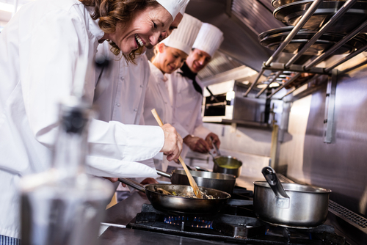

Professional kitchen roles
Executive chef – is the manager of the kitchen responsible for supervision, creation of the menu, and the business side of the kitchen. An executive chef obviously is very experienced in cooking, but their day-to-day work may involve very little hands‐on cooking.
Head chef – is the hands‐on individual in charge of everything going on in the kitchen. Sometimes a chef de cuisine may be the individual in charge of one location of a chain, or a group of restaurants. Also, the titles head chef, executive chef and chef de cuisine may sometimes be used interchangeably.
Sous chef – the sous chef is second in line in the kitchen. A sous chef may be in charge of the kitchen when the executive chef or chef de cuisine is absent. The sous chef may take over for any of the line cooks that may be missing.
Chef de Partie – these chefs are in charge of a particular section of the kitchen’s service.
Specialist (patisserie) – has specialist knowledge and skills in certain areas of the kitchen such as patisserie/pastry department. Tasks include preparation of bread items, chocolate and desserts.
Commis/Line chef – a commis or line chef is a basic chef in larger kitchens who works under a chef de partie in order to learn the station's responsibilities and operation. They will have recently completed formal culinary training or still be undergoing training.
Kitchen/Catering assistant – duties including chopping or peeling fruits and vegetables before they are cooked. Kitchen assistants also work with meat, seafood, and poultry, doing everything from plucking the feathers from poultry, to cutting a steak or gutting a fish before the chef further prepares it.
Apprentices – apprentices are usually young people wanting to get into the hospitality industry. They perform basic tasks as they learn. This role is aimed at learning a trade whilst equipping the chef with other skills needed to work in the industry, such as maths and English.
The apprentice chef usually works in a professional kitchen, training under a full-time chef. This has proved to be a beneficial way to learn about the industry for many aspiring chefs.
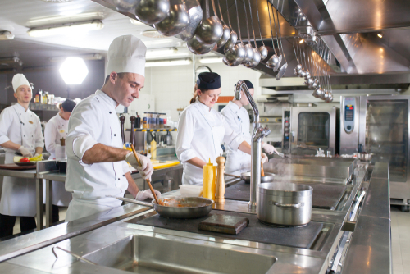
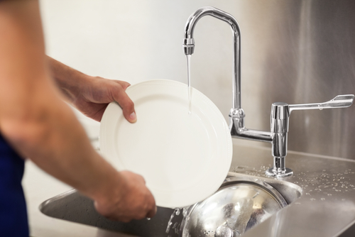

Catering manager – this role is similar to the executive chef and is usually works within the cost sector part of the industry. They may have a number of catering outlets to manage and have very little hands-on cooking. Traditionally they have worked in a catering role in the kitchen before.
Kitchen porter – often known as Kitchen assistants, porters are usually kitchen workers who assist with basic tasks but have had no formal training in cooking. Tasks could include peeling potatoes or washing salad. Smaller kitchens more commonly have kitchen assistants who would be assigned a wide variety of tasks (including washing-up) in order to keep costs down.
Food and beverage service roles
Restaurant manager – the manager is responsible for overseeing the efficient running and profitability of restaurants and for managing the staff; including planning and coordinating menus. They will coordinate the operation of the restaurant during scheduled shifts and respond to guest queries and complaints.
Maître D’hotel – is the head front of house member of staff at a dining establishment/restaurant, responsible for ensuring that the connection between kitchen and front of house runs smoothly. They may meet guests as they arrive, visits tables to check on guests, and do everything they can to cater to each guest's needs.
Sommelier – a sommelier (or wine steward) is a trained and knowledgeable wine professional, who specialises in all aspects of wine service as well as wine and food pairing. Sommeliers usually practice in fine dining restaurants and hotels.
Waiter/waitress – sets up the front of house area prior to service. They meet and greet customers, organise table reservations and offer advice about menu and wine choices, as well as taking guests’ orders and delivering food and beverages.
Bar manager/supervisor – primarily responsible for keeping the bar operations running with no problems. The bar manager/supervisor controls, organises, and directs bar staff. Additionally, they will check stock levels, order supplies and prepare cash drawers.
Bar staff/mixologist – also referred to as bartenders – are mainly employed to serve drinks at pubs, restaurants and other establishment. They also process payments from guests.

Events manager – an events manager will coordinate a variety of event activities, and be responsible for the scheduling, coordinating and running of events such as wedding parties and dinner and dances. They will be required to maintain quality standards and health and safety.
Conference and banqueting manager – this is a very similar role to the events manager and is a high profile and senior role in a hotel. They develop menus and event requirements to fits the guests’ needs and expectations.
Barista – a barista will have great customer service skills and knowledge of how coffee brewing equipment operates. They produce a range of high-quality espresso-based beverages but also have the skills and knowledge to produce hot and cold beverages such as teas and cold coffees.

Front of house roles

Front office manager – will coordinate the operation of the hotel’s front of house operations during scheduled shifts and respond to guest queries and complaints. They will manage staff to ensure the guest needs are met. They will plan and organise accommodation and other hotel services.
Concierge – this role is at the heart of meeting guests’ needs. A concierge provides information, advice, guidance and assistance to guests in all manner of things; from making dinner reservations, to reserving entertainment tickets, arranging transport and ordering food for delivery.
Porter – ensures that guests of a hotel receive services which make their stays more enjoyable. The precise duties of a hotel porter vary, depending on the hotel and the region of the world that the porter works in.

Housekeeping roles
Executive housekeeper – is in charge of overseeing and directing the cleaning activities for a hotel. The work schedules are prepared and planned in advance by the executive housekeeper, and they handle customer service and complaints as well. They will also carry out housekeeping audits.
Floor housekeeper – is responsible for maintaining the cleanliness and the hygiene of the hotel premises. They are in charge of a team of cleaners and room attendants.
Room attendant – responsible for cleaning the room, making beds and supplying fresh towels, removing rubbish, washing bathrooms and replacing toiletries and consumables. Often, they work as a part of a team to cover all the rooms in a hotel.
Public areas cleaner – similar to a room attendant, but they focus on public/front of house areas such as receptions, corridors, and guest toilets contained within public spaces.
Laundry attendant – responsible for ensuring that all areas of the hotel are kept properly stocked with clean linens. Additional tasks may involve collecting, cleaning and delivering guest laundry/dry cleaning.
Maintenance – maintenance staff carry out preventive and corrective maintenance activities on hotel areas such as rooms, as well as equipment and tools.

