Unit 207: Food safety

Handout 3: Cleaning chemicals
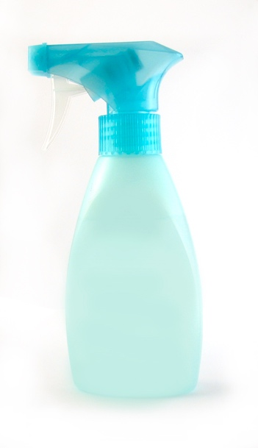
Chemicals should be used to make sure that the correct standards of cleaning and disinfection are met to ensure food safety.
In most cases the chemical is added to water to dilute it to the correct strength needed to clean always following manufactures instructions effectively.

There are some very important rules to be followed when using cleaning chemicals:
- follow the manufacturer’s instructions for dilution and safe storage
- wear the recommended protective equipment: rubber gloves, mask
- keep chemicals in storage areas away from food areas
- keep chemicals in a cool storage area
- make fresh supplies regularly to ensure the product effectiveness

NEVER mix chemicals. They may react with each other and produce poisonous gases.

Detergents: these chemicals will dissolve grease from utensils and equipment and help with the removal of food debris. Detergents do not kill bacteria.

Disinfectants: these are chemicals which have been designed to destroy bacteria or reduce them to a safe level. They do not remove grease or dirt and so are not used for washing up purposes. Disinfectants may be strong smelling and so care should be taken in their use on food preparation areas.

Sanitisers: these chemicals combine the effects of detergent and disinfectant. They have been produced to remove grease and dirt and disinfect at the same time.

Disinfection can also be carried out by heat as it is an effective way to kill bacteria. If using hot water it should be over 82°c.

Contact time is the amount of time the chemical needs to be in contact with the ‘dirt’ to ensure it works properly.

When carrying out cleaning tasks it is important to select the correct equipment and chemicals to maintain hygiene standards. There are six stages of cleaning that should be followed they are:
- pre-clean
- main clean
- rinse
- disinfect
- rinse
- dry.

