Unit 207: Food safety

Handout 5: Food storage
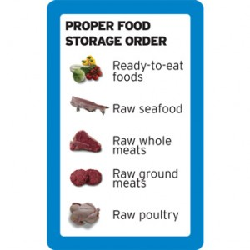
Most businesses have to store food, even if it is only for a short time.
Correct storage helps to:
- prevent illness linked to food
- preserves the food’s taste, appearance and nutritional
value
- provide adequate supplies when they are needed
- avoid spoilage and wasted food
- keep to the budget
- keep within the law and avoid prosecution for selling
unfit food.

Types of storage
- Dry goods store – long and short-term storage of canned and bottled foods, grains, spices, tea, coffee, etc.
- Refrigerators and cold stores - for storing high-risk and perishable foods for short periods
- Chiller cabinets – for displaying food for very short periods.
- Freezers – for longer term storage of frozen items.

Consideration for storage conditions
Are the foods:
- ambient
- chilled
- frozen.

General rules for safe storage
- Keep storage areas clean and tidy
- Store food immediately after delivery
- Store high risk and perishable foods before dry and canned goods on delivery
- Keep high risk and perishable foods out of the temperature danger zone
- Cover foods to prevent contamination
- Store foods in appropriate storage areas
- Always store foods off of the floor
- Stack shelves safety, do not overload and allow air to circulate
- Make sure all food items are labelled / date
- Check all foods regularly and in particular before use
- Rotate stock – first in, first out (FIFO).

