Unit 207: Food safety

Handout 7: Allergens
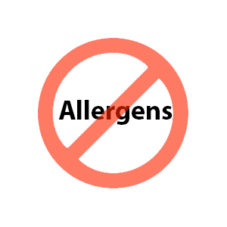
Some people are particularly sensitive to certain foods and as a result of this have an allergic reaction or become ill after eating them. Allergic reactions to food result in the immune system react as if the body were under attack.
Allergic reactions can occur within minutes of a person eating a food and can be life threatening in severe cases.

It is the responsibility of the food handlers to provide accurate information on the dish ingredients to inform customers.

Other people may have an intolerance to a food item and so will avoid eating these foods to reduce the likelihood of associated symptoms.

Foods and ingredients that are identified as containing allergens must be kept separate to avoid cross contamination when storing, preparing, cooking and serving dishes.

List of allergens
- cereals containing gluten: wheat, rye, barley, oats
- crustaceans
- eggs
- fish
- peanuts
- soybeans
- milk
- tree nuts – almonds, hazelnuts, walnuts, cashews, pecan nuts, Brazil nuts pistachio nuts, macadamia
- celery
- mustard
- sesame seeds
- sulphur dioxide and sulphites
- lupin
- molluscs.

Allergens chart

Dishes | 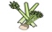 |  |  |  |  | 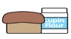 | 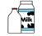 |  | 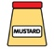 |  |  | 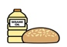 |  | 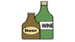
 | Celery | Cereals with gluten | Crust-aceans | Eggs | Fish | Lupin | Milk | Mollusc | Mustard | Nuts | Peanuts | Sesame seeds | Soya | Sulphur Dioxide
Tuna Salad [example] | ✓ |  |  | ✓ | ✓ |  | ✓ |  | ✓

