Unit 207: Food safety

Activity 6: Bin rules

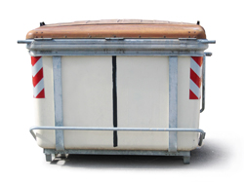
Remember the BIN rules!

- E _ _ _ _ B _ _ _ R _ _ _ L _ _ _ Y THROUGHOUT THE D _ _
- W _ _ _ Y _ _ _ H _ _ _ S A _ _ _ _ E_ _ _ _ _ _ _ BINS
- DIS_ _ _ _ _ _ ALL BINS D _ _ _ _
- Where should outside bins and waste skips be positioned?
…………………………………………………………………………….
- Why should external bins have well fitting lids?
……………………………………………………………………………
- What should you do to the bin area after the refuse has been collected?
……………………………………………………………………………

