Unit 305: Sustainability in professional kitchens

Handout 2: Is there such a thing as humane meat or eggs?
An article by Jacy Reese published in The Guardian states that there is no such thing as humane meat or eggs.

Extracts from the article are provided below:

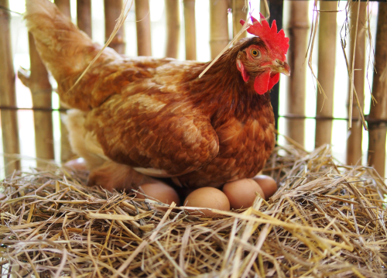
“Consumers go out of their way to buy cage-free or pasture-based eggs or buy meat at the local farmers’ market. In fact, when vegans ask their friends to stop eating animals, one of the most common responses they hear is, “Don’t worry. I only eat humane meat.”
Are consumers right? It’s impossible for all of them to be. Data on the number of animals per farm in the US suggests that over 99% of US farmed animals live on “factory farms”. Globally, that figure is probably over 90%.
Take cage-free eggs, for example. Just because the birds aren’t in cages doesn’t mean they’re healthy or happy. Cage-free birds have around the same total space per bird; they just live in a large shed with thousands of other birds.
In this stressful environment, birds frequently peck each other so much that they lose feathers, bleed, and even die. The air quality on cage-free farms tends to be worse as chickens walking around kick up dust and faeces, which threatens food safety.
Raising chickens on pasture avoids some of these issues, but it invites new problems. Pasture-based flocks suffer due to predation and disease from wild animals.
By some measures grass-fed cow farming is potentially worse than grain-fed cow farming. Grass-fed cow farming leads to two to four times more production of methane, a major greenhouse gas, than grain-fed cow farming. It also takes more land, water, and fossil fuels to produce grass-fed beef.
Maybe there are some methods that do reduce environmental impact. However, eco-conscious animal farming does little to mitigate health concerns aside from the overuse of antibiotics. And the animal suffering, especially on chicken farms, is still staggering.
We would need extensive regulations and enforcement to maintain high animal welfare throughout the industry. This would include the expenses of regular independent inspections and livestreamed security footage at all facilities.
Consumers or taxpayers would also need to pay for direct costs such as more space per animal, an army of veterinarians and medical supplies for sick animals, and a reversion of the artificial breeding that has made animals grow meat and produce milk and eggs at ultra-fast rates. That level of welfare doesn’t exist at the very best farms today.
So even if humane animal farming is possible in theory, and maybe even real in a handful of isolated cases, it can’t feasibly feed around 10 billion people by 2050.”
Reference: https://www.theguardian.com/food/2018/nov/16/theres-no-such-thing-as-humane-meat-or-eggs-stop-kidding-yourself

