Unit 305: Sustainability in professional kitchens

Handout 4: Food sustainability cycle

Food Sustainability
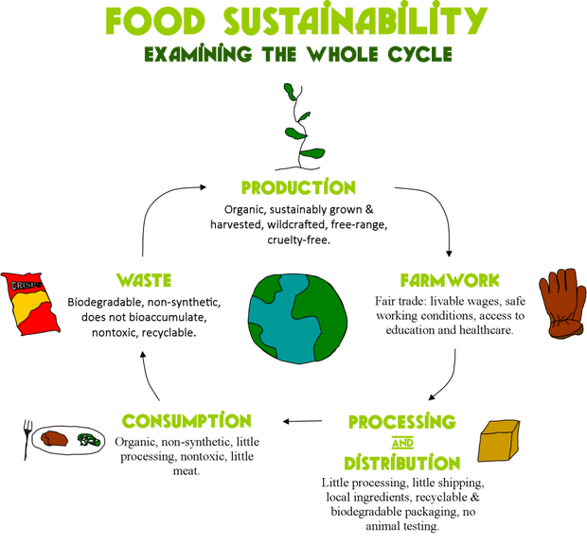

Reference: https://foodforlife2016gs.wordpress.com/food-sustainability/

