Unit 308: Produce and present advanced main course dishes using standardised recipes

Handout 8: Braised fillet of cod, pan-fried scallops, beurre blanc, pickled radish, spring herbs and greens

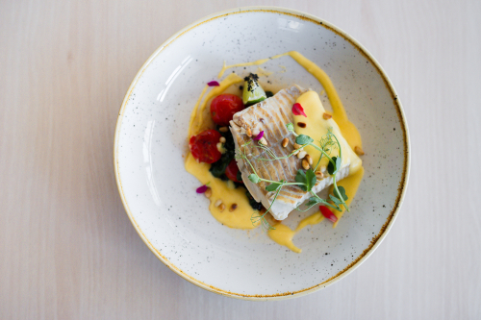

Cod and pan-fried scallops – ingredients

- 4 cod fillets (150g each)
- 4 large scallops (80g)
- 100g unsalted butter
- lemon juice
- sea salt
- black pepper
- fish stock

Sauce – ingredients

- 20g butter
- 50g shallots, peeled and diced
- 120g girolles and chanterelles mushrooms
- 100ml white wine
- 80ml fish stock
- 1 tbsp double cream
- 20g cold unsalted butter, diced

Cod and pan-fried scallops, and sauce – method

Lay the cod fillets on a board. Mix the softened butter with the lemon juice and seasoning, and brush over the fillets.

Preheat the oven to 190°C/gas mark 5. In an ovenproof sauté pan over a medium heat, melt the butter and sweat the shallot for 2 minutes. Add the mushrooms and sweat for a further minute.

Meanwhile, bring the wine to the boil in another pan and boil for 10 seconds. Add the boiled wine, water and some seasoning to the sauté pan and bring to the boil. Sit the cod fillets on top of the mushrooms and cover with a lid. Cook in the oven for five minutes
Pan fry the scallops in a little butter until golden brown on the outside and still a little raw on the inside.

Transfer the fish and scallops to a small baking tray and set aside to rest for three minutes, then put back in the oven for one minute to keep warm while you finish the sauce and cook the vegetables.

While the fish is resting, add the cream to the pan, bring to the boil and whisk in the butter. It is important to use cold butter, adding little pieces and whisking to create an emulsion.

Radishes – ingredients
- 8 radishes
- 100ml apple cider vinegar
- Sea salt

Radishes – method

Thinly slice the radish and soak in vinegar and salt solution for 30 minutes.

Spring herbs and greens – ingredients

- 100g baby spinach
- 1 tsp lemon juice
- ½ tbsp chopped chives
- ½ tbsp chopped chervil
- 20g baby plum tomatoes, halved

Spring herbs and greens – method

Cook the spinach for one minute and take off the heat. Check the seasoning and add a little lemon juice. Finish with the chopped herbs and tomato. Place the vegetables in the middle of each warmed large serving bowl.

Garnish – ingredients
- micro-cress
- herb Oil

Plating up

Warm a large serving bowl .Place the vegetables in the middle of each bowl, keeping it centred as much as possible. Place radishes, on top of the vegetables. Place the rested cod on top of the vegetables, place the scallops around the dish. Sauce the dish around the fish, garnish with micro-herbs and a green herb oil. Ensure that when presenting that the colours of the dish are displayed.

