Unit 309: Produce and present advanced desserts and dough products using standardised recipes

Handout 1: Baked cheesecake with honeycomb and shortbread crumble

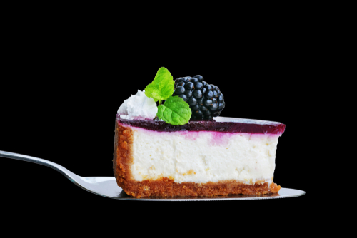

Ingredients

Cheesecake filling
- 1400g mascarpone, or high-quality cream cheese
- 450g white chocolate
- 225g caster sugar
- 6 large eggs

Cheesecake base
- 400g digestive biscuits
- 300g caster sugar
- 140g butter, melted

Honeycomb
- 200g caster sugar
- 4 tbsp golden syrup
- 3 tbsp water
- 2 tsp bicarbonate of soda

Shortbread
- 170g plain flour
- 110g unsalted butter, at room temperature
- 50g caster sugar
- 1/4 tsp vanilla extract
- salt, to taste

Blackberry gel
- 300ml balckberry, purée
- 100ml water
- 100g caster sugar
- 4g agar agar
- 1 pinch salt

Method

- Preheat the oven to 110°C/gas mark 1/4

- To make the cheesecake filling, first melt the chocolate in a microwave. Blend the melted chocolate, sugar, mascarpone and eggs in a food processor until homogeneous and completely smooth.

- Pour the filling mixture into a small, deep baking tray and cover with foil. Bake in the oven for about 1 hour or until just set, checking the mixture after 40 minutes of baking. Once baked, remove the foil and allow to cool to room temperature.

- While the filling is baking, make a start on the base of the cheesecake by lining a baking sheet with greaseproof paper.

- Gently heat the sugar in a heavy-based saucepan until caramelised – do not to stir the sugar. Pour the caramel onto the pre-lined baking sheet to cool.

- Line the base of a 20cm springform cake tin with greaseproof paper.

- Break the cooled caramel into pieces and add to a food processor with the digestive biscuits. Blitz to an even powder then add the melted butter and blend again.

- Tip the base mix into the pre-lined cake tin, smooth down with a spoon and place in the fridge to set.

- Blend the set filling in a food processor, pour over the set base and smooth down with a hot palette knife. Return to the fridge for at least 3 hours, preferably overnight, to re-set

- Whilst the cheesecake is setting, line a roasting tray with greaseproof paper for the honeycomb.

- Pour the sugar, golden syrup and water into a pan and place over a low heat to dissolve the sugar. Once the sugar has dissolved, turn the heat up and bring to the boil. Allow the sugar syrup to boil until it turns a deep amber colour.

- Quickly mix the bicarbonate of soda into the amber syrup using a spatula, being careful not to over-mix. Pour the contents of the pan into the pre-lined roasting tray and leave the honeycomb to set for 30 minutes .

- Preheat the oven to 180°C/gas mark 4 .

- To make the shortbread, start by lining a small baking tray with greaseproof paper.

- Whisk the butter until smooth and creamy, then add the sugar, salt and vanilla and whisk again.

- Gently fold in the flour with your hands until well combined and smooth.

- Push the shortbread dough into the pre-lined tray so that it forms an even layer about 2cm deep. Bake for 10–15 minutes, or until golden brown.

- To make the gel first bring the purée, water, salt and sugar to the boil in a small saucepan and whisk to make sure the sugar has dissolved. Blend the agar in with a stick blender and re-boil the liquid.

- Pass the liquid through a sieve into a plastic container and allow to set in the fridge for a minimum of 1 hour.

- Once set, blend the gel until smooth and funnel into a plastic bottle ready to serve. You can reset and re-blend the gel if not used immediately.

- When ready to serve, slice the cheesecake into individual portions. Crumble the shortbread and honeycomb over each slice, decorating with fresh seasonal fruit and the blackberry gel to finish.

