Unit 309: Produce and present advanced desserts and dough products using standardised recipes

Handout 3: Spiced brioche buns

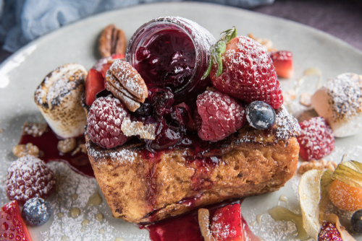
Ingredients

- 500g plain flour
- 50g sugar
- 1/2 tsp cinnamon
- 1/2 tsp ground nutmeg
- 2 tsp salt
- 6 eggs
- 25g dried yeast
- 250g butter, diced
- 1 tbsp sunflower oil

Garnish
- 10 toasted marshmallows
- Pecans
- Fresh berries – blueberries, strawberries, raspberries
- Icing sugar for dusting
- Fruits of the forest jam

Method

- Preheat the oven to 180°C/gas mark 4.

- Combine the flour, sugar, cinnamon, nutmeg and salt in a large mixing bowl. You can double the sugar for a sweeter result.

- Make a well in the middle and mix in the eggs with your hands for 5 minutes.

- Add the yeast and continue to mix for another 5 minutes to form a smooth dough.

- Switch to a wooden spoon and gradually add the cubes of butter, keep mixing until all of the butter is incorporated and the dough is shiny and elastic.

- Rub a little oil into each mould of a muffin tray, or line each with a square of parchment paper. Place 40g of dough into each mould and leave in a warm place for 25 minutes to prove and double in size.

- Bake in the oven for 8 minutes, until golden brown and puffy, returning to the oven for an extra 3–4 minutes if not ready.

- Serve warm with butter and jam, or with ham and cheese.

